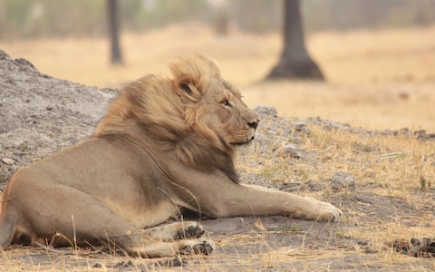 serving Jesus

Topic: Spring 2018 Year 2 **Wild About Animals**

**Humanities: Wild About Animals**

**History -Scientists and explorers**

**Geography Focus**

***Map Work, Continents Africa as a main focus looking at the land and animals.***

**Drama/S&L Opps:**

Role Play will be an African Hut

**Stories/Texts/links:**

***Various stories set in Africa and a range of nonfiction books on animals and Africa.***

**Writing Opportunities:**

**All literacy this term will be directly linked to the topic.**

**We will be looking at nonfiction text including lifecycles of animals.**

**Then we will look at stories set in Africa.**

**PE and Music:**

**Outdoor Games**

**Music: We will be looking at African Music**

**And following the Manchester Music Scheme**

**Art /DT:**

**DT** – African Masks

How to make healthy snacks.

**Art – Tinga Tinga paintings**

**Questions children want to investigate:**

Why do giraffes have long necks?

Why do dogs sniff their food?

Why do lions eat meat?

Why do owls only come out at night?

Why do lions hide?

How do sharks sleep?

How do snakes slither?

How do chameleons go invisible?

Why do turtles go slow?

Why do chameleons hide to catch their pray?

Why do chameleons change colour?

Why do tigers crouch down low when they are hunting?

Why do lions roar?

Why do wolves howl at night?

Why are dinosaurs extinct?

-

**ICT:**

Graphics: We will be creating African Pictures using computer programs.

**Science:**

**Plants - we will be looking at different types of plants and how some plants are foods. We will also be looking at healthy foods. Mini Worlds- where we will be looking closely at invertebrates and their habitats and comparing them to animals found in Africa.**



**Numeracy Links:**

Primary Numeracy Framework linking with Medium Term White Rose Maths plans:

Preparing for SATs

Counting back in 2s,5s and 10s from any number.

Learning our 2s,5s, and 10 times tables beginning to learn the 3 times table.

Telling the time.

Using money

**RE:**

Using the Blackburn scheme of work:

Jesus: Friend to Everyone and Easter Symbols

Link to Heartsmart