“Growing together to let our light shine”

Welcome to your weekly newsletter!! WC 2nd October 2017!
Diary Dates-
-Tuesday 3rd October pm Reception-Year 4 Nasal Flu Spray
-Tuesday 10th October Whole School Creative Write Day
-Tuesday 10th October 9am & 2.45pm Reception Home Learning Packs session
-Wednesday 11th October Harvest Worship
-Wednesday 11th October-Year 5 Recycling Plant Trip
-Thursday 12th October New Reception Class Welcome Service (Nursery are not attending)
-Monday 16th October CHAMP- Height & Weight Screening for Reception- Year 6 pupils
-Monday 16th October Y4 Experience Day
-Tuesday 17th October EYFS Families around the World Experience Day
-Tuesday 17th October Y6 World War 2 Bombers Experience Day
-Tuesday 17th & Wednesday 18th October- Parent/Carer meetings after school
-Wednesday 18th October Thank Reverends Paul & Tom Worship
-Wednesday 18th October Y1 Senses Experience Day
-Thursday 19th October Y3 Greek food Experience Day
-Thursday 19th October Y5 Anthony Gormley Experience Day
-Friday 20th October 3.15pm- End of Autumn 1 half term
-Monday 30th October SCHOOL CLOSED-STAFF INSET DAY
-Tuesday 31st October School Re-opens for Autumn 2 Half Term at 8.50am

Behaviour Jumper Winners- Year 1-Jayce Pennill-Coombes, Year 2-Kaisha Jay Knight, Year 3-Rhys Williams, Year 4-Olivia Callaghan, Year 5-Stacy Mark, Year 6-Codi-Leigh Wilson.

Top Table Winners- Reception-Lacey McNicol, Year 1-Coby Ryan, Year 2-Elsie Poole, Year 3-Lilly Mae Morrow, Year 4-Macy Bonnar, Year 5-Denzel Nhamburo, Year 6-Christiana Bembo, Buddy Award-Lilly Connor and EYFS Buddy-Leah Sudworth.

This week’s school attendance:
CLASSES- HIGHEST TO LOWEST ATTENDANCE | ATTENDANCE FOR WC 25TH SPETMEBER TO 29TH SEPTEMBER
YEAR 6 | 98.1%
YEAR 5 | 95.8%
YEAR 4 | 94.8%
YEAR 3 | 94.3%
RECEPTION | 89.6%
YEAR 2 | 88.6%
YEAR 1 | 87.1%
WHOLE SCHOOL | 92.6%
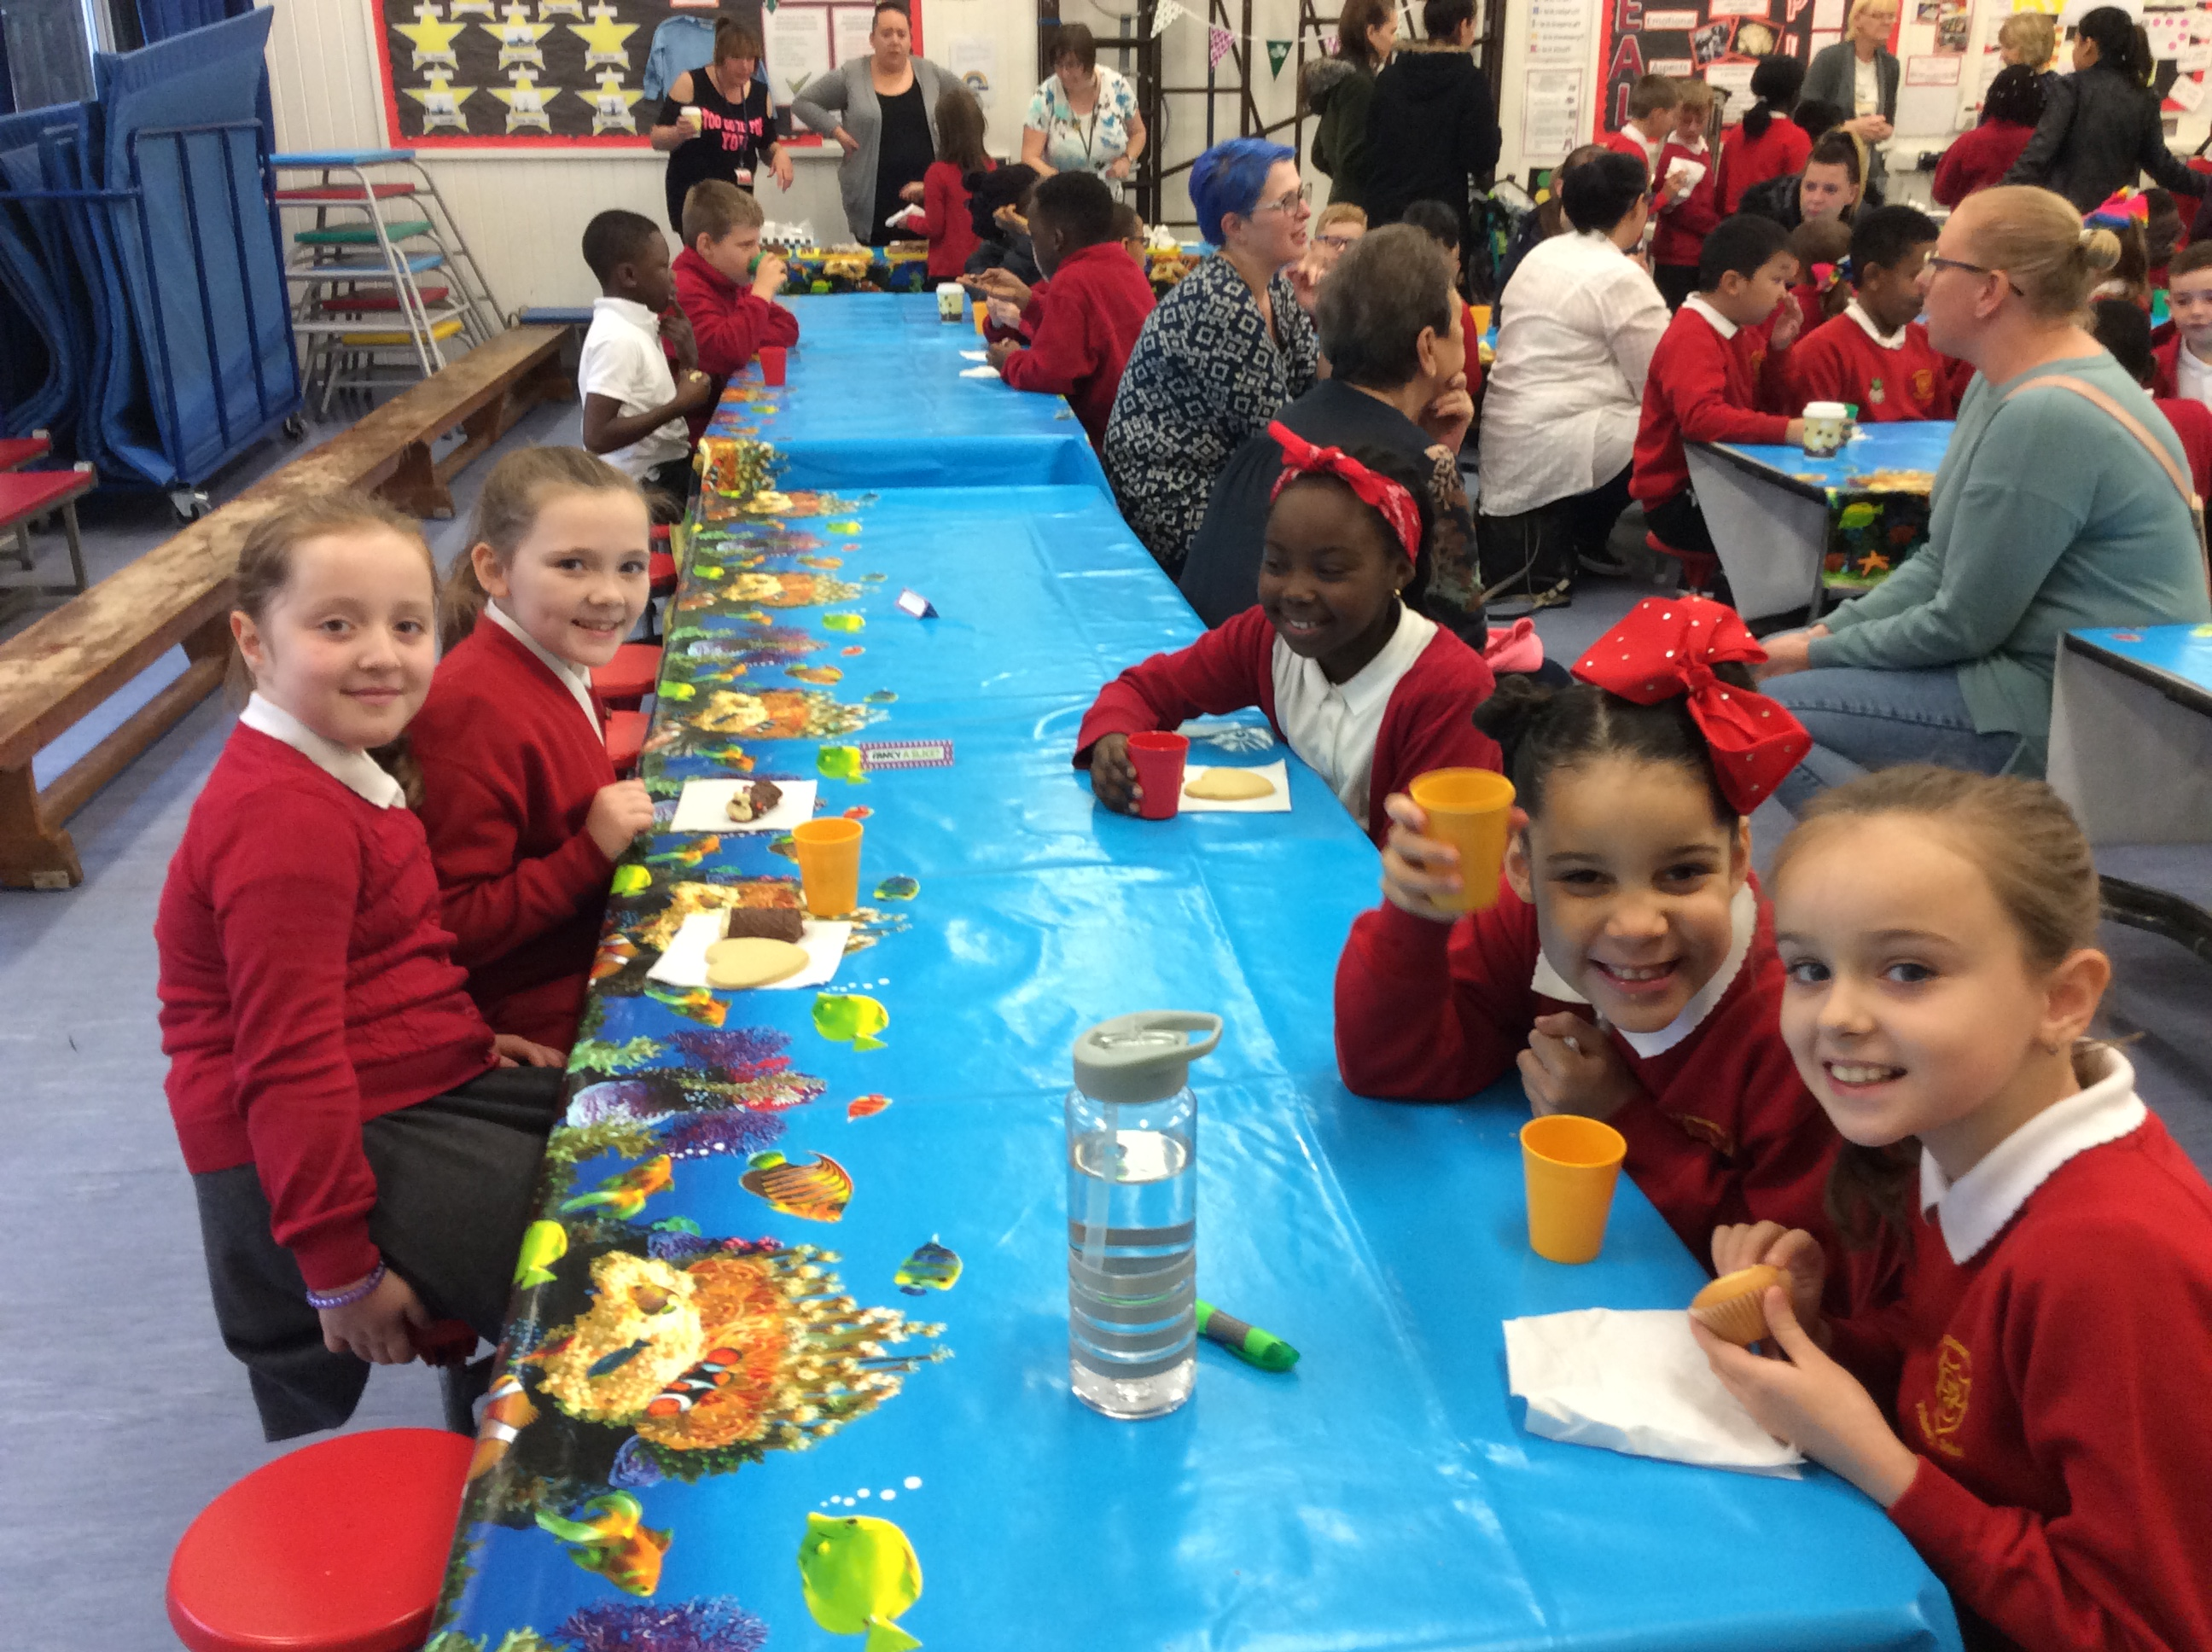
Macmillan & Christies Coffee Morning- This morning we hosted our annual Macmillan Coffee Morning like lots of other places across the country. This year, we have decided to donate to Christies as well because a number of staff and families have also been supported by them last year and in recent times, and they also do brilliant work.
In total, we raised £263.50 so far! Thanks again for your generosity and it was good to see everyone. It is also good for the children to get involved in events like this as it reinforces our Christian values- particularly compassion, thankfulness, respect, faith, hope, and not forgetting love.

Jeans for Genes Day- Last Friday we raised £164.81 for genetic research charity by getting involved in Jeans for Genes day. Fantastic and thank you again!

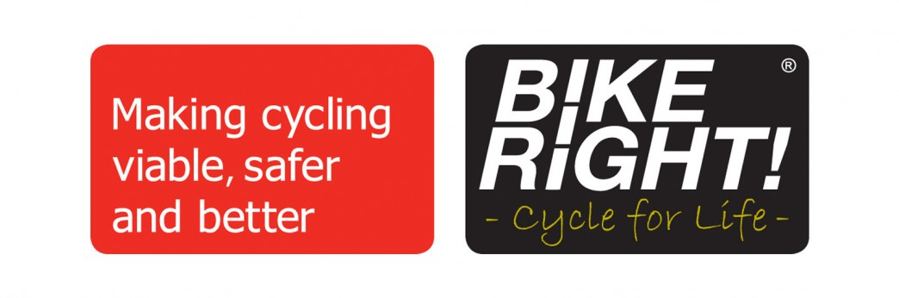
Year 5 Bikeright- On Tuesday, some of our Year 5 pupils bought their bikes into school to learn how to be safe when riding their bikes on the roads. They listened well and were very brave when they went out and about on local roads. There is another session next week. Well done to those Year 5 pupils.

Year 2 Balloon Experience Day- On Wednesday, Year 2 experienced making hot air balloons and learning lots of other things about flight in their Experience Day. The day was linked to their topic of ‘Flying High’ and the class worked really hard.

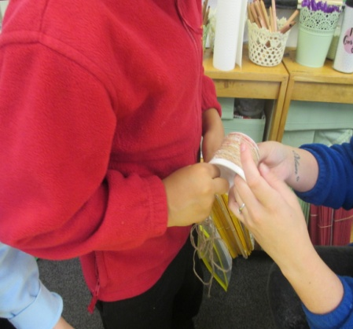
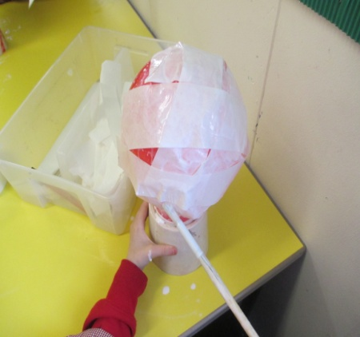
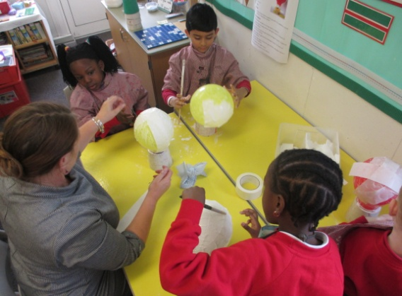

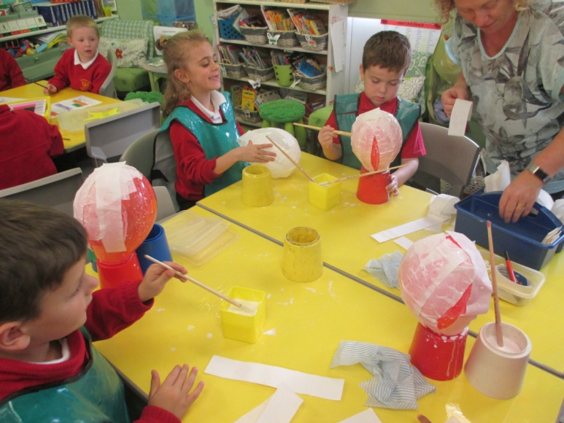

Parent/Carer Evening Appointment Letter-This evening, your child should have bought home their letter for you to arrange an appointment to see their teacher at our October Parent/Carer Evenings on 17th and 18th October. Please return the appointment slip to your child’s teacher by Monday 9th October when we will be setting appointments. If you are unable to attend on these dates, then please speak to your child’s teacher to arrange another mutually convenient time to meet.

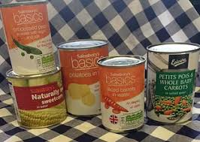
Harvest Donations- On Wednesday 11th October, we will be having our Harvest worship in school and are asking for donations of tinned veg, soup, beans etc to be donated to the Night Shelter for the homeless at St Clements Church. Thanks to those children who have already bought in their donations. The children have set themselves a target of 500 tins this year. Let’s hope we can achieve it!
Reminders:
-PLEASE RETURN YOUR COMPLETED CONTACT FORMS TO THE OFFICE AS SOON AS POSSIBLE SO WE HAVE UP TO DATE CONTACT DETAILS FOR YOU IN CASE OF AN EMERGENCY RELATING TO YOUR CHILD/REN
-CHILDREN IN YEARS 3,4,5&6 CAN BUY A HEALTHY SNACK FOR UP TO 30P. THEY CAN ALSO BRING A PIECE OF FRUIT OR A HEALTHY SNACK FROM HOME. CHILDREN ARE NOT ALLOWED TO EAT CRISPS AND CHOCOLATE AT MID MORNING BREAK.
-PARKING: PLEASE DO NOT PARK ON THE YELLOW ZIG ZAG LINES OUTSIDE SCHOOL.

