
Welcome to your weekly newsletter!! WC 11th September 17!
Diary Dates-
-WEEK BEGINNING 11th September- extra curricular school clubs begin
-Tuesday 12th September- Y4 Viking experience day in school
-Thursday 14th September- Y5 Stone Age and Y6 War Tatton Park Trips
-Friday 15th September at 9.15am- Friends of St Clements Group meeting in school
-Thursday 21st September at 9.00am- VIP Attendance Awards
-Thursday 21st September- School Council elections
-Tuesday 26th September & 3rd October- Y5 Bikeability
-Tuesday 26th September & Wednesday 27th September 9.00am & 2.45pm- Tapestry info session for EYFS parent/carers
-Wednesday 27th September- Y2 Balloon Experience Day
-Tuesday 3rd October pm Reception-Year 4 Nasal Flu Spary

EPIC Award Winner- I have been so impressed by the excellent start our new Head Boy has made in his role and the progress he made last year, that I have chosen Emanuel in Year 6 as this week’s EPIC award winner- well done Emanuel you are a great role model.

Behaviour Jumper Winners- Reception-Toby Saturday, Year 1-Alfie Sheridan, Year 2-Lexie Cornwall,Year 3- Whole Class, Year 4-Lee Callaghan, Year 5-Thomas Weaver, Year 6-Tyler Walker.

Top Table Winners- Reception-Afomiya Alam, Year 1-Isabelle Rushton, Year 2-Byron Dolan, Year 3-Mubarak Year 4-Grace Ward, Year 5-Pax Banda, Year 6-Codi Leigh Wilson, Buddy Award- Melissa Sainsbury.

This week’s school attendance:
CLASSES- HIGHEST TO LOWEST ATTENDANCE | ATTENDANCE FOR WC 5TH SPETMEBER TO 8TH SEPTEMBER
YEAR 6 | 99.2%
YEAR 1 | 98.8%
YEAR 3 | 98.7%
RECEPTION | 95.8%
YEAR 2 | 95.0%
YEAR 5 | 94.3%
YEAR 4 | 92.5%
WHOLE SCHOOL | 96.3%
Welcome Back- I hope you have all had a good Summer? It was great to see everyone back safe, sound and looking so smart on Tuesday.
Your child should have come home with a named envelope containing a number of important documents to read, sign and return to us.
IT IS VERY IMPORTANT THAT PARENT/CARERS COMPLETE THE CONTACT FORM SO WE HAVE UP TO DATE CONTACT DETAILS ON THE SYSTEM IF WE NEED TO CONTACT YOU IN AN EMERGENCY.

New Letterhead, Slogan, Mission Statement and Christian Values- After consultation with yourselves, pupils, staff and governors last term, here is our new letterhead.

It includes our new slogan: “Growing together to let our light shine” and our updated 7 Christian Values: Faith, Hope, Love, Thankfulness, Compassion, Respect & Forgiveness. This half term our focus Christian Values ara Thankfulness and Love
Our Mission Statement is: As a compassionate, Christian school, we are strong in our faith. We believe in love and forgiveness and are thankful for the opportunity we have to live and learn in our community.

New Term Staff Updates:- Miss Eyres got married in the holiday and is now known as Mrs Rodgers; Miss Allen also got married and is now known as Mrs Renshaw- congratulations to you both.
-Welcome back to Mrs Leigh as she returns from her maternity leave.
-Mrs Murphy has moved from the Lunchtime Team to the Teaching Assistant team- supporting pupils in Year 1 &6
-Miss O’Connor also has a new role in school- supporting me with the management of our Special Educational Needs provision in school.
Buildings Improvements- Over the holidays, we have had a number of improvements made to the building.
To make access easier and our pupils more secure, we have had new automatic & security doors installed in our office area. Our pupil’s toilet refurbishment plan is now complete with our nursery and reception pupils being treated to updates and a more organised pupil changing area and kitchen for our nursery and reception staff. Jim and the cleaners have also worked hard ensuring the school looks its best for the pupils on their return- thanks Jim, Pauls, Shaz and Joyce.

Operation Encompass- Greater Manchester Police have introduced a new scheme to the area.
Operation Encompass means that school will be informed the next day if there has been an incident of domestic violence where our pupils were present in the home.
This measure has been taken so that all agencies are aware and can support and safeguard the family.
If anyone requires support around domestic abuse and violence, please come into school and speak confidentially to myself, Mrs Street or Ms Steeles- we are here to help.

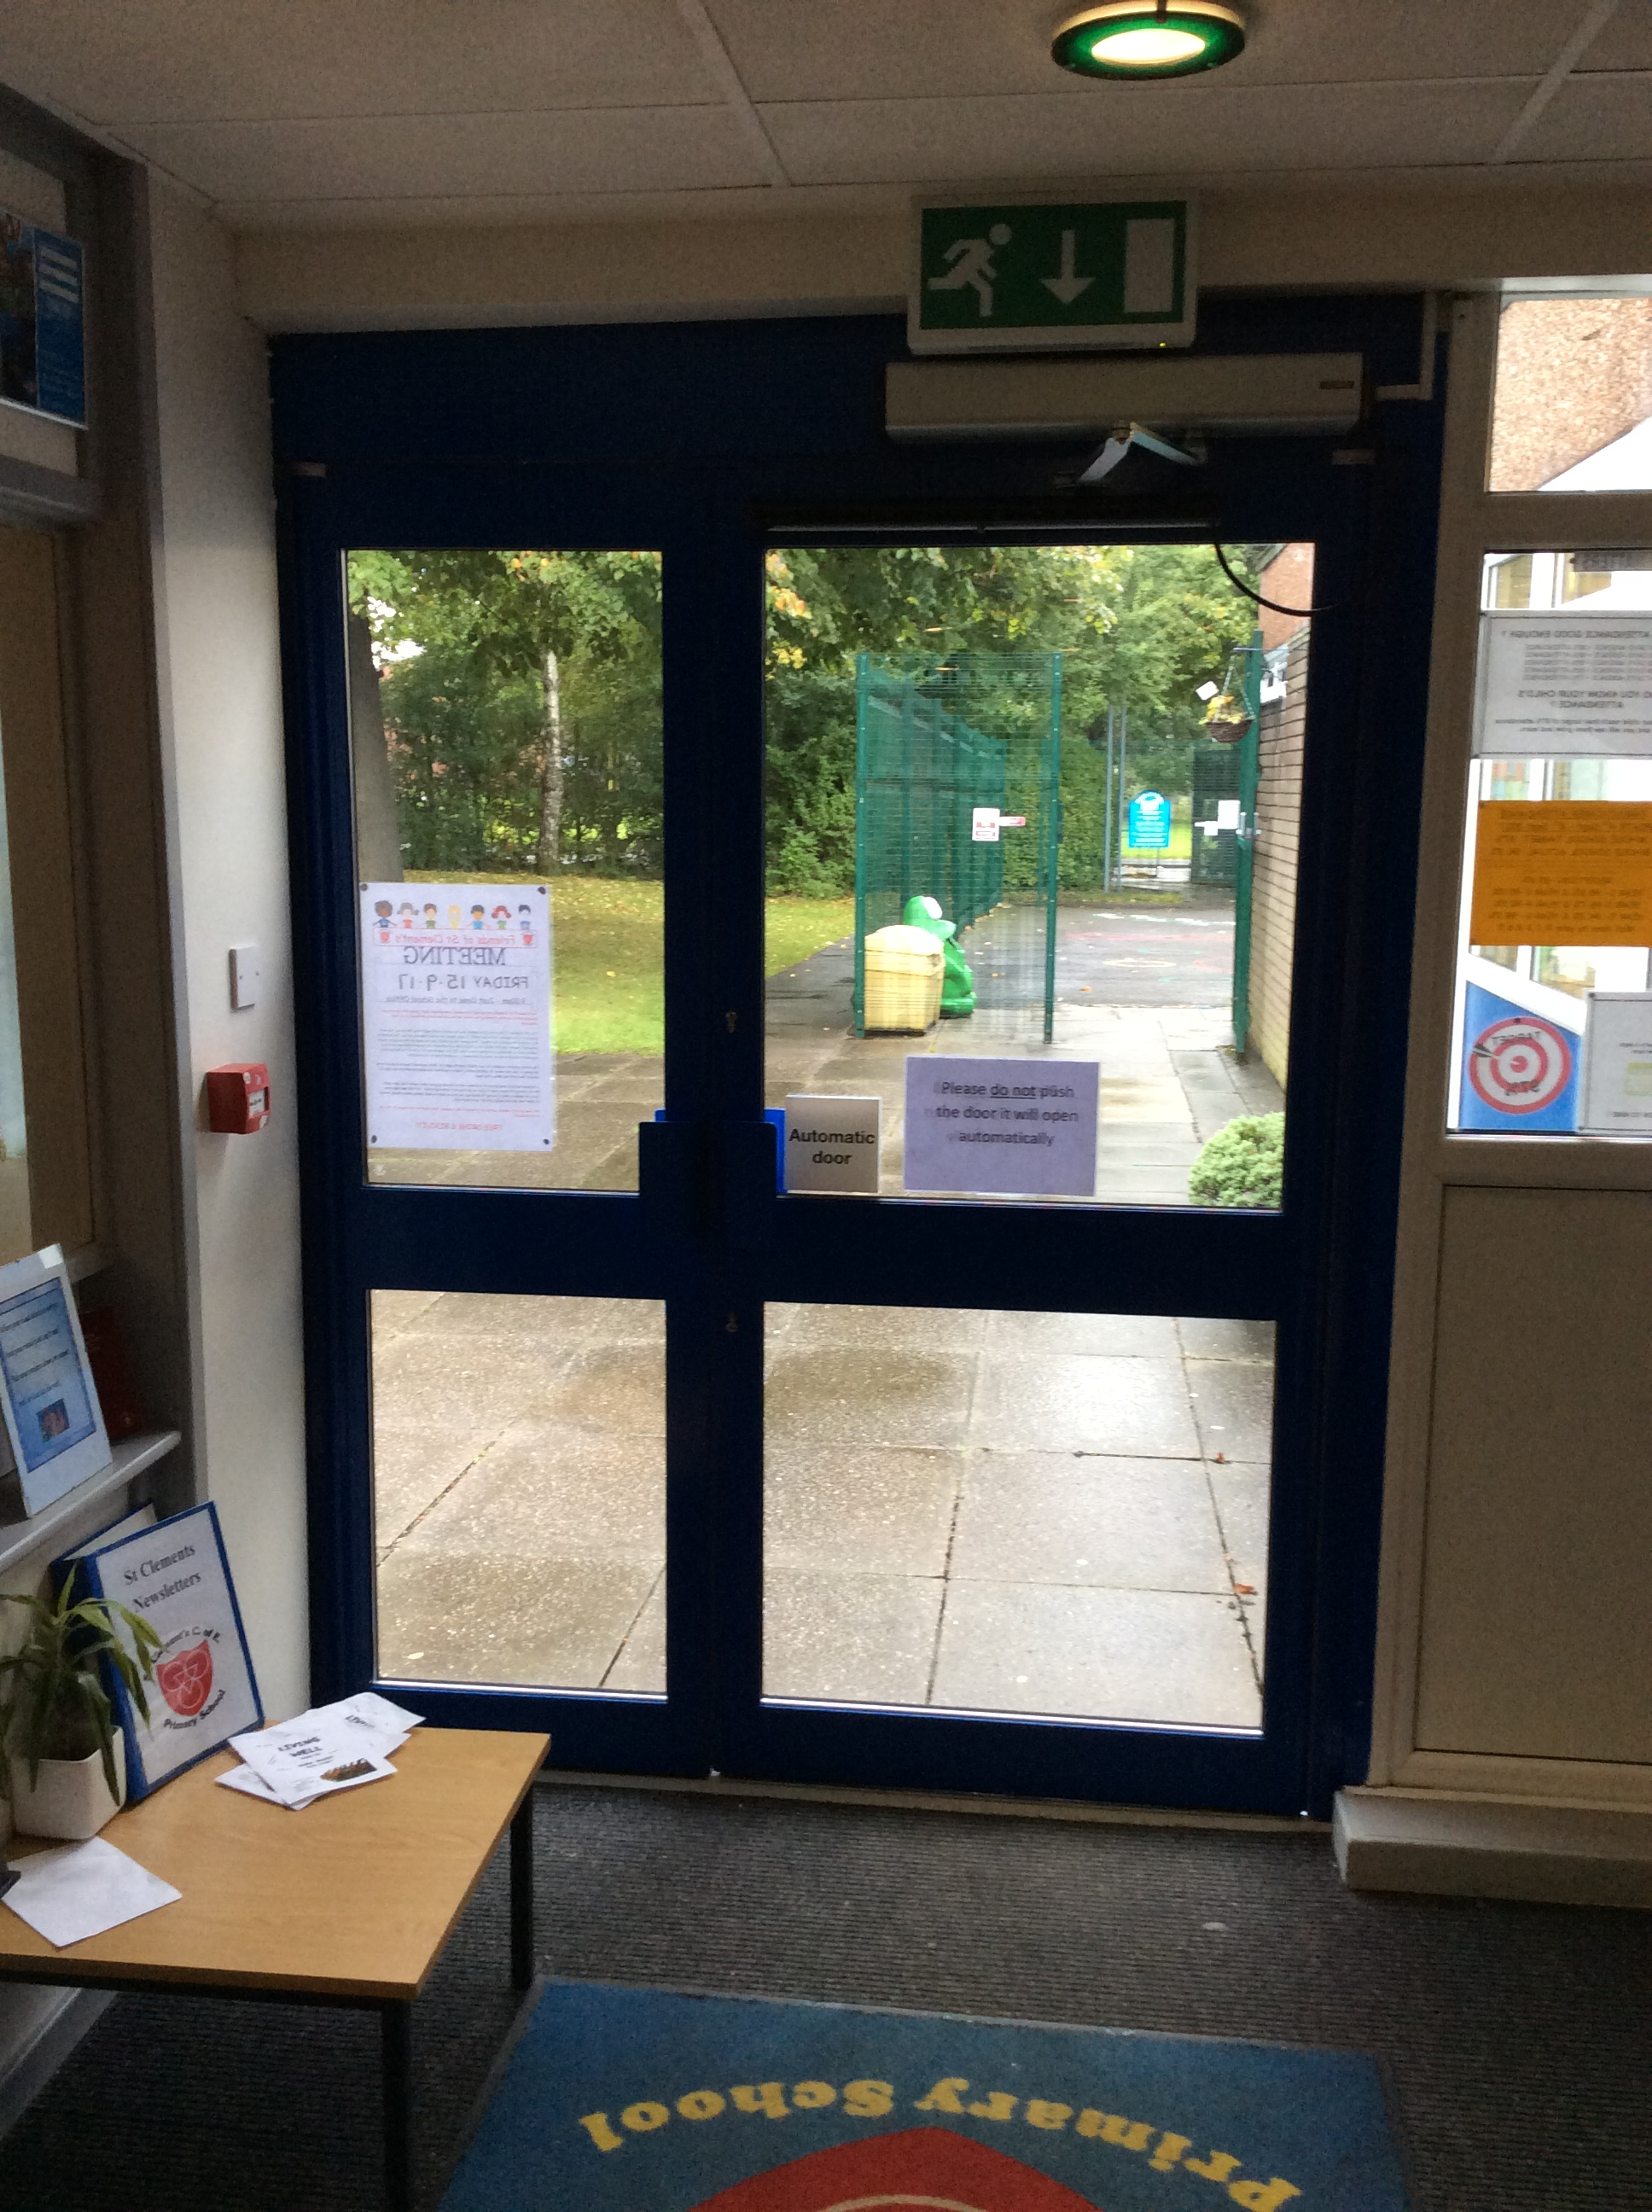
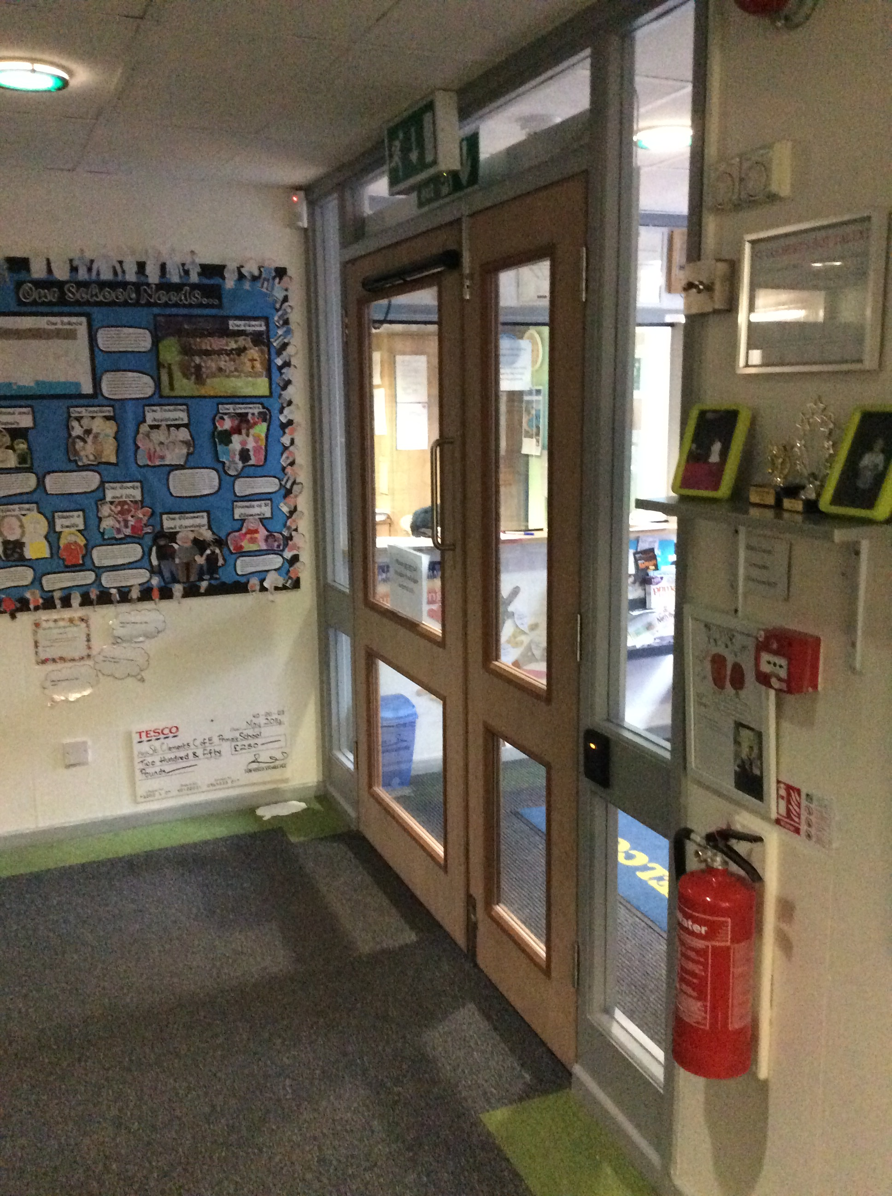
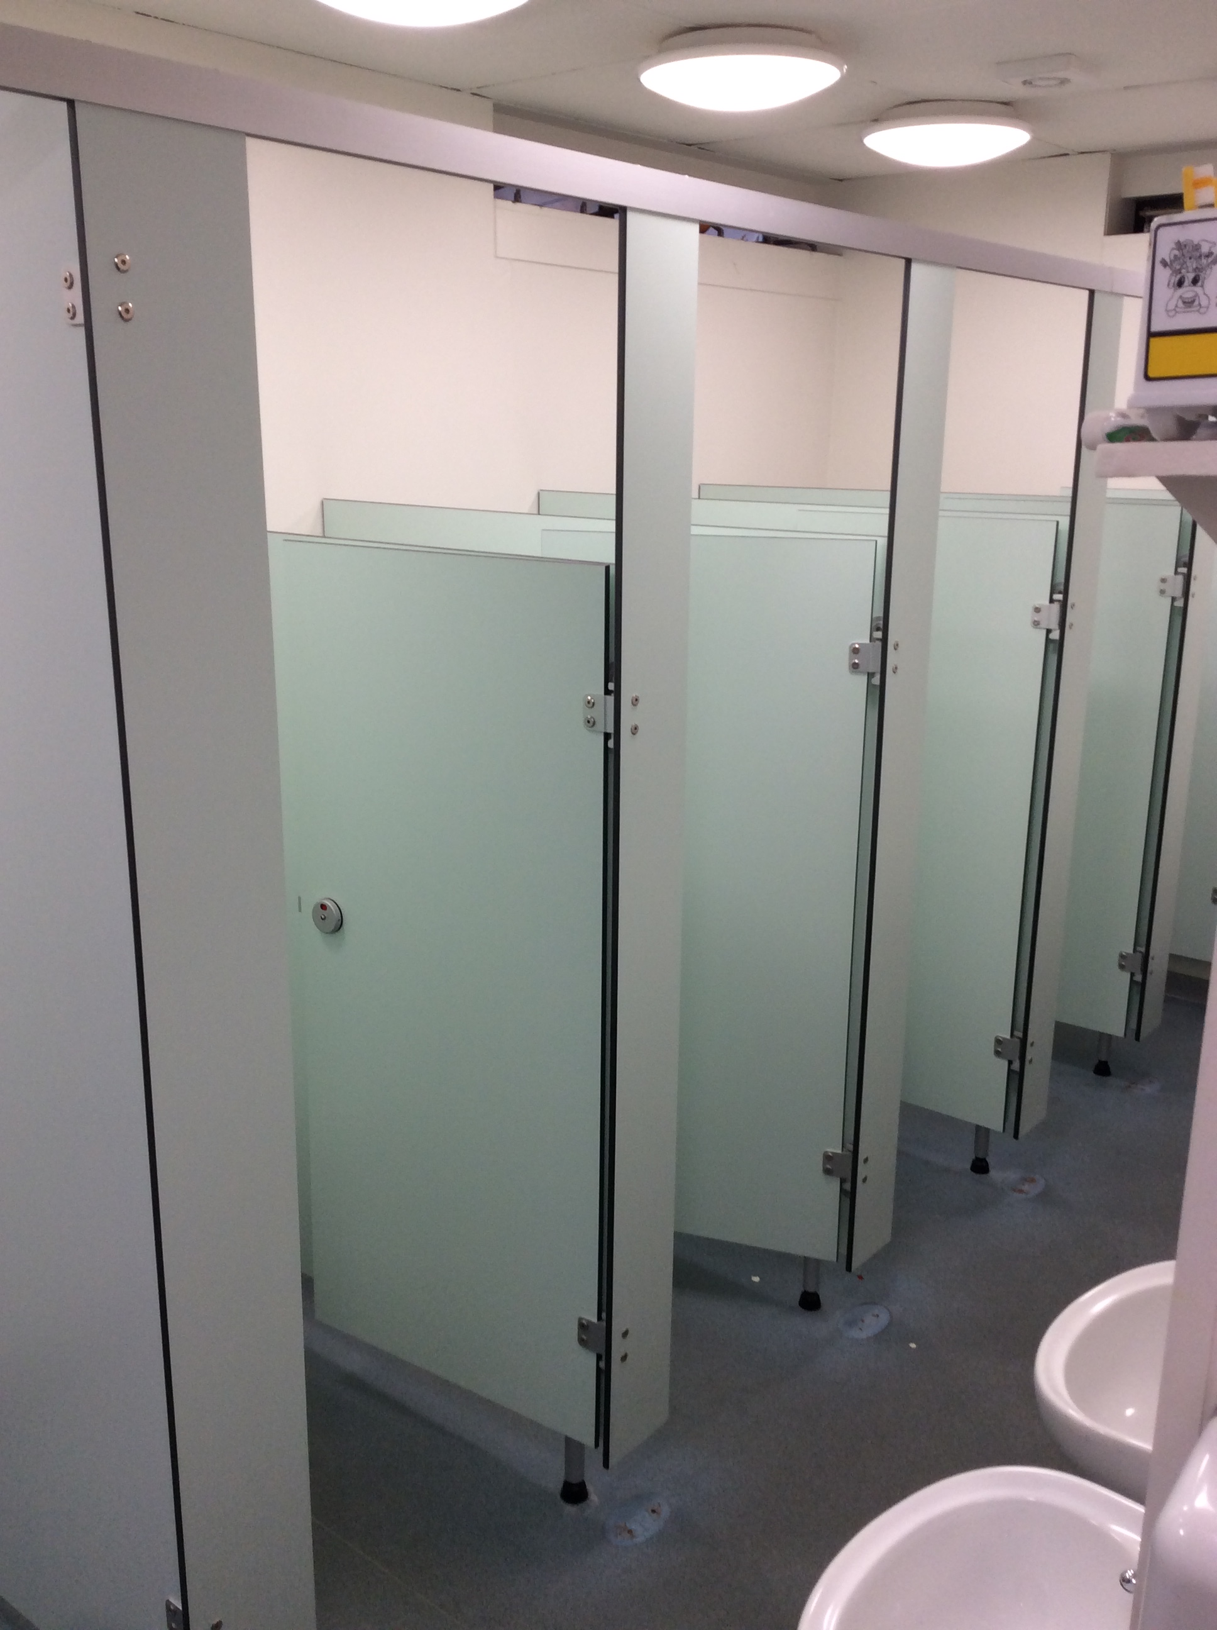
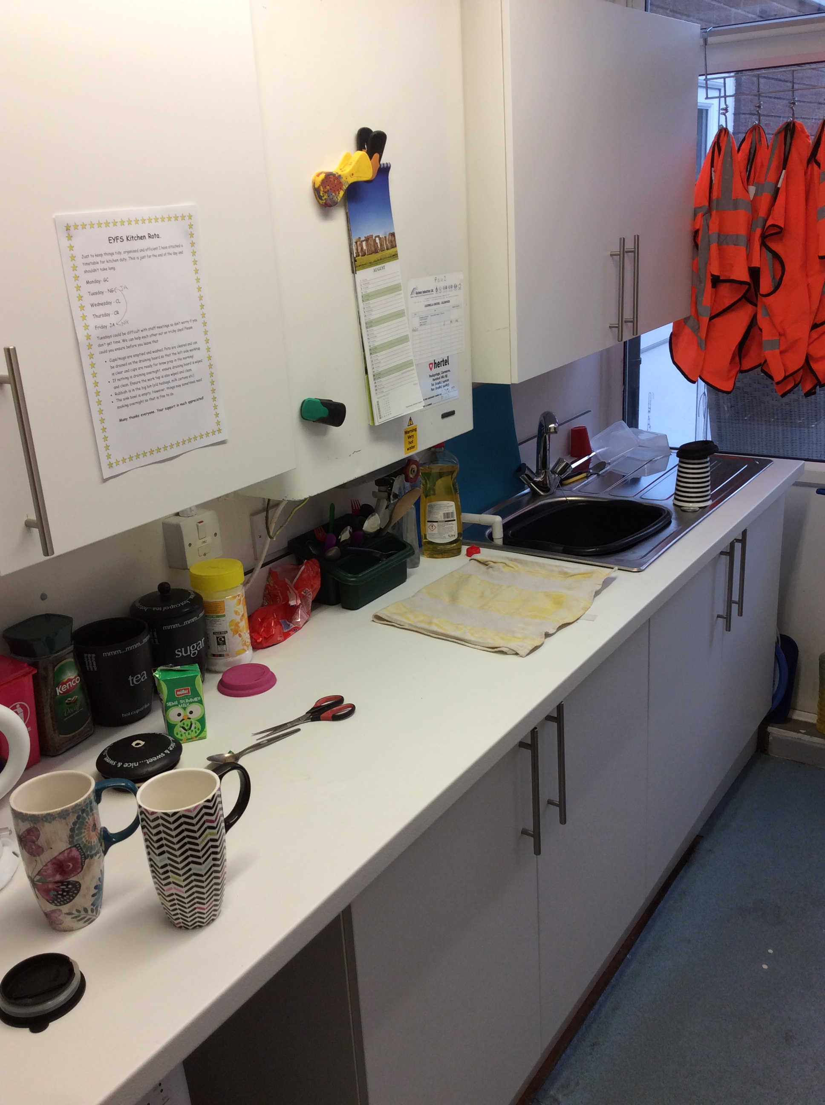

Healthy Eating Reminders- Pupils in Year 3,4,5 & 6 can buy a mid morning break snack. We have a wide range of things to sell- yoghurt drinks, fruit bags, boxes of raisins etc for a little as 20p or at the most 30p.
We don’t want to see crisps, chocolate bars etc being eaten as some children take them out of their lunch box. If you child does this, they will be told to return it to their lunch box.

Our children and a number of parent/carers feel we need to do more to educate the children about healthy lifestyles- this is part of it, as well as our 10 minute mile.
Pupils in Year 3,4,5&6 go outside for 10 minutes per day & run or walk briskly. Some classes trialled it last term and staff found that levels of concentration improved after doing this, so we are continuing with it this year as well.



