“Growing together to let our light shine”

Welcome to your weekly newsletter!! WC 13th November 2017!
Diary Dates-
-Week Beginning Monday 13th November- National Anti Bullying Week- ‘Power for Good’
-Thursday 16th November 9am- Year 6 Class Worship
-Friday 17th November- Children in Need Pudsey Bear biscuits for sale
-Monday 20th November- Individual and Sibling Photographs
-Thursday 23rd November- Year 3 Greek Experience Day
-Friday 24th November- Y3, 4, 5&6 One Goal Team Challenge Day
-Tuesday 28th November- Whole School Enterprise day- Moon Base Challenge
-Thursday 30th November-Nursery and Reception Parent/Carer access to Tapestry Help Session
-Friday 1st December-Christmas Jumper or outfit day in exchange for a tombola donation for our Christmas Fayre
-Tuesday 5th December After School- Christmas Fayre
-Thursday 7th December AM- Key Stage 1 Christmas Performance
-Friday 8th December-‘The Nutcracker & the Mouse King’ theatre company performance in the hall
-Monday 11th December after school- Friends of St Clements Movie Night
-Thursday 14th December AM-Nursery and Reception Christmas Performance
-Friday 15th December PM- Nursery, Reception, Years 1&2 Christmas Parties
-Monday 18th December PM- Years 3,4,5 and 6 Christmas Parties
-Tuesday 19th December AM- End of Term Awards
-Wednesday 20th December 9.30am- Christmas Church Service at St Clements Church
-Wednesday 20th December- Christmas Dinner
-Wednesday 20th December 3.15pm End of Term

EPIC Winner- This week’s EPIC award goes to Desmond in Year 6. Desmond is EPIC because he works hard, is always positive towards his friends and staff and has a lovely smile! Well done Desmond!

Behaviour Jumper Winners- Year 1-Abdallah Al-Saffar, Year 2-Derron Duffty, Year 3-Maira Anwar, Year 4-Ellice Omene and Fantacy Mark, Year 5-Niamh Wilkinson, Year 6-Laura Morgan.

Top Table Winners-Nursery-Florence Hollingsbee, Reception-Stanley Poole, Year 1-Isabelle Rushton, Year 2-Chelcy Mark, Year 3-Brooke Austen, Year 4-Liam Flanagan, Year 5-Pax Banda, Year 6-Joshua Gyan, Buddy Award-Geralyne Albert, EYFS Buddy-Daisy Fryar.

This week’s school attendance:
CLASSES- HIGHEST TO LOWEST ATTENDANCE | ATTENDANCE FOR WC 6TH NOVEMBER TO 10TH NOVEMBER
YEAR 4 | 99.7%
YEAR 1 | 99.3%
YEAR 3 | 99.3%
YEAR 6 | 98.7%
RECEPTION | 96.5%
YEAR 5 | 95%
YEAR 2 | 90%
WHOLE SCHOOL | 96.9%
Reminders:
-PLEASE RETURN YOUR COMPLETED CONTACT FORMS TO THE OFFICE AS SOON AS POSSIBLE SO WE HAVE UP TO DATE CONTACT DETAILS FOR YOU IN CASE OF AN EMERGENCY RELATING TO YOUR CHILD/REN
-CHILDREN IN YEARS 3,4,5&6 CAN BUY A HEALTHY SNACK FOR UP TO 30P. THEY CAN ALSO BRING A PIECE OF FRUIT OR A HEALTHY SNACK FROM HOME. CHILDREN ARE NOT ALLOWED TO EAT CRISPS AND CHOCOLATE AT MID MORNING BREAK.
-PARKING: PLEASE DO NOT PARK ON THE YELLOW ZIG ZAG LINES OUTSIDE SCHOOL.

Second Whole School Ethos Day-On Tuesday, each class took part in our second whole school ethos day. It was an opportunity for staff and pupils alike to learn more about our Christian Values by talking about each value, understanding what they meant and doing lots of creative work such as our collage hearts, linking the Values to Bible stories and taking part in other activities too. A big thank you to Ms Nichol for organising and arranging the day and also thanks to our friend Ken at Pharmaco Chemist for his donation of a healthy banana for each child!

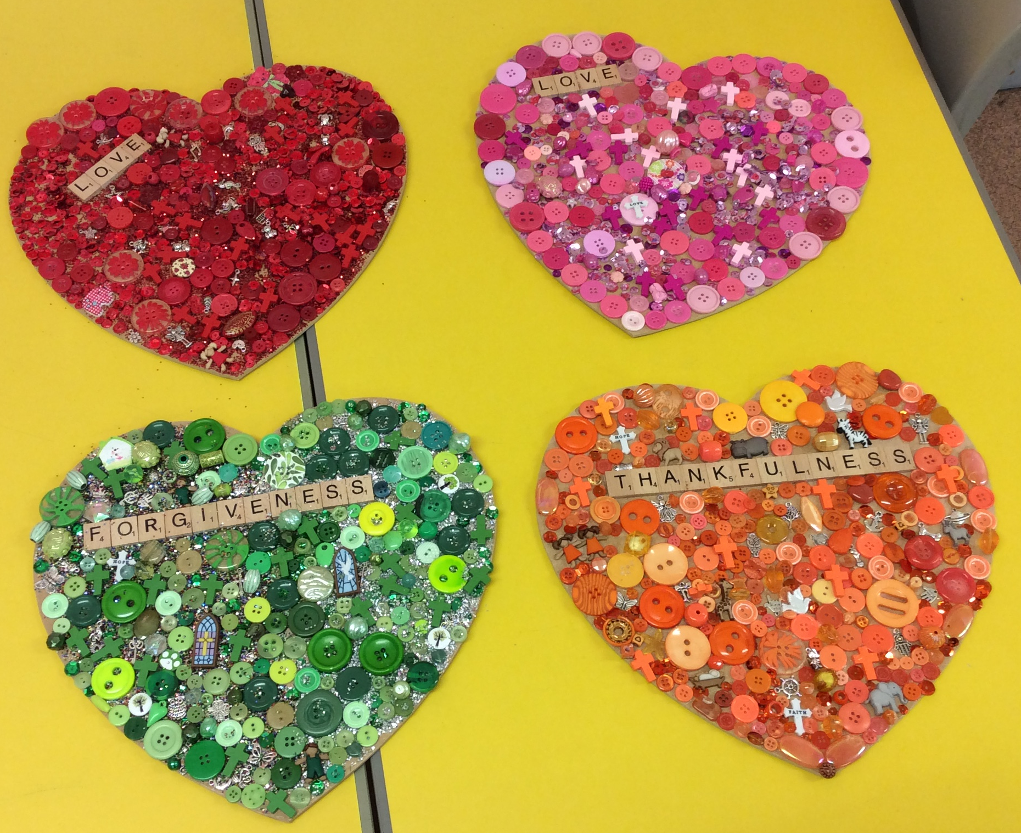
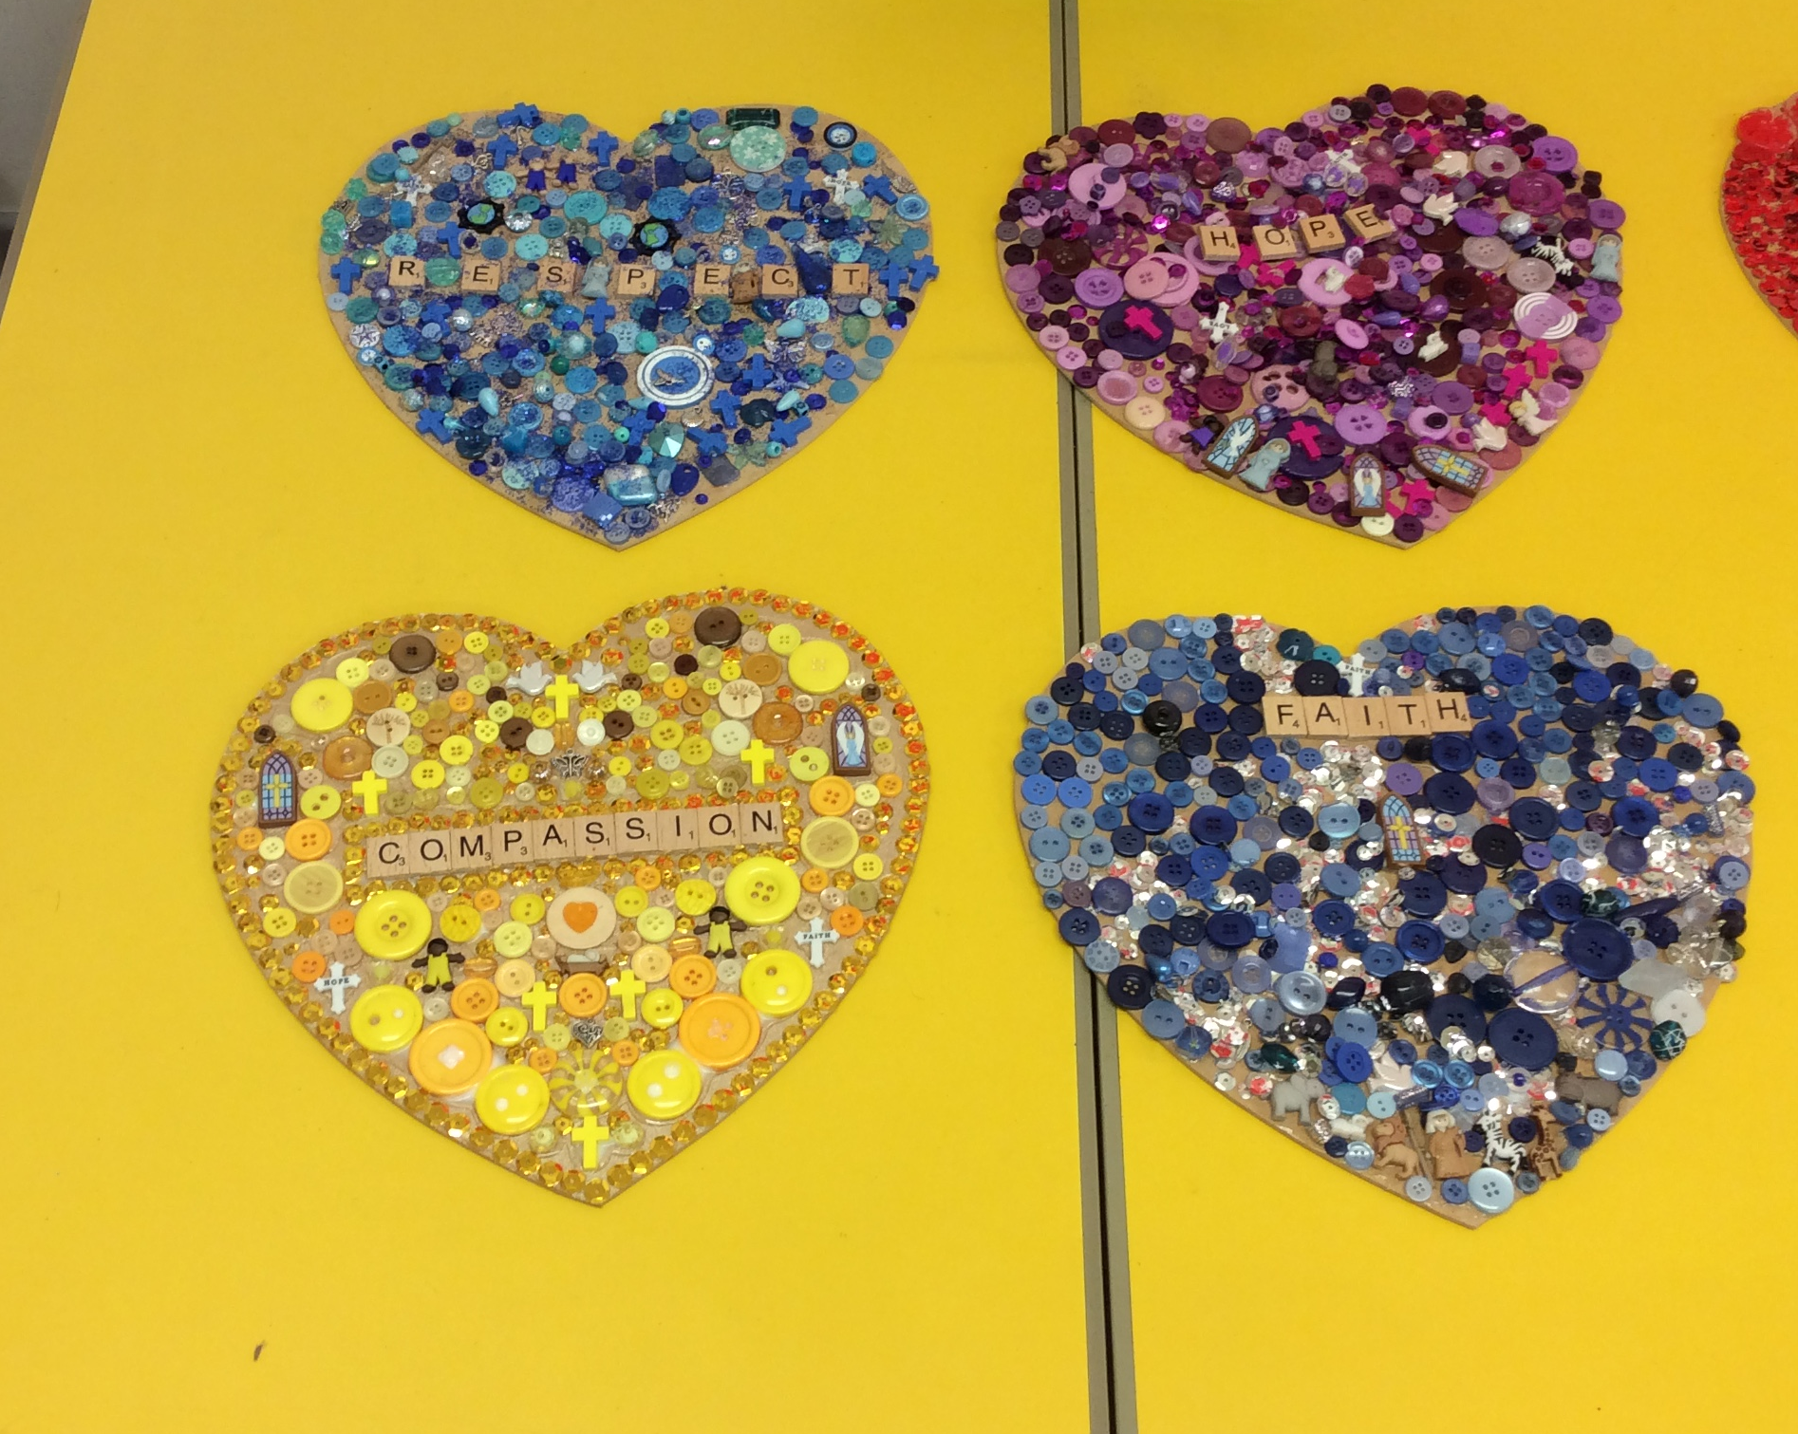

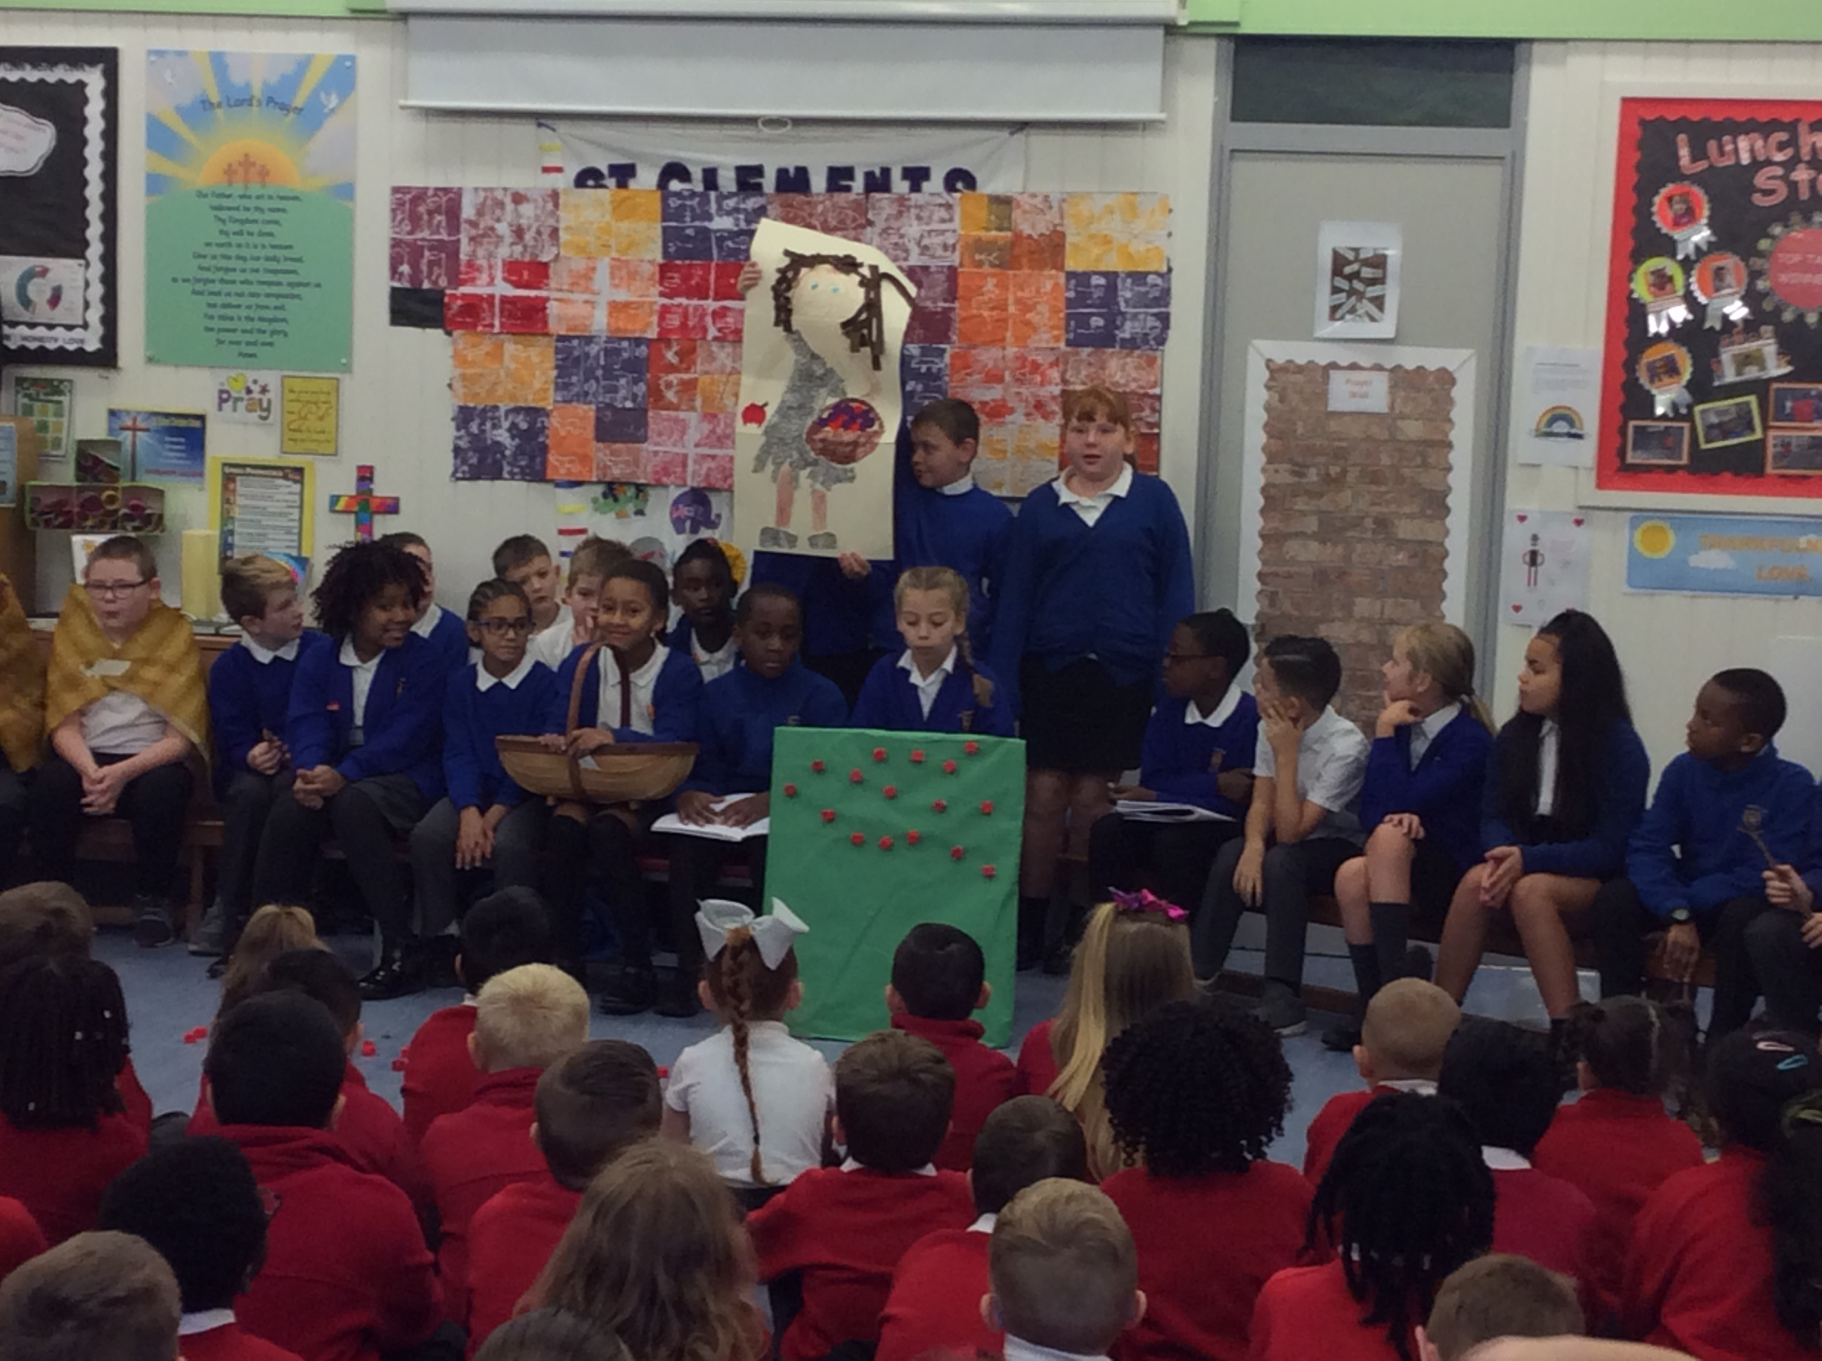

Year 5 Class Worship- On Thursday, Year 5 did their class worship for their parent/carers, staff and pupils. Thank you to those parent/carers who came along to support their child and Year 5 and also to Mrs Stokes and Mrs Campbell for their work with the class.

Year 6 Trip to the Imperial War Museum- On Thursday, Year 6 went to the Imperial War Museum at Salford Quays to learn more about their World War 2 topic. The children got to see artefacts from the time and linked what they has been learning about in class, about how the soldiers felt at war, with the actual letters and diaries at the museum. Lexie in Year 6 tells us more about their trip.
‘When we arrived at the museum we were introduced to Claire who worked at the museum who took us around and explained more information about items in the museum.’ ‘We got to look around the museum in groups and there were tins that you could smell and you had to guess what they were. There was a gun powder one and one that smelt of trench foot- it smelt very bad’ ‘Before lunch we watched a picture show which was projected onto the walls of the museum.’ After lunch we got to meet some veterans who had been part of wars and we learnt more about their experiences.’ ‘Before we left the museum we got to look around the museum at things we didn’t get chance to look at in the morning, my group went to look at the letter and outfits around the museum and the information on the concentration camps.’ ‘My favourite part of the trip was getting to meet the veterans as it is not something that happens every day.

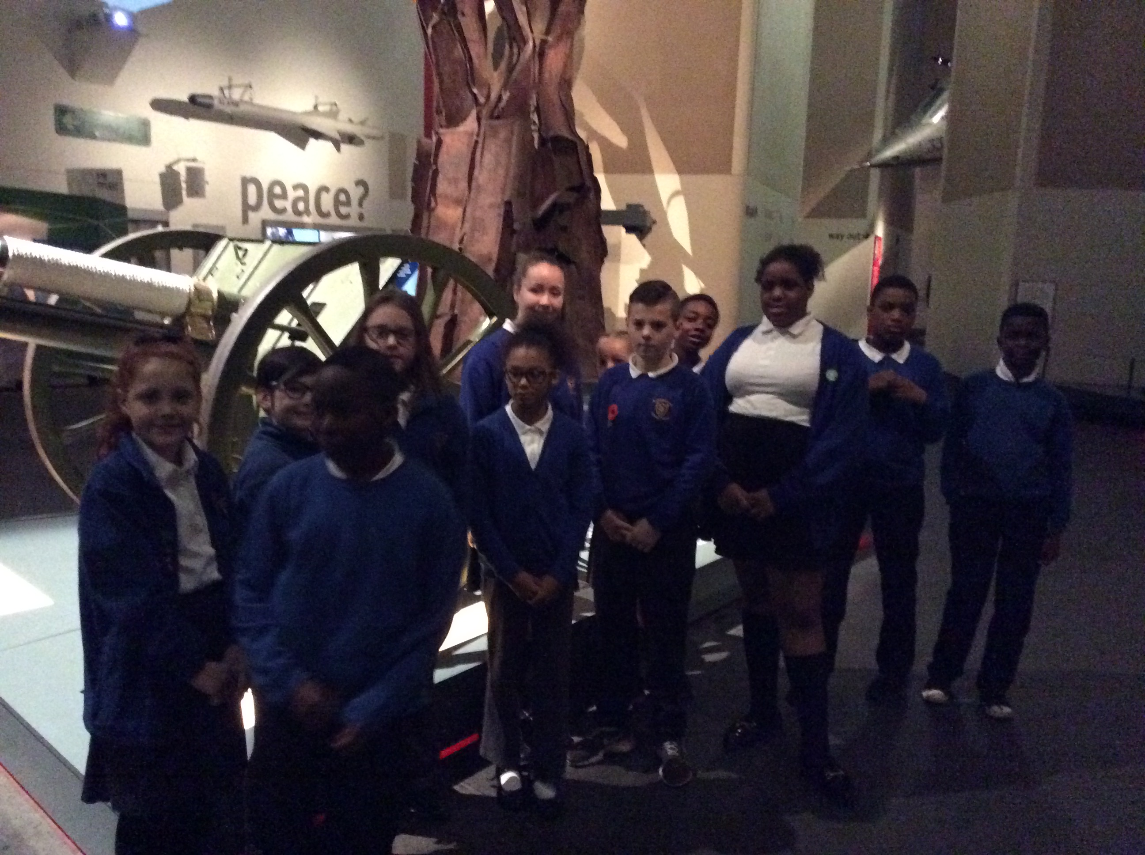

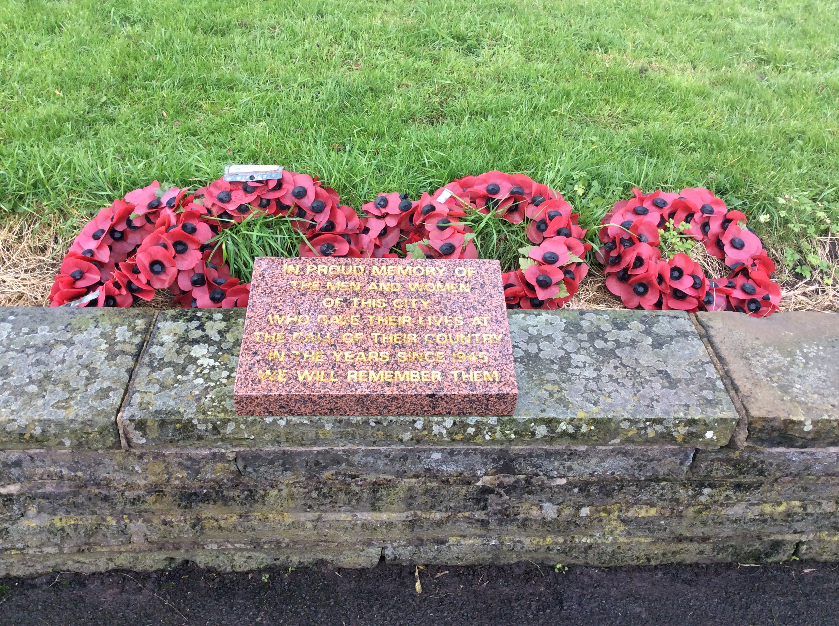

Year 6 Remembrance Service at Abbey Hey Cenotaph- Today our Year 6 pupils and staff went to the Abbey Hey war memorial to pay their respects to all those who had lost their lives or been injured whilst serving for their country. They laid wreaths that they had made, said prayers and observed a silence at 11 o’clock. Our Year 6 pupils have made us very proud with their mature attitudes and level of respect shown.


Children in Need Pudsey Biscuits for Sale- On Friday 17th November we will be helping to raise money for Children in Need. Joanne has offered to make her Pudsey Bear biscuits for sale again this year. The biscuits will be 50p each and it is a maximum of 2 per child. Please can you let staff know on Thursday 16th November if you want to buy a biscuit and how many biscuits you require so we can get them ready for Friday morning.


Individual and Sibling Photographs- Monday 20thNovember- On the day siblings will have their picture taken as a family group unless you let us know in the school office that you would like them to have their pictures taken individually. If you would like to bring pre-school children to be photographed with older ones please come to the school hall at 9.00am. All children must go to their lines at ten to nine as usual to get their mark as we will get them for their photo.

Enabling Enterprise- Moon Base Challenge Day- Please can you send in any boxes, plastic bottles, cartons etc to your child’s class in preparation for their Moon Base Challenge Day on Tuesday 28th November!

