
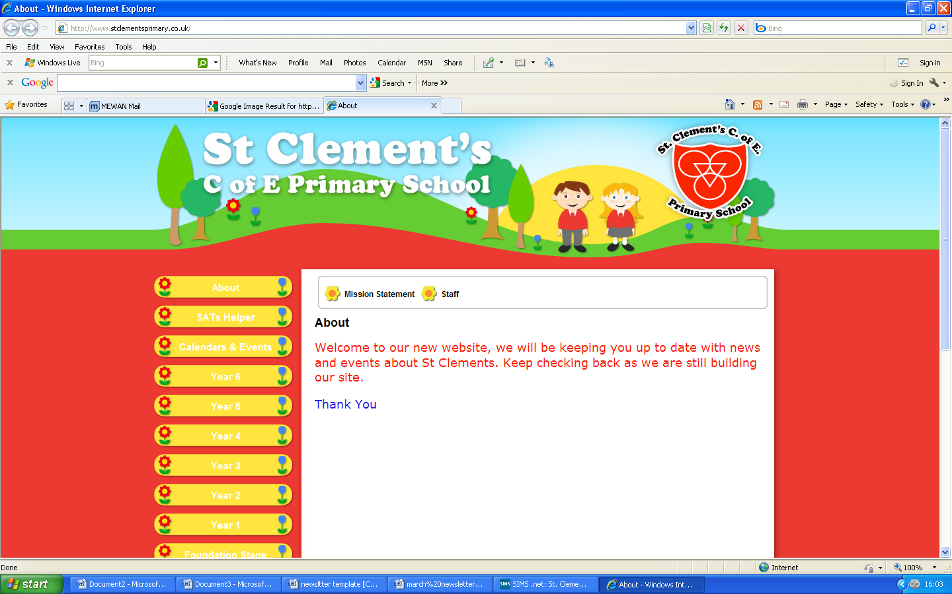

Welcome to your weekly newsletter!! WC 19th June 17!
Diary Dates
-Monday 19th June-Year 1 Indian food Experience day
-Tuesday 20th June- Whole school creative write
-Wednesday 21st June-Class photographs
-Friday 23rd June am- Mary’s Meals event in Delamere Park & Picnic Lunch in the school playground
-Monday 26th June-Year 4 Rainforest Experience Day
-Tuesday 27th June- Nursery and Reception trip to Jodrell Bank
-Tuesday 27th June-Key Stage 2 Modern Foreign Languages Day
-Wednesday 28th June- Year 1 & 2 trip to St Anne’s beach
-Thursday 29th June 9am- Reception class worship
-Thursday 29th June am- some Year 5&6 pupils to Big Sing Showstoppers at Bridgewater Hall
-Friday 30th June- Sunday 2nd July- Year 6 residential to Robinwood

EPIC- This week’s EPIC award goes to Ajna Bajro in Reception. Ajna is EPIC because she works hard, is always smiley and positive and a good friend to others. Well done Ajna.

Behaviour Jumper Winners- Year 1-Elsie Poole, Year 2-Emanuel Vadana, Year 3-Lee Callaghan, Year 4-Tiantia Knight, Year 5-Mckyla Cooper, Year 6-Whole Class.
Top Table Winners-Nursery-Emmanuel Sunmola, Reception-Nasibo Agerso, Year 1-Daria Dumitrascu, Year 2-Lilly Mae Morrow, Year 3-Fantacy Mark, Year 4-Sonny Gibbons, Year 5-Joshua Gyan, Year 6-Lydia Sarpong, Buddy Award- Desmond Ahiadzipe, EYFS Buddy Award-Ellie Fidler.

This week’s school attendance:
CLASSES- HIGHEST TO LOWEST ATTENDANCE | ATTENDANCE FOR WC 12TH JUNE TO 16TH JUNE
YEAR 3 | 98.0%
RECEPTION | 97.0%
YEAR 2 | 96.7%
YEAR 1 | 95.7%
YEAR 6 | 95.2%
YEAR 5 | 95.0%
YEAR 4 | 93.0%
WHOLE SCHOOL | 95.8%
Year 6 Leavers Service at Manchester Cathedral- On Wednesday, Year 6, Mrs Shaw, Mrs Campbell, Miss Naylor & myself attended the leaver’s service at Manchester Cathedral. The children heard about the things that they had achieved throughout primary school and what hopes they may have for moving onto high school. We were very proud to see our school banner and prayer board in the cathedral.
Afterwards, Year 6 enjoyed a celebration meal at Chiquittos.

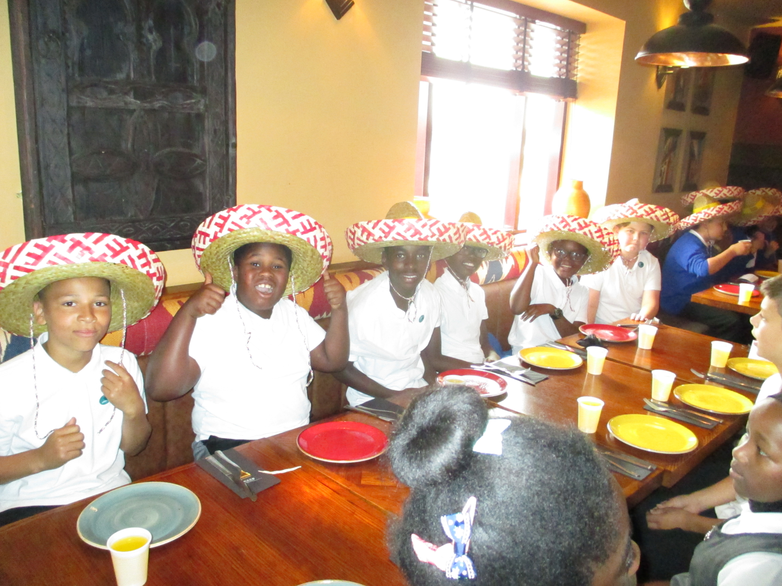
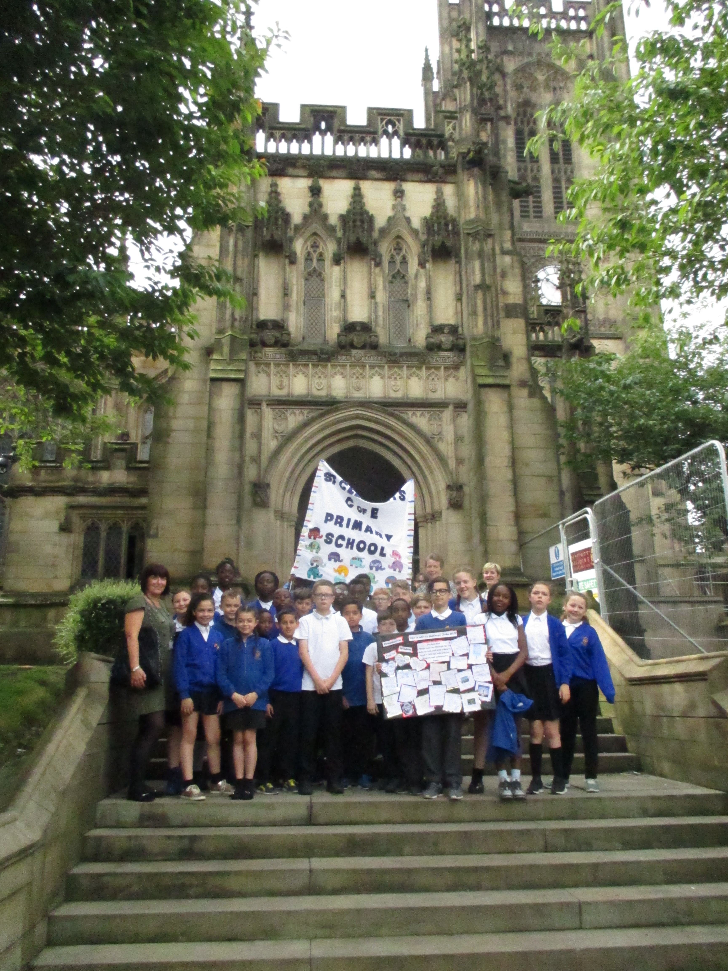
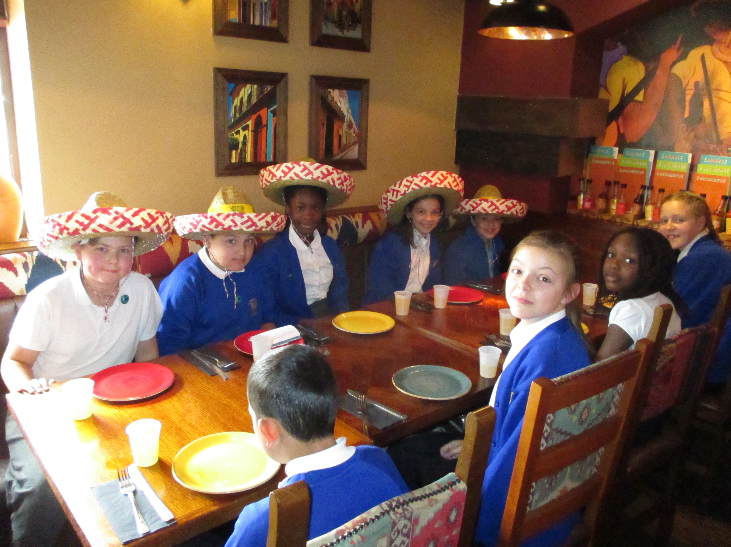

Year 3 Class Worship- Year 3 enjoyed sharing what they have learnt about the Romans in Britain so far. We had soldiers and slaves building straight roads across the country using their engineering skills. There was also a busy husband and wife and their slaves preparing for a visit from the Emperor, his elephants and his wife. The children also shared what life was like for ordinary people or slaves who did not have the freedoms of being Roman citizens. The whole class performed brilliantly as a team and everyone was astonished by their beautiful singing.
Thank you to all the parent/carers who came to watch the assembly and show their support.

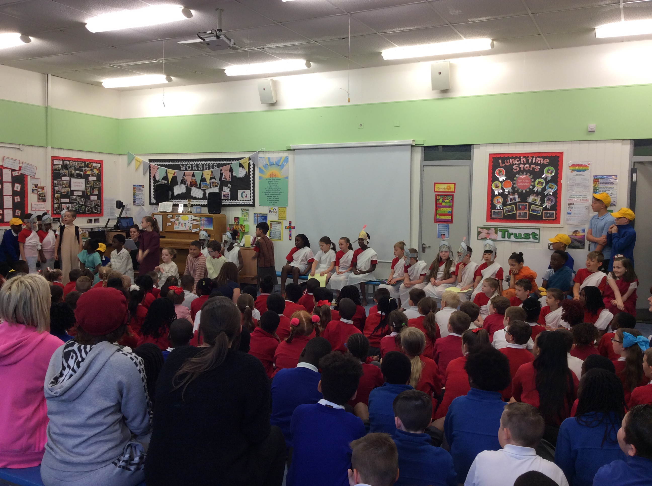
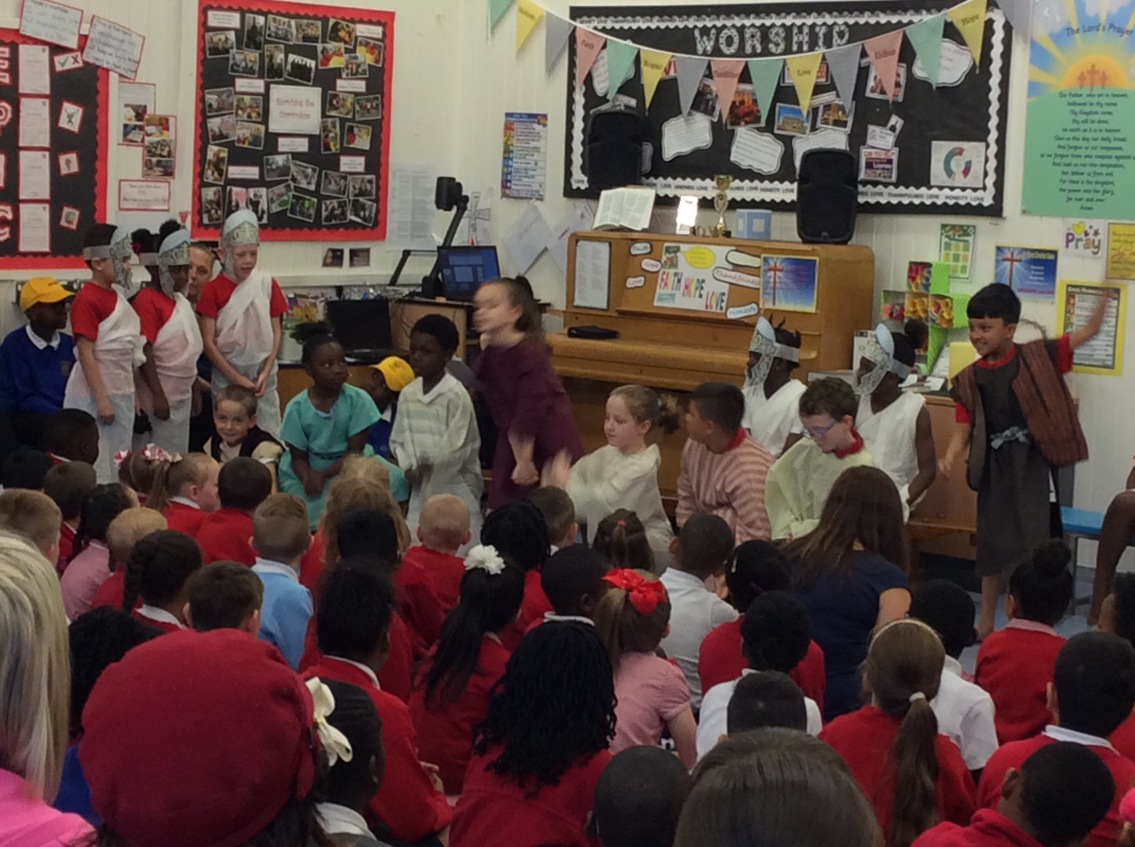

Year 1 Phonics Screening Checks- Miss Nichol has been very proud of her class as they have taken part in the phonics screening check this week. We have seen the children remembering their letters sounds and doing some great blending and segmenting as they read the tricky words. Well done Year 1 and some of our Year 2 children too.

Buy a Gift Event- Today, our Friends Group sold gifts for special men in our children’s lives for £1.00. A total of £60 was raised to go towards resources and educational visits and visitors. We hope dads, step dads, grandads and uncles enjoy their gifts.

Mary’s Meals Event- Friday 23rd June- Mary’s Meals is a no-frills charity with a simple idea that works: by providing one good meal in a place of learning, children are drawn into the classroom where they can receive an education that could one day free them from poverty.
On Friday 23rd June we will be holding a healthy school fundraising event to ‘Run a Mile for a Meal’ for the charity Mary’s Meals.
The event will take place in Delamere Park and parents are welcome to attend to cheer on our runners. We will be asking for just £1.00 per child to run.
Healthy drinks and snacks will be available to buy on the day-sponsored by our friend Ken at Pharmaco Chemist!
Children will also be invited to wear their football shirts, PE kits or sports gear for the day for a donation of £1.00 to the charity.
The classes will be running at the following times:
10.00-10.20-Nursery and Reception
10.25-10.45-Year 1 and Year 2
10.50-11.10-Year 3 and Year 4
11.15-11.35-Year 5 and Year 6
As a treat, when we all return to school, we will be having our annual picnic lunch in the playground. Fingers crossed for good weather on 23rd June!

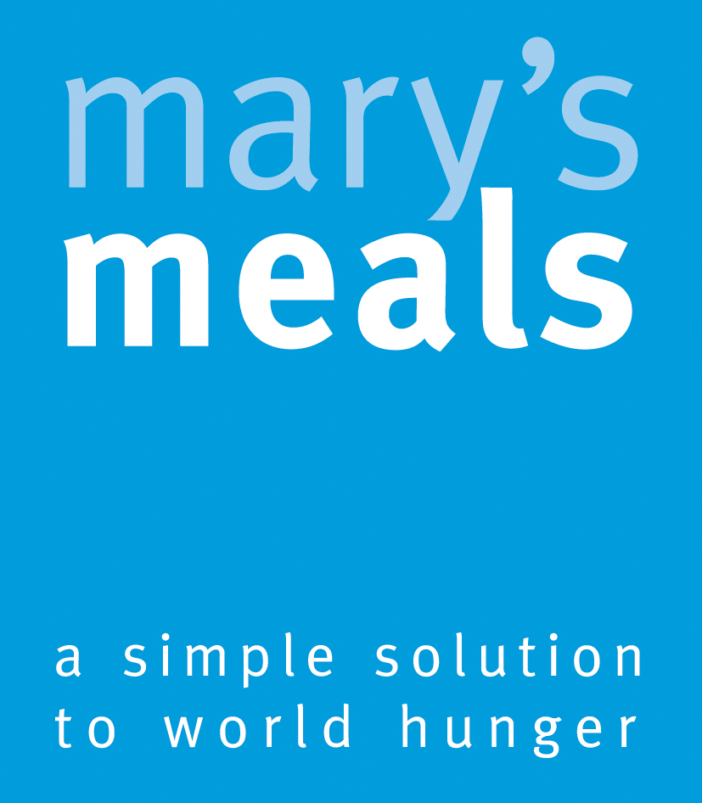

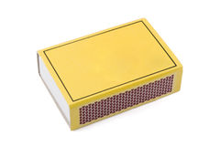
Whole School Creative Write- Week beginning Monday 19th June, school will be doing a creative writing week. Miss Thompson has sent a letter home today as children have been given a very special task. Children have been asked to bring an object into school in the Match box that they have been given by their teacher. The object must be linked to a special memory you have, it could be linked to a special place you have visited, a special friend/person in your life or who was in your life, a special event you were involved in or went to, a special hobby you have or a celebration you were involved in. If you do not have a special object don’t worry, you could draw a picture of something linked to the memory and put it in your box. Please bring your box with your objects in by Friday 16th June, ready for the creative writing week. We look forward to seeing what is in all your boxes.
Class Photographs- On Wednesday 21st June, all of our classes, except Year 2, will be having their class photographs taken as a memento of their last school year.

