
“Growing together to let our light shine”
Welcome to your weekly newsletter!! WC 26th March 2018!
Diary Dates-
-Tuesday 27th & Wednesday 28th March- Parent/Carer Evenings
-Tuesday 27th March- Year 5 Space Art Experience Day
-Tuesday 27th March- Year 3 Weather 2 Experience Day
-Wednesday 28th March- Year 2 Habitat Experience Day
-Thursday 29th March 9.30am- Easter Celebration at St Clements Church
-Thursday 29th March 3.15pm-End of Spring Term

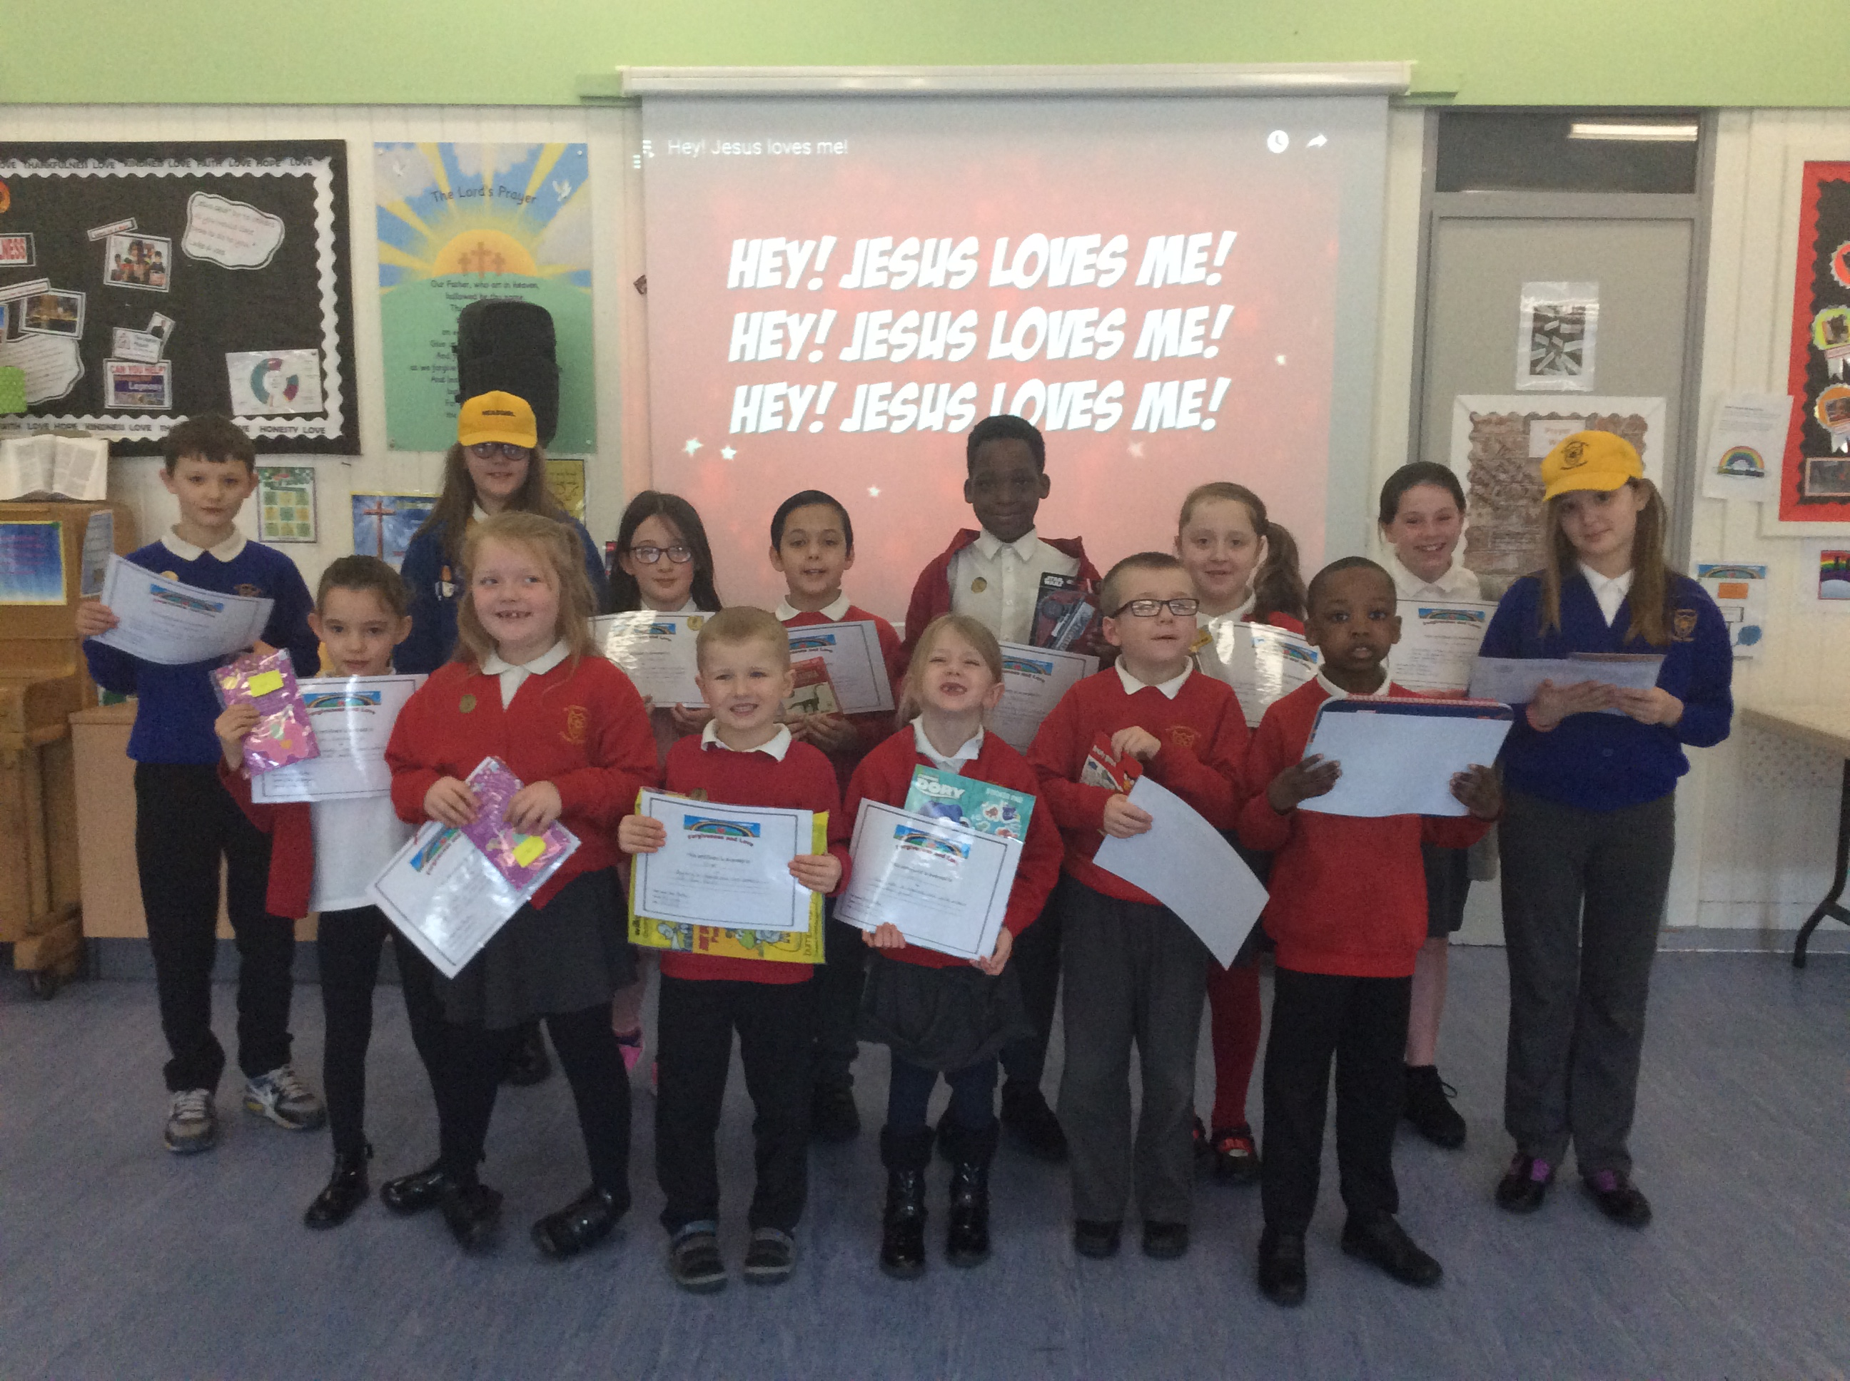

Values Award Winners- As it is nearing the end of a half term, today we have celebrated those pupils who have shown our focus Christian Values in action- Forgiveness & Love. Well done to you all for setting a great example. The winners are- Reception- Olivier and Darcey, Year 1- Brandon and Isabelle, Year 2-Daria and Amos, Year 3- Conner and Maisy, Year 4-Grace and Junior, Year 5- Connor and Lilly C and Year 6- Rebekah and Angelika.

Year 2 Trip to Knowsley Safari Park- On Wednesday, our Year 2 class went to Knowsley Safari Park as part of their learning around habitats. They got the chance to be explorers, saw a range of animals and learn more about how the animals survive. Daria in Year 2 tells us more about their trip: ‘When we got there we met our tour guide who took us around the safari park in our coach’ ‘We saw lots of different animals like tigers, lions, rhinos’ ‘We got to eat our lunch watching the sea lion show and then we went to the classroom where we learnt more about animals in different habitats, we got to touch a snake and a giant snail.; ‘We then went onto a walking safari where we got to see the meerkats and the giraffes’ ‘ I really enjoyed the safari and the walking safari’ ‘I really enjoyed getting to see the meerkats as we are learning about them in class.’

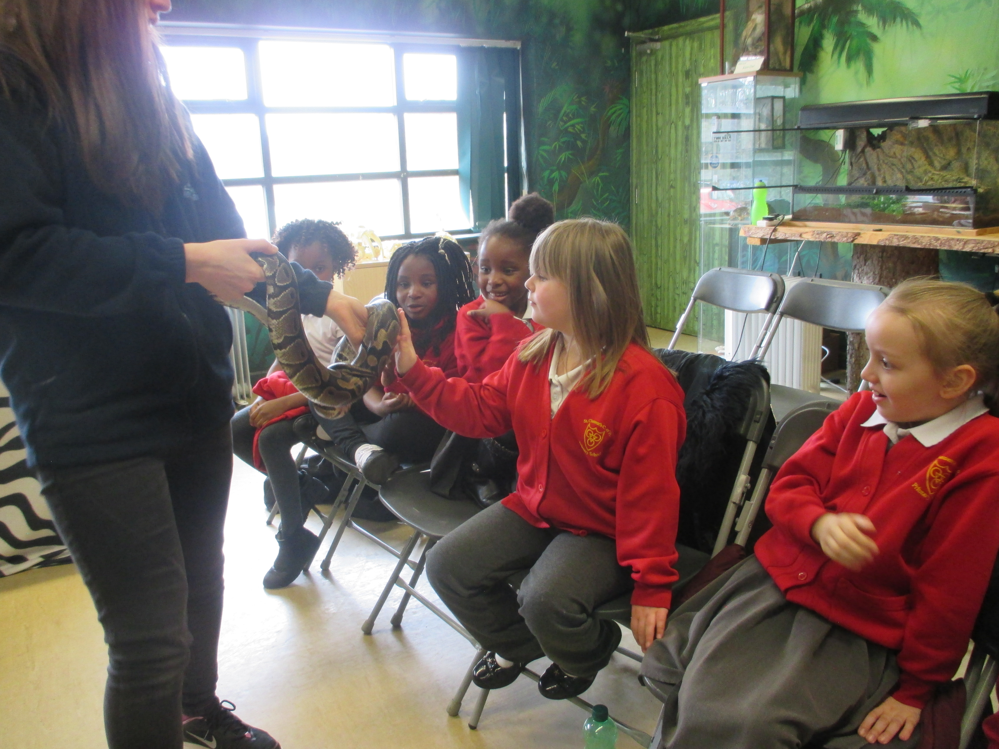
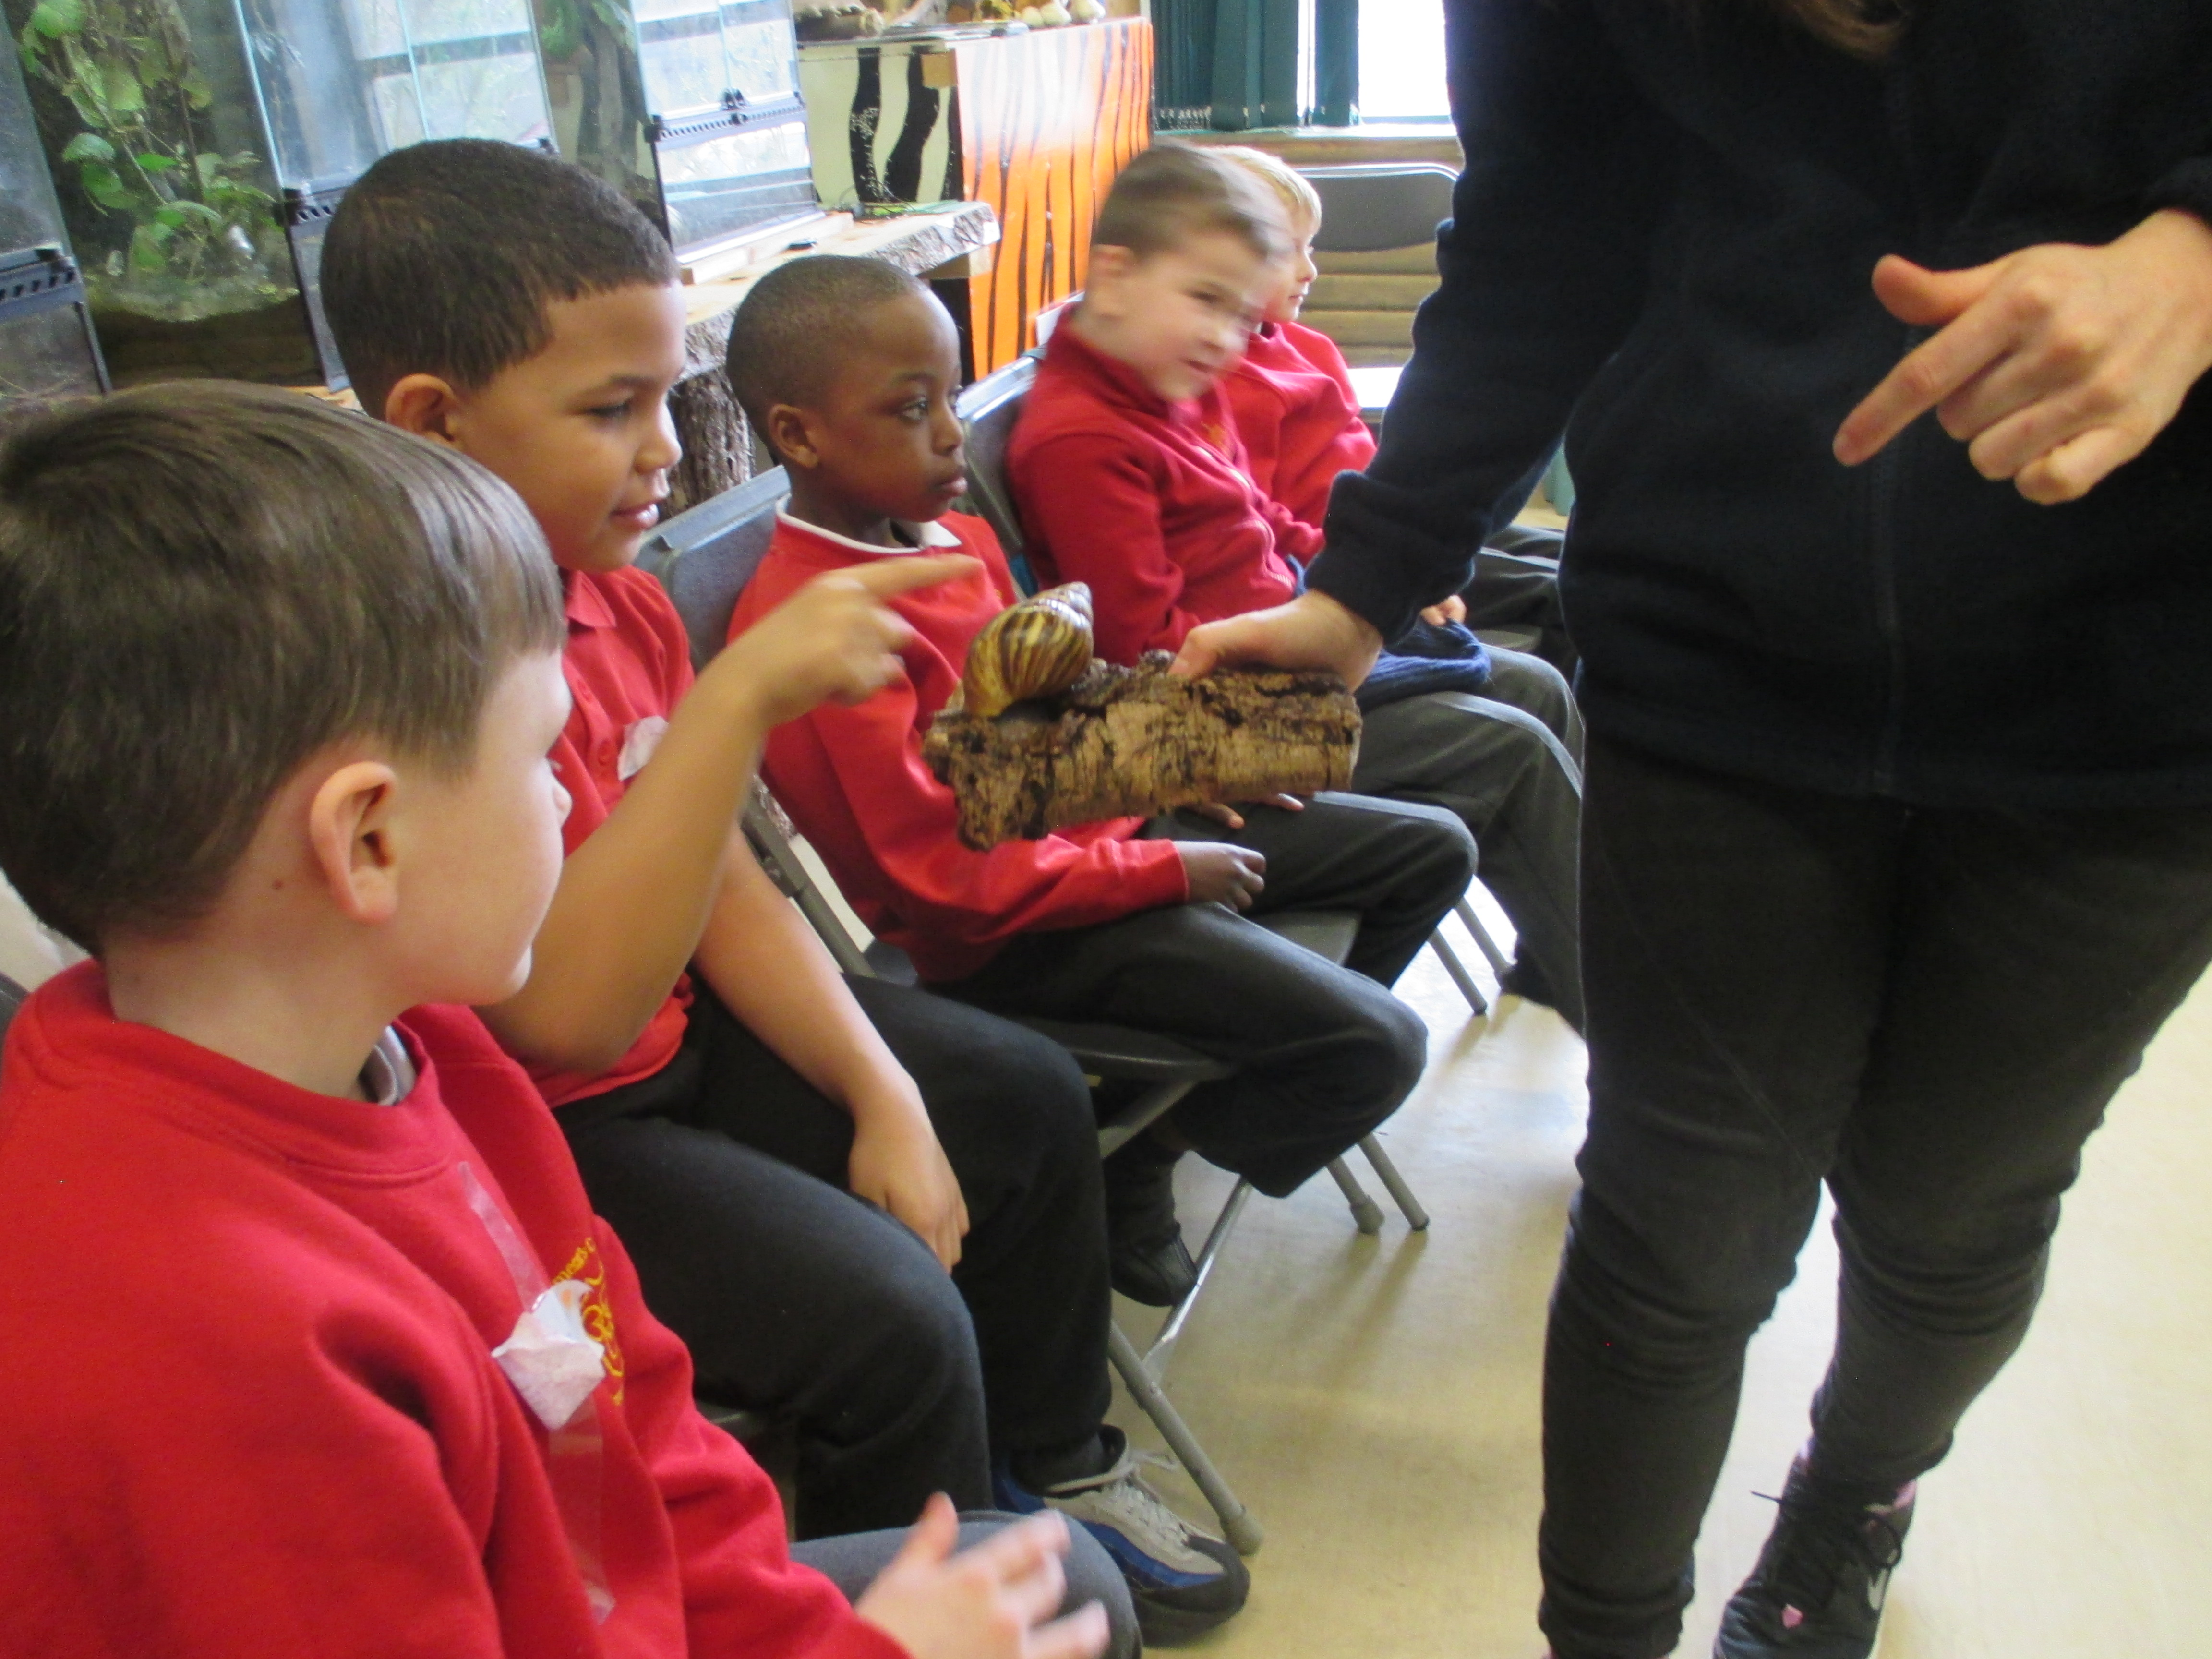

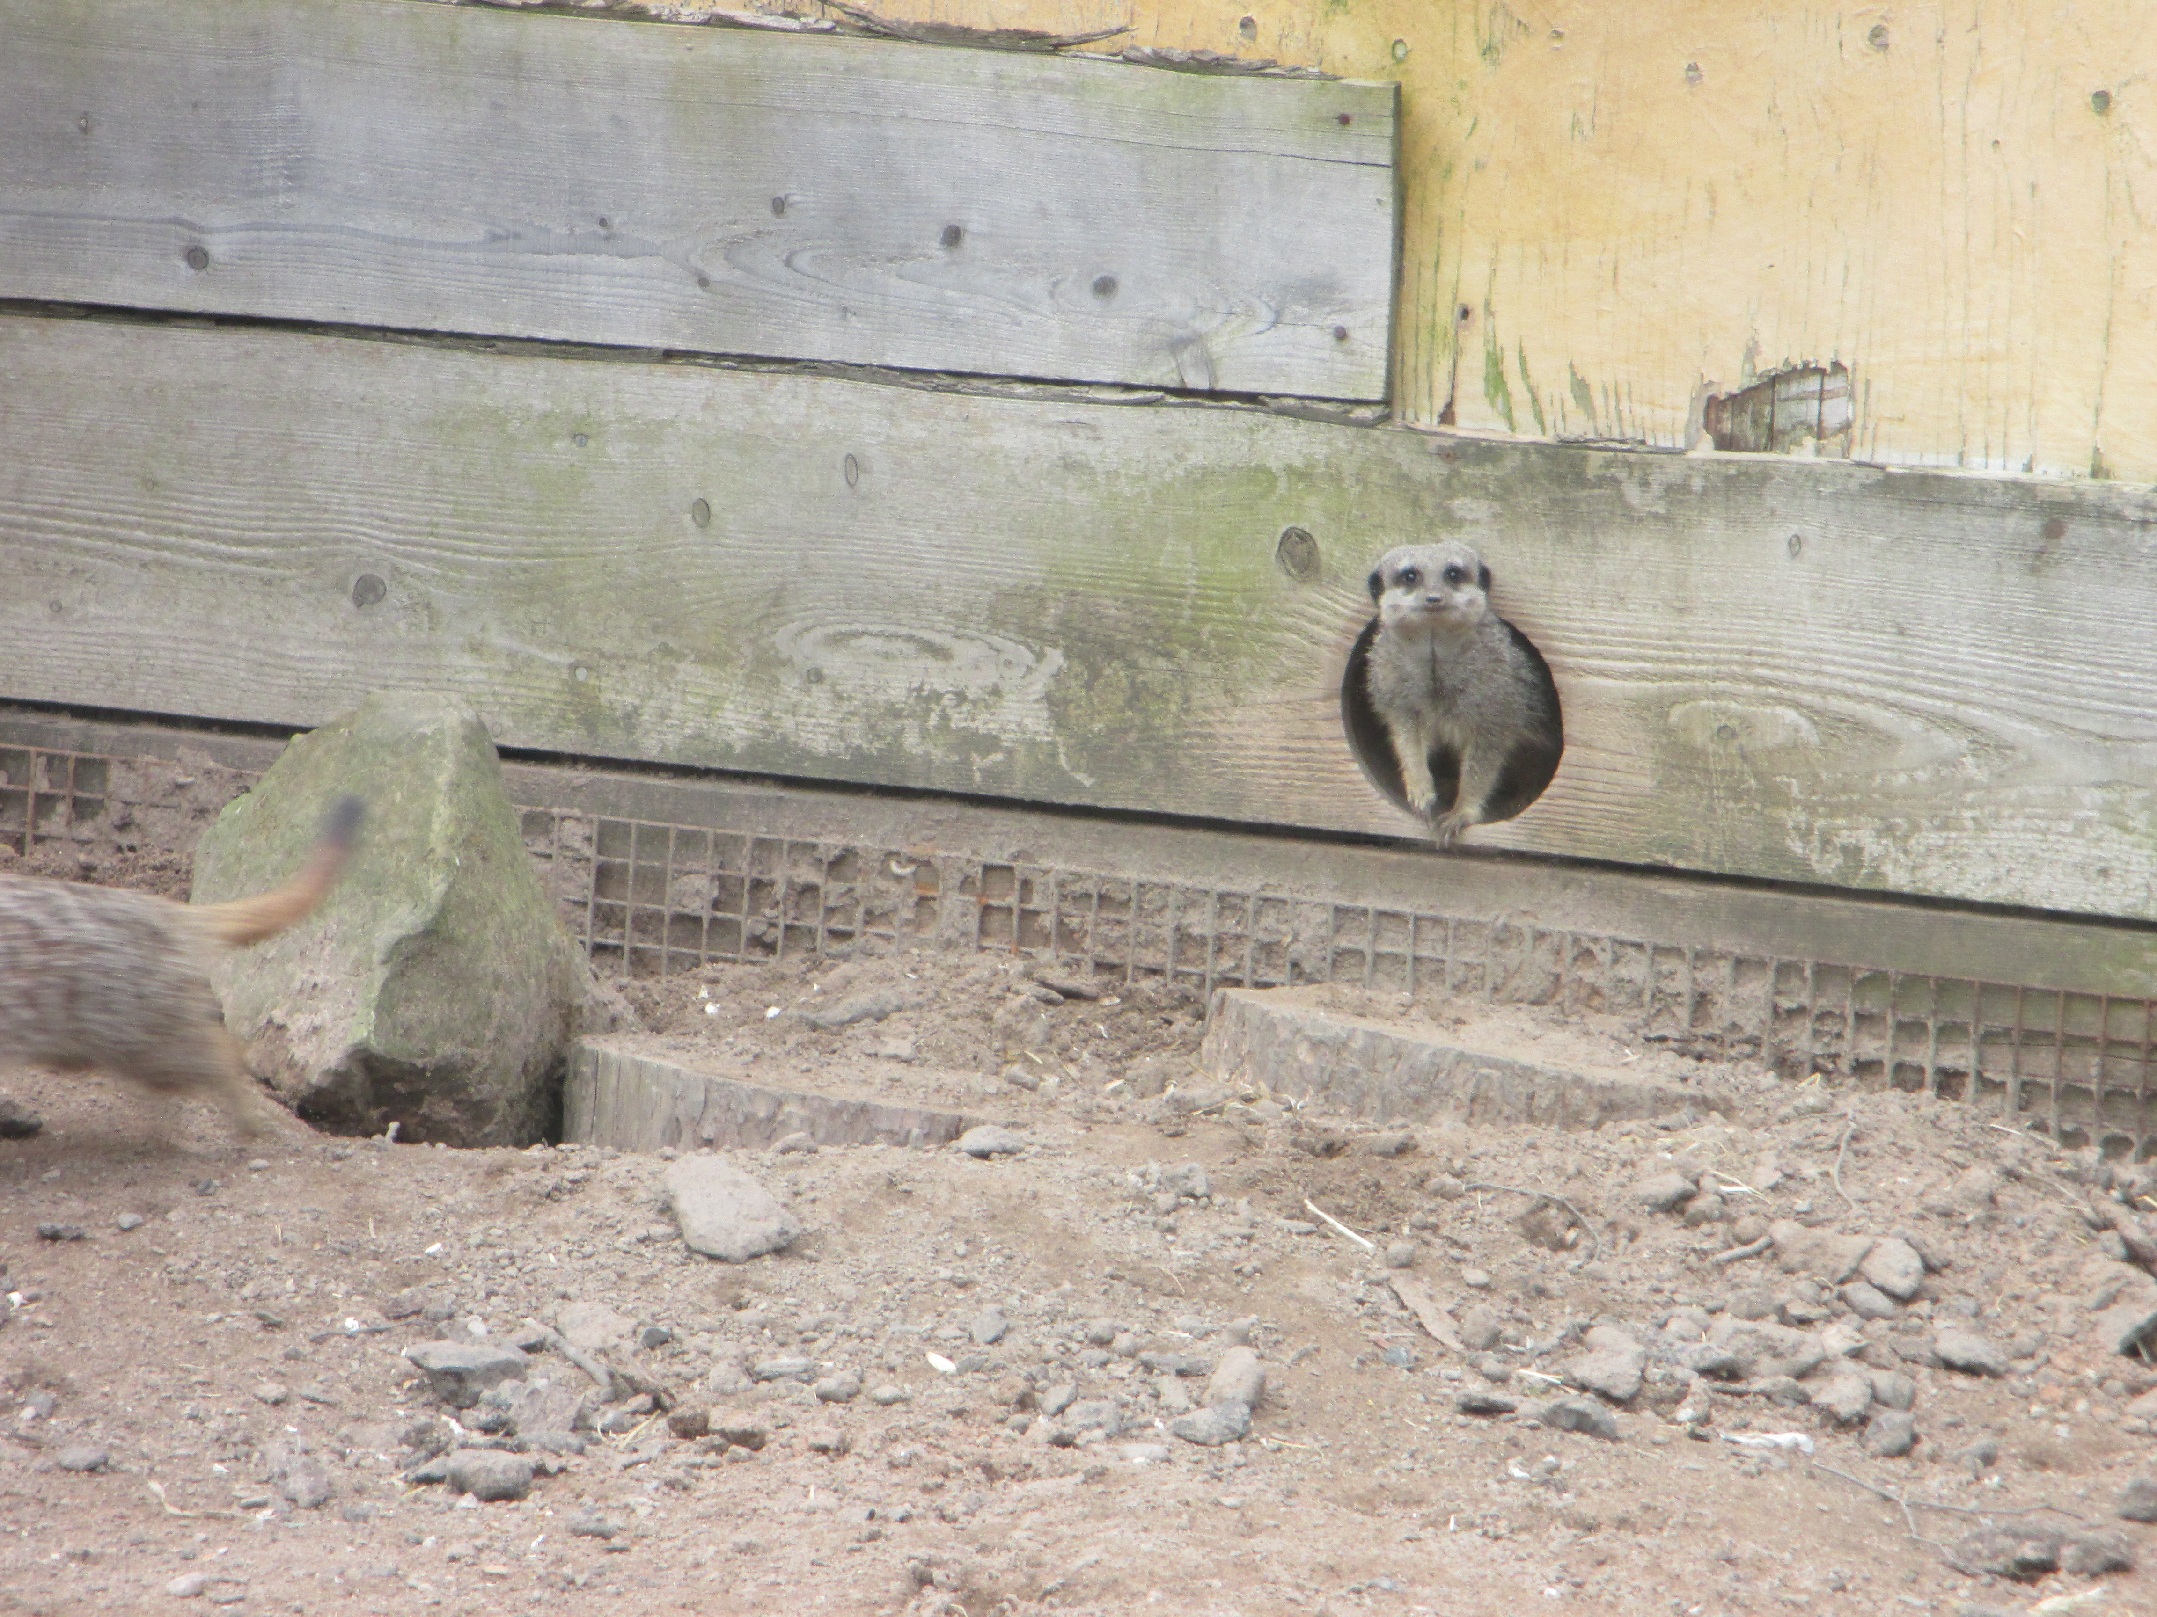
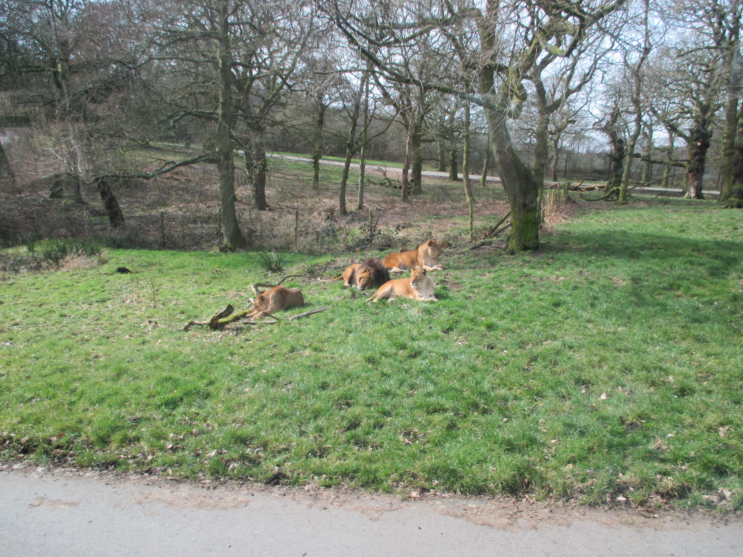

Nursery and Reception Buildings Experience Day- Our nursery and reception children are learning a lot about different materials at the moment. In their classrooms, they have thought about which material is the best for the 3 Little Pigs to make their house from and have been exploring what objects are made from and how this makes them move and behave. Today, they have learned a bit more about materials by checking what buildings are made from and asking why that material is best. Our Nursery children went on a walk around the local area to look at the buildings and what they were made from.

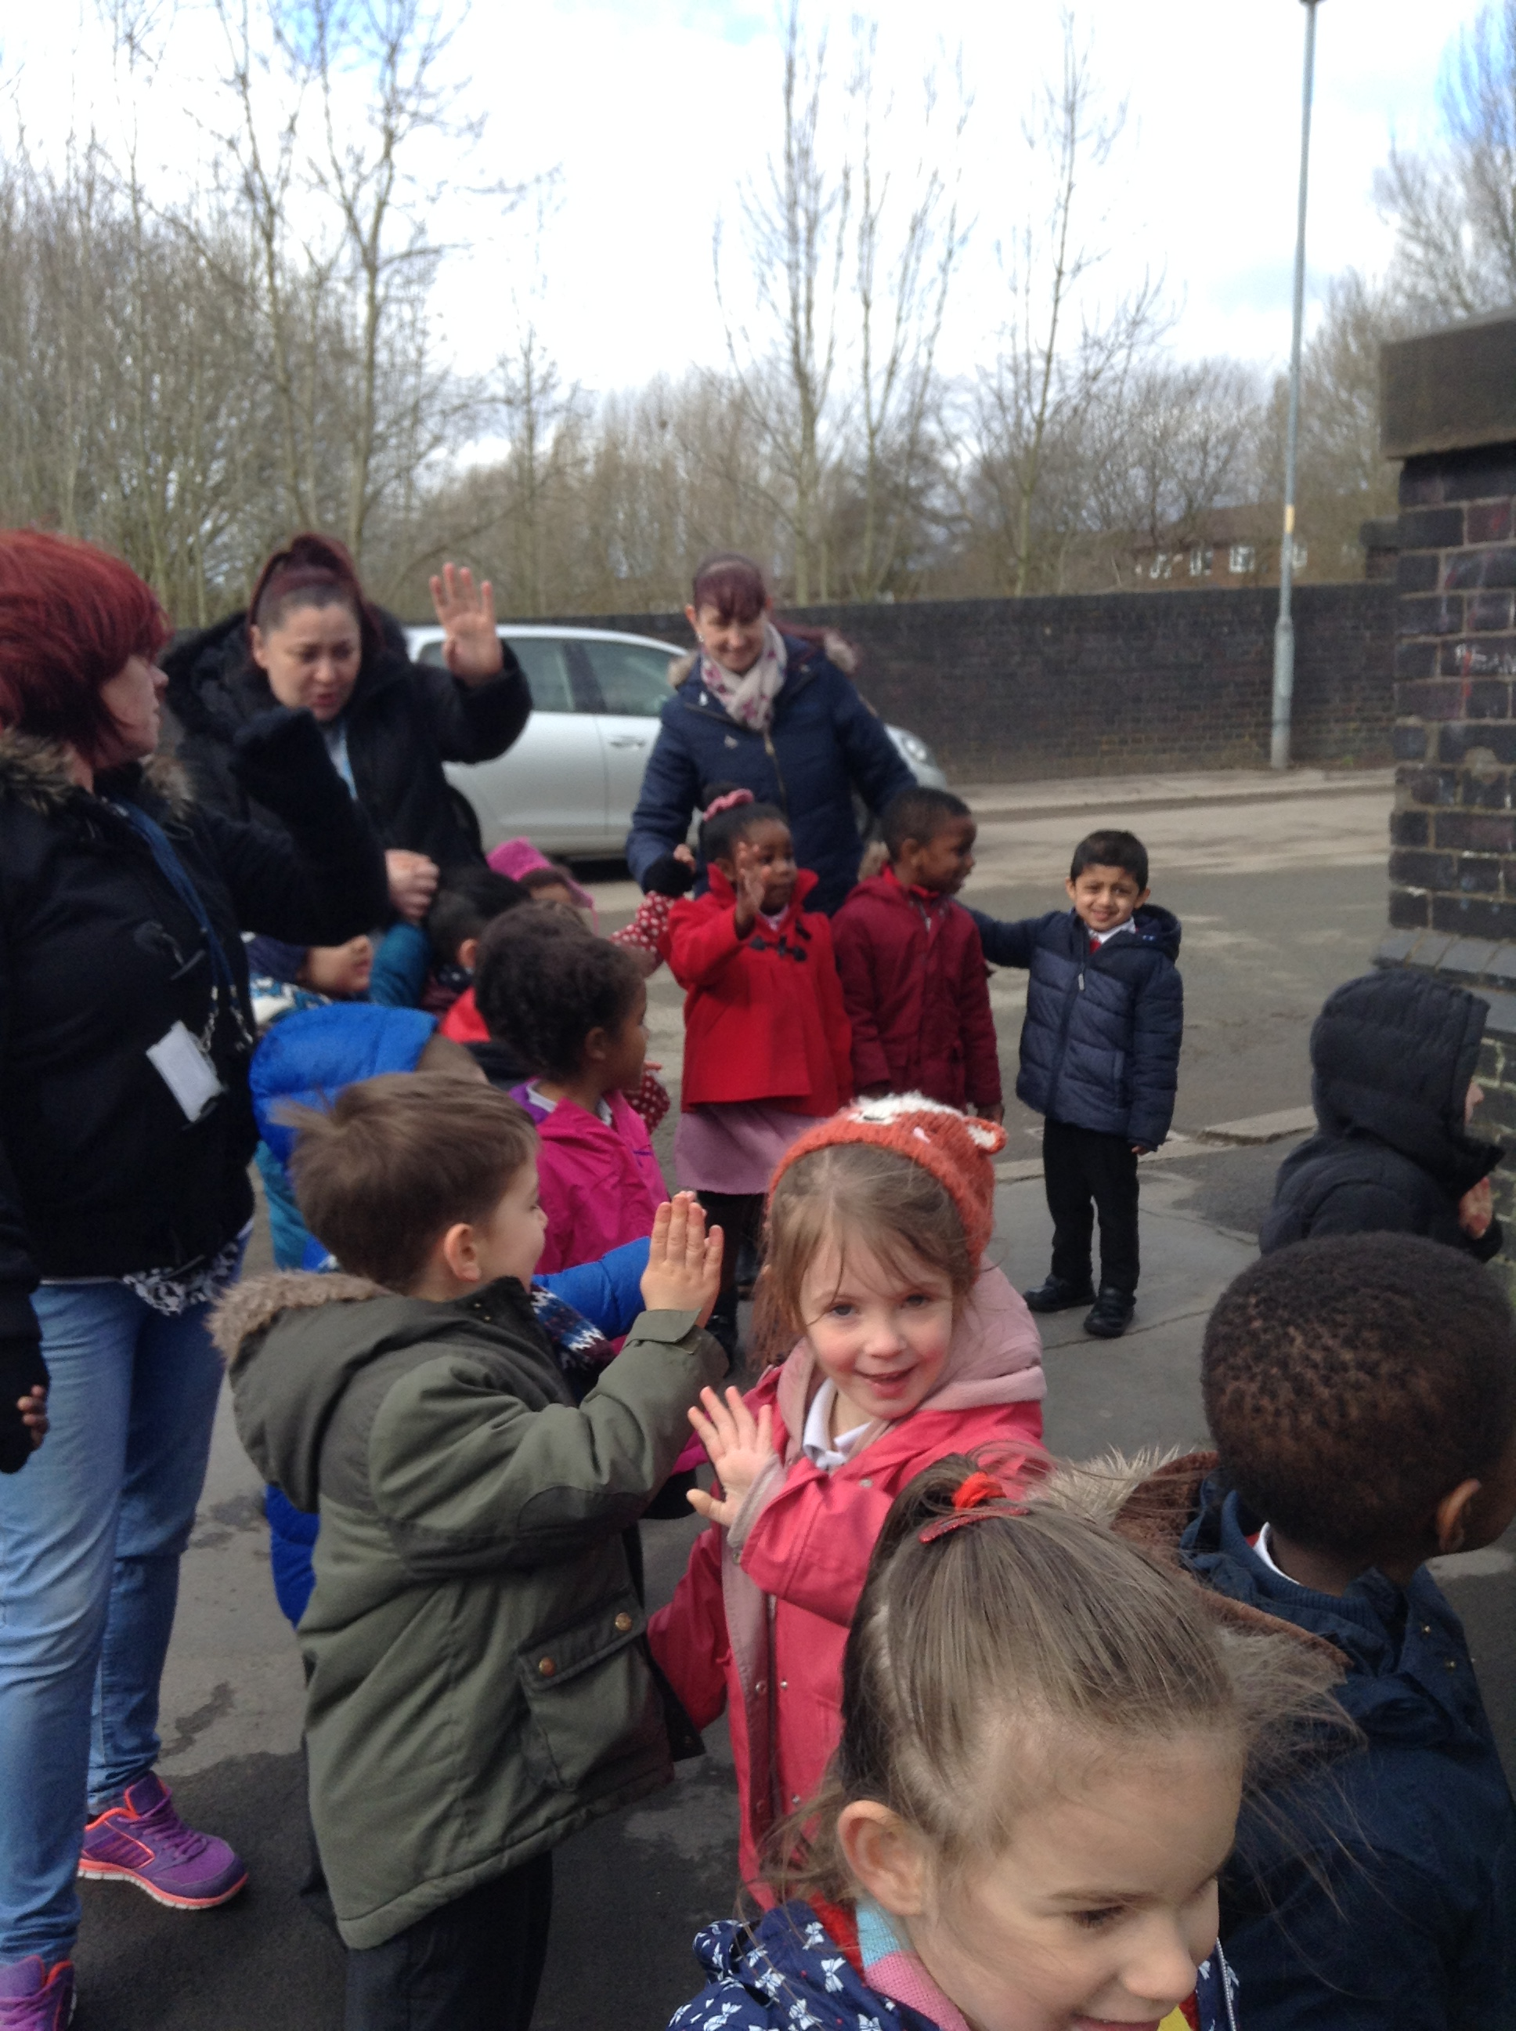

Easter Raffles- The Friends Group have made some beautiful prizes that they are currently selling raffle tickets for in the playground in the morning and also at the end of school. The raffle tickets are £1 a strip and the winner will be drawn on Wednesday 28th March during assembly. We will inform the winners so they are able to come and collect their prize. Thank you for your ongoing support and helping the Friend’s Group raise extra funds for school. Good Luck!!!!!

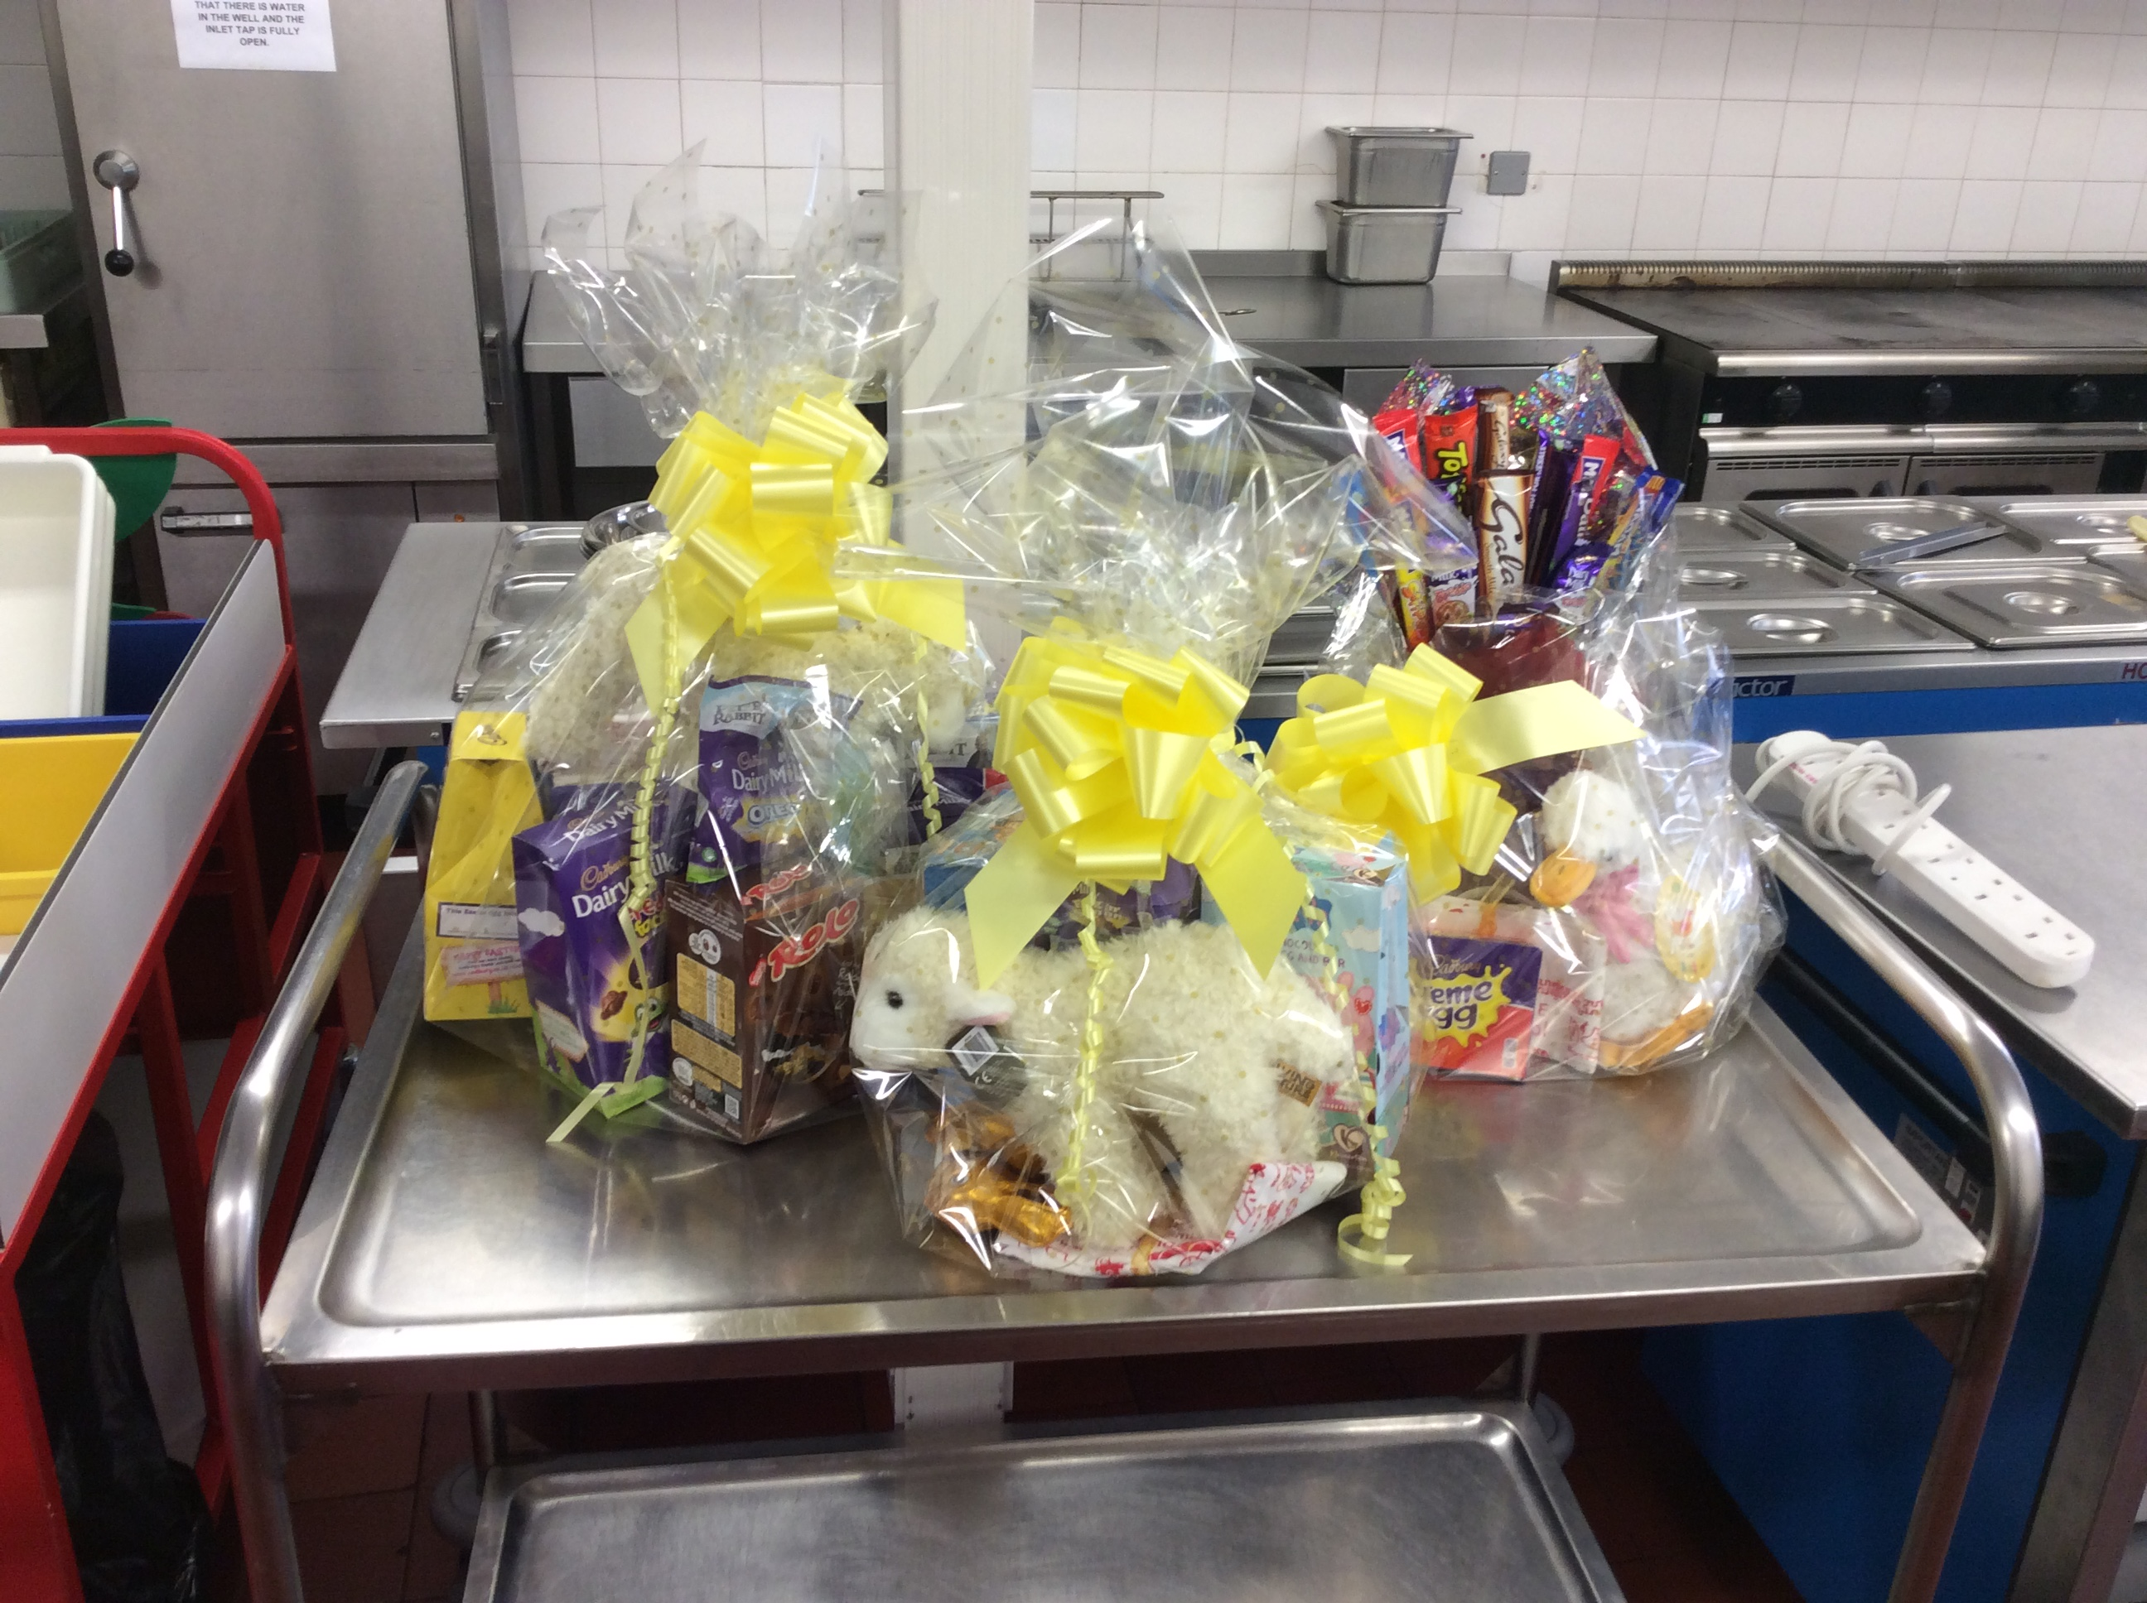

World Book Day- Due to the bad weather, we were unable to have our World Book Day dress up as a word event. It has been re-scheduled to Monday 26th March 2018. So, get the outfits back out again & we will try to guess what they are.
Parent/Carer Evening Letters- This week your child should have come home with a slip informing you of when your child’s appointment to meet their class teacher is for Parent/Carers evening on Tuesday and Wednesday next week. If you have not arranged an appointment or have not been given a time please speak to your child’s class teacher and they will try their best to arrange one for you.


Easter Church Service at St Clements Church- Everyone is welcome to join us at our Easter Celebration at St Clements Church on Thursday 29th March. The service of song, readings and prayer will start around 9.30am and finish around 10.15am.
If any parent/carers are able to support their child’s class in walking to and from church on 29th March, then please speak to your child’s class teacher/staff. Thanks in advance for your support.

