
“Growing together to let our light shine”
Welcome to your weekly newsletter!! WC 30th April 2018!
Diary Dates-
-Monday 30th April 9am- Growing & Changing Parent/Carer Information Session to be held in school
-Wednesday 2nd May- Year 2 Inuit Experience Day
-Y1-6 Growing and Changing Material Sex and Relationships Education to be delivered from Monday 7th-Friday 25th May
-Wednesday 9th May- Year 3 Grosvenor Museum Romans Trip
-Week Beginning 14th May- YEAR 6 SATS WEEK
-Week Beginning 14th & 21st May- YEAR 2 SATS
-Wednesday 16th May- Year 1 Playgrounds Experience Day
-Friday 18th May Nursery & Reception Buildings Experience Day
-Monday 21st May- Year 4 Rainforest Art Experience Day
-Tuesday 22nd May- Year 5 Magical Cities Food Experience Day
-Wednesday 23rd May- Year 6 Experience Day
-Thursday 24th May PM- Talent Night auditions
-Friday 25th May- End of half term Values awards

EPIC Winner- Bousso Thiam in Year 3 has been awarded the EPIC award this week. Bousso works hard both in and out of school, she takes pride in her work and as a result has made great progress in school. I look forward to having afternoon tea with you in a few weeks Bousso!

Behaviour Jumper Winners- Year 1-Xavie, Year 2-Amos, Year 3-Omaru, Year 4-Jonathan, Year 5-Tyroney, Year 6-PJ.

Top Table Winners- Nursery-Adaline, Reception-Julia, Year 1-Noorjahan, Year 2- Gracie, Year 3-Eric, Year 4-Yakub, Year 5-Stacy, Year 6-Leah, Buddy Award-Millie-Ann, EYFS Buddy-Daisy.

St George’s Day Lunch- On Monday, we celebrated St George’s day by having a lovely lunch of Traditional toad in the hole served with seasonal vegetables, soup and spring selection of sandwiches (including coronation chicken) or British bake potatoes followed by spring fruit crumble and vanilla sauce or a jam button cooked by Joanne, Shaz and Sam. The dining hall also looked lovely as Mrs Loftus had decorated it with flags and roses were also on the tables! Thank you to our Kitchen & Lunchtime teams for making it a good event.

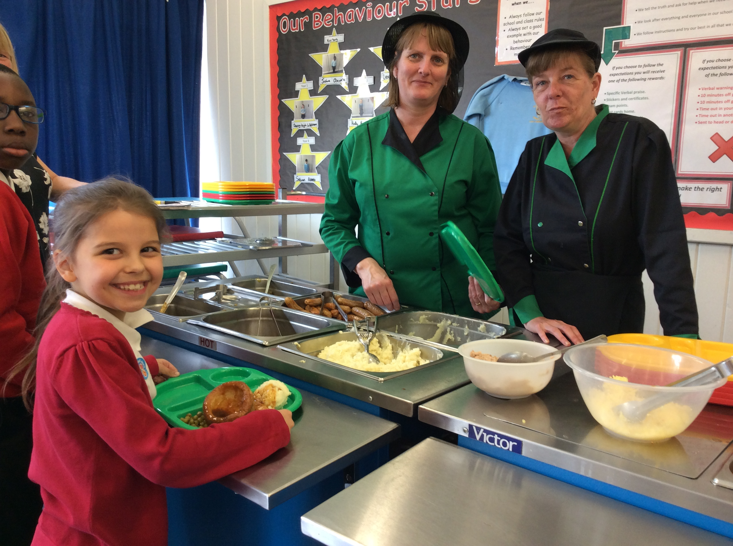
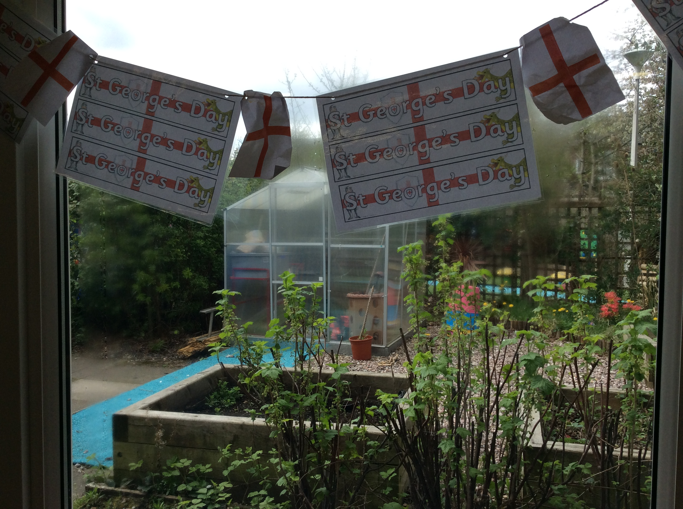

Year 3 Celtic Experience Day- Yesterday, Year 3 had an experience day to help them learn more about the Celts before their Roman trip to Chester in a few weeks. Rhys and Brooke in Year 3 tells us what they did: ‘We each got to design our own Celtic Shield’s which we individually designed. ‘ In the afternoon, we got to make our own Celtic Round Houses which we made out of straw sticks, plastersine, paper plates, clay, lollypop sticks and card which we used to make the lid.’ ‘To build the walls we had to weave the straws in and out of the lolly sticks which was the hardest part’. ‘We worked as a team to build the houses which was good as we found it difficult to get the weaving started. The team work also helped when making the roof as someone had to measure the straws to cut and someone was moving the house around so the other person could measure.’ ‘We are going to paint the houses at another time.’ ‘We really enjoyed making them and it was nice to try and make a model of the houses that the Celts would have lived in.’

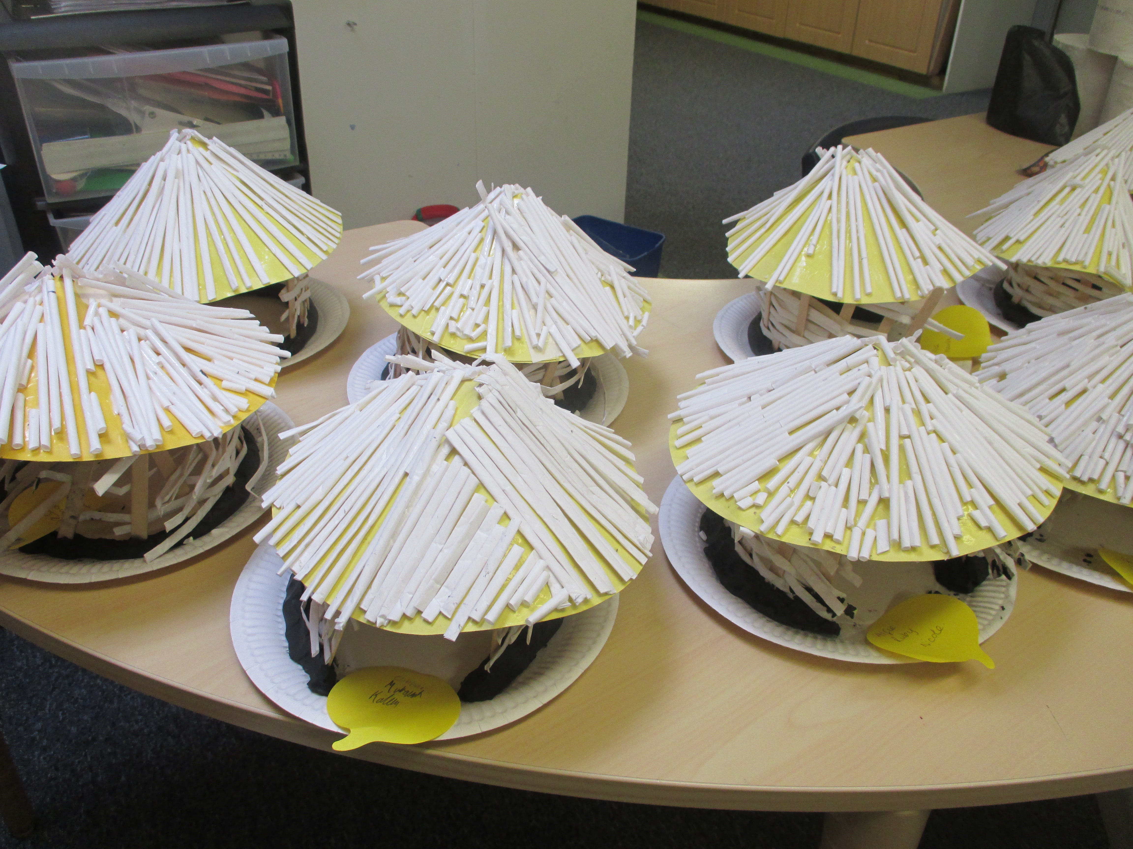
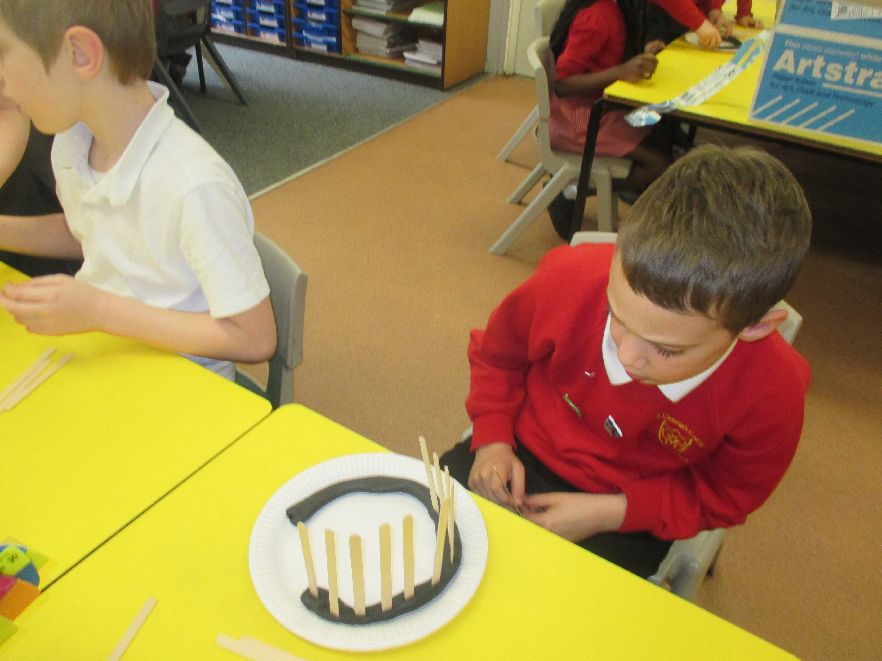


Growing and Changing Lessons- On Monday, parent/carers of pupils in Year 1-6 are invited to come into school to find out more about what we will be teaching your children during the Growing & Changing lessons that are going to take place from 7th-25th May. School Nurse and a representative from the Healthy Schools term, will be coming in to show you the materials, answer any questions that you may have & offer you further support if you need it. The session is on Monday 30th April at 9.00am in the ICT suite in school.


Reminders-
PE Kit- For safety and hygiene reasons, we ask that pupils have a change of clothing for when we do PE. The PE kit- consisting of shorts (jog trousers can be worn when it is cold), t-shirt, pumps or trainers can be left in school & washed on a half termly basis so that it is in school ready for your child to use.

Data Forms- Please can parent/carers ensure they have signed and dated the Data Protection forms by Friday 4th May and return them to your child’s class teacher or to the main office.

GENERAL DATA PROTECTION REGULATIONS
From May 25th, 2018, the way we manage data and information in the school is changing and we have appointed Global Policing to act as the school’s data protection officers. General Data Protection Regulations give parents, children, teachers and anyone we hold information on the power to request:
1. To arrange an appointment to view all the information we hold on you.
2. To ask for the information to be changed.
3. To ask for the information to be deleted.
To request any of these services you are to contact Global Policing directly and request them to contact you back:
Email: datarequests@globalpolicing.co.uk
Website: www.globalpolicing.co.uk
Phone: 0161 212 1681 (Voicemail Service)
We will soon be sending out new notices called privacy notices that will give you more information about the new regulations and will need to be signed by you.
If you have any questions, contact Global Policing directly.

