[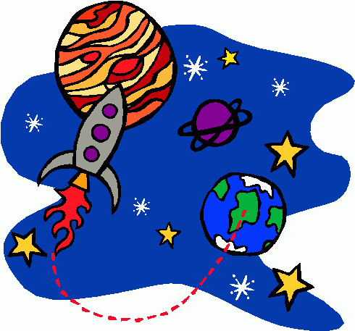](http://www.google.co.uk/url?sa=i&rct=j&q=&esrc=s&frm=1&source=images&cd=&cad=rja&docid=gzP1HPtB2x5XcM&tbnid=rI18YIJp3ZiOHM:&ved=0CAUQjRw&url=http://bestclipartblog.com/25-space-clip-art.html/space-clip-art-4&ei=vIPcUZGwK9Cb0AXn0oDIDw&bvm=bv.48705608,d.d2k&psig=AFQjCNGQKCz-0zOv_4R0Cn0oyc1QKcTyXw&ust=1373492535522801) serving Jesus

**Art /DT:**

**DT** – Children will evaluate moving vehicles and their designs and then make their own moving Mars buggies with wheels and axils.

**Art –** collage and mixed media space pictures linked with the music and dance. Children will explore space image printing.

**Humanities: Geography Focus**

Children will be looking at map work and aerial photos. Children will be exploring ordinance survey maps and their symbols, then making their own maps.

Children will be exploring digital mapping and using the eight points on a compass, as well as 4 and 6 grid point references.

Children will look at the History of Space travel and how this has impacted on life today. Children will explore the important people who are associated with Space travel.

**Questions children want to investigate:**

* What are the sun and moon made from?
* How do rockets break into space?
* Are there aliens out there?
* Has NASA found life on Mars?
* How many planets are there and what are their names?
* Who was the first man on the moon?

Topic: Spring Term 2018 Year 5

Out of This World

**Science:**

**Out of This World( rising stars scheme)**

Children will be learning about Space.

The focus will be on planets, seasons, tides and the different phases of the moon. The children will look at past scientists who have been in space.They will be looking at orbits and axis of planets.

Let’s Get Moving

Children will be looking at the forces acting on Earth, in particular gravity and friction. They will then be investigating springs, pulleys and levers.

**PE and Music:**

**Dance:** Children to make up their own space dance using the Planets suite dance.

**Outdoor Games:** Team games

**Music:** Manchester Music scheme (Focus on the planet suite by Gustav Holst (especially Jupiter) Learning to play the recorder.

**Drama/S&L Opps:**

In the reading area, children will be able to explore a rocket for role play and drama. S+L activities will be available.

**Stories/Texts/links:**

Selection of nonfiction books about space

Extracts from Astronaut Journals

Poetry about Space

Recounts – Alien earth experiences.

**Debate:** Animals sent to Space…is it right to take something from their home?

**Writing Opportunities:**

**All literacy this term will be directly linked to the topic.**

* **Nonfiction information booklets about Space.**
* **Diary entries in the life of an Astronaut.**
* **Newspaper report – invading aliens.**

**ICT:**

**Create IT (graphics)**

**Using a search engine**

**Numeracy Links:**

Primary Numeracy Framework linking with Medium Term plans:

This term links directly to positional and directional language. Children will be using eight point compass directions.

In Science children will be using data and tables, interpreting them and analysing it. They will also be making graphs and presenting data.

**RE:**

**Using the Manchester scheme of work**

Women of the Old Testament

Easter Victory

**PSHE:**

Animals sent to Space…is it right to take something from their home?

Enabling Enterprise week