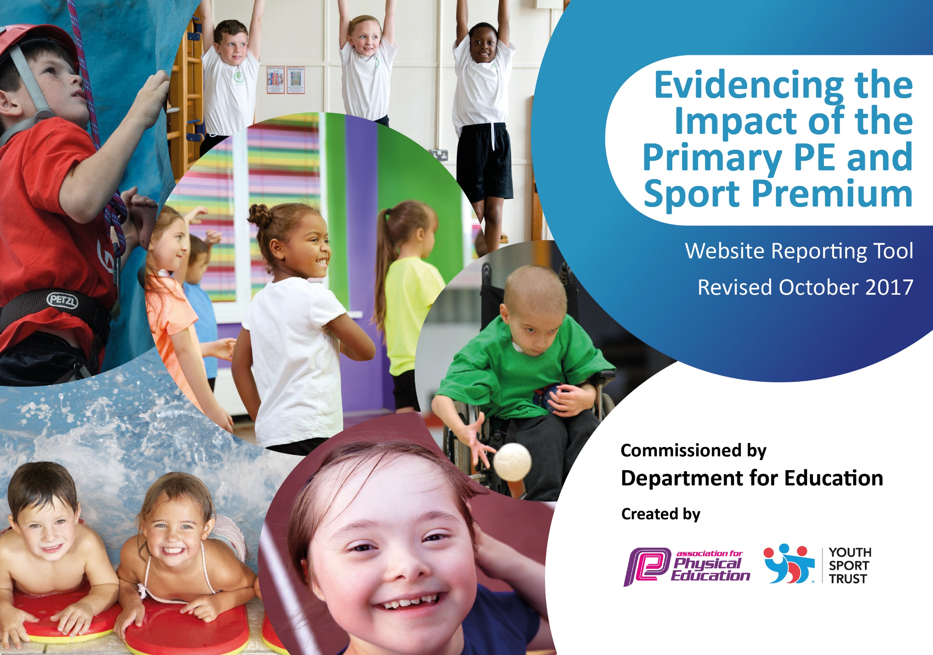

Schools must use the funding to make additional and sustainable improvements to the quality of PE and sport they offer. This means that you should use the Primary PE and Sport Premium to:

- develop or add to the PE and sport activities that your school already offers
- build capacity and capability within the school to ensure that improvements made now will benefit pupils joining the school in future years

Please visit gov.uk for the revised DfE guidance including the 5 key indicators across which schools should demonstrate an improvement. This document will help you to review your provision and to report your spend. DfE encourages schools to use this template as an effective way of meeting the reporting requirements of the Primary PE and Sport Premium.

We recommend you start by reflecting on the impact of current provision and reviewing the previous spend.
Under the Ofsted Schools Inspection Framework, inspectors will assess how effectively leaders use
the Primary PE and Sport Premium and measure its impact on outcomes for pupils, and how effectively governors hold them to account
for this.

Schools are required to publish details of how they spend this funding as well as on the impact it has on pupils’ PE
and sport participation and attainment.
We recommend regularly updating the table and
publishing it on your website as evidence
of your ongoing review into how you are using the money
to secure maximum, sustainable impact. To see an example of how to complete the table please click HERE.

Support for review and reflection - considering the 5 key indicators from DfE, what development needs are a priority for your setting and your students now and why? Use the space below to reflect on previous spend, identify current need and priorities for the future.

Key achievements to date: | Areas for further improvement and baseline evidence of need:
Achieved Bronze school games mark award (July 17).  Increased participation and range of extra-curricular activities (Dec 17).  Daily mile rolled out to years 3-6.  A range of activities are provided at lunchtime in zoned areas.  Y5 playground buddies in place every lunchtime.  Sports coach provision is quality assured by head teacher. | To work towards the achievement of the silver school games mark (July 18).  To respond to pupils feedback about extra-curricular activities and action their feedback in terms of changing extra-curricular provision regularly.  Daily mile rolled out to all classes and ensuring that it is happening regularly (July 18).  To vary the activities being provided in the zoned areas e.g. alternative to football.  To organize and train current y4 in the PALs programme.  Wider staff to observe sport coach practice to develop their personal PE skills.

Meeting national curriculum requirements for swimming and water safety | Please complete all of the below:
What percentage of your Year 6 pupils could swim competently, confidently and proficiently over a distance of at least 25 metres when they left your primary school at the end of last academic year? | 78.8%
What percentage of your Year 6 pupils could use a range of strokes effectively [for example, front crawl, backstroke and breaststroke] when they left your primary school at the end of last academic year? | 78.8%
What percentage of your Year 6 pupils could perform safe self-rescue in different water-based situations when they left your primary school at the end of last academic year? | 78.8%
Schools can choose to use the Primary PE and Sport Premium to provide additional provision for swimming but this must be for activity over and above the national curriculum requirements. Have you used it in this way? | Yes/No

Action Plan and Budget Tracking
Capture your intended annual spend against the 5 key indicators. Clarify the success criteria and evidence of impact that you intend to measure to evaluate for students today and for the future.

Academic Year: 2017/18 | Total fund allocated: £ | Date Updated: November 2017
Key indicator 1: The engagement of all pupils in regular physical activity – Chief Medical Officer guidelines recommend that primary school children undertake at least 30 minutes of physical activity a day in school |  |  |  | Percentage of total allocation:
 |  |  |  | %
School focus with clarity on intended impact on pupils: | Actions to achieve: | Funding allocated: | Evidence and impact: | Sustainability and suggested next steps:
- Use of physical activity to engage pupils, improve behavior and concentration  - Development of Playground Activity Leaders to support physical activity at breaktime and lunchtime. | - Daily Mile rolled out throughout the school in every year group  - Lunchtime and KS1 area resources and equipment eg skipping ropes, hoops, scoops etc investment  - Support for lunchtime organiser’s activity training to increase physical activity at lunchtime.  - Selection and training of PALs- current y4 pupils  - SLO to maintain PALs and report to PE SL as appropriate. | 2000 | - Increased engagement in lessons  - Reduction in behavioural incidents at lunchtime and breaktime  - Increased physical activity at break and lunch | - Training cascaded year on year  - Embedded Daily Mile  - Resource annual budget  - Ongoing training and support for PALs
Key indicator 2: The profile of PE and sport being raised across the school as a tool for whole school improvement |  |  |  | Percentage of total allocation:
 |  |  |  | %
School focus with clarity on intended impact on pupils: | Actions to achieve: | Funding allocated: | Evidence and impact: | Sustainability and suggested next steps:
- Pupil voice to ensure increased engagement of pupils in PE and Sport activities  - Increased profile of PE and Sport in assemblies to demonstrated respect, teamwork, honesty  - To achieve Silver School games mark as a result of pupils improved participation in PE and sport. | - Continue sports star of the week awarded in assembly  - PE Lead to ensure Sports coaches allocate a PE star of the week  - PE Lead to introduce School Games Organising Committee (Sports Council)  - Look at Silver school games mark criteria and plan activities to achieve. | 1000 | - Increased participation  - Reduced behavioural incidents | - Annual election of sports representatives from each class

Key indicator 3: Increased confidence, knowledge and skills of all staff in teaching PE and sport |  |  |  | Percentage of total allocation:
 |  |  |  | %
School focus with clarity on intended  impact on pupils: | Actions to achieve: | Funding  allocated: | Evidence and impact: | Sustainability and suggested  next steps:
- Support and quality assure current teaching and learning in PE  - Move towards staff upskilling in PE | - New PE lead to access training  - New PE lead to audit PE  - Audit and QA current PE provision  - Audit staff confidence and skills  - Plan support as appropriate to upskill staff in teaching PE using current coaching company.  - Update and share PE policy  - Ensure all staff aware of the Safe Practice guidelines  - Ensure PE curriculum map completed and appropriate  - Investigate new SoW to support teaching. Collate current planning and assessment from coaching company as part of QA process | 2000  3500 | - Updated PE policy in place and shared with staff  - Curriculum map updated  - Collated assessments and planning to ensure progress  - Staff aware of Safe Practice guidelines | - Move towards teachers teaching PE  - Ongoing support for teachers to teach PE  - New SoW introduced with appropriate training to continue year on year
Key indicator 4: Broader experience of a range of sports and activities offered to all pupils |  |  |  | Percentage of total allocation:
 |  |  |  | %
School focus with clarity on intended  impact on pupils: | Actions to achieve: | Funding  allocated: | Evidence and impact: | Sustainability and suggested  next steps:
- Wide variety of clubs offered to pupils  - Use of clubs to support and improve behavior management | - Audit range of activities on offer both lunchtime and after school  - Little Dragons club introduced | 2000 | - Increased participation - registers  - Improved behavior as per intended outcomes | - Use of PP funding in future to sustain??
Key indicator 5: Increased participation in competitive sport |  |  |  | Percentage of total allocation:
 |  |  |  | %
School focus with clarity on intended  impact on pupils: | Actions to achieve: | Funding  allocated: | Evidence and impact: | Sustainability and suggested  next steps:
- Increased opportunity to access a range of competitive opportunities to support the social development of pupils and to use as a reward for outstanding behavior  - Series of special events to be organized throughout the year to increase intra competition | - Membership of Mcr PE association  - Access the competition calendar and plan for the year  - All associated administration – risk assessment, letters, transport, allocation of staff  - Headteacher to arrange special events in conjunction with selected providers to increase competition. | 600  1200  1000 | - Improved understanding and display of appropriate sporting behaviours  - All pupils to have experience intra-school competition  - Some pupils to have experience of inter-school competition.  - All pupils to gain greater understanding of appropriate behaviour and character education | - Staffing – allocated and distributed fairly  - Minimal contribution from pupils to cost of transport  - Intra-competition is sustained by staff

