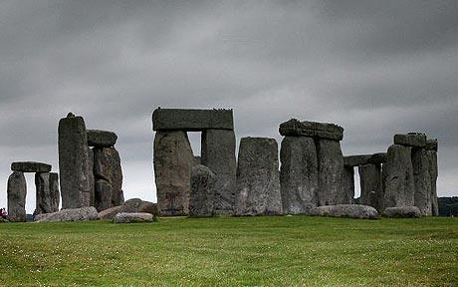 serving Jesus

**RE:**

**Jesus the Teacher/ New Beginnings**

**Christmas Around the World/Getting on and Falling Out**

**Heart smart:** Get Heart smart

Don’t Forget to Let Love in

**PE and Music:**

**Outdoor Games:** Team games

**Music:** Manchester Music scheme –

Topic: Autumn term 2018 Year 5

Rock of Ages!

**Humanities: Stone Age/ Iron Age/ Bronze Age**

**Geography Focus:**

Children will be looking at how England and Manchester have changed over time.

**History Focus:**

Children will be looking at what life was like for pre-historic man. They will be ordering key events in the stone/iron and bonze ages and discussing the impact that this has had on man through history.

Children will be exploring why settlers settled where they did and what a settlement was like. Thy will also be learning about archaeology and how we find out about early man.

**Numeracy Links:**

Primary Numeracy Framework linking with Medium Term plans:

**3d art work with shape and position, timelines in history and statistics and graphing in science.**

**Drama/S&L Opps:**

**Stories/Texts/links:**

We will be acting out Stone Age living and producing drama around the theme. We will role play newspaper reporters and perform our own poetry. Through the term we will develop our philosophy skills with BIG questions.

**Writing Opportunities:**

Throughout the term we will be looking at and writing Stone Age myths and legends,

Stories from other cultures,

Newspaper articles and

Poetry

**Art /DT:**

* Children will be studying Anthony Gormley as an artist and linking his work with both Stone Age and our science (materials) topic. Children will make natural sculptures.
* Through the Stone Age work, children will be exploring cave paintings and mark making, looking at their relevance in that part of History. Children will be making their own cave painting style images.
* Children will be making primitive clay pots/plates/earthenware in the style of Stone Age pieces.
* Children will be using sewing skills to create art work linked with materials and natural objects.

**Science:**

**Unit 1:** Material World – children will be exploring different states of matter (solid/liquid/gas) and the properties of materials. There is a heavy emphasis on AT1 (investigation skills)

**Unit 2:** Circle of Life – children will be exploring Life cycles with the plant and animal world (Not humans) Biology based unit.

**ICT:**

Code IT (Scratch)

Children will be learning and practising their programming skills using specialist programmes.

**MATHS LINKS: Problem solving and reasoning, directional language,**

**E-Safety**

Pupils will be taught safely, respectfully and responsibly; recognise acceptable/unacceptable behaviour; identify a range of ways to report concerns about content and contact.

**Questions children want to investigate:**

**When was the Stone Age?**

**What was life like in the Stone Age?**

**Where did people live in the Stone Age?**

**What happened in the Bronze Age?**

**What tools did they use?**

**What did they eat?**