
“Growing together to let our light shine”
Welcome to your weekly newsletter!! WC 8th October 2018!
Diary Dates-
-Wednesday 10th October- Harvest Worship
-Thursday 11th October 9.15am- Nasal Flu Spray Vaccinations
-Monday 15th October- Year 5 Anthony Gormley Experience Day
-Tuesday 16th October- Year 4 Viking Experience Day
-Tuesday 16th October- Year 1 Senses Experience Day
-Wednesday 17th October- Year 2 Experience Day
-Tuesday 16th and Wednesday 17th October- Parent/Carer Evening
-Wednesday 17th October- Thank Reverend Tom and Paul Worship
-Thursday 18th October- Year 3 Greek food Experience Day
-Thursday 18th October 9.30am- Reception Class Welcome service at St Clements Church
-Friday 19th October 9.00am- Values award worship

EPIC Winner- Darcey has been awarded this week’s EPIC award due to how hard she works, how she is always calm and polite and a great friend to others. I look forward to seeing you at afternoon tea in a few weeks Darcey.

Top Table Winners- Nursery- Louie, Reception-Susie, Year 1-Divine, Year 2-Leo, Year 3-Dinal, Year 4-Mia, Year 5-Liam, Year 6-Kio, Buddy Award-Ruth, EYFS Buddy-Mia.

Thanks for your Support and Understanding- We are now back to usual in our nursery and reception classes after a flood caused a lot of damage to the carpet, shelves, units and toys on Monday morning. Thanks very much to our parent/carers who sent messages of support and showed great understanding during this time when we had to close our nursery for 2 days and relocate our reception class to the hall. It was very much appreciated. Our Reception pupils coped very well and got on with it in the hall and our Early Years staff all mucked in to get things sorted out.

Our New School Councillors- Last week, our Year 2-6 pupils went to the polling station in school to cast their votes for their new school councillors. Congratulations to all of those children who were nominated by your friends and the new councillors have a lot to work on with Miss Male!



Harvest Festival- 10th October- This year for our Harvest St Clement’s are supporting St Clement’s Church and their winter night shelter. The Nightshelter runs every Wednesday evening from October until the end of April each year. St Clement’s Church is one of 7 churches in Manchester working alongside The Boaz Trust to provide food and accommodation for homeless asylum seekers. A team of volunteers set up beds, cook delicious food and extend warm hospitality to some of the most vulnerable members of our society. This year we are asking for children to bring in tins of vegetables which the shelter can use to help provide meals for the people who use the Night Shelter. We are hoping to hit our biggest target yet this year so please donate what you can.



Parent/Carer Evening Appointments-If you wish to meet with your child/ren’s teacher on the evening of Tuesday 16th or Wednesday 17th October, please return the slip at the bottom of the letter requesting a time. Your child’s teacher will then return the slip to you next week. If you are unable to attend the evenings, then please speak to your child’s teacher who will arrange a mutually convenient time to meet with you.

Confidential Information Envelopes- Your child should have come home with a large, brown envelope with their name on. The envelope contains important policies for you to read and sign the reply slips on some of the policies. It also contains the information sheet about your child that we put onto our computer system. It is very important that this is returned to us so we can record any changes to contact details that we may need to use in an emergency.

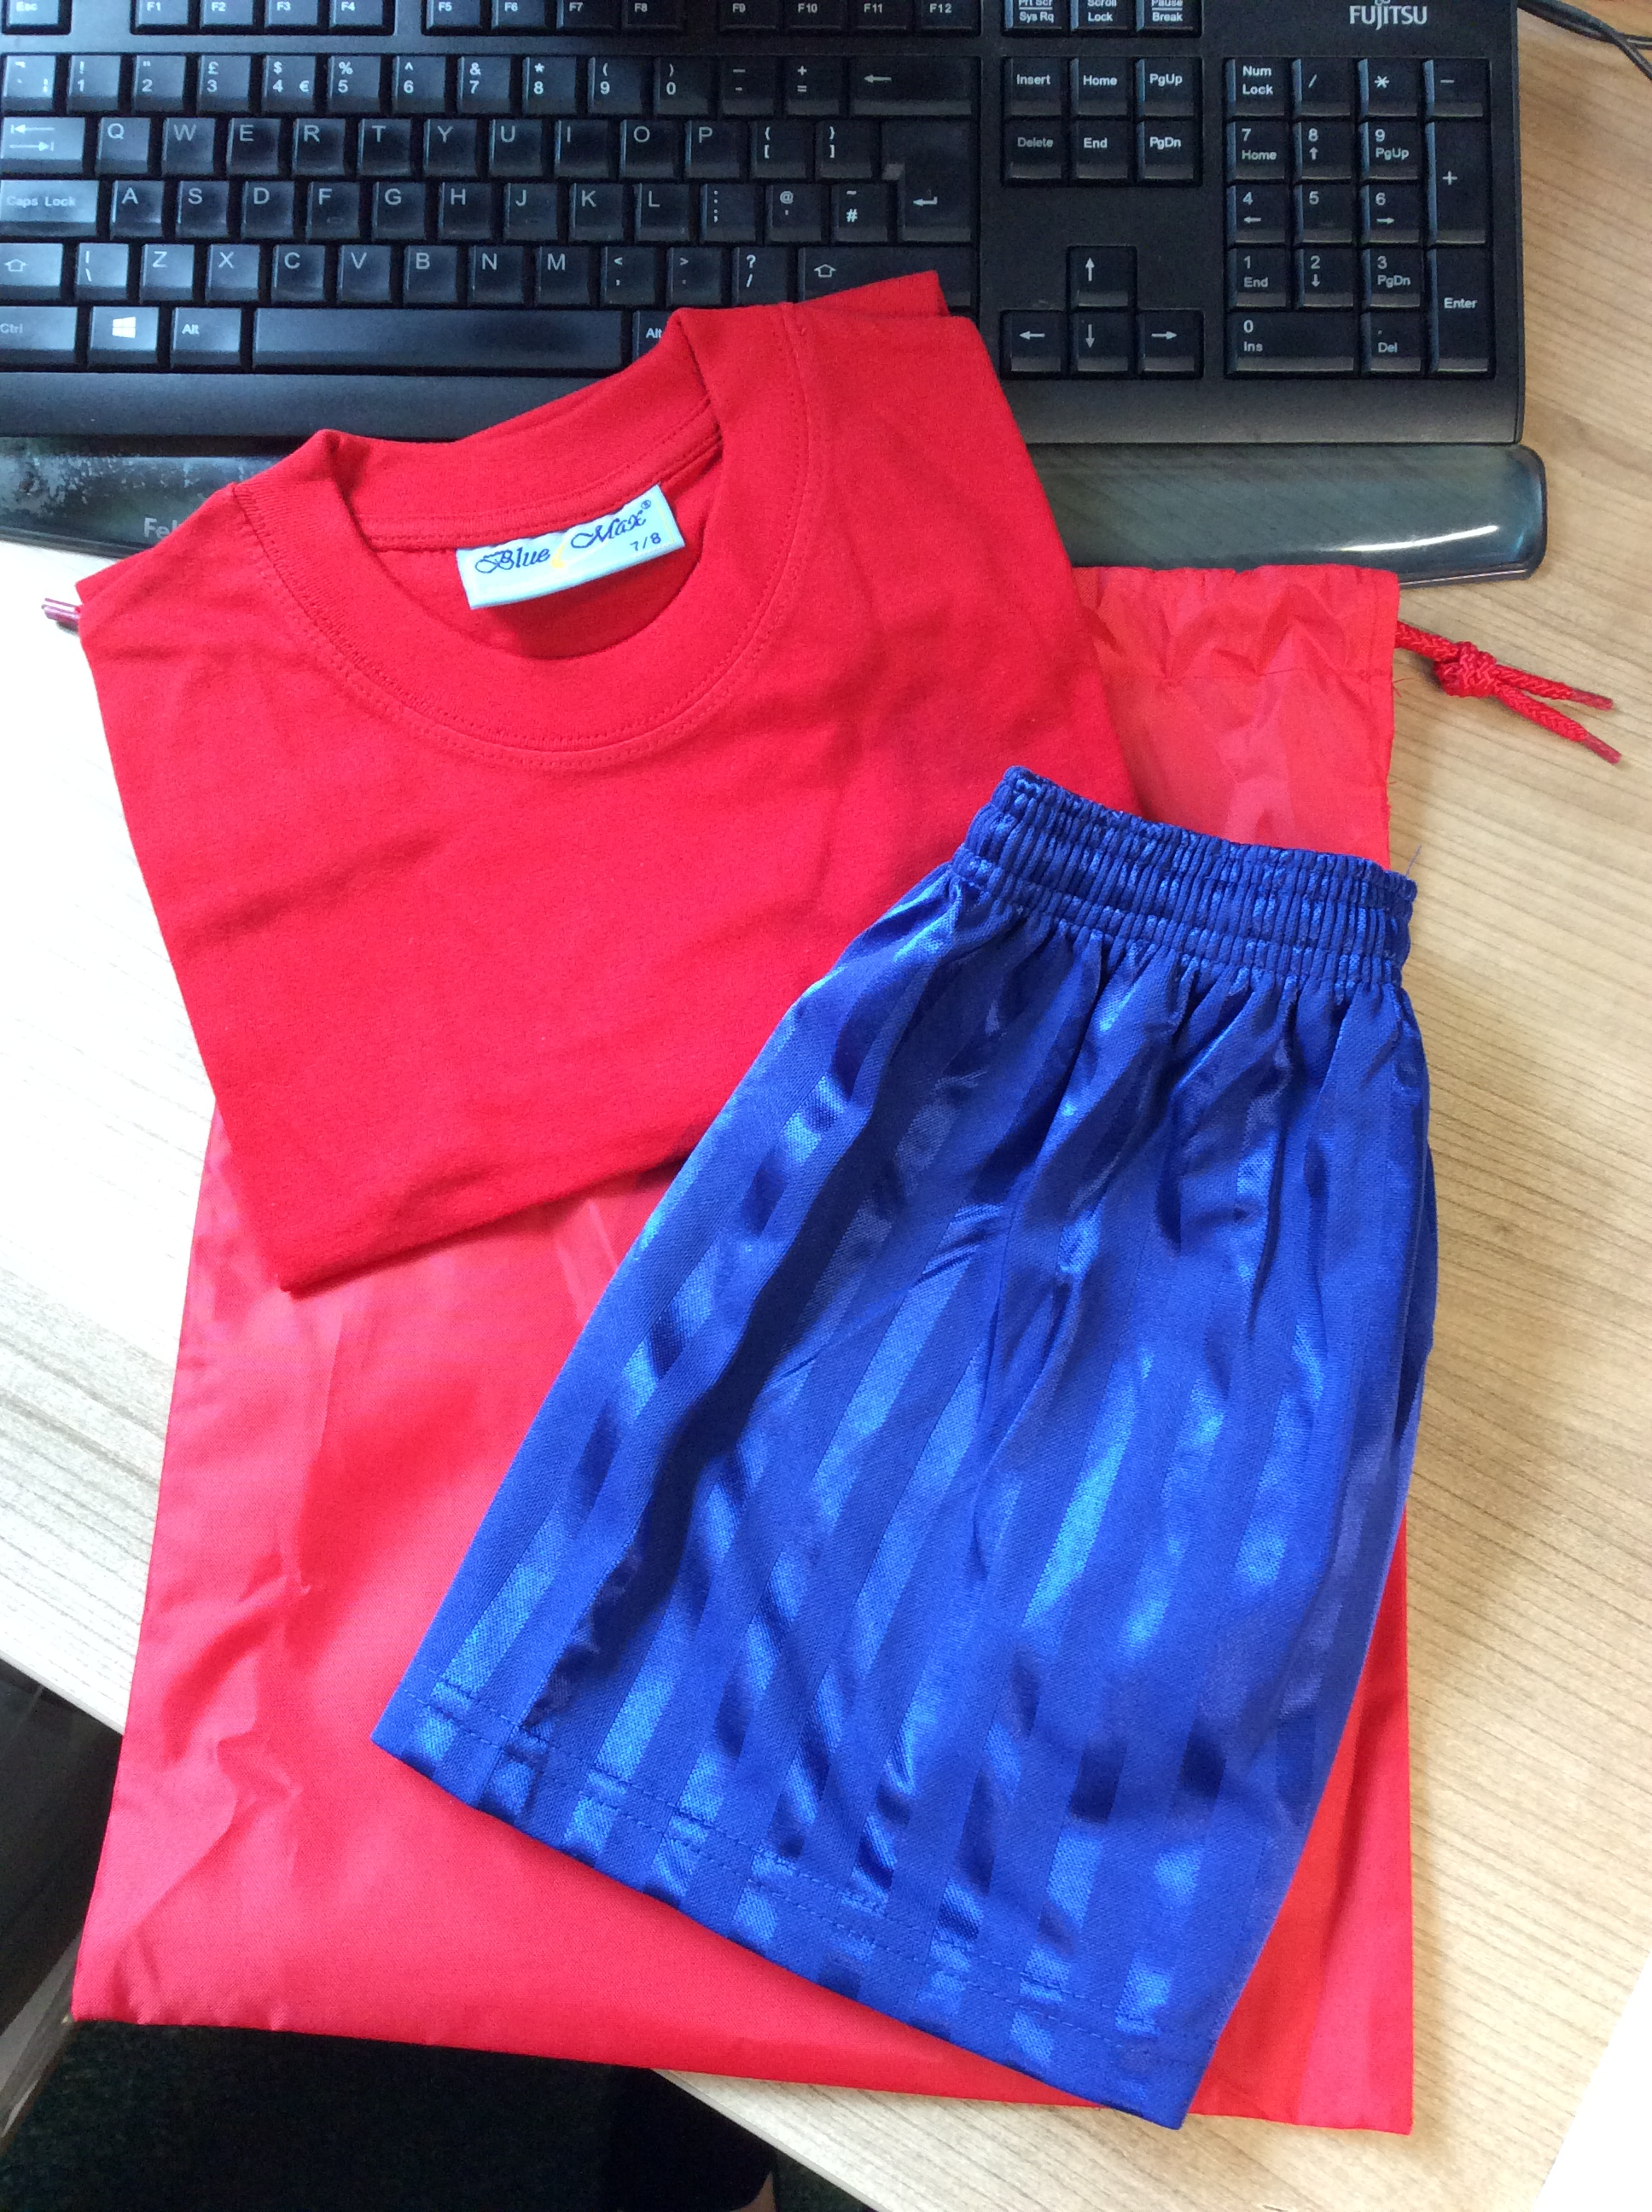
PE Kit- We do have some children who do not come to school prepared for when they have a PE lesson and they cannot do PE in their uniforms- they need a change of clothes for this area of the curriculum. NB: PE kit is not needed for children in nursery and reception yet.
We sell a school PE kit at the office- they cost £6.00 and include the red bag, red t-shirt and blue shorts. The sizes that they come in are 3-4, 5-6, 7-8, 9-10 and 11-13.
However, children can also wear their own shorts and t-shirt or jog trousers when it gets colder.
Black PE pumps or trainers are also to be worn.
If any parent/carers have a problem, providing this, then please speak to us.

Reminder- If you are paying for school meals, school trips, uniform etc PLEASE can you make sure that you come to school with the correct change as school does not have any change. If you would like to pay for anything and you do not have the correct change you are able to pay for it on the school in the school payment system SIMS Agora. If you do not have a password for this or would like help setting up the account then please speak to a member of staff in the office who will be happy to help you.

