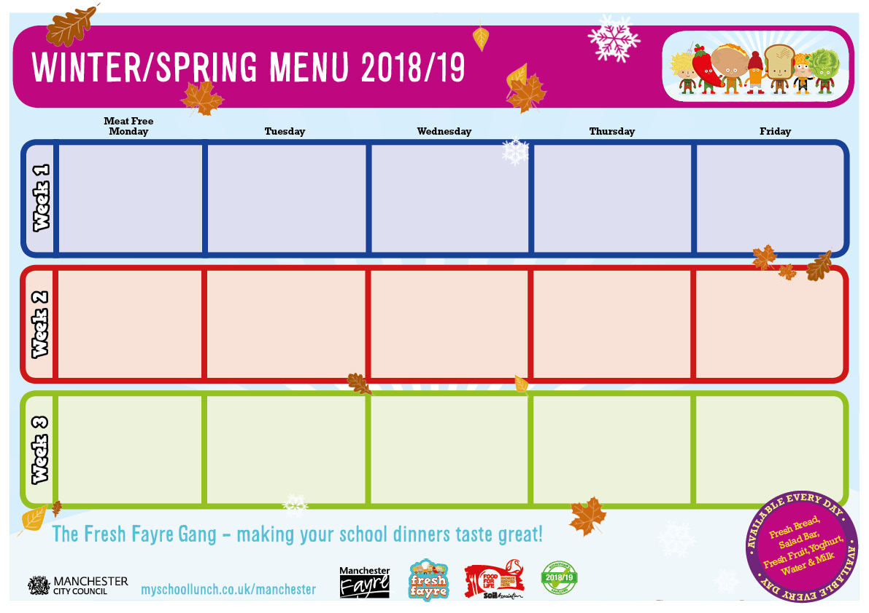

St Clements nursery menu week 4-6

Tempura Fish

Mashed Potatoes, Garden Peas

Homemade Muffin

Cheese Flan

Jacket Wedges & Sweetcorn

Fruit Salad with Blueberry Frozen Yoghurt

Roast Dinner

Roast & Mash Potatoes

Cabbage & Carrots

Parsnip & Apple Cake & Custard

Homemade Chicken Pie

Crusty Baguette & Green Beans

Cheese & Crackers with Vegetable Sticks

Veggie Chilli con Carne

Brown Rice & Carrots

Melon Boat

Filled Jacket Potato

Mixed Vegetables

Jelly & Fruit

Baked Sausage, Yorkshire Pudding & Gravy

Mashed Potatoes, Carrot & Swede

Chocolate & Pear Sponge with Custard

Quorn Sausage & Gravy

Baked Jacket Wedges & Garden Peas

Mango Frozen Yoghurt & Fruit

Roast Dinner

Roast & Mashed Potatoes,

Broccoli

Peach Melba

Salmon & Sweet Potato Fishcake

Chips & Garden Peas

Fruit Sponge & Custard

Filled Jacket Potato

Vegetable Stics

Oat Crunchie with Fruit Slices

Homemade Lamb Curry

Vegetable Rice & Chopped Salad

Cheese & Crackers with Vegetable Sticks

Vegeballs in Homemade Sauce

Pasta & Carrots

Jelly & Fruit

Quorn Bites

Diced Potatoes & Mixed Vegetables

Fruit with Ice Cream

Fish Fingers

Chips & Peas

Shortbread Bite & Fruit