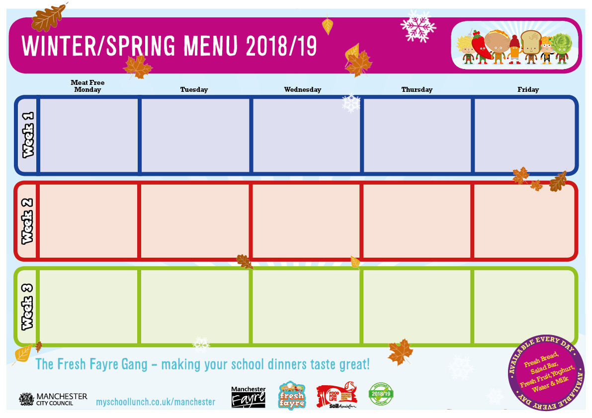

St Clements Primary School

Tempura Fish

Quorn Chow Mein

Filled Jacket Potato

Mashed Potatoes, Garden Peas

Homemade Muffin

Lasagne

Cheese Flan

Sandwich Selection

Garlic Flavoured Bread or Jacket Wedges & Sweetcorn

Fruit Salad with Blueberry Frozen Yoghurt

Roast Dinner

Hot Filled Tortilla Boat

Pasta & Sauce

Roast & Mash Potatoes

Cabbage & Carrots

Parsnip & Apple Cake & Custard

Homemade Chicken Pie

Tandoori Quorn

Sandwich Selection

Sunshine Rice or Crusty Baguette, Vegetable Selection

Cheese & Crackers with Vegetable Sticks

Homemade Lamb Curry

Veggie Chilli con Carne

Sandwich Selection

Brown Rice & Carrots

Melon Boat

Tandoori Chicken

Cheese Whirl

Filled Jacket Potato

Jacket Wedges & Mixed Vegetables

Jelly & Fruit

Baked Sausage, Yorkshire Pudding & Gravy

Quorn Curry

Pasta with Sauce

Mashed Potatoes or Rice & Carrot & Swede Chocolate & Pear Sponge with Custard

Cheese & Onion Pie

Quorn Sausage & Gravy

Hot Sandwich Special

Baked Jacket Wedges & Garden Peas

Mango Frozen Yoghurt & Fruit

Roast Dinner

Hot Filled Tortilla Boat

Sandwich Selection

Roast & Mashed Potatoes,

Broccoli

Peach Melba

Salmon & Sweet Potato Fishcake

Quorn Biryani  
Sandwich Selection

Chips & Garden Peas

Fruit Sponge & Custard

Spaghetti Bolognaise

Samosa Pie

Filled Jacket Potato

Garlic Bread or Mashed Potatoes & Carrots

Oat Crunchie with Fruit Slices

Homemade Lamb Curry

Quorn & Vegetable Stirfry

Pasta with Sauce

Vegetable Rice or Sliced Baguette & Tomato Salsa

Cheese & Crackers with Vegetable Sticks

Homemade Pizza Selection

Vegeballs in Homemade Sauce

Filled Jacket Potato or

Pasta & Corn on the Cob

Jelly & Fruit

Homemade Pizza Slices

Quorn Bites

Filled Jacket Potato

Diced Potatoes & Mixed Vegetables

Fruit with Ice Cream

Fish Fingers

Vegetable Pasta Bake

Jacket Potato Selection

Chips or Garlic Bread & Peas or Sweetcorn

Shortbread Bite & Fruit