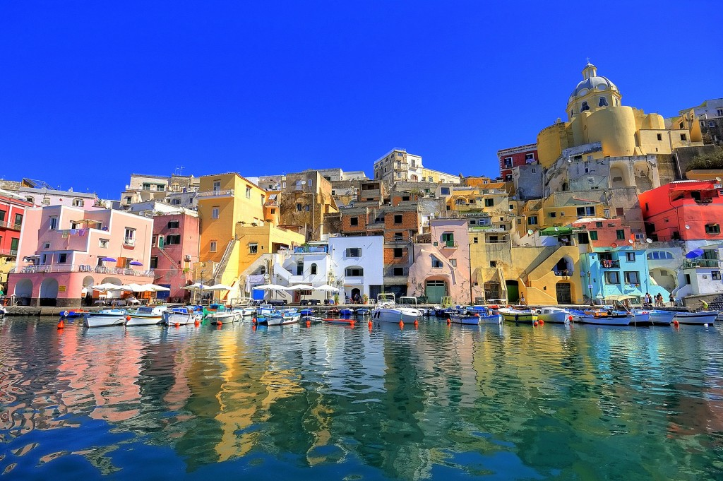

**Humanities: World Weather**

We are going to study the different weathers that affect the world. We are going to explore why some places have weather that is similar to ours in the UK and why some places have different weather.

We are going to choose a country in Europe to focus on and find out what the weather is like there. The children will also start to find out about extreme weather and the natural disasters that can occur.

We will visit Chill Factor e to experience extreme cold.

**Year 3 Topic:** **Spring 2019**

**World Weather**

**Questions children want to investigate:**

1. Where does weather come from?
2. Why does is rain?
3. What happens when a volcano erupts?
4. Why are some places hot?
5. Why is the weather different in different places?
6. Where is snow from?

-

**Computing:** CodeI.T. / SortI.T.

Children will begin to explore how to use computers to make a simple set of instructions and to test them.

Children will plan and begin to develop a simple database that can be used to answer simple questions.

**Art /DT:**

In Art we will look at famous artists from Italy. We will also explore how the weather can be depicted in art.

In DT we will explore how the weather affects the food that people in different places eat and trying recipes from other cuisines.

**PE and Music:**

**PE:** Our sports coaches will be working on a range of outdoor games throughout the term.

**Music:** Following our School Scheme .

**RE:**

Lent and Easter Joy and Sadness

**HEARTSMART:**

Too Much Selfie Isn’t Healthy!

**Drama Opportunities:**

Acting out the water cycle.

Exploring natural disasters and the impact on people.

Literacy work - linked to Fantastic Mr Fox.

**Writing Opportunities:**

Information texts about the weather and the water cycle.

Persuasive text, such as holiday brochures.

**Numeracy Links:**

**Learning the 3x, 4x, 8x tables**

Multiplication & Division

Measurement – Money

Statistics

Measurement – Length & Perimeter

Fractions

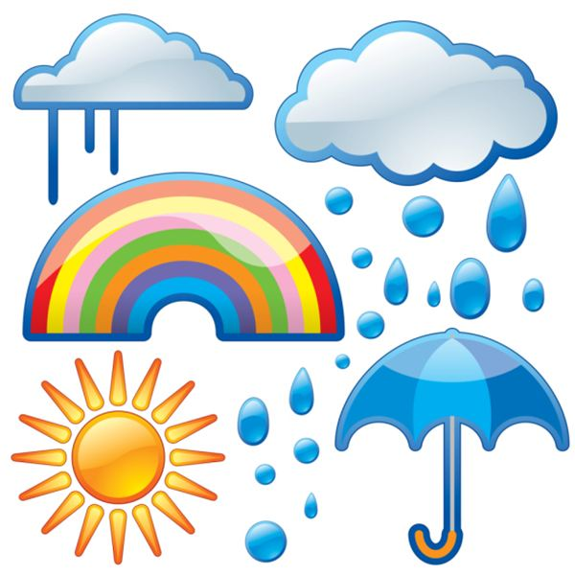

**Science:**  **Food and our bodies**

Understanding different food groups.

Understanding how foods affect our bodies.