
“Growing together to let our light shine”
Welcome to your weekly newsletter!! WC 14th January 2019!
Diary Dates-
-Monday 14th January- Year 4 Egyptian Workshop in school
-Tuesday 15th January- Nursery and Reception Dinosaur Experience Day
-Thursday 17th January- Year 3 Weather Experience Day 1
-Tuesday 22nd January 9am- Special Educational needs Parent/carer session
-Tuesday 22nd January- Year 5 Jodrell Bank Trip
-Wednesday 23rd and 30th January 2.15pm-3pm- Nursery Parent/Carer early phonics session
-Thursday 31st January 9am- Year 2 class worship
-Friday 1st February- MATHS NO PROBLEM EVENT
-Friday 1st February AM- Year 5 to Wright Robinson to watch School of Rock
-Monday 4th February- Children’s Mental Health Week- Healthy Inside & Out
-Tuesday 5th February- Chinese New year themed lunch
-Tuesday 5th February- Safer Internet Day
-Wednesday 6th February- Year 1 trip to Lowry (am) and People’s History Museum (pm)
-Wednesday 6th February PM- EPIC Afternoon Tea
-Wednesday 6th February- Year 2 African Geography and Art Experience Day
-Thursday 7th February PM –Year 6 South America Experience Day
-Friday 8th February- Year 1 Lowry Art Experience Day
-Monday 11th February- Year 5 Space Buggies Experience Day
-Tuesday 12th February- Year 4 Egyptian Art Experience Day
-Wednesday 13th February 9.30-2pm- KS2 pupils Enabling Enterprise trip to business in town
-Thursday 14th February- pm- Year 6 South America Experience activity
-Friday 15th February- Year 4 & 5 pupils to Swimming Gala
-Friday 15th February 9am- Compassion & Love Values Awards
-Friday 15th February 3.15pm- End of Spring 1 half term
-Monday 25th February 8.50am- Start of Spring 2 half term

This Week’s Award Winners:
EPIC- The first EPIC award winner of the new year is…. Lola in Year 1. Congratulations Lola- you deserve the award because you are hard working, doing well in school and set a good example to others with your caring personality- EPIC!
Mathlete- Ellie and Liam
Sports Star- Ezer
Behaviour Jumpers- Year 1-Andrea, Year 2-Ajna, Year 3-Ezer, Year 4-Keenan, Year 5-Safwan, Year 6-Tiantai..

Top Table Winners- Nursery-Zaccary, Reception-Abdullah, Year 1-Olivier, Year 2-Noorjahan, Year 3-Kihara, Year 4-Promise, Year 5-Scarlett, Year 6-Pax, Buddy Award-Gerry, EYFS Buddy-Geralyne.

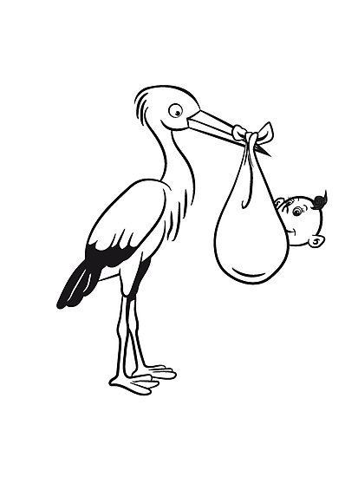

New Year News- Coming back to school, it has been lovely to see new babies being born safely in a number of our families over the holiday. Miss Mellon has also welcomed another grandchild, Alfie, who was a whopper at 9lb 9oz! Congratulations to you all.

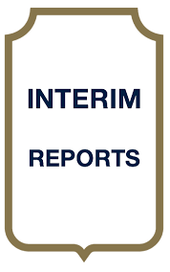
Mid Year Reports- Your child should have brought home their mid year report in a named envelope today. The report is to give parent/carers and idea of how their child is progressing after their first term in school and has been set up in response to parent/carer’s requests to know more about the progress that their child is making. If you have any questions about the report, then please speak to your child’s class teacher.

Holiday Homework- A number of children have worked hard over the holidays in completing their holiday homework- a lot of it was about preparing them for their new topics this term. Thanks for supporting your child with the research, model making, powerpoints, posters etc. Here are some Year 4 children showing us their holiday homework about their new Egyptian topic which they’ll learn more about on Monday when they have an Egyptian day in school.

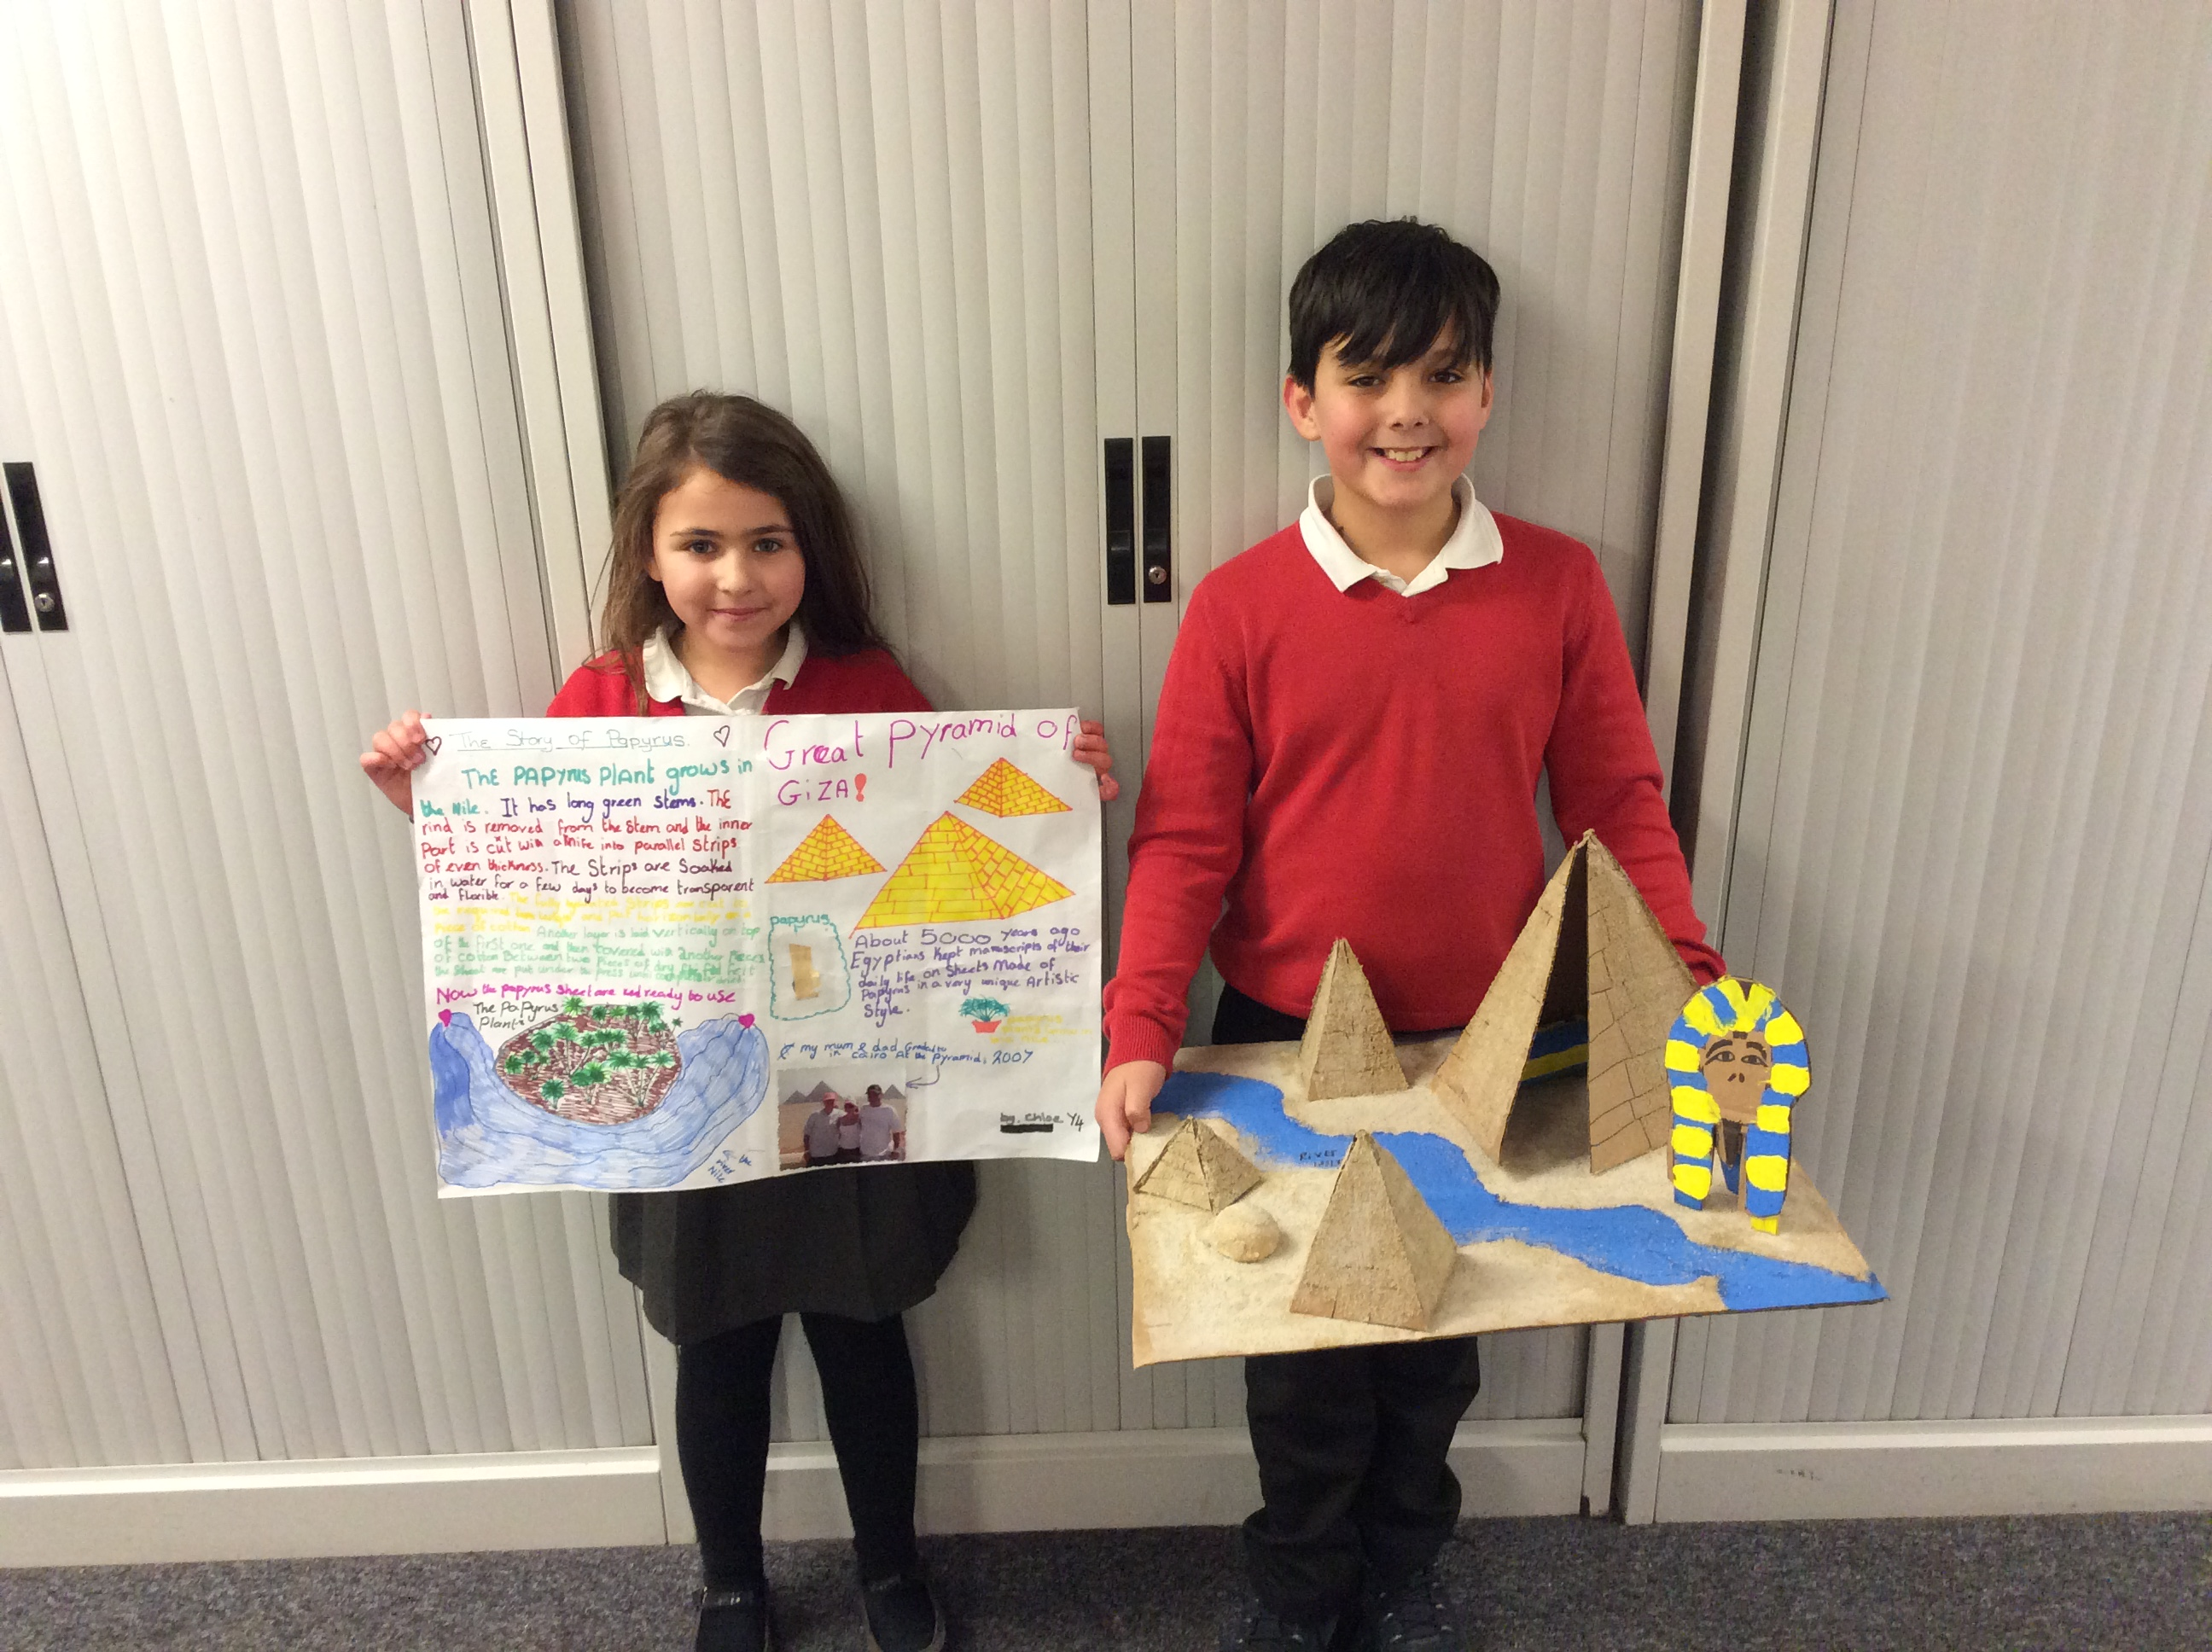

Those Who Read Succeed!- The CLEMS shop was busy on Monday, particularly with children in Years 1, 2 & 3 who had read over the holidays, so they earned CLEMS to spend in the shop- good job I stocked up in the holidays!!

Please continue to encourage your child to read daily if they are older and can read for themselves or put a small amount of time aside to hear younger children read each day- the change it makes to their future life chances has been proven to make a huge difference.

We will be inviting parent/carers into our weekly VIP reading slots on Friday afternoons starting from next week.



