
“Growing together to let our light shine”
Welcome to your weekly newsletter!! WC 18th March 2019!
Diary Dates-
-Tuesday 19th March AM- Year 4 and 5 football tournament
-Tuesday 19th March all day- Year 2 Knowsley Safari Park
-Tuesday 19th March all day- Year 1 Spring Experience Day
-Wednesday 20th March 10am- Special Educational needs Early Help drop in- trip to RHOSEY school
-Friday 22nd March all day- Year 2 Habitat Experience Day
-Monday 25th March 3.20pm- Year 6 Parent/Carers SATS information session.
-Wednesday 27trh March 4pm- Drama Club performance of Dick Whittington
-Thursday 28th March- Year 3 Weather Experience Day
-Friday 29th March 9am- Values Award Worship
-Friday 29th March- Friends of St Clements Buy a Gift Day
-Monday 1st April- World Autism Awareness Week
-Tuesday 2nd April and Wednesday 3rd April after school parent/carer evenings
-Wednesday 3rd April after school Kwik Cricket event
-Thursday 4th April 9.20am- Easter Church Service at St Clements Church
-Friday 5th April 9am- End of Term Awards
-Friday 5th April 3.15pm- End of Spring Term

This Week’s Award Winners
EPIC Award Winner- This week’s EPIC awards goes to …. Kihara. Kihara always works hard and wants to do her best. She is a good friend to others and helps her family too. Kihara is EPIC.

Behaviour Jumper winners- Year 1-Stanley, Year 2-Hollie-Rose, Year 3-Amos, Year 4-Emanuel, Year 5-Abdi, Year 6-Millie-Ann.

Top Table Winners- Nursery-Alfie, Reception-Kaison, Year 1-Afomiya, Year 2-Adonea, Year 3-Kihara, Year 4-Ruby, Year 5-Ellie, Year 6-Tilly, EYFS Buddy Award-Mia.

Change for Life Festival- On Wednesday, a group of pupils went with Miss Naylor and Mrs Law to Platt Lane Complex to join in the Change for Life Festival. At the Festival, they took part in events such as Wall mania, tackle the obstacle, Strike a pose, Disc boule, Bullseye, Hunt ‘n’ Grab and Slalom relays. A good time was had by all, as well as getting to try new activities and being active!

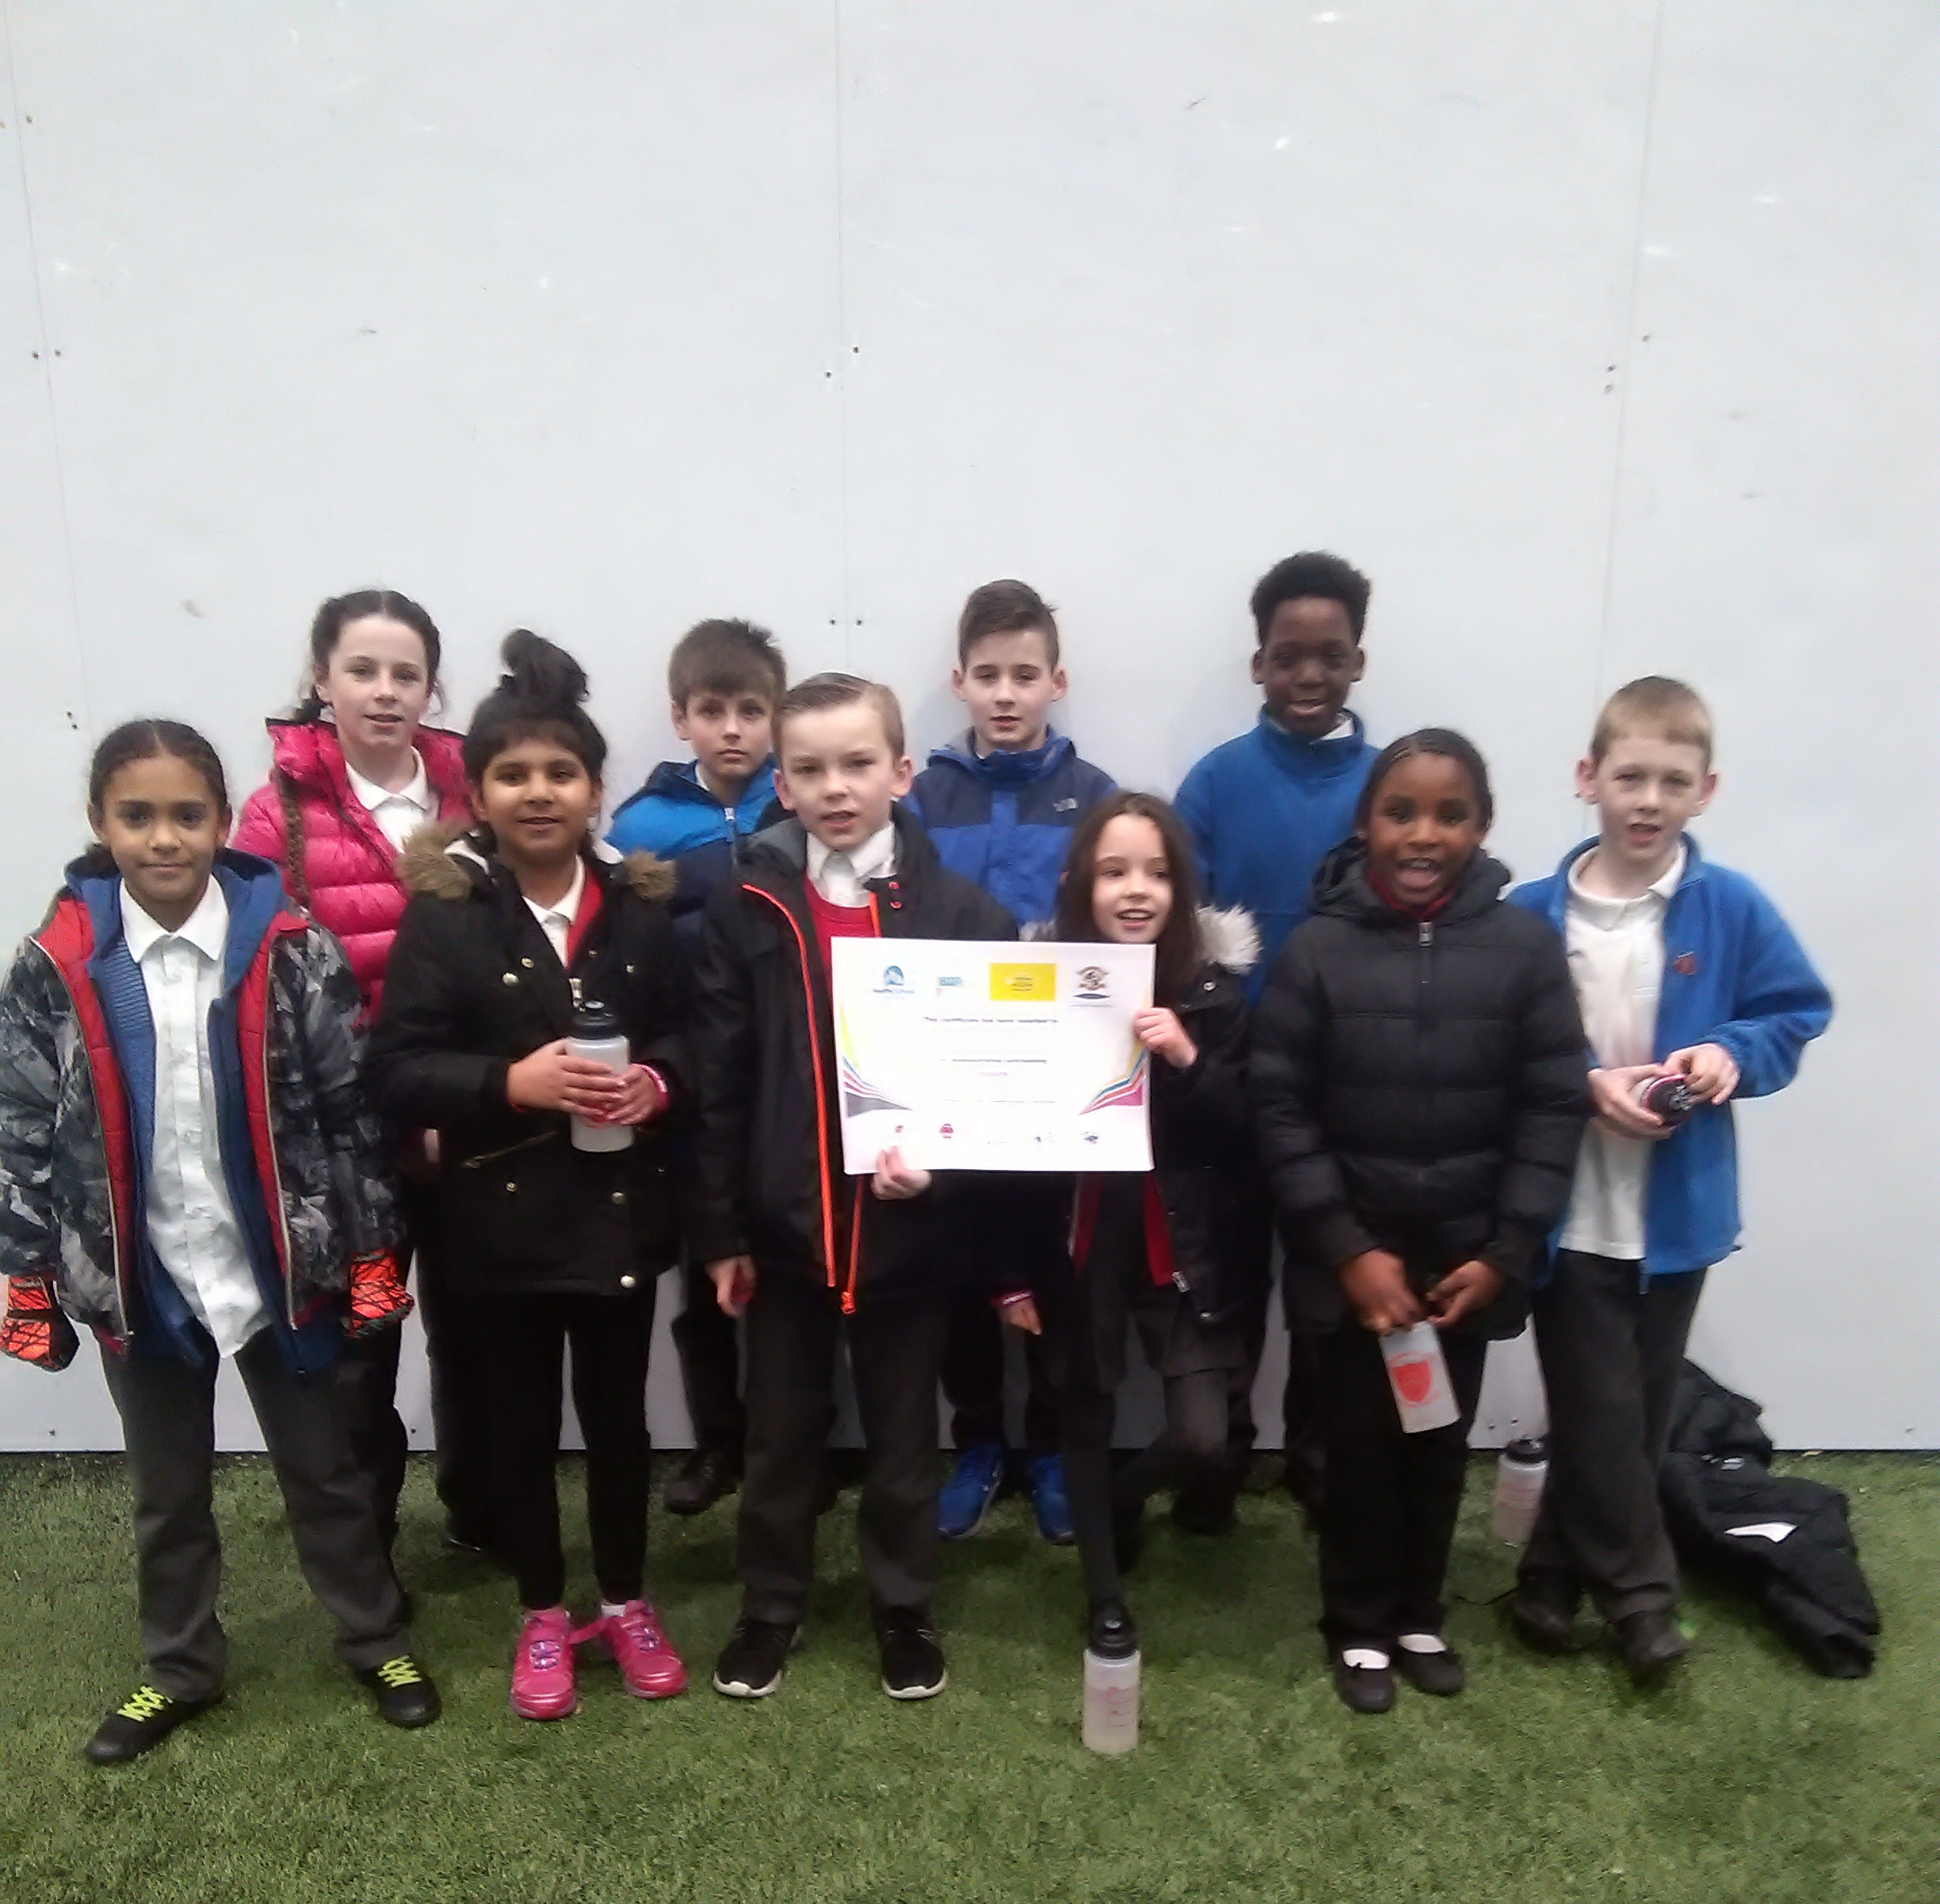
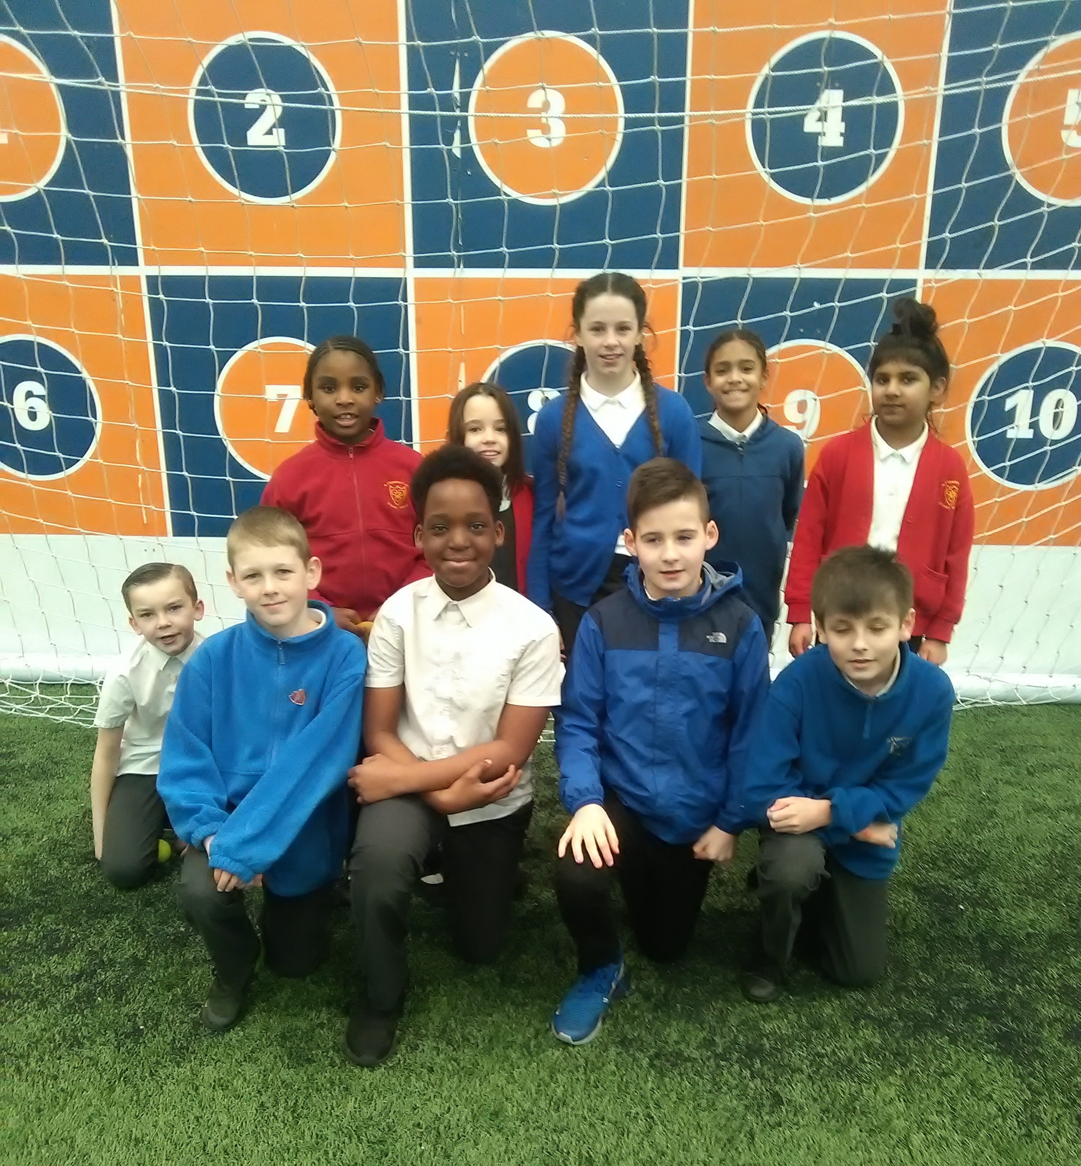

Trip to Early Help Drop in at RHOSEY School- On Wednesday 20th March at 9.45am, Miss O’Connor and I will be organising a mini bus trip to RHOSEY school in Longsight where an Early Help Drop In will be taking place. These drop ins give parent/carers valuable advice and support about activities and agencies that are out there that can support children and families with Special Educational Needs. If you are interested in attending, please speak to myself or Miss O’Connor by Monday 18th March at the latest.

Parent/Carer Evening Appointment Letters- Last week, your child should have brought home a letter for you to book an appointment with your child’s teacher on 2nd and 3rd April. Please can you return the reply slips as soon as possible, as we are setting appointments next week. If you are unable to attend on 2nd and 3rd April, please can you speak to your child’s teacher to arrange a mutually convenient time to meet or a phone consultation. Please let us know if parents require separate appointments also.



Drama Club Performance- Dick Whittington- Wednesday 27th March at 4pm- Mr Nield and the Drama Club have been working hard all year to put on a great performance and its nearly time for them to perform to us! Tickets will cost £2.50 and will be on sale from Wednesday 13th March from the school office. The tickets are on a first come first served basis and there are a limited number of tickets due to fire regulations. The money from the tickets will go towards next year production.
We cannot wait to see it!

Friends of St Clements- FUNDRAISING UPDATES-
Thanks to our Friends Group for organising a cake sale last week and this Monday. Using cakes donated by staff and the Friends Group a total of £73.00 was raised to support all children in school. Thanks for supporting this event.
Coming up later this month- Buy a Gift day on 29th March. Easter Raffle and Easter Colouring Competition too!
We are fortunate to have such a proactive and supportive group of parent/carers in school who are raising funds to support all children. Please speak to Miss Steeles if you want to know more about the group and how you can get involved.

