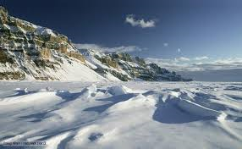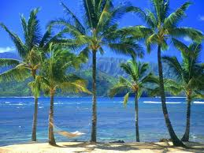

**Year 2 Topic: Fire and Ice**  
Summer term 2019

**Humanities:**

**Geography - Polar and Tropical Regions**

Children are going to continue to examine a globe and think about where the hottest and coldest places are. They will consider why this might be and then look in more detail at these two habitats.

They will be able to identify where the north and south poles are and the Equator.

They will also start to explore what life is like in these two environments.

**History:** Seaside holidays in Victorian times, similarities and differences, how seaside towns have changed

**Questions children want to investigate:**

1. Where are the hot and cold places in the world?
2. What is it like to live in these places?
3. What or who lives there?
4. How do you get to these polar and tropical places?
5. What is Africa like?

-

**Art /DT:**

**DT** – Design and make healthy snacks

**Art –** Making different polar and tropical habitats from shoe boxes (please send one in for your child to use for their habitat box) .

**Art** – Tinga Tinga inspired art work

**PE and Music:**

**Dance and Gym:** Dance based on simple movement patterns

**Music:** Following the Music Express Scheme .

**ICT:**

Branching Databases

Animation

Algorithms – giving instructions

**Science:**

Living things and their habitats.

Food Chains

Plants and factors that affect how plants grow.

**Drama Opportunities:**

Travel and exploration, the lives and movement of animals. Acting out traditional stories / hot seating / freeze framing.

Performing animal poems.

**RE:**

Special Places

**Writing Opportunities:**

Traditional Stories

Character descriptions

Animald from around the world - animal reports

Animal poems inspired by Matt Goodfellow

**Maths and topic links:**

Comparing distances

Measuring and comparing temperature

Time work based around travelling, distances and journeys.