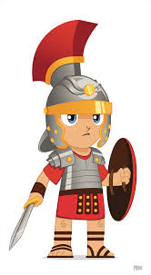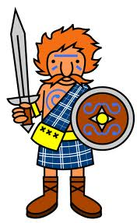u

**Humanities: History/Geography Focus**

* Using maps to locate countries in northern Europe.
* Identifying the countries in which the Romans chose to settle.
* Exploring maps of the UK and locating key settlements of the Romans
* Using aerial photographs and maps to identify archaeological sites left by the Romans
* Identifying and exploring the physical features of Britain that attracted the Romans to Britain (Chester)
* Exploring Roman homes
* Finding out about the role of baths in Roman life

**Year 3 Summer Term Topics:** Roman and Celtic Life

**Art /DT:**

**DT** – Designing, making and evaluating a Celtic roundhouse.

Exploring the construction and use of Roman mosaics

**Art –** Sketching Roman artefacts and archaeological sites, mosaic design and decoration.

**RE:**

Rules for living in Christian and non-Christian faiths

**Questions children want to investigate:**Where did the Romans come from?

Why did they come to Britain?

What was life like during Roman times?

What were houses like in Roman Britain?

What was it like to be in the Roman army?

How do we know about the Romans?

What did the Romans leave behind in Britain?

Who were the Celts?

**PE and Music:**

**Dance:** Movements based on Roman soldiers

**Music:** Using the Music Express scheme.

**Drama/Speaking & Listening:**Creating the ‘Roman Shield’

Role play based around the Roman army

Debate- Was the Roman invasion a good thing for Britain?

**Writing Opportunities:**

Units- Information texts

(Roman Soldiers)

Myths and legends

(Roman Mythology)

Adventure stories

Additional Opportunities

A day in the life of a Roman soldier

**Numeracy Topics:**

* **Fractions**
* **Measures – length, perimeter, time**
* **Geometry – Properties of shapes**
* **Measurement – mass and capacity**

**Science :**

**Plants** – Conditions for growth, plant lifecycles, name the different parts of a plant and discuss their function, investigate how water moves through a plant.

**Forces & Magnetism –** How magnets repel and attract, testing everyday materials, how magnets can attract at a distance.

**Computing: Programming and coding**

Children will focus on applying problem solving skills to direct, write and debug programs