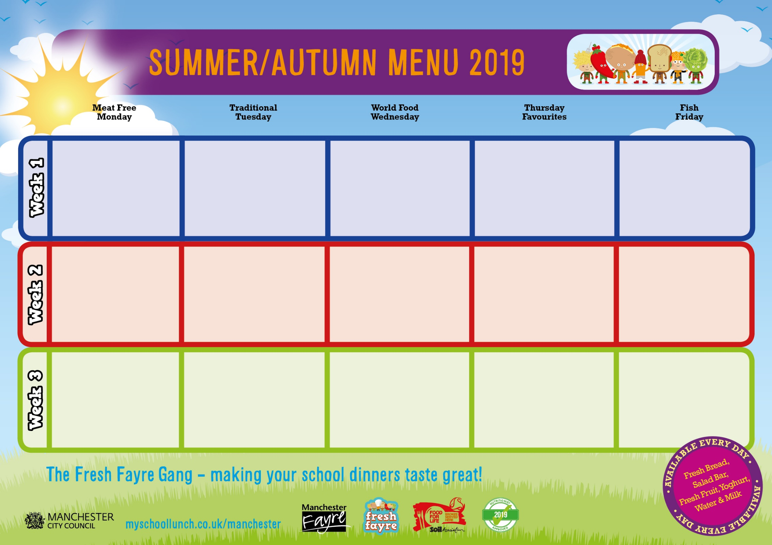

Baked Sausages & Onion Gravy Filled Tortilla Boat Pasta & Sauce Mashed Potatoes Peas Carrots

Fruity Cookie

Seaside Vinegar Salmon Goujon Veggie Sausage Jacket Potato Selection Creamed Potatoes Baked Beans

Arctic Roll with Fruit

Sweet Chilli Chicken Quorn Bites Sandwich Selection Sweet Potato Wedges Crunchy Carrot & Cucumber Sticks Cheese & Crackers with Vegetable & Fruit Sticks

Spring Lamb Pie Cheesy Pasta Sandwich Selection Sliced Malted Bloomer Mixed Vegetables

Fruit Salad with Mango Frozen Yoghurt

Sausage & Bean Hotpot Cheese & Potato Bake Jacket Potato Selection Wholemeal Pasta Tomato Bread Broccoli

Homemade Muffin

Tempura Fish Vegetable Pasta Bake Jacket Potato Selection Chips Peas Garlic Flavoured Bread

Homemade Muffin

Shepherd’s Pie Quorn Fillet & Gravy Sandwich Selection Sliced Malted Bloomer Roast Potatoes Sugar Snap Peas Mixed Vegetables Cheese & Crackers with Vegetable & Fruit Sticks

Cheese & Potato Quesadilla Cheese Flan Jacket Potato Selection Jacket Wedges Baked Beans

Strawberry & Kiwi Mousse

Festive 5 Spice Chicken Vegetable Curry Sandwich Selection Sunshine Rice Mini Corn on the Cob

Chocolate Frozen Yoghurt with Peaches

Birdseye Fish Fingers with Lemon Mayo Dip Veggie Balls in Sauce Jacket Potato Selection Sweet Potato Wedges Peas

Jelly & Fruit

Bolognaise Quorn Dippers Sandwich Selection Wholemeal Spaghetti Naan Bread Baked Wedges Green Beans/ Seasonal Salad Homemade Fruity Cereal Bar

Chicken Curry Quorn Pie Pasta & Sauce Sunshine Vegetable Rice New Potatoes Sugar Snap Peas Mixed Salad

Chocolate & Beetroot Muffin

Cheryl’s Winning Meat & Vegetable Swirl Cheese Omelette Jacket Potato Selection Roast & Mashed Potatoes Spring Cabbage & Carrots Cheese & Crackers with Vegetable & Fruit Sticks

Homemade Pizza Slices

Hot Filled Tortilla Boat

Pasta & Sauce

Baked Jacket Wedges

Mini Corn on the Cob

Blueberry Frozen Yoghurt with Seasonal Fruit Salad

**St. Clement’s**

Homemade Pizza Slices Vegetarian Bolognaise Pasta & Sauce Sauté Potatoes Super Sweet Sweetcorn Wholemeal Spaghetti

Fruit Salad with Yoghurt