





**No Way Through Isn’t True**

**Just because you’ve found something impossible in the past doesn’t mean that it’s impossible today. No matter what problem you encounter there is always a solution and what’s more, you’ll know what it is. If you believe there’s a solution, you’ll keep searching for it. The first thing that makes something impossible is the belief that it is. We are more likely to take risks from a place of love and love of others means seeing the potential in them. Hope springs from love. As we approach problems with hope, we begin to see solutions we hadn’t seen before. There’s always a way through, it might be different to what we originally thought but it’s true.**



**Love** - **1 Corinthians 13:4-7 New International Version (NIV) 4. Love is patient, love is kind. It does not envy, it does not boast, it is not proud. 5 It does not dishonour others,t is not self-seeking, it is not easily angered, it keeps no record of wrongs. 6 Love does not delight in evil but rejoices with the truth. 7 It always protects, always trusts, always hopes**, **always perseveres.**



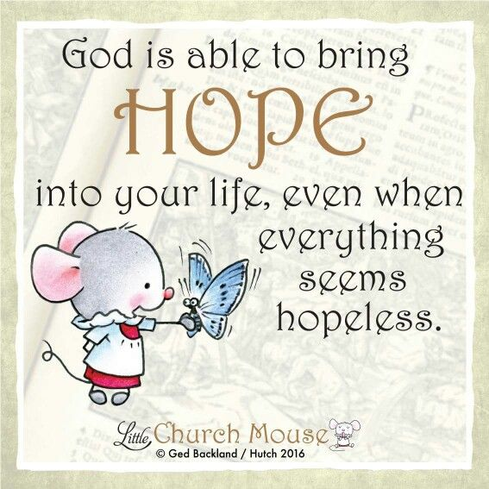

The word "**HOPE**" in the Bible expresses confidence and assurance concerning the future because it's based on God's promises, character and faithfulness. As Will, 10, says, "**Hope** is to look forward to something with a feeling of expectation or confidence. Christians always know they have **hope** because they have God in their hearts."

**Hope** isn't pie in the sky; it's practical, says Justin, 10: "**Hope** is talking to God every day, expecting an answer. **Hope** is having Jesus to talk to. **Hope** is being satisfied with what God has given you."

Every day can be like Christmas morning for Christians who realize the best is yet to come. This kind of **hope** asks questions like "What new adventure does God have for me today?" and "I wonder what God is up to in this or that situation."

"**Hope** is what you believe, but you cannot see it," says Charlotte, 10. Yes, hope and faith are cousins, says Lauren, 9: "**Hope** is faith; it is a thing to help you set your goals. Hope helps you to believe in Christ."

Memorize this truth: "**Hope i**s God's gift to us," says Amal, 10. Yes, God's gift of **hope** is a person: "Christ in you, the hope of glory" (Colossians 1:27).

Some people might ‘place their **hope**’ in technology or modern science, as they see the improvements that these  make to lifestyles, at least in the developed world.  But these advances have not brought progress in the human heart—there is still war and terror, disease, and self serving leaders who neglect their people.

 Christian **hope** is  more than a general expectation that things will get better. It is grounded in the Christian’s understanding of the nature of God:  God is known to be loving and faithful, and there is a confidence that His promises can be trusted.  This confidence in God supports Christians through the greatest suffering.  Christians’ **hope** is a future **hope**, to be with Christ, it is based on God’s promises and salvation through the death of Jesus.  Love and goodness ultimately will; in fact already have; overcome all evil.

**Hope** is linked with faith and love as one of the three gifts of the Spirit in I Corinthians chapter 13 verse 13.

**Hope** -  Christian **hope** is grounded in the character of God. Often, in the Psalms, the writer says to God: ‘My **hope** is in you’. It is a **hope** rooted in the **love** and faithfulness of God. **Hope** is not wishful thinking but a firm assurance that God can be relied upon. It does not remove the need for ‘waiting upon the Lord’ but there is underlying confidence that God is a ‘strong rock’ and one whose promises can be trusted. The writer to the Hebrews describes the Christian **hope** as ‘an anchor for the soul, firm and secure’.