SUBJECT PLANNING & ASSESSMENT GUIDANCE 19 - 20

SUBJECT & LEADERs: Literacy/H St. Hill & J Younge

ASPECT | DESCRIPTION
SUBJECT LEADER GUIDANCE ABOUT WHAT IS REQUIRED IN THIS SUBJECT-  (Eg Frequency of teaching) | - It is recommended English should be taught 5 hours per week and English should continue to be delivered and embedded across the curriculum.  - There may be a need to have additional whole class SPAG sessions.  - It is recommend Guided reading should take place for 2 ½ per week. Shared reading should take place throughout the teaching of English (particularly in phase 1) and across the curriculum.  - There may be a need to have additional whole class comprehension sessions to develop comprehension skills further.  - Spelling should be taught within English sessions, but separate sessions (x 3 15 minute sessions) should be taught weekly to focus on developing specific spelling patterns, which should be applied within writing across the curriculum. Please see our spelling policy for more details about the approach of the teaching of spelling.
PLANNING REQUIRED & ON WHICH FORMAT  (EG SEPARATE FOR FAST MATHS, PHONICS ETC)  MONITORING | We are following the New National Curriculum for English:  Planning requirements in our school for English:  Writing:  - Literacy units Overview of units to be covered within year – to ensure there is coverage of genres.  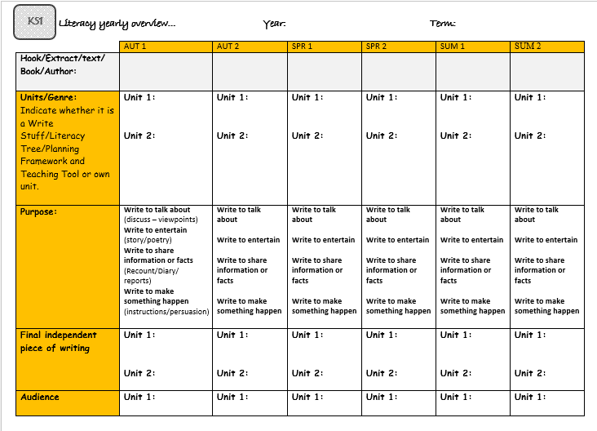  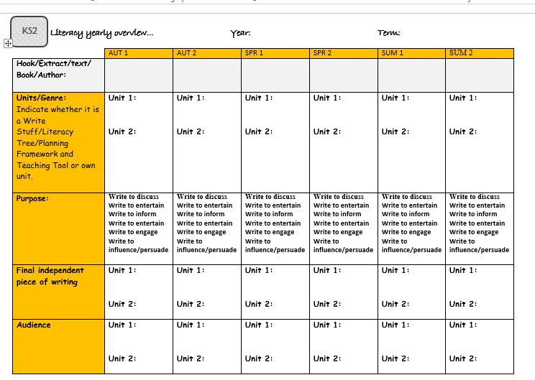  - Learning Journey for unit to show learning writing the three phases:  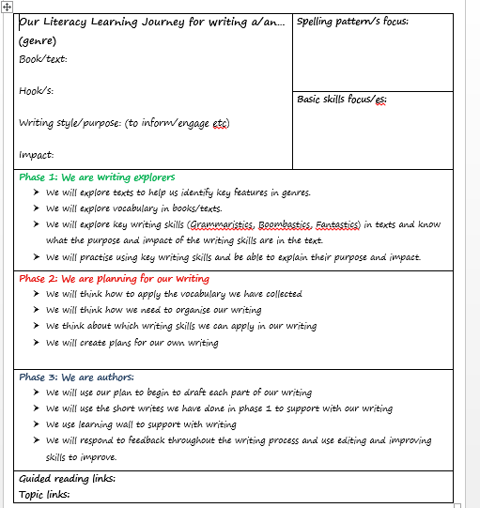  - Guided writing session plans (If needed)  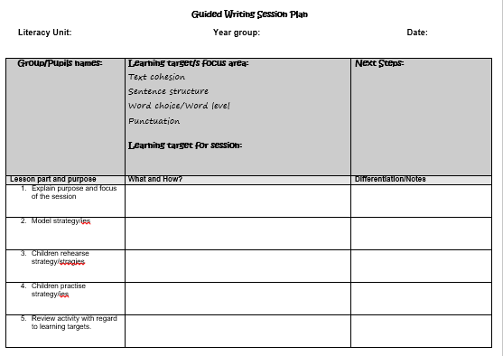  - We are also using strategies from the Write Stuff approach to enhance what we already have in place.  - Teachers can use the Write Stuff plans/Plans from Literacy Tree (need to be purchased) and Planning Framework and Teaching Tool kit to support planning.  - English for more able pupils should be used to challenge more able pupils with their learning e.g for homework (Aspirational Authors challenge books).  (All resources needed for planning can be found in Teachers Only in the folder in Literacy resources 2017/2018/2019)  Handwriting:  - We follow the Martin Harvey writing scheme. Please see specific details in our handwriting policy. (The MH handwriting resources can be found in Teachers Only in the folder: Handwriting )  For focussed SPAG or additional SPAG sessions:  - SPAG session planning sheet (If needed)  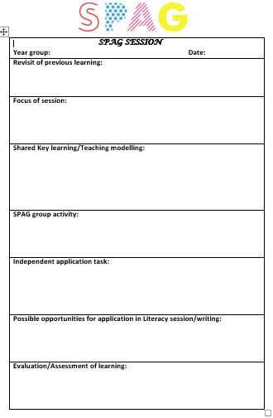  For editing and Improving:  - How we edit & improve St. Clément’s guidance  - Rising Stars Editing and Improving Books  *All planning formats and resources can be found in Teachers Only in the folder named: Literacy new planning resources 2017 2018 2019 and the Rain tree spelling program. Cracking Writing books have also been provided to each year group to support with planning.  Spellings:  - We are still referring to the planning sheets created by Ruth as a guide and the Rain tree spelling program (Spelling plans and Rain tree resources can be found in the folder Literacy new planning resources 2016).  - The spelling plans and sessions from the Rain tree program can be annotated, this is suffice for Spelling planning. Also support for spelling resources for different year groups/focuses can be found in found in Teachers Only in the folder in Literacy resources 2017/2018/2019) these are really useful resources for the delivery of spelling sessions and interactive activities etc.  - Spelling activities/investigations should also be planned for within phase 1 sessions of the Literacy learning journey and across the curriculum – using the spelling approaches we explored in the TT education Spelling training in March 2019.  *Please see the Spelling Policy for more information  Reading:  - When shared reading is taking place it should be shown on the Literacy learning journey and the Reading Gems being focussed on should also be referred to on the journey. Shared reading and the use of the Reading Gems should be embedded across the curriculum to develop reading skills in all areas of the curriculum.  - Guided reading planning sheets by EY2P (If needed).  - Reading assessment by EY2P sheets should be used to highlight Reading Domain (GEMS) focuses for the session/focuses for groups and used to record on.  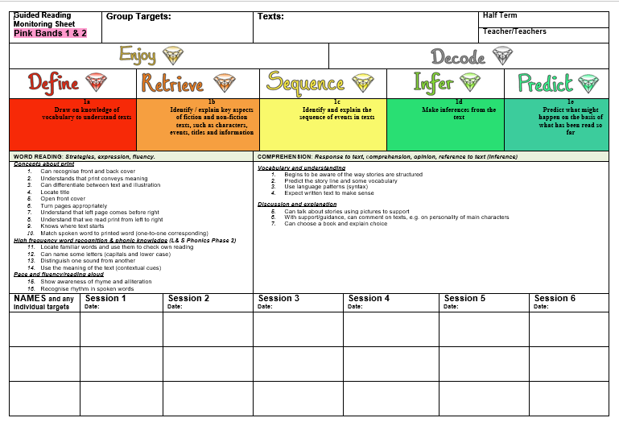  *These plans can be found in Literacy resources 2017/2018/2019 in a file named: Guided Reading Assessment with Gems  - The inference reading folder contains detailed plans, which can be photocopied and used as part as interventions or for inference focussed guided reading sessions. These plans found in the file can be used as they are, or can be edited or annotated or used wholly as a guide. (The file can be found in the Year 5 cupboard and the year 2 cupboard).  - The carousel planning should show the activities each group is carrying out and these should be wholly linked to developing reading skills. Please use Reading guidance created by HSH & JY and also guidance from EY2P to support planning for this.  The Literacy leads will carry out the following monitoring:  - Supportive monitoring through Literacy workshops to look at planning for units.  - Book looks to monitor the Literacy Learning Journey and the effectiveness of task design for each phase of the journey/differentiation.  - Book looks to monitor the implementation of marking and feedback and the impact it is having on pupil’s progress.  - Pupil interviews to monitor pupils’ understanding of the learning in journey for the Literacy units being delivered, if they understand the purpose of each phase and how it helps them with their final piece of writing in phase 3.  - Teaching observations with specific focuses, which will be outlined clearly before observations e.g. PM observations/Observations looking at specific area of English/Observations to look at specific groups within classes.  - During half termly pupil progress meetings for English, progress of pupils will be discussed and English action plans will be looked at to discuss progress towards previously set actions.
ASSESSMENT PROCEDURES IN THIS SUBJECT  (WHAT, WHEN & WHERE TO STORE (PAPER,ELECTRONICALLY ETC) | Writing:  - FS use EY2P exemplars and the foundation stage profile outcomes.  - Writing is ongoing teacher assessment – The Lancashire KLIPS are used for teachers to highlight writing expectations being met. (These can be completed for individuals or for groups)  - KS1 and KS2 use Standards of Testing Agency Interim teacher assessment frameworks for writing to assess pupil’s writing skills at the end of KS1 and 2.  - Writing Moderations take place termly, where teachers work together to moderate writing across the school using the agreed assessment resources.  - Assessment of spelling is ongoing and assessed throughout all writing.  - We do not promote spelling tests in our school as it could affect pupils self esteem if not achieving high scores on tests etc, and agree pupils should be given motivating spelling activities to explore and investigate spelling patterns and understand spelling patterns, rather than just learning spelling by heart. However, there may be times at the teachers discretion where a test to assess application of spellings is needed, these must be carried out sensitively and differentiated appropriately to avoid upset.  - At the end of KS1 and 2, pupils will carry out a spelling test to assess their development of spelling skills from the new curriculum.  Ongoing Reading Assessment:  - Reading assessment forms by EY2P, to be used as an assessment tool to inform planning and measure progress.  - A range of comprehension materials available in school (Year 5 stock cupboard) can be used to assess pupil’s reading development.  End of term Reading Assessments:  - Currently, we are using the NFER Tests to assess reading at the end of each term.  - Year 2 and Year 6 are using CPG Reading Assessments and past SATs papers to assess pupils throughout year 2 and 6.  - KS1 and KS2 use Standards of Testing Agency Interim teacher assessment frameworks for Reading to assess pupil’s reading skills.
ANYTHING ELSE?  (EG useful resources & location of resources) | The Literacy Learning Environment:  - All year groups (FS – Year 6) are following the agreed Literacy Learning wall (Guidance for this can be found in Teachers Only in the folder named: Literacy new planning resources 2016.) Teachers will also be using the Write Stuff approach, therefore teachers will be modelling writing and displaying this around the class.  - The whole school Wonderful Writing Wall is to display any pieces of writing staff want to be celebrated and should be updated at the teacher’s discretion, but regularly – to show the pupils we celebrate writing in our school.  - The whole school Creative Writing displays are updated termly, and display the writing produced Literacy units planned around a book/extract/text or if there has been a whole school writing event worked will be displayed from this.  - Each class should have an organised, child friendly reading area, which they can use at their leisure to take books home for home reading.  Intervention resources:  - Inference reading folder (stored in year 6 stock cupboard – please return when finished with and make sure all resources are put back in the folder in the correct place.  - Rising Stars – On track English: Writing and Grammar Teacher’s Guide  - Rising Stars – On track English: Reading Comprehension  Awards:  - A handwriting award is given out weekly during our awards assembly.  Writing Moderations:  - Take place termly within school – teachers will carry out moderation with the year group’s before teacher and the year group’s above teacher. We use Teacher’s moderation Tool Kit – Prim ed to support with assessing writing accurately across the school. Y2 & 6 will using the writing examplars provided by the government for accurate assessments.  Reading:  - It is non-negotiable all teachers carry out the Big Read every Friday after lunchtime and also take part in reading with the children.  Pupil Progress meetings:  - English pupil progress meetings will take place half termly, to discuss pupil’s progress/discuss progress and impact of actions identified previously.
PLEASE APPEND BLANK PLANNING & ASSESSMENT FORMATS (IF APPLICABLE)

