
“Growing together to let our light shine”
Welcome to your weekly newsletter!! WC 17th June 2019!
Diary Dates-
-17th, 24th June, 1st and 8th July- PM- New Nursery Stay and Play in our hall
-Thursday 20th June- Picnic Lunch
-Friday 21st June- Year 6 Leavers Service at the Cathedral
-Friday 21st June- Year 1 Playgrounds and Picnic in the Park Experience Day
-Monday 24th June- Nursery and Reception Space Experience Day
-Tuesday 25th June- Year 4 Rainforest Food Experience Day
-Wednesday 26th June- Year 1 and 2 to St Anne’s Beach
-Friday 28th June- Year 5 Big Sing at Bridgewater Hall
-Friday 28/06- Sunday 30/06-Year 6 Robinwood Residential
-Tuesday 2nd July- Summer Fair after school
-Wednesday 3rd July-EYFS trip to Julia Donaldson experience at Z-Arts
-Thursday 4th July- Year 3 Roman Art Experience Day
-Thursday 4th July- Year 6 USA Experience Day
-Friday 5th July 1.15pm- Year 6 Basic First Aid training
-Monday 8th July- Wednesday 10th July- Transition to new classes in school
-Wednesday 10th July- EPIC Afternoon tea
-Thursday 11th July- Year 4 trip to Knowsley Safari Park
-Thursday 11th July 5.00-7.00pm- Year 6 Prom
-Friday 12th July 9am- Values awards assembly
-Friday 12th July- Year 6 Parent/carer voice session with governor
-Friday 12th July- End of Year Reports to Parent/carers
-Monday 15th July Sports Morning (OR Tuesday 16th July am if wet)
-Thursday 18th July 9.20am- Year 6 Leaver’s Service at St Clements Church
-Friday 19th July- End of Year Awards

This Week’s Award Winners
EPIC Award- The EPIC award this week goes to Ini in Year 3. Ini always works hard, loves to learn and as a result, has made great progress. She is also caring to others and she is …. EPIC! I look forward to having afternoon tea with you in a few weeks.

Top Table Winners- Nursery-Adriel, Reception-Ryan, Year 1-Julia, Year 2-Noorjahan, Year 3-Holly, Year 4-Maira, Year 6-Mia, EYFS Buddy-Conner.

Experience Pentecost- Miss Naylor organised an Experience Pentecost Event for Y1-6 classes to attend at St Clements Church on Tuesday. Supported by parishioners at St Clements Church, pupils learnt more about what Pentecost is through interesting activities at stations around the Church. It was a great experience and thanks also to Reverend Tom for organising this with Miss Naylor.

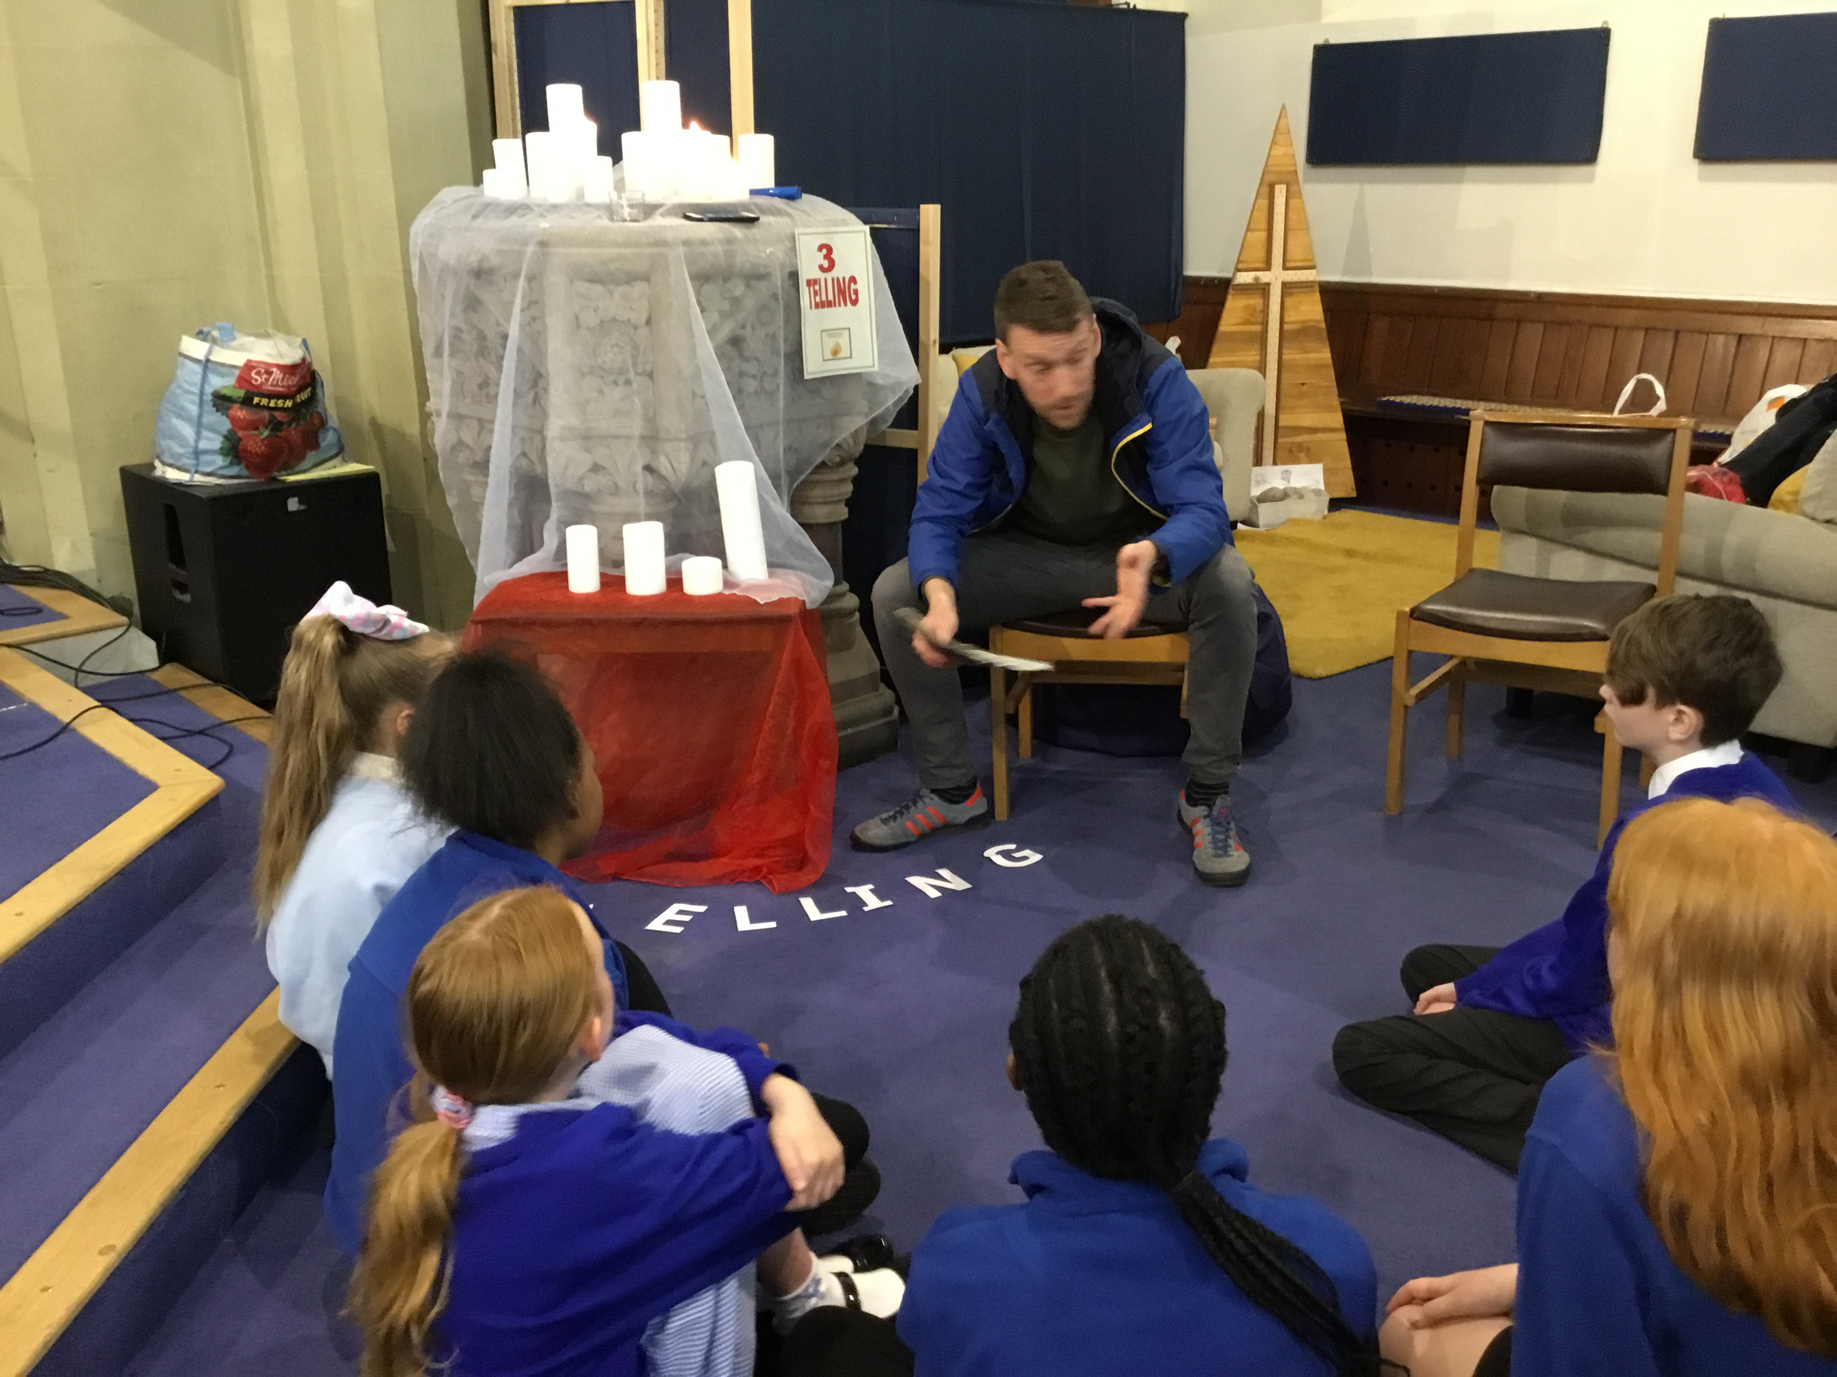
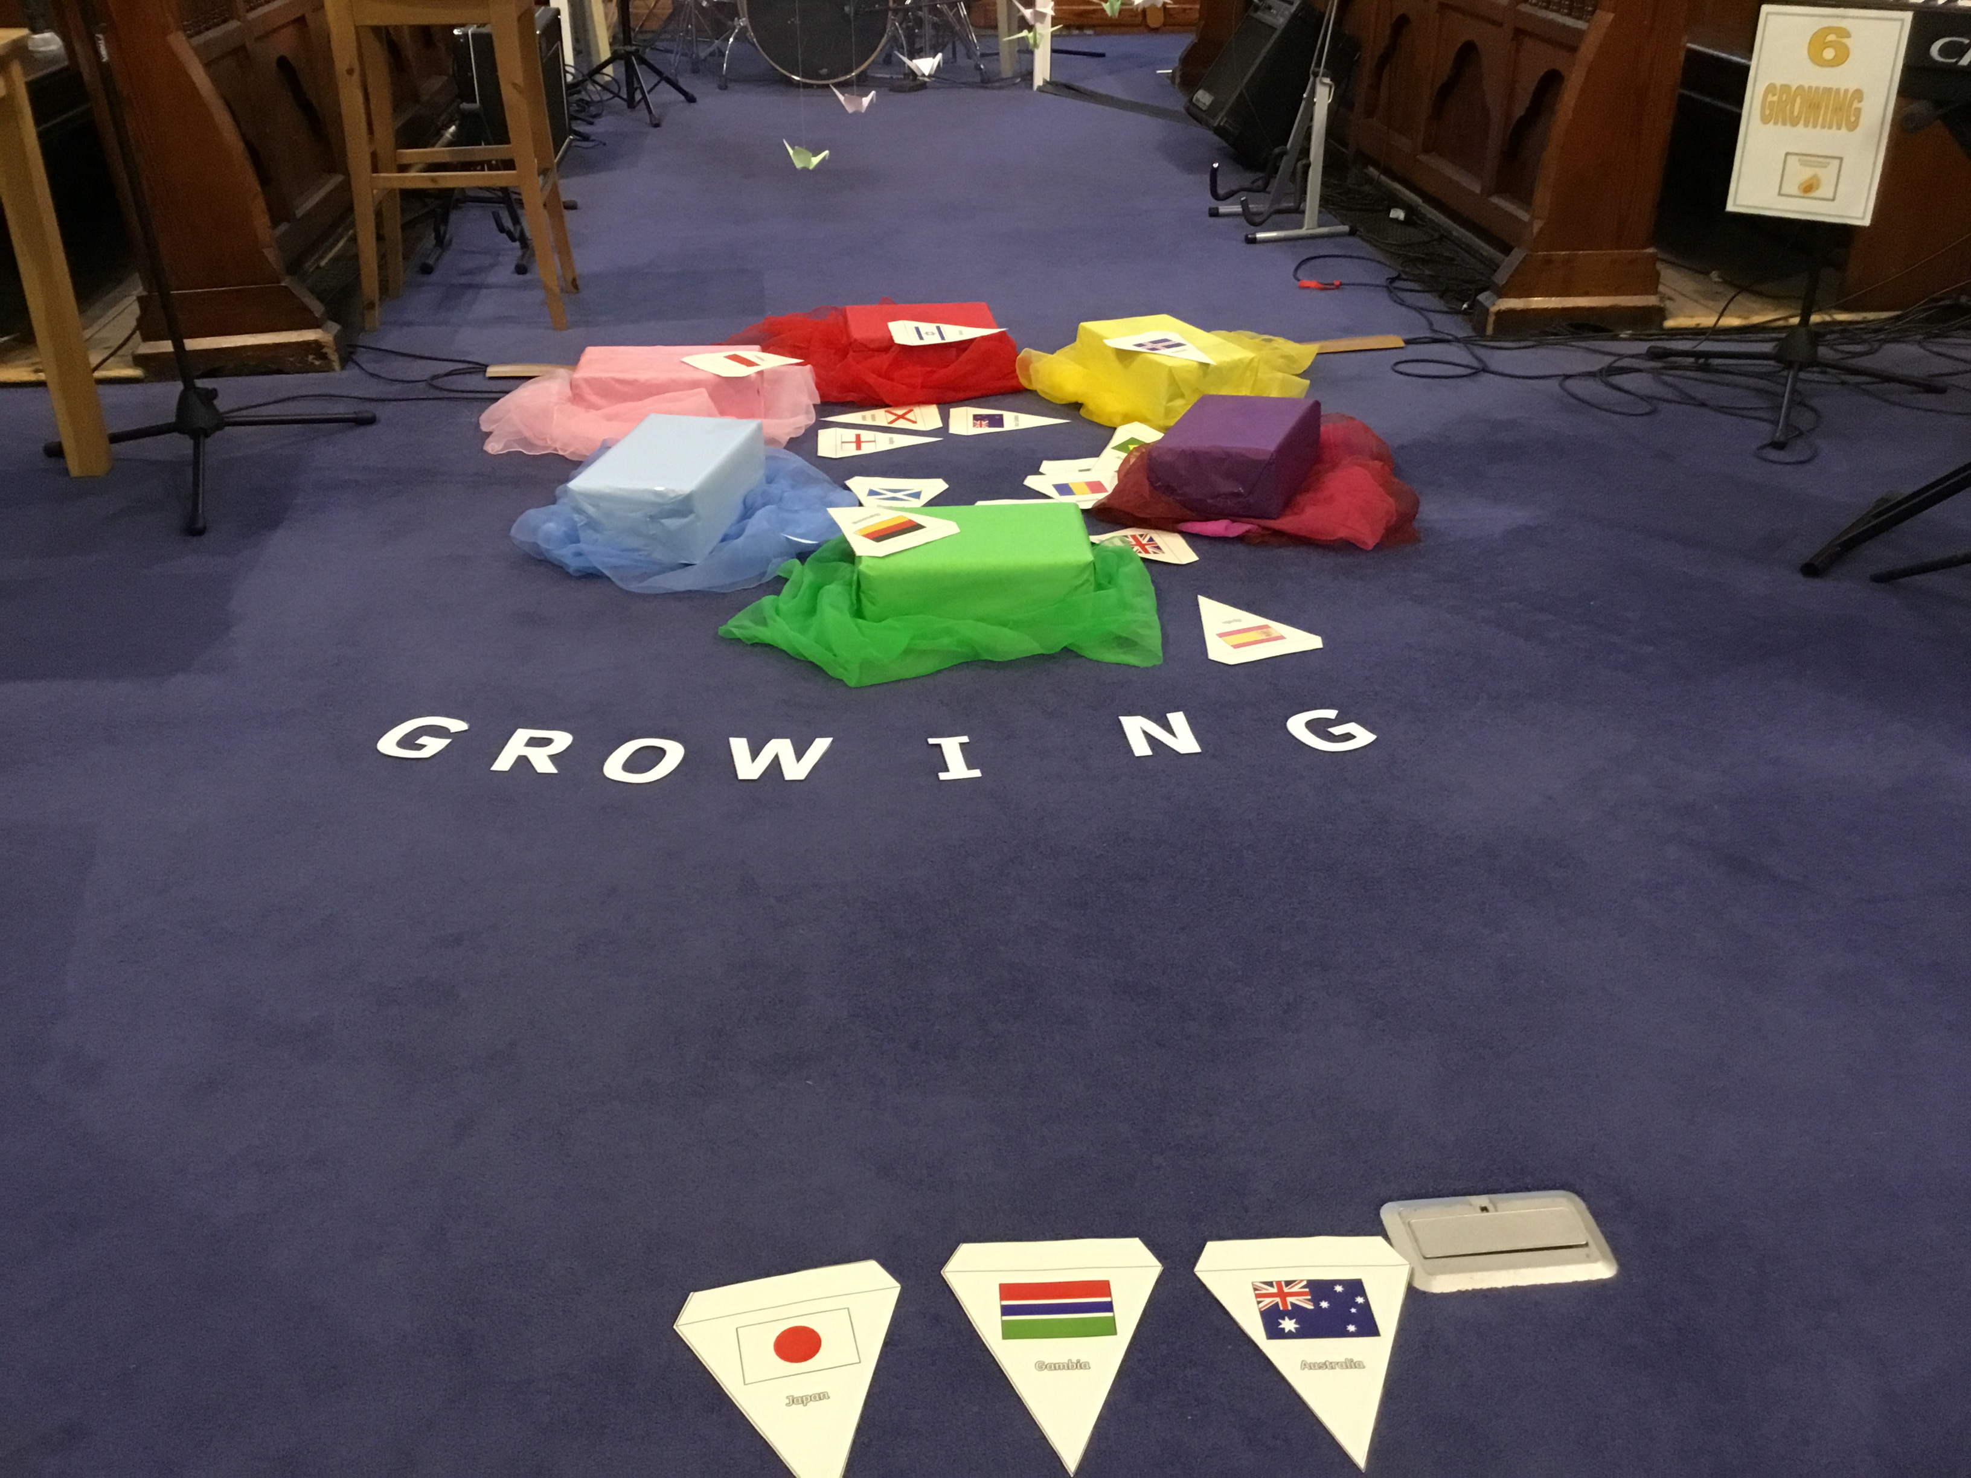

Empathy Literacy Day- Also on Tuesday, the whole school took part in Empathy Literacy Day. As a school, we read a range of books to promote children’s understanding of empathy and through reading, stories and book characters, this will help build our real life empathy! Thanks to Mrs St Hill and Ms Younge for organising this and to the rest of the teaching team for selecting interesting texts.

Friends of St Clements Buy A Gift Events for Father’s Day- On Friday 14th June the friends group organised a buy a gift day again where children brought a gift for £1.00 for a special gentleman in their life for Father’s Day on Sunday 16th June. A total of £107 was raised from the event. Thanks to everyone for their support and the money raised will go towards resources and trips for all children in school.

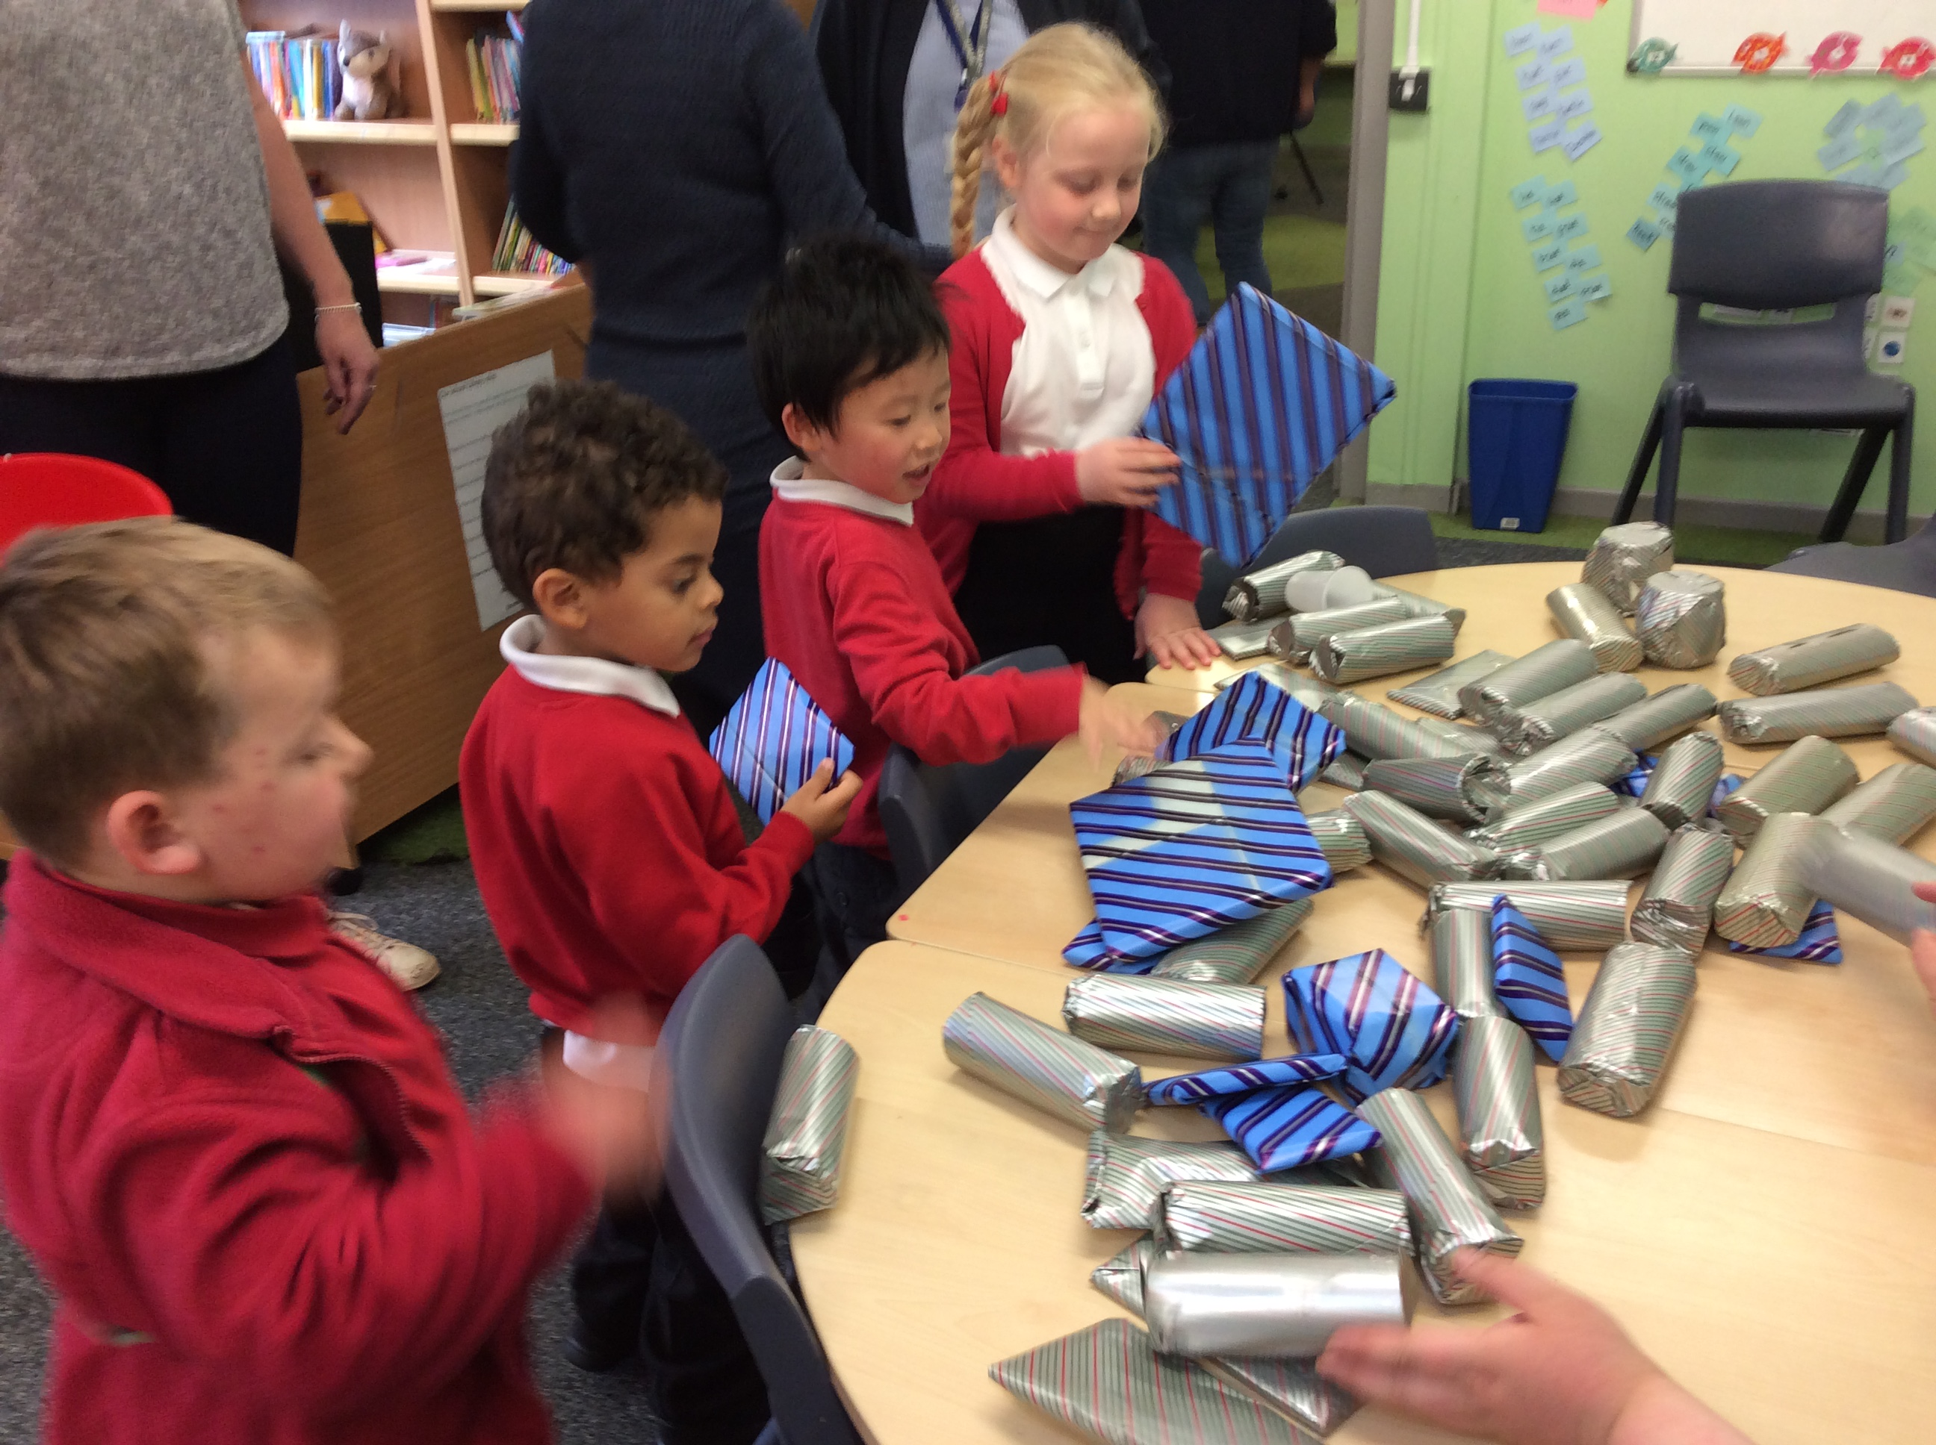
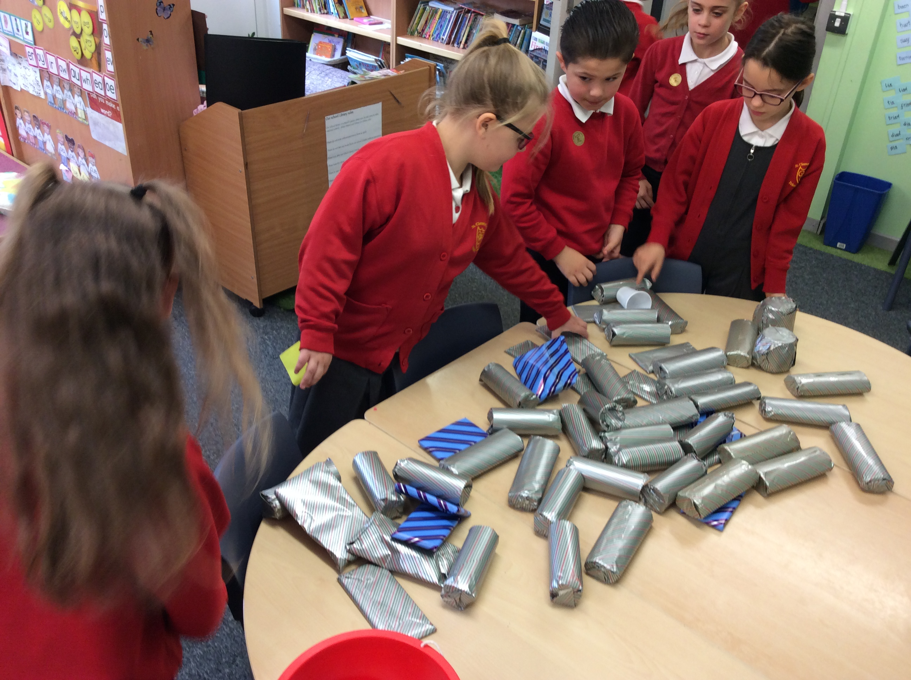

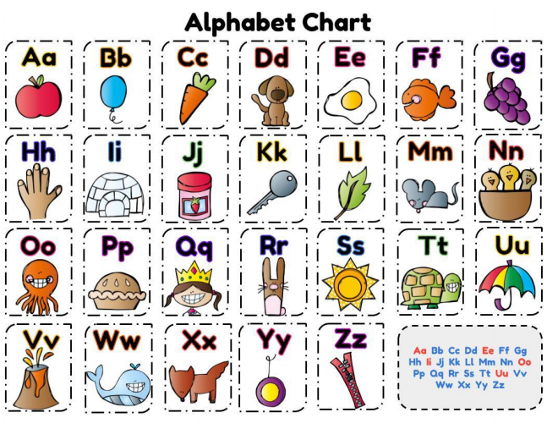

Year 1 and 2 Phonics Screening Checks- Our Year 1 children have made a great start to their Phonics Screening Checks this week in school. We can tell that they have worked really hard to use their phonics skills to read their words. Well done Year 1- we are proud of you!

Coming Up Next Week….

Thursday 20th June- Picnic Lunch- We hope to be able to have our picnics outdoors next week! Children can come to school wearing Sports kit.

Friday 21st June- Year 6 Leaver’s Service at Manchester Cathedral- Our Year 6 pupils and staff will take part in a leaver’s service at Manchester Cathedral to celebrate their great years at Primary School and to think about moving onto the next stage in their life journeys to high school.

