
“Growing together to let our light shine”
Welcome to your weekly newsletter!! WC 20th May 2019!
Diary Dates-
-Week Beginning 20th May- Healthy Lifestyles Week
-Wednesday 22nd May PM- EPIC Afternoon Tea
-Thursday 23rd May 9am in the hall- Year 5 Class Worship
-Thursday 23rd May- Year 4 Rainforest Art Experience Day
-Friday 24th May- Year 5 Magical Cities Food Experience Day
-Friday 24th May 9am- Values Award Worship
-Friday 24th May 3.15pm- End of Summer 1 Half Term
-Monday 3rd June 8.50am- Start of Summer 2 Half Term.
-Wednesday 5th June am Class Photographs
-Thursday 6th June- Year 5 Building Magical Cities Experience Day
-Friday 7th June- Year 2 Geography Experience Day
-Week Beginning 10th June- Years 1 and 2 Phonics Screening Checks
-Week Beginning 10th June- Pentecost Week
-10th, 17th, 24th June, 1st and 8th July- PM- New Nursery Stay and Play in our hall
-Tuesday 11th June- Whole School Empathy Literacy Day
-Thursday & Friday 13th & 14th June- Year 5 Kip in a Ship Residential to London

This Week’s Award Winners
EPIC Award Winner- This week’s EPIC award goes to Leo. Leo always works hard, is respectful, polite and has grown in confidence. Well done on your achievements Leo. You are EPIC!

Well Done Year 6- This week our Year 6 pupils have completed their SATS tests. Staffs in school have been so proud of how they have calmly and confidently approached the tests and they have clearly given their all and done their best. We will wait for the results in July. Thanks also to Mrs St Hill, Mr Thirsk, Mr Neild, Miss O’Connor and Mrs Yadav for your organisation and support of the pupils this week- pupils and staff, all of you have a good rest this weekend!




Help us to Review our Curriculum- In order for us to continually improve the curriculum we provide for your children, we would like your views on what has gone well, what you would like to know more about and how we can make changes to make our curriculum even better for September. Please complete the questionnaire that your child has brought home and please return it to school by Wednesday 5th June. All questionnaires that are returned will go into the prize draw for a Morrisons voucher. If you need help in completing the questionnaire, please ask at the office and the staff or Miss Steeles will be able to help you.

Very Important Parent/Carers Reading Sessions- Thanks to those parent/carers who continue to come into school and read with their child when they receive their VIP invite on Friday afternoons. To thank you, we hold a half termly prize draw of a £10.00 Morrisons Voucher and last half term, the name drawn out of the hat was Henrietta’s mum in Nursery- congratulations! Not only do you get a thank you from us, you are also giving your child valuable time on something that will make a big difference to their future- as we say… THOSE THAT READ, SUCCEED!
We look forward to seeing you in school on Friday afternoons for the VIP sessions.

This week, our youngest pupils in school showed that they are getting into good reading habits by reading at home and earning CLEMS to spend in the CLEMS shop. Well done Nursery- really proud of you!

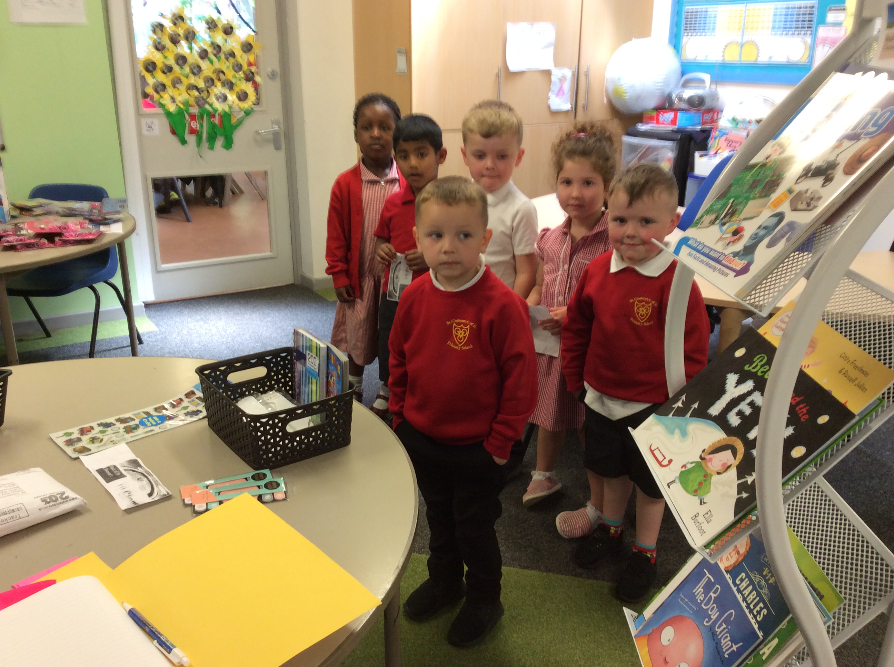



Here comes the Sun- This week, the warmer weather seems to have arrived, so a reminder to send your child into school wearing their suncream and also a named sun hat as it can get really warm in our play areas.
Please ensure that your child is wearing appropriate footwear- strappy sandals are not appropriate for running in or using on our play equipment- we don’t want any accidents!

What’s Coming Up?

Week Beginning 20th May- Healthy Lifestyles Week- Miss Steeles has arranged a number of sessions for our pupils to learn more about how to keep themselves safe and healthy. The sessions include Dental Health for all year groups, Eat well sessions with ABL for Reception up to Year 6 children, I MATTER sessions with the school nurse for Year 5 and 6 children and Mr Nield will also be carrying out a pupil e-safety survey during the week too.

Thursday 23rd May at 9am- Year 5 Class Worship- Year 5 pupils will be entertaining us at their class worship- parent/carers, family, and friends are welcome to come along.

