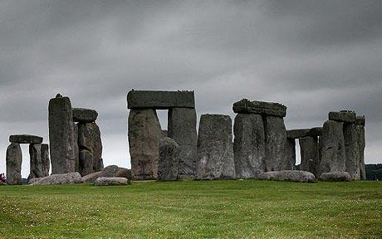

Topic: Autumn term 2019 Year 5

Rock of Ages!

**PE and Music:**

**Outdoor Games:** Invasion games (Hockey, football and netball)

**Music:** Keeping Healthy

Our Community

**RE:**

Jesus the Teacher

Christmas around the world

**Heart smart:**

Get Heart smart

Don’t Forget to Let Love in

**Art /DT:**

* Children will be studying Anthony Gormley as an artist and linking his work with both Stone Age and our science (materials) topic. Children will make natural sculptures.
* Through the Stone Age work, children will be exploring cave paintings and mark making, looking at their relevance in that part of History. Children will be making their own cave painting style images.
* Children will be making primitive clay pots/plates/earthenware in the style of Stone Age pieces.
* Children will be using sewing skills to create art work linked with materials and natural objects.

**Drama Opportunities:** We will be acting out Stone Age living and producing drama around the theme. We will role play newspaper reporters and perform our own poetry.

**Stories/Texts/links:**

Stone Age Boy

**Writing Opportunities:**

Throughout the term we will be looking at and writing Stone Age myths and legends,

Stories from other cultures,

Newspaper articles and

Poetry

**Science:**

**Unit 1:** Material World – children will be exploring different states of matter (solid/liquid/gas) and the properties of materials. There is a heavy emphasis on AT1 (investigation skills)

**Unit 2:** Circle of Life – children will be exploring Life cycles with the plant and animal world (Not humans) Biology based unit.

**Numeracy Links:**

* 3D art with shape and sculpture
* Timelines
* Statistics for science

**ICT:**

Code IT (Scratch)

Children will be learning and practising their programming skills using specialist programmes.

**MATHS LINKS: Problem solving and reasoning, directional language.**

**E-Safety**

Pupils will be taught safely, respectfully and responsibly; recognise acceptable/unacceptable behaviour; identify a range of ways to report concerns about content and contact.

**Geography Focus:**

Children will be looking at how England and Manchester have changed over time.

**History Focus:**

Children will be looking at what life was like for pre-historic man. They will be ordering key events in the stone/iron and bronze ages and discussing the impact that this has had on man through history.

Children will be exploring why settlers settled where they did and what a settlement was like. Thy will also be learning about archaeology and how we find out about early man.

**Questions children want to investigate:**

When was the Stone Age?

What was life like in the Stone Age?

Where did people live in the Stone Age?

What happened in the Bronze Age?

What tools did they use?

What did they eat?