
“Growing together to let our light shine”
Welcome to your weekly newsletter!! WC 30th September 2019!
Diary Dates-
-3/10/19 School council elections
-9/10/19 Y6 Defending the Realm Trip at Tatton Park
-9/10/19 9-10am - Nursery Rhyme/Reading workshop 1
-10 /10/19 Harvest Assembly
-10/10/19 pm Nasal Flu Spray
-10/10/19 2.45pm Reception Writing meeting/learning packs
-11/10/19 9am- Reception Writing meeting/learning packs
-15/10/19 Y5 Anthony Gormley Experience Day
-16/10/19 9-10am - Nursery Rhyme/Reading workshop 2
-16/10/19 9.00am Thank Rev Paul & Tom worship
-16/10/19 Y1 Senses Experience Day
-16/10/19 Y2 DT/Art Experience Day
-16/10/19 Y4 Viking Experience Day 1
-17/10/19 Y5 Tatton Park Stone Age Trip
-18/10/19 Y3 Greek Food Experience Day
-18/10/19 pm Reception- People Who Help Us Experience
-23/10/19 Reception- Y6 Height & Weight Screening
-22 & 23/10/19 PARENT/CARER EVENING MEETINGS
-24/10/19 9.30am Reception Class welcome service at St Clements Church
-25/10/19 9.00am Values award worship
-25/10/19 3.15pm End of Autumn 1 Half term
-Tuesday 5th November 8.50am Start of Autumn 2 Half term

This Week’s Award Winners

Behaviour Jumper winners- Year 1-Eason, Year 2-Andrea, Year 3-Coby, Year 4-Michelle, Year 5-Shafin, Year 6-Safwan.

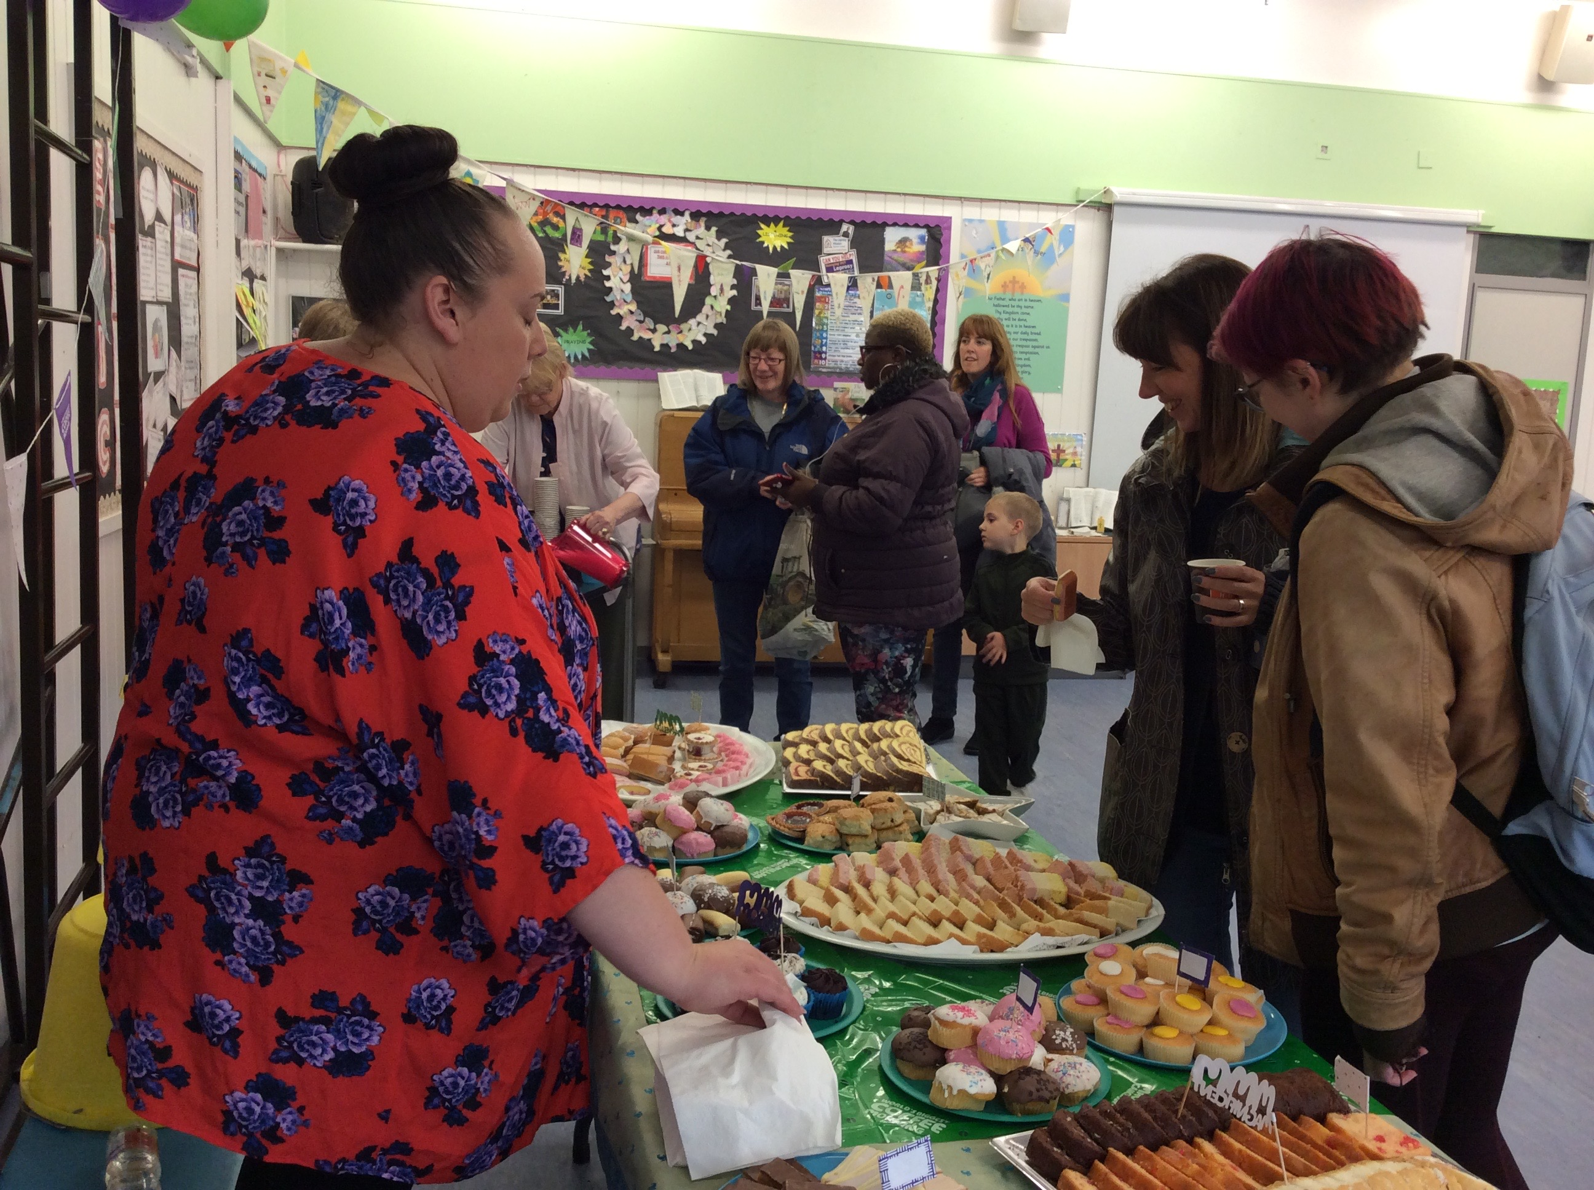
Macmillan Coffee Morning-
This morning we held our annual coffee morning for the Macmillan cancer charity. It is a good event to get together, but to also raise money for this valuable charity that does some fantastic work for those affected by cancer. Thanks to our Friends of St Clements group who organised the event- buying the cakes and serving the refreshments and thanks to those of you who came along to support the event too. A total of £97 was raised so far for Macmillan- thank you!

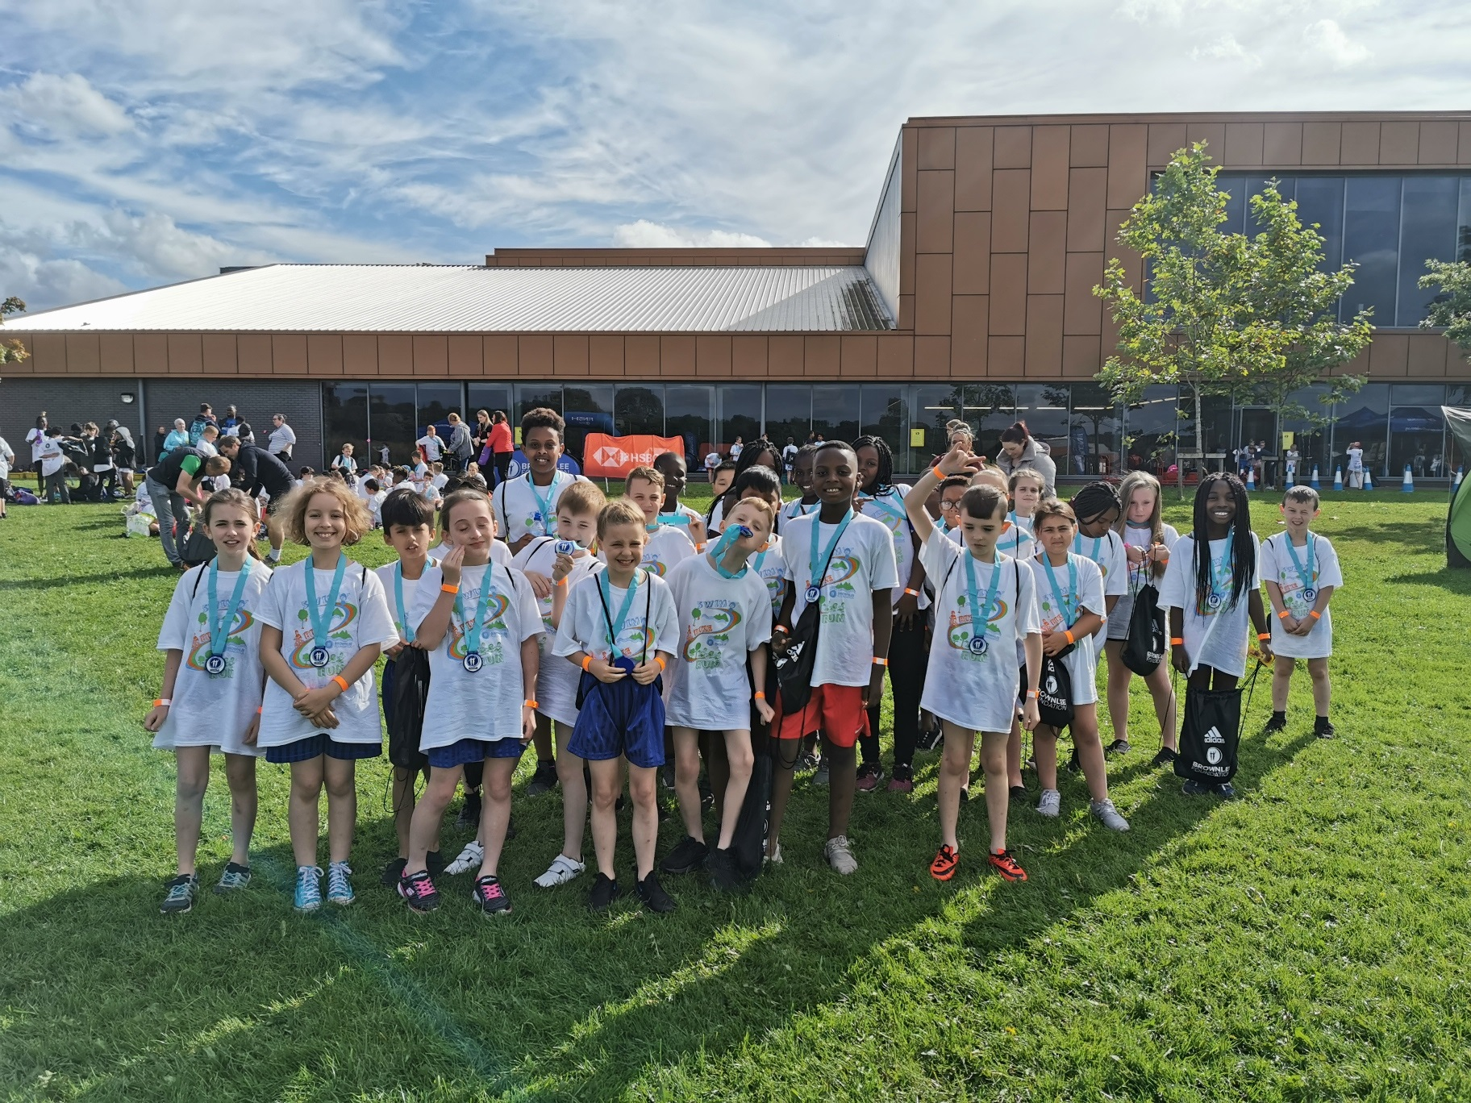
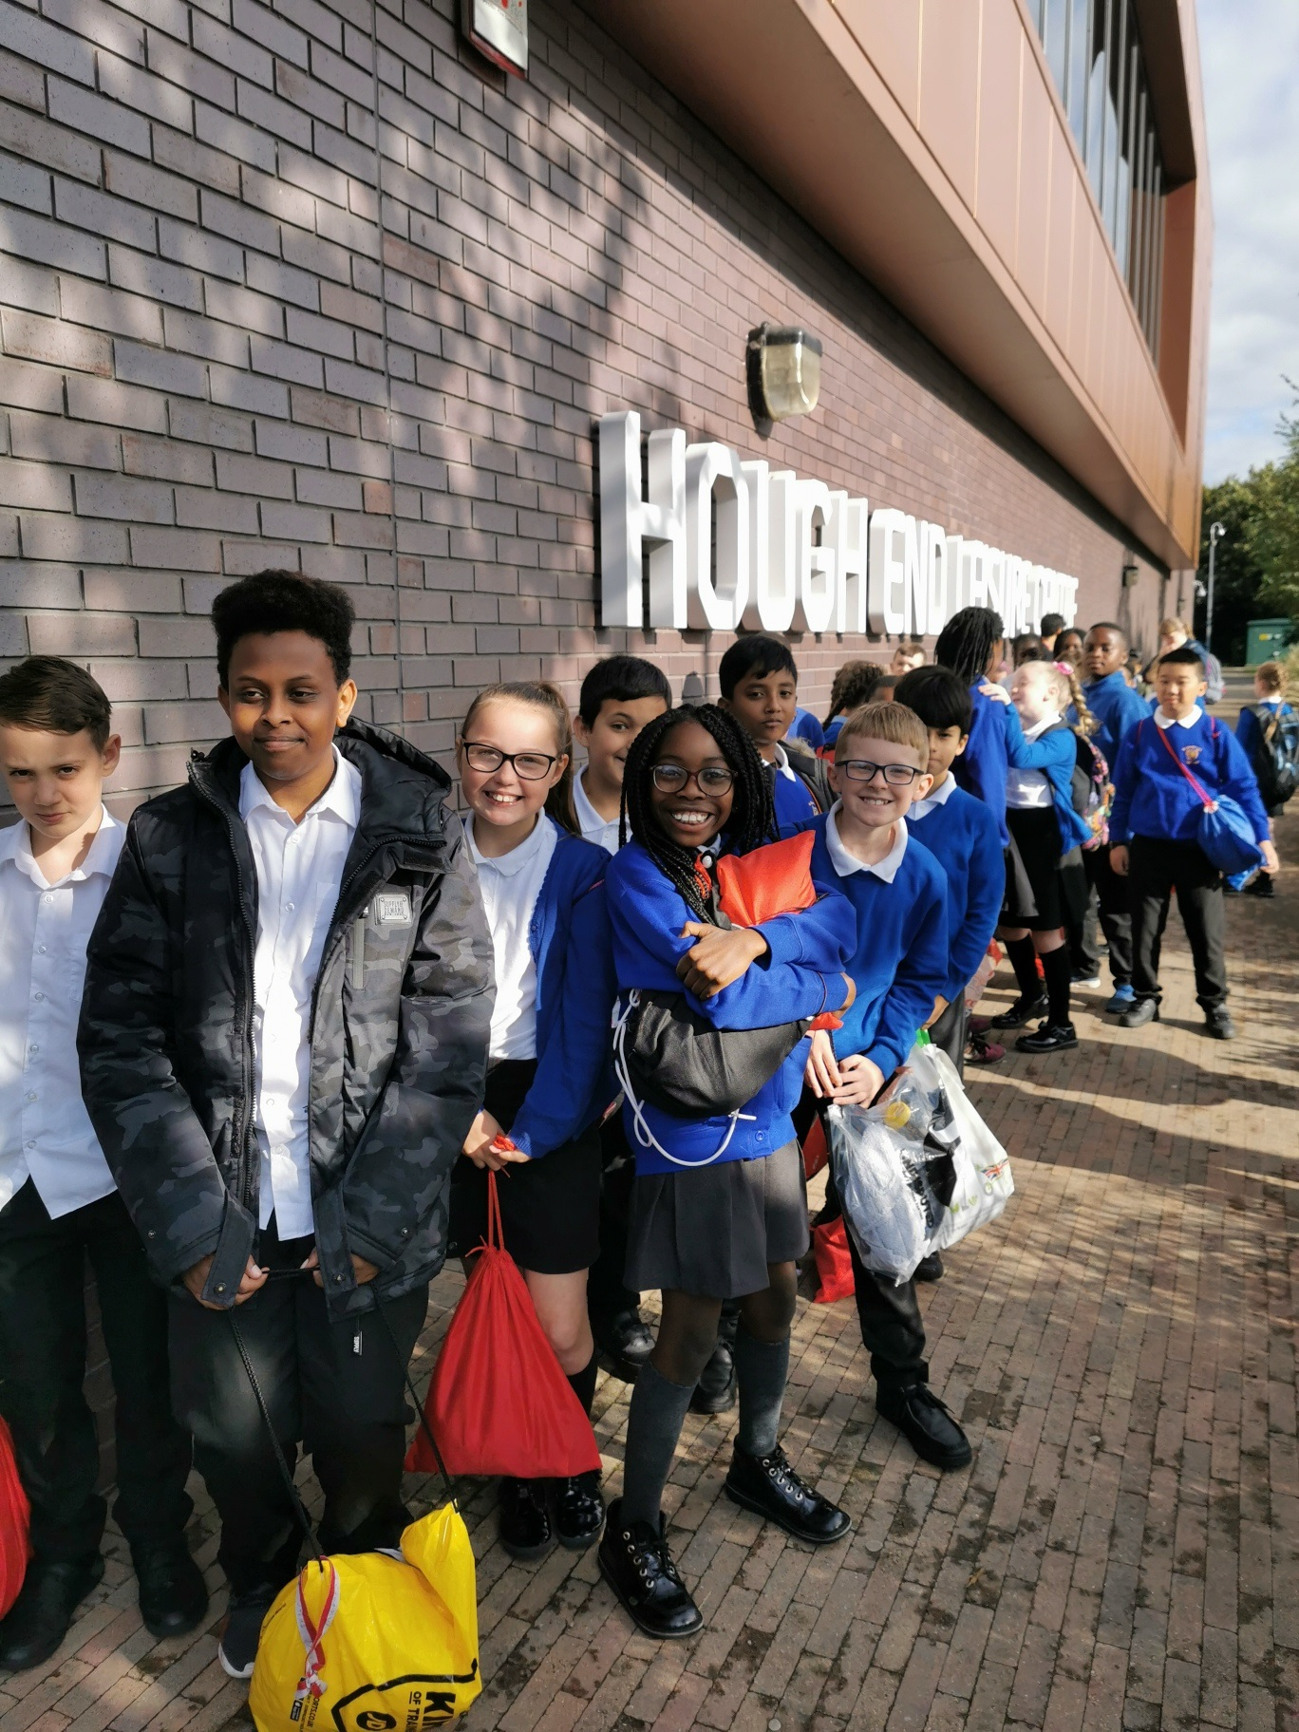
Year 5 Triathlon
On Monday, Miss Male, Miss O'Connor & Mrs Renshaw took Year 5 to participate in the Brownlee foundation triathlon event in Chorlton. The children ran, swam and rode a bike and also got to meet the Brownlee Brothers who are Olympic medal winners!
Miss Male said the class really enjoyed the experience and were cheering one another one as they completed 3 events in just a few hours. The children got medals, t-shirts and swim hats for their participation in the event.

Cross Country Success
More Good Sporting News!! The cross country competition results are in and Ruth and Riley in Year 6 have got through to the city wide final on November 11th at Wythenshawe Park!
As a team, the girls and boys came 5th out of 11- so a good result there too!
So, the long distance training will be starting soon and whatever the outcome, a great achievement for Ruth and Riley and our school- EPIC!!

Year 5 & 6 Tag Rugby Tournament
On Monday night, Miss Male was on her travels again, this time with Miss Thompson and a group of Year 5 & 6 pupils who took part in a tag rugby tournament. They won 2 out of their 3 matches and were also given points for team work, co-operation and resilience. The group enjoyed it so much that they have asked Miss Male if we can have a tag rugby after school club!
Thanks to Miss Male for all she is doing to raise the profile and increase participation of sport in school.
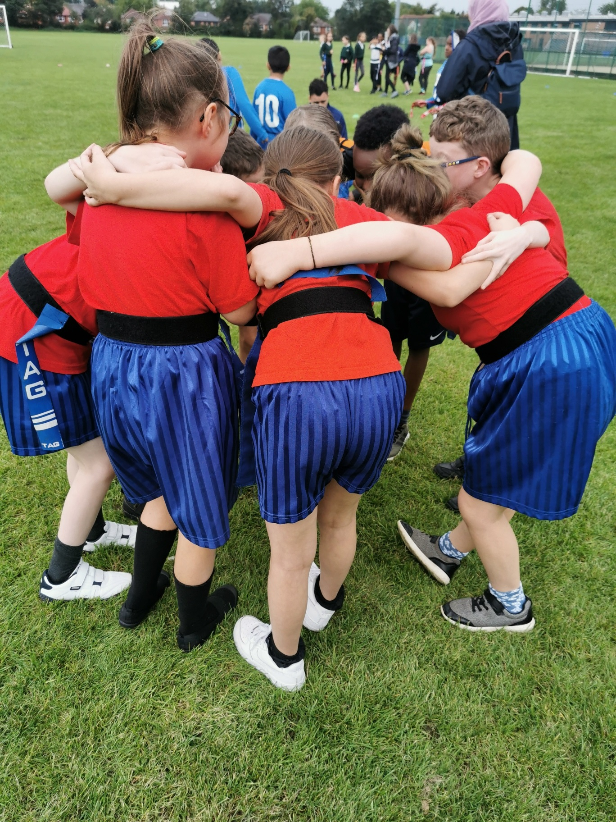
Parent/Carer E-safety- Check your Devices Session
On Wednesday afternoon, Mr Nield & our e-cadet team held a session for parent/carers about making sure their children's devices had the correct settings on them to ensure they were suitable for them to use and not come across any unsuitable content.
We are very fortunate that we have Mr Nield in our school to share his ICT expertise with us and if you were unable to attend the session, but would like further help on this, please speak to Mr Nield or ask at the school office.

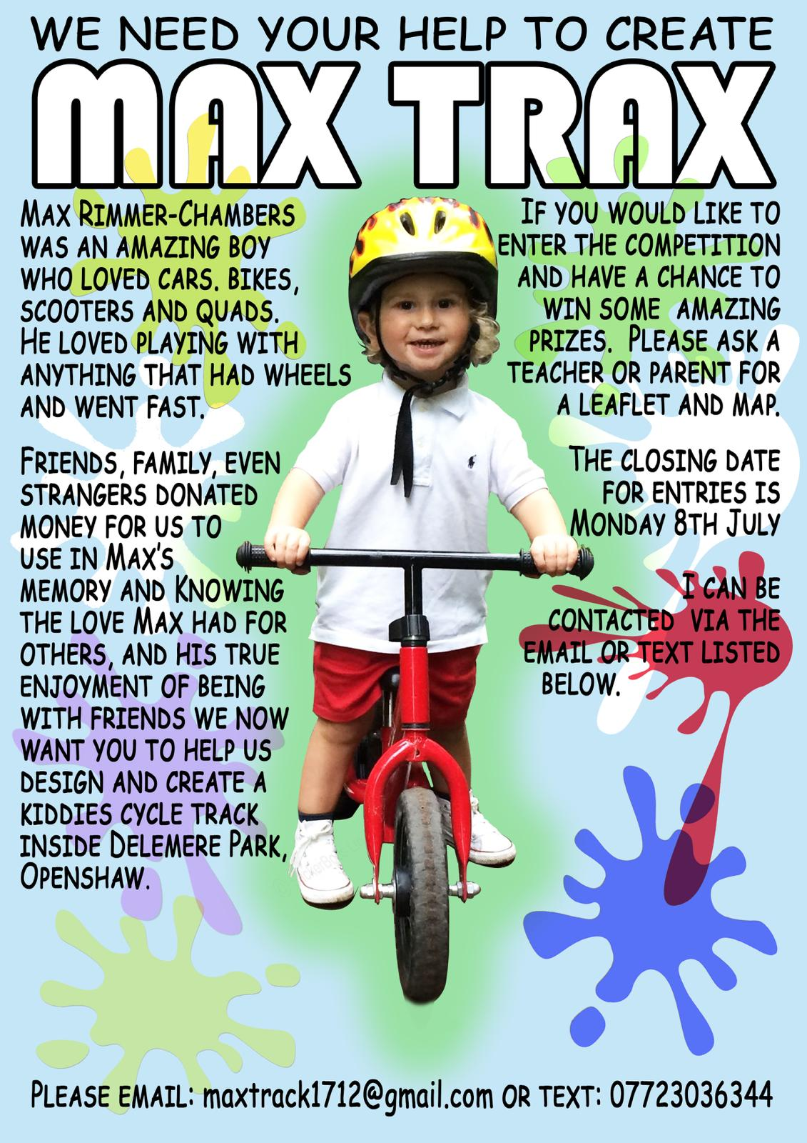
Max Trax Update
This week, we received a lovely letter from Kerrie, Max's mum, to let us know how the development of Max's bike track is going.
The plan is to install a bike track in Delamere Park so that local children can use this great facility whilst it serving as a reminder of how special Max was before he so tragically died a few years ago.
Our Year 1 class when they were in reception, sent their designs to Kerrie and she has informed us that meetings, plans and ideas are coming together. We will keep you updated on the progress of the project.

