**Questions children want to investigate:**

1. Where is Greece?
2. What is Greece like?
3. What food did the Greeks eat?
4. What were their lives like?
5. Why were they important?
6. What did they believe in?

-

**Humanities: The Ancient Greeks.**

We are going to study one of the most developed early civilisations. The Ancient Greek way of life was so advanced that many aspects are still in evidence today such as politics, medicine, sports and education. The children will explore and compare life in Ancient Greece to modern life.

The Ancient Greeks also created some fascinating myths and legends to help them understand their world and we will learn some of these interesting tales.

**Year 3 Topic:** **Autumn 2019**

**The Ancient Greeks**

[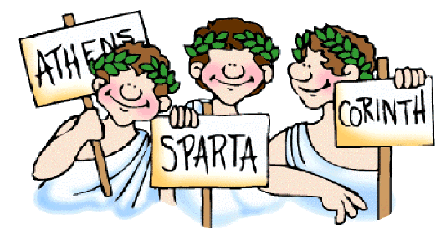](http://www.google.co.uk/url?sa=i&rct=j&q=&esrc=s&source=images&cd=&cad=rja&uact=8&ved=0CAcQjRw&url=http://standrewsmethodistschool.co.uk/year-4-the-groovy-greeks/&ei=XyGMVaTVNeGy7QaY8p9I&bvm=bv.96782255,d.ZGU&psig=AFQjCNFzGBFvAEOYppfNPmxdzBg9Ew1r7g&ust=1435333251857581)

**Art /DT:**

We will look at art, pottery and sketching to discover about the Ancient Greeks. We will look at the design of Greek pottery and attempt some work in this style. We will also look at important buildings such as the Parthenon.

We will also begin to develop our cooking skills with some Greek recipes to try.

**Computing:** Communication

Children will begin to explore how to use computers to present text and images. They will work on the skills of using effects on photos and begin to consider how pictures and text complement each other.

**PE and Music:**

**PE:** Our sports coaches will be working on a range of athletics based disciplines inspired by the Ancient Olympics.

**Music:** Following our school scheme

**RE:**

Using the Blackburn scheme of work:

Harvest /Change the World.

**HeartSmart:** Get Heartsmart! / Don’t Forget To Let Love In!

**Numeracy Links:**

We will focus on building on the skills the children have and moving them on to greater challenges. We will begin looking at:

* Place value to 1000
* Different ways of representing numbers to 1000
* Different methods for addition and subtraction.
* Multiplication tables, including using this in problem solving, particularly x3 and x4

**Drama Opportunities:**

Class Assembly

Re-enacting the first Olympics.

Role playing and acting based on the Greek Gods and other myths and legends.

**Writing Opportunities:**

Information texts about Ancient Greek life, Greek Gods and Goddesses and key events such as the first Olympics.

Stories inspired by Greek Gods, myths and legends.

[](http://www.google.co.uk/url?sa=i&rct=j&q=&esrc=s&source=images&cd=&cad=rja&uact=8&ved=0CAcQjRw&url=http://questgarden.com/97/47/3/100301103814/&ei=oyGMVZfXMKyU7QaGtqmwBw&bvm=bv.96782255,d.ZGU&psig=AFQjCNGGBTHuob2gVv5vFbBxpJBxA6VD2w&ust=1435333386685856)

**Science:** **Rocks & Soils / Light**

Comparing and grouping rocks. Sources of light / Sun & Moon

Testing rocks and describing their properties. Shadows

Exploring soil and how it is made.