
“Growing together to let our light shine”
Welcome to your weekly newsletter!! WC 7th October 2019!
Diary Dates-
-9/10/19 Y6 Defending the Realm Trip at Tatton Park
-9/10/19 2.45pm - Nursery Rhyme/Reading workshop 1
-10 /10/19 Harvest Assembly
-10/10/19 pm Nasal Flu Spray
-10/10/19 9am Reception Writing meeting/learning packs
-11/10/19 9am- Reception Writing meeting/learning packs
-15/10/19 Y5 Anthony Gormley Experience Day
-16/10/19 9-10am - Nursery Rhyme/Reading workshop 2
-16/10/19 9.00am Thank Rev Paul & Tom worship
-16/10/19 Y1 Senses Experience Day
-16/10/19 Y2 DT/Art Experience Day
-16/10/19 Y4 Viking Experience Day 1
-17/10/19 Y5 Tatton Park Stone Age Trip
-18/10/19 Y3 Greek Food Experience Day
-18/10/19 pm Reception- People Who Help Us Experience
-23/10/19 Reception- Y6 Height & Weight Screening
-22 & 23/10/19 PARENT/CARER EVENING MEETINGS
-24/10/19 9.30am Reception Class welcome service at St Clements Church
-25/10/19 9.00am Values award worship
-25/10/19 Friends of St Clements Design a Christmas poster competition for the Fayre
-25/10/19 3.15pm End of Autumn 1 Half term
-Tuesday 5th November 8.50am Start of Autumn 2 Half term

This Week’s Award Winners

EPIC Award-This week's EPIC award goes to....Susie in Year 1. Susie is working very hard in school and she has shown great gardening skills by making our potatoes grow so big! I look forward to seeing you at afternoon tea in a few weeks Susie.

Behaviour Jumper winners- Year 2-Afomiya, Year 3-Charlotte, Year 4-Derron, Year 5-Junior, Year 6-Mia.

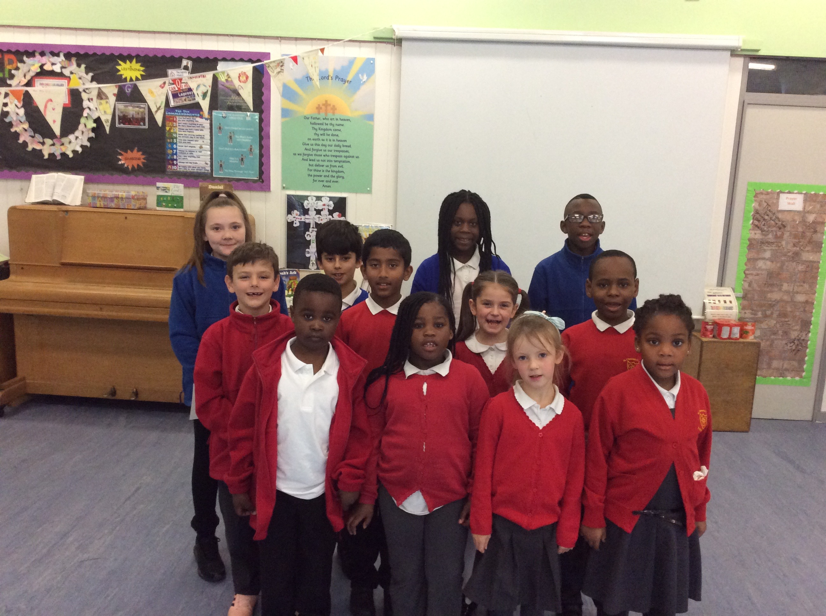
School Council Elections
On Thursday, pupils in Years 2-6 took to the polls to elect their new school councillors. Pupils who wanted to be a school councillor, had to explain their reasons to staff and peers so everyone knew who they wanted to vote for when the polls opened yesterday.
Mr Thirsk announced the successful candidates and I know he is looking forward to working with you all on a number of things that will help improve our school further.

Harvest Donations- This year we are once again supporting the Greater Manchester Winter Night Shelter. We are holding our harvest assembly on Thursday 10t^{h} October and we are asking children to bring in tins of vegetables that the shelter will be able to use to make food at the shelter.

We are doing a competition between the classes to see which class brings in the most tins and that class will get a prize. Good luck to all classes and also thank you to all the parent/carers and children who donate to this great cause.

Update on Mrs Campbell
As some of you may know, Mrs Campbell has not been able to work due to ill health since June. I am pleased to say that she has now had the operation she was waiting for and is recovering at home. We continue to send her our best wishes.

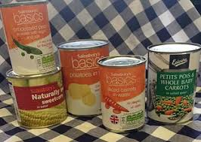

Parent/Carer Evening Appointments
Your child should have bought home a letter inviting you to pick a day & time to meet their teacher to discuss how they have settled in and what we can do together to ensure your child makes progress.
If you haven't got a letter, please ask your child's teacher. If parent's who live separately would like individual appointments, then please ask your child's teacher & this can be arranged.
If you are unable to attend on Tuesday 22nd or Wednesday 23rd October, please let us know and we can arrange to meet you at another time or speak to you over the phone.



Coming up next week....
-9/10/19 Year 6 are off to Tatton Park for their World War 2 trip- Defending the Realm
-9/10/19 2.45pm - Nursery parent/carers are invited to join us to learn more at our Rhyme/Reading workshop
-10/10/19 pm Nasal Flu Spray
-10/10/19 9am & 11/10/19 at 9am- Reception Parent/Carers are invited to join us to learn more about Writing and to pick up learning packs for their child to use at home.

