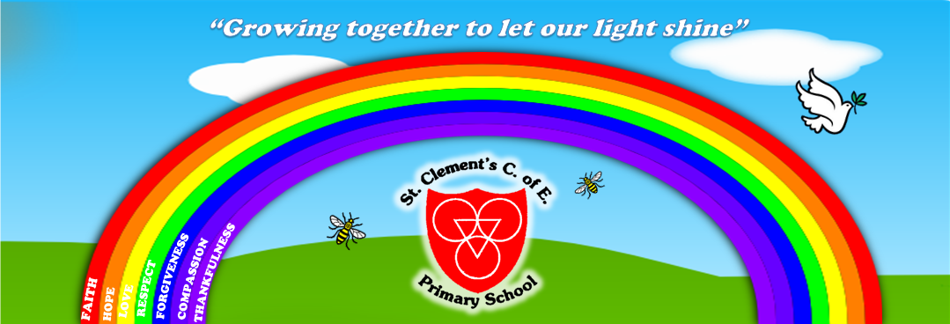
What are we doing in school to learn about Respect?

Each class is thinking about the different ways we can show respect for ourselves, others and our environment. On the Playground we are thinking about treating each other, the equipment and environment with respect. We also show respect when we learn about and take part in ‘Remembrance Day.’ A day to celebrate and remember those who have died in war all over the world.

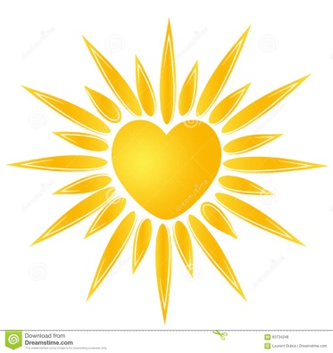
If love feels like the sun…
What colour is it?
What does it feel like?
What does is sound like?
What does it smell like?
‘Lord, help us to be loving every day. Remind us to be patient and kind.’

“Lord Jesus, help us to remember to put other people and their feelings first”
Love
Love is patient, love is kind.
1 Corinthians 13:4
Love is at the heart of the Christian faith. The love of God is boundless and never fails. Jesus tells us to love our neighbours as we love ourselves. Sharing God's love with everyone is very important in our daily lives.

Respect
Whatever you wish that others would do to you, do also to them.
Matthew 7:12
Showing respect for others is essential in our daily lives. It means being aware of and understanding differences in religion, race, age, gender, opinions and beliefs. Everyone is unique and precious to God and therefore deserves to be treated with respect at all times.

BE HEART SMART!!

HOW ARE YOU GOING TO LET YOUR LOVE OUT?
We need...
Pens, Pencils, Notepads, Peanuts, Teabags, Coffee, Packets of tissues, Biscuits and Chocolates,toiletries.
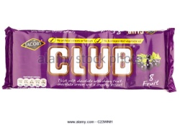
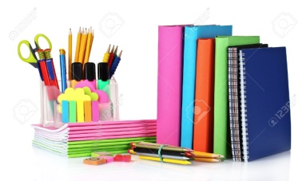
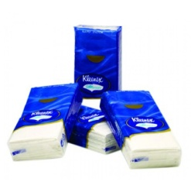
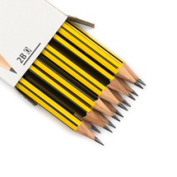

This year we are supporting Manchester Night Shelter and St. Clement’s Court.
Jesus said, ”DO TO OTHERS AS YOU WOULD HAVE THEM DO TO YOU.” Luke ch 6v31
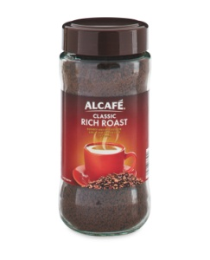
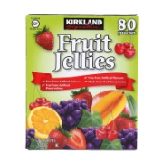
This year we are once again showing our school Christian Values to our neighbours.
