**Maths – Number and SSM**

**Expressive Arts and Design (exploring and using media and materials, being imaginative)**

* Making puppets.
* Junk modelling- moving toys e.g. robots and cars.
* Phase 1 phonics – Instrumental sounds and action songs
* Observational drawing and painting bears.
* Dance and Movement- The Bear Hunt.
* Small world and role play.

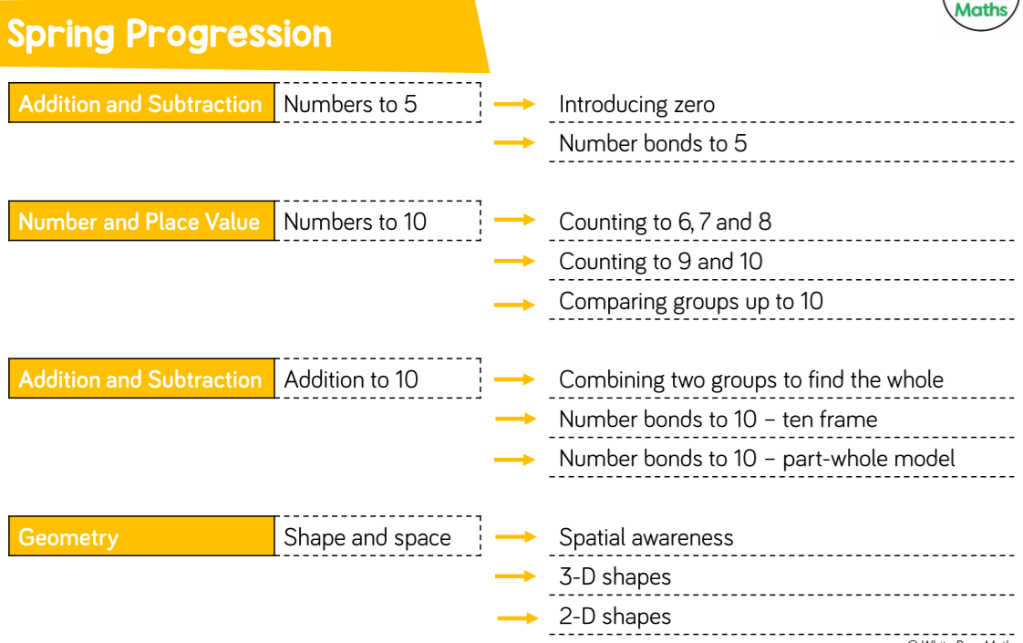

**Understanding the World (people and communities, the world, technology)**

* Sorting and grouping toys
* Exploring how toys work
* Weather, seasons and seasonal change
* Baking and food preparation- Teddy Bears Picnic
* Investigation- Food, change and decay (Porridge, toast, picnic food)
* ICT- remote control toys e.g. cars and beebots
* Retrieving information from computers about toys and bears
* RE- Stories Jesus Heard- The Bible Key Old Testament Stories Inc: Daniel, Jonah, Joseph, Moses

**Physical Development (moving and handling, health and self-care)**

* Developing and improving fine and gross motor skills during indoor and outdoor play.
* Observing the effects of activity on our body.

**Literacy (reading, writing)**

* Stories about toys and bears (Goldilocks and the 3 Bears, We’re Going on a Bear Hunt, Kipper’s Toybox )
* Non- fiction texts about toys
* Rhyming texts- This is the Bear, Teddy Bears Picnic
* Daily phonics session- Phase 3 letters and sounds.
* Guided reading sessions using reading gems.
* Guided and supported writing sessions- Focus on sentence composition and structure. captions, lists, invitations and recipes
* Writing opportunities throughout the environment.

**Communication and Language (listening and attention, understanding and speaking)**

* Developing speaking and listening skills at circle times and with talk partners.
* Vocabulary and language development through our “Write stuff” lens approach.
* Asking and answering simple questions- who, what where, why and how.
* Understanding and responding to instructions/directions
* Recall and reflection times e.g. holiday and weekend news
* Talk about our favourite toys/teddy bears
* Discussing stories, characters, settings and main events and making predictions.

Role Play

* Toy shop
* Teddy Bears Picnic
* Three Bears House

**Personal, Social and Emotional Development (making relationships, self confidence and self-awareness, managing feelings and behaviour**

* HEARTSMART- Too much selfie isn’t healthy (I love others, friendship)
* Christian Values- Love and Compassion

**Topic: Toys**

**Spring 1 2020 (Reception)**