**Geography: World Weather**

We will use our locational knowledge to locate the cities and countries of the world and use the 8 points of the compass.

We will study the different weathers that affect the world and their causes and effects.

We will explore why some places have weather that is similar to ours in the UK and why some places have different weather.

We are going to choose a country in Europe to focus on and find out what the weather is like there.

We will learn about extreme weather and the natural disasters that can occur.

We will visit Chill Factor e to experience extreme cold.

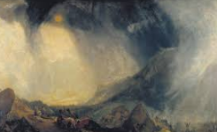

**Year 3 Curriculum:** **Spring 2020**

**World Weather**

**Questions children want to investigate:**

1. Where does weather come from?
2. Why does is rain?
3. What happens when a volcano erupts?
4. Why are some places hot?
5. Why is the weather different in different places?
6. Where is snow from?

-

**Computing:** CodeI.T. / SortI.T.

Children will begin to explore how to use computers to make a simple set of instructions and to test them.

Children will plan and begin to develop a simple database that can be used to answer simple questions.

**Art /DT** We will:

Continue to explore primary, secondary and tertiary colours, how they can be mixed and what effect they can have in artwork.

Explore how the weather can be depicted in art and plan and develop our own artwork based on the work of JMW Turner and Hokusai.

In DT we will explore how the weather affects the food that people in different places eat and trying recipes from other cuisines.

We will design and make a wind turbine.

**PE and Music:**

**PE:** Our sports coaches will be working on a range of outdoor games throughout the term.

**Music:** Following our School Scheme .

**RE:**

Lent and Easter Joy and Sadness

**HEARTSMART:**

Too Much Selfie Isn’t Healthy!

**Drama Opportunities:**

Exploring natural disasters and the impact on people.

Linking weather to movement.

Literacy work - linked to ‘The Flood’.

**Writing Opportunities:**

Narrative writing based on ‘The Flood’ by Alvaro Villa

Persuasive text - holiday brochures.

**Numeracy Links:**

**Learning the 3x, 4x, 8x tables**

Multiplication & Division

Measurement – Money

Statistics

Measurement – Length & Perimeter

Fractions

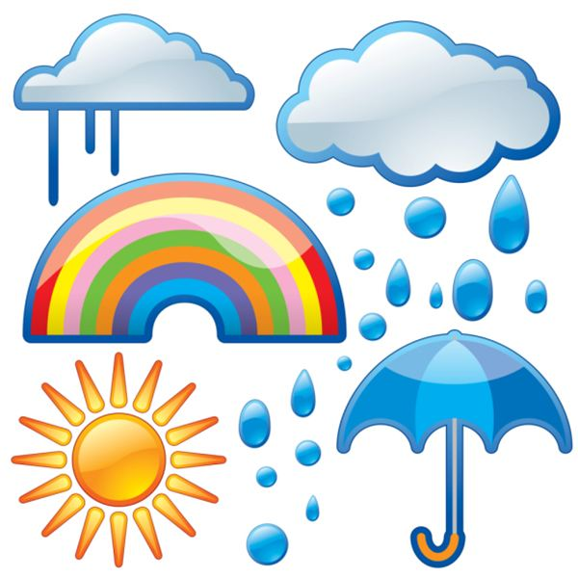

**Science:**  **Food and our bodies**

Animals including humans: Bones

Biology: Plants

**Languages:** The children will learn vocabulary, stories, songs and formulate sentences about being ‘Animals’ and ‘Food’.