serving Jesus

**Art /DT:**

**Art –** Studies of portraits and self-portraits, using different media to create images.

Children will access a range of art and design resources independently to make pictures and models.

**Questions children want to investigate:**

What are our senses and what do they do?

What are the different parts of my body called?

How tall am I? How long are my legs? How many hops can I do in one minute?

What changes will I see in Autumn?

What changes will I see in Winter?

What colours will I see in Autumn?

Why is the weather cold in Winter?

-

**Challenges:**

***Throughout this term the children will be given lots of opportunities to work independently on challenges in our indoor and outdoor classrooms. These will include:***

Water

Sand

Malleable

Creative

Construction

Investigation

Reading, Writing & Maths Challenges

Topic: Year 1 All About Me Autumn 1 and 2 2020

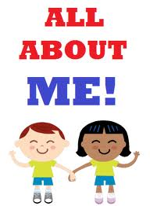

**Science:**

Humans

Seasonal Change – Autumn & Winter

**Writing Opportunities:**

All literacy this term will be directly linked to the topic.

All About Me – lists of favourite things, labelled pictures of ourselves and our families, captions for a display of pictures from our trip; A story based on a naughty character; Instructions for washing hands / cooking / other everyday processes; Using our senses and writing poetry based on what we see, hear, smell, touch and taste**.**

**ICT:**

Getting to know IT

(basic skills)

**Drama/S&L Opps:**

**Role Play: Home Corner / Bus**

**Stories/Texts/links:**

Lists, Labels and Captions

Stories with Familiar Settings –No David, David Goes to School and Fleabag

Instructions – washing hands / cooking

Senses Poetry

**PE and Music:**

**Dance:** children will be using simple movements to create dances.

**Gym:** Apparatus work

**Music:** Music Express

**Maths**

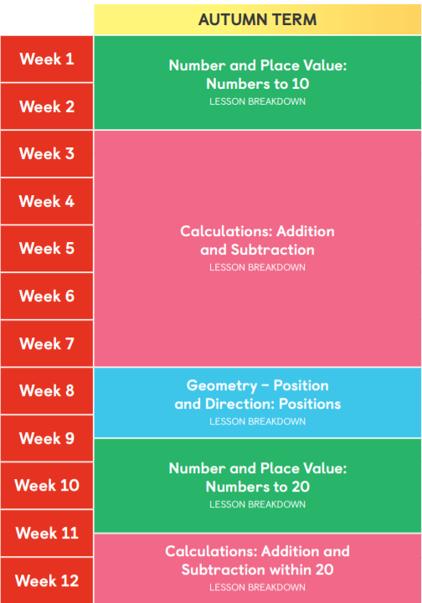

**RE:**

Harvest

Baptism

Christmas Gifts

Heartsmart:

Get Heart smart

Don’t Forget to Let Love in