
“Growing together to let our light shine”
Welcome to your weekly newsletter!! End of Autumn 1 Half Term 2020
Diary Dates-
-Friday 23rd October - School closes for half term holiday

-Tuesday 3rd November- Start of Autumn Half Term 2
-Tuesday 3rd, Wednesday 4th & Thursday 5th November- Y5 Bikeability
-Friday 6th November am- Y6 to Abbey Hey cenotaph
-Tuesday 10th November- Individual & sibling photos
-Wednesday 11th November Reception (poss Nursery) Welly Walk
-wb 16th November NATIONAL ANTI BULLYING WEEK ‘UNITED AGAINST BULLYING’
-Wednesday 18th November Y1 5 Senses Experience day
-Thursday 19th November pm Nasal flu vaccinations for pupils in R-Y6
-Tuesday 24th November Nursery Experience Day- Families
-Tuesday 24th November Reception Experience Day- When I Grow Up



Reception Class Welcome Service

On Wednesday, our Reception Class Welcome Service was different than usual in that we had to hold the service in the Reception Classroom instead of in St Clements Church or our hall with our families and friends.
Despite the change, the children enjoyed the special video message from St Clements Church and joined in a song that the church had recorded too. We all prayed and sent special wishes to our reception pupils for a happy and successful time in our school over the years to come.

Each child then received their own Bible and everyone clapped one another as Mrs Parker called out the names.

To finish, each class also sent a gift to welcome our reception class- beautifully made cards, nice books to read and a plant to look after too!

Here are some photographs from the service:

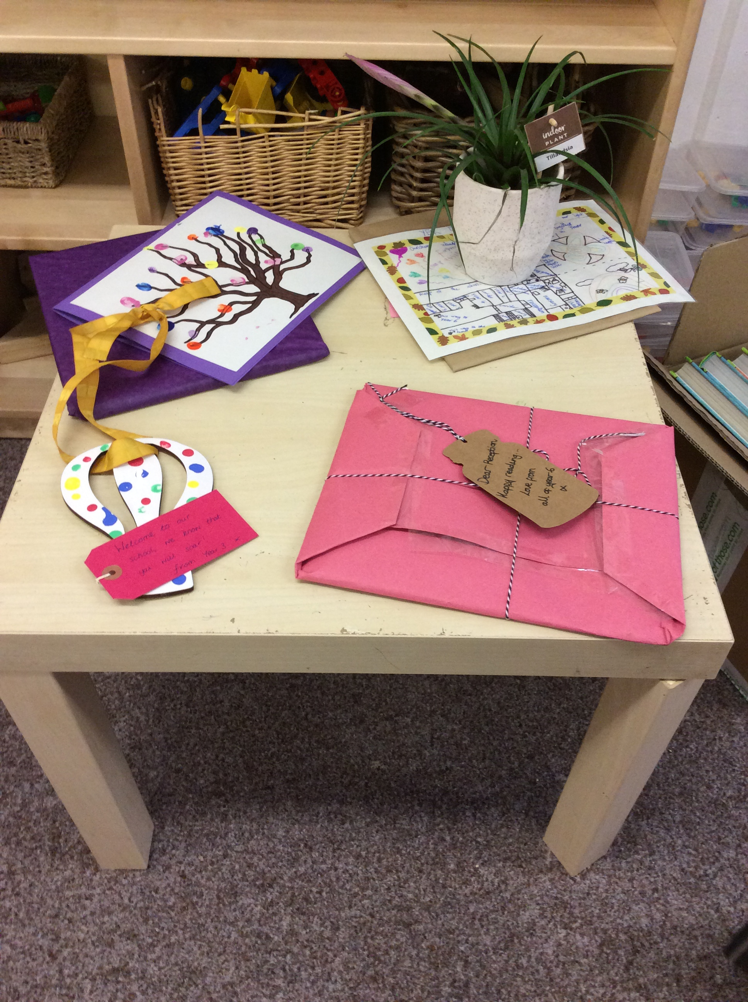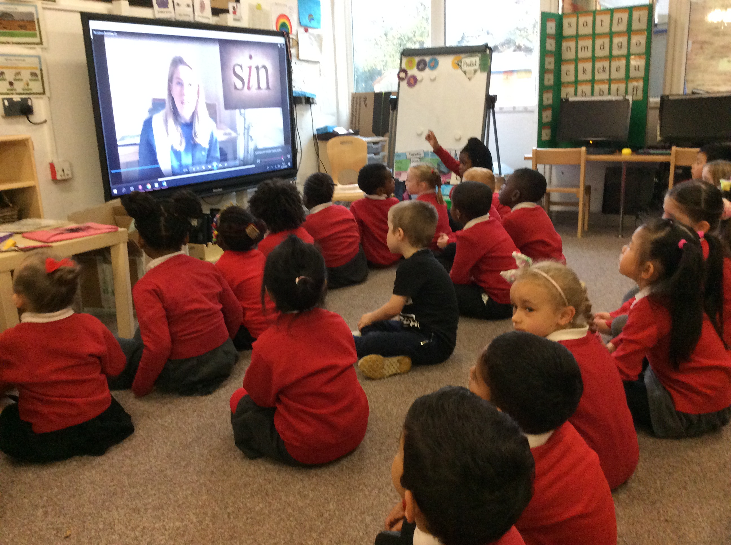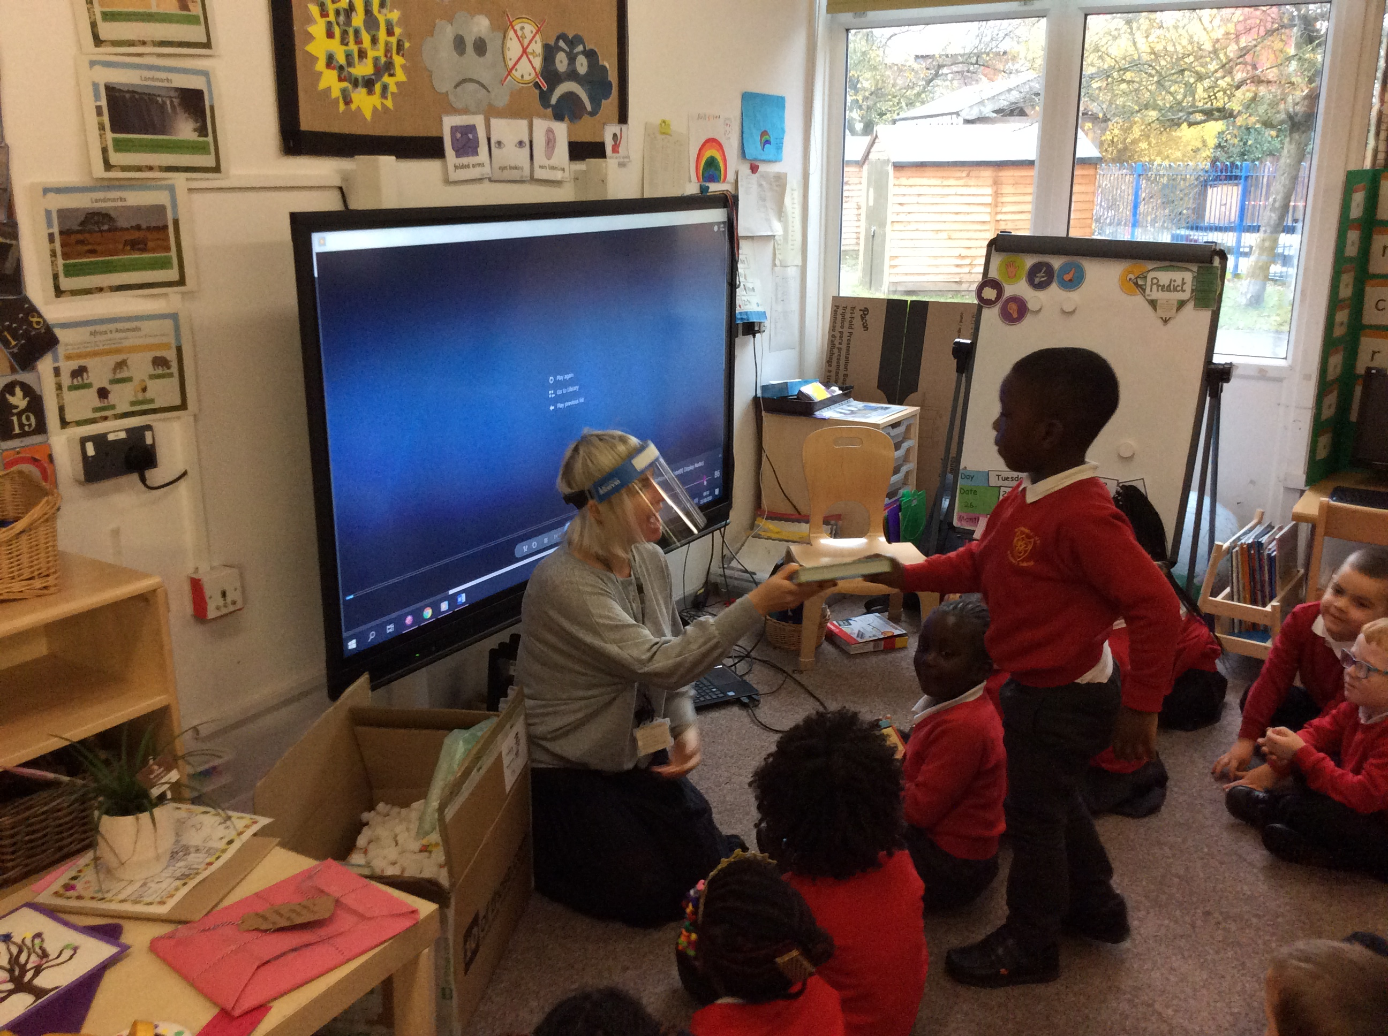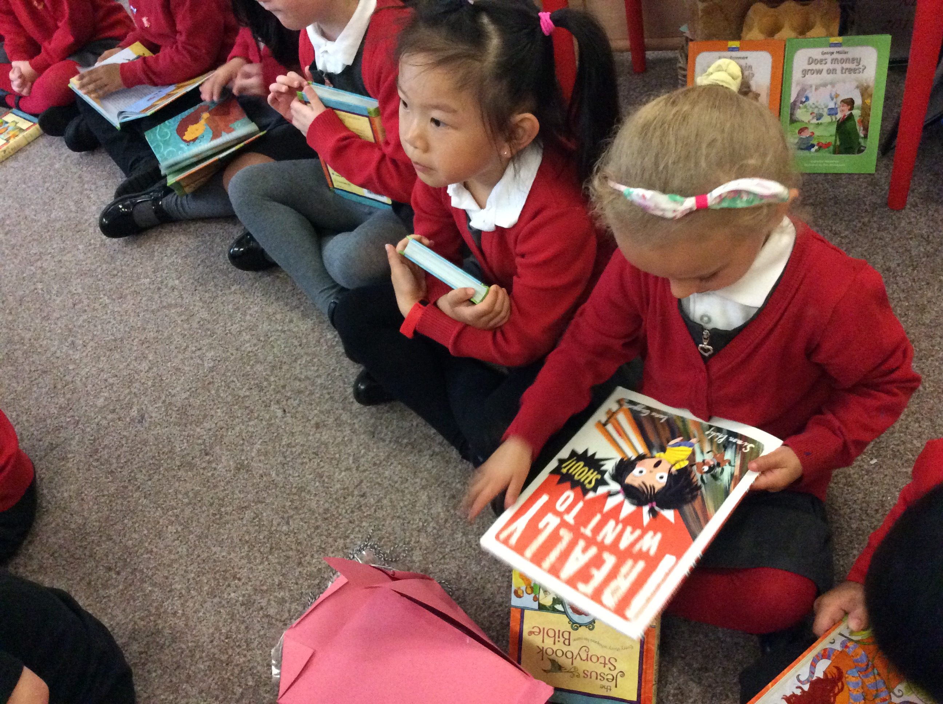



This Week’s Award Winners:
As it is the end of a half term, we award those pupils who have demonstrated our Christian Values of Thankfulness and Love through their actions towards others. Well done to you all!

Value awards winners: R – Matias and Fatoumata, Year 1-Erla and Lakeisha , Year 2- Vojta and Mya, Year 3- Elizabeth and Andrea, Year 4-Isabelle and Mia, Year 5-Prince and Michelle, Year 6- Cherif and Bousso.
Lunchtime winners: R – Elim, Year 1-Adriel , Year 2- Alfie, Year 3- Matthew, Year 4- Brandon, Year 5- Crown, Year 6- Rhys.

.



Thank Your Vicar Week
We have also had to change the way we have said thank you to Reverend Paul and Daniel this year! Instead of holding a worship to present them with their thank you cards and gifts for all they do in our school & community, they have collected them from the office.
Here's a photo showing what each class made for them.
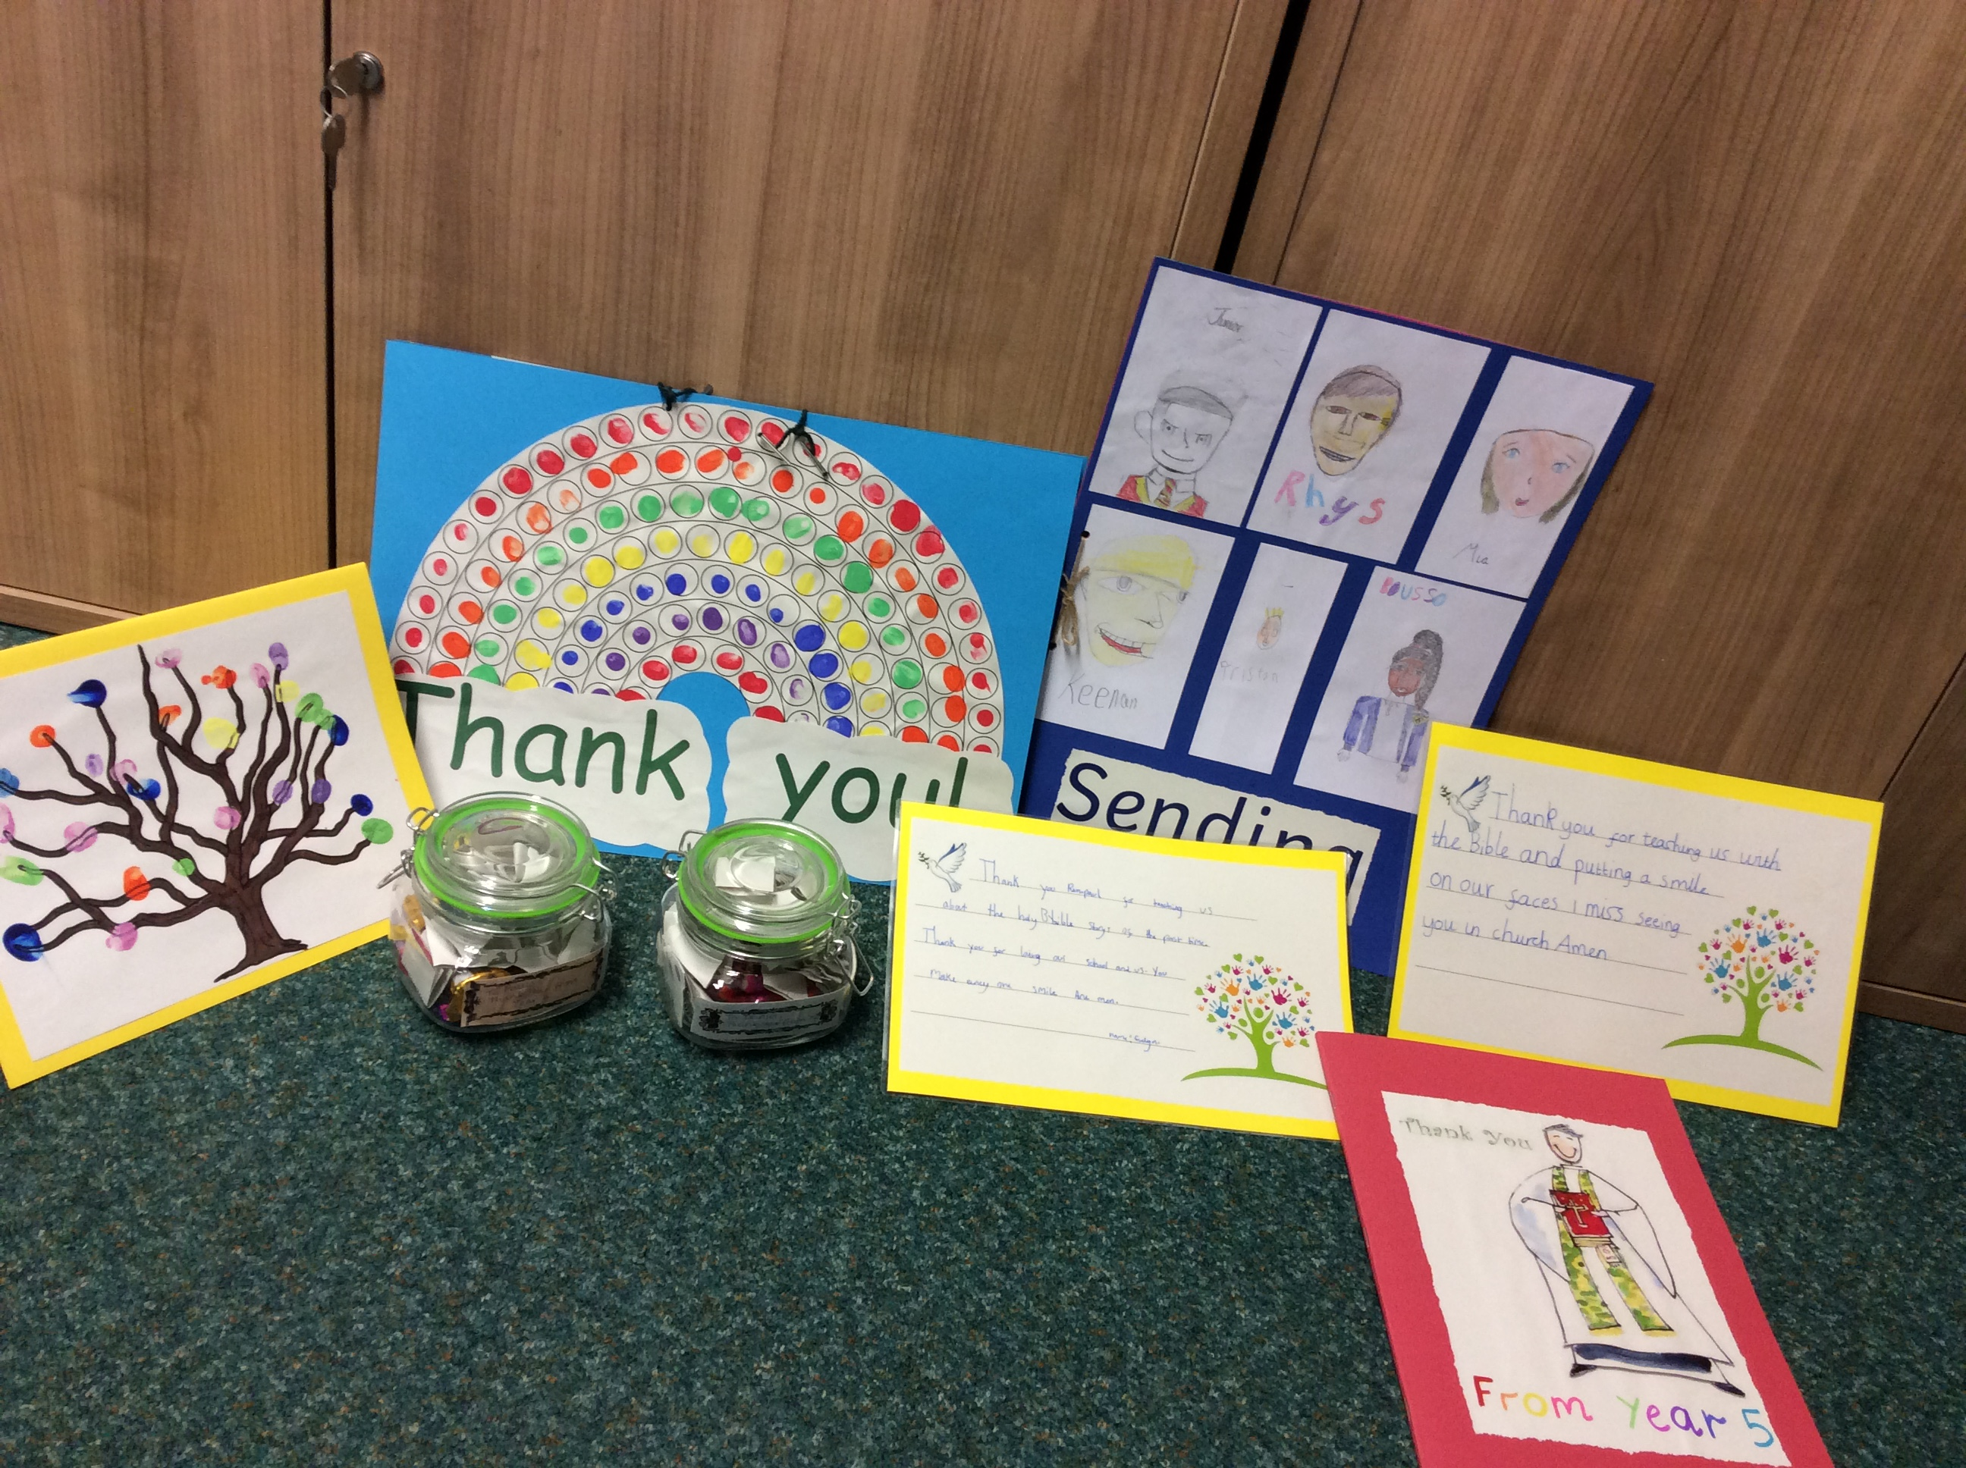

Very Important Attendance Awards

Yesterday, a number of children attended school wearing their smartest outfits as a reward for achieving 100% attendance in the last academic year.

Each class held a special attendance award ceremony in their classes and the VIPs received certificates and prizes.

Thanks to Mrs Street for organising the event. Congratulations to the VIPs and thanks to their families too for supporting us in showing your child the value of education.

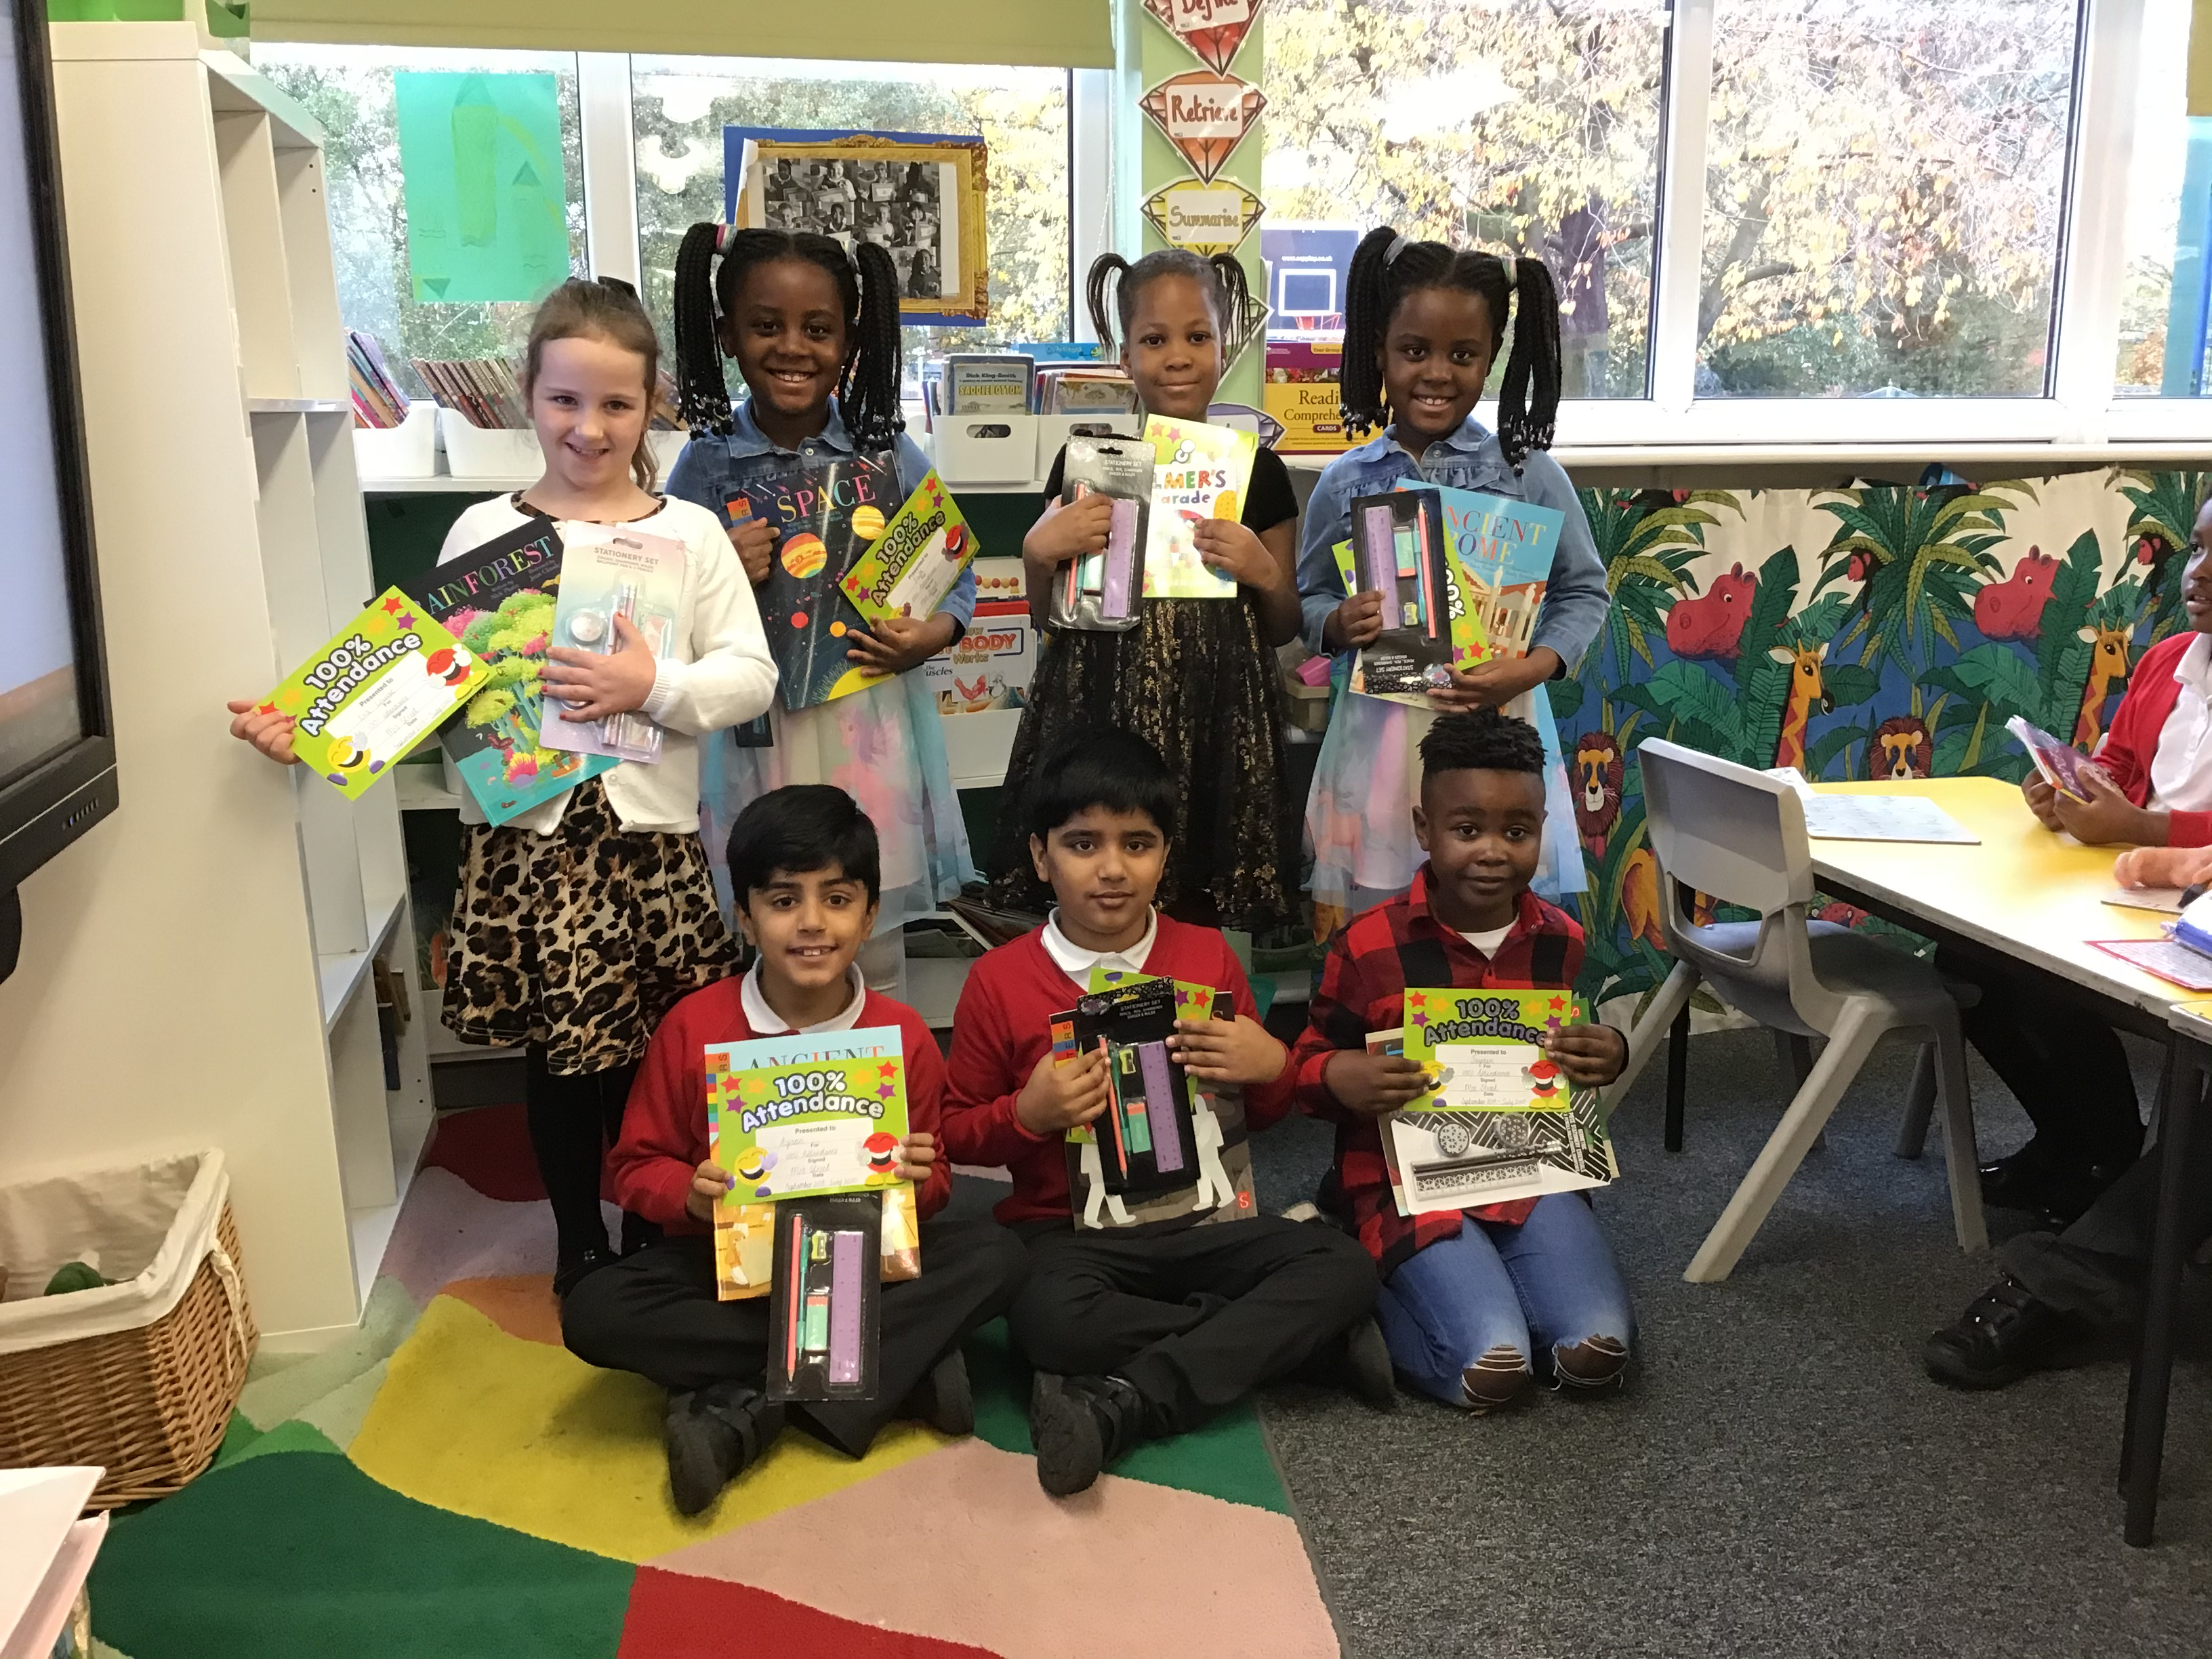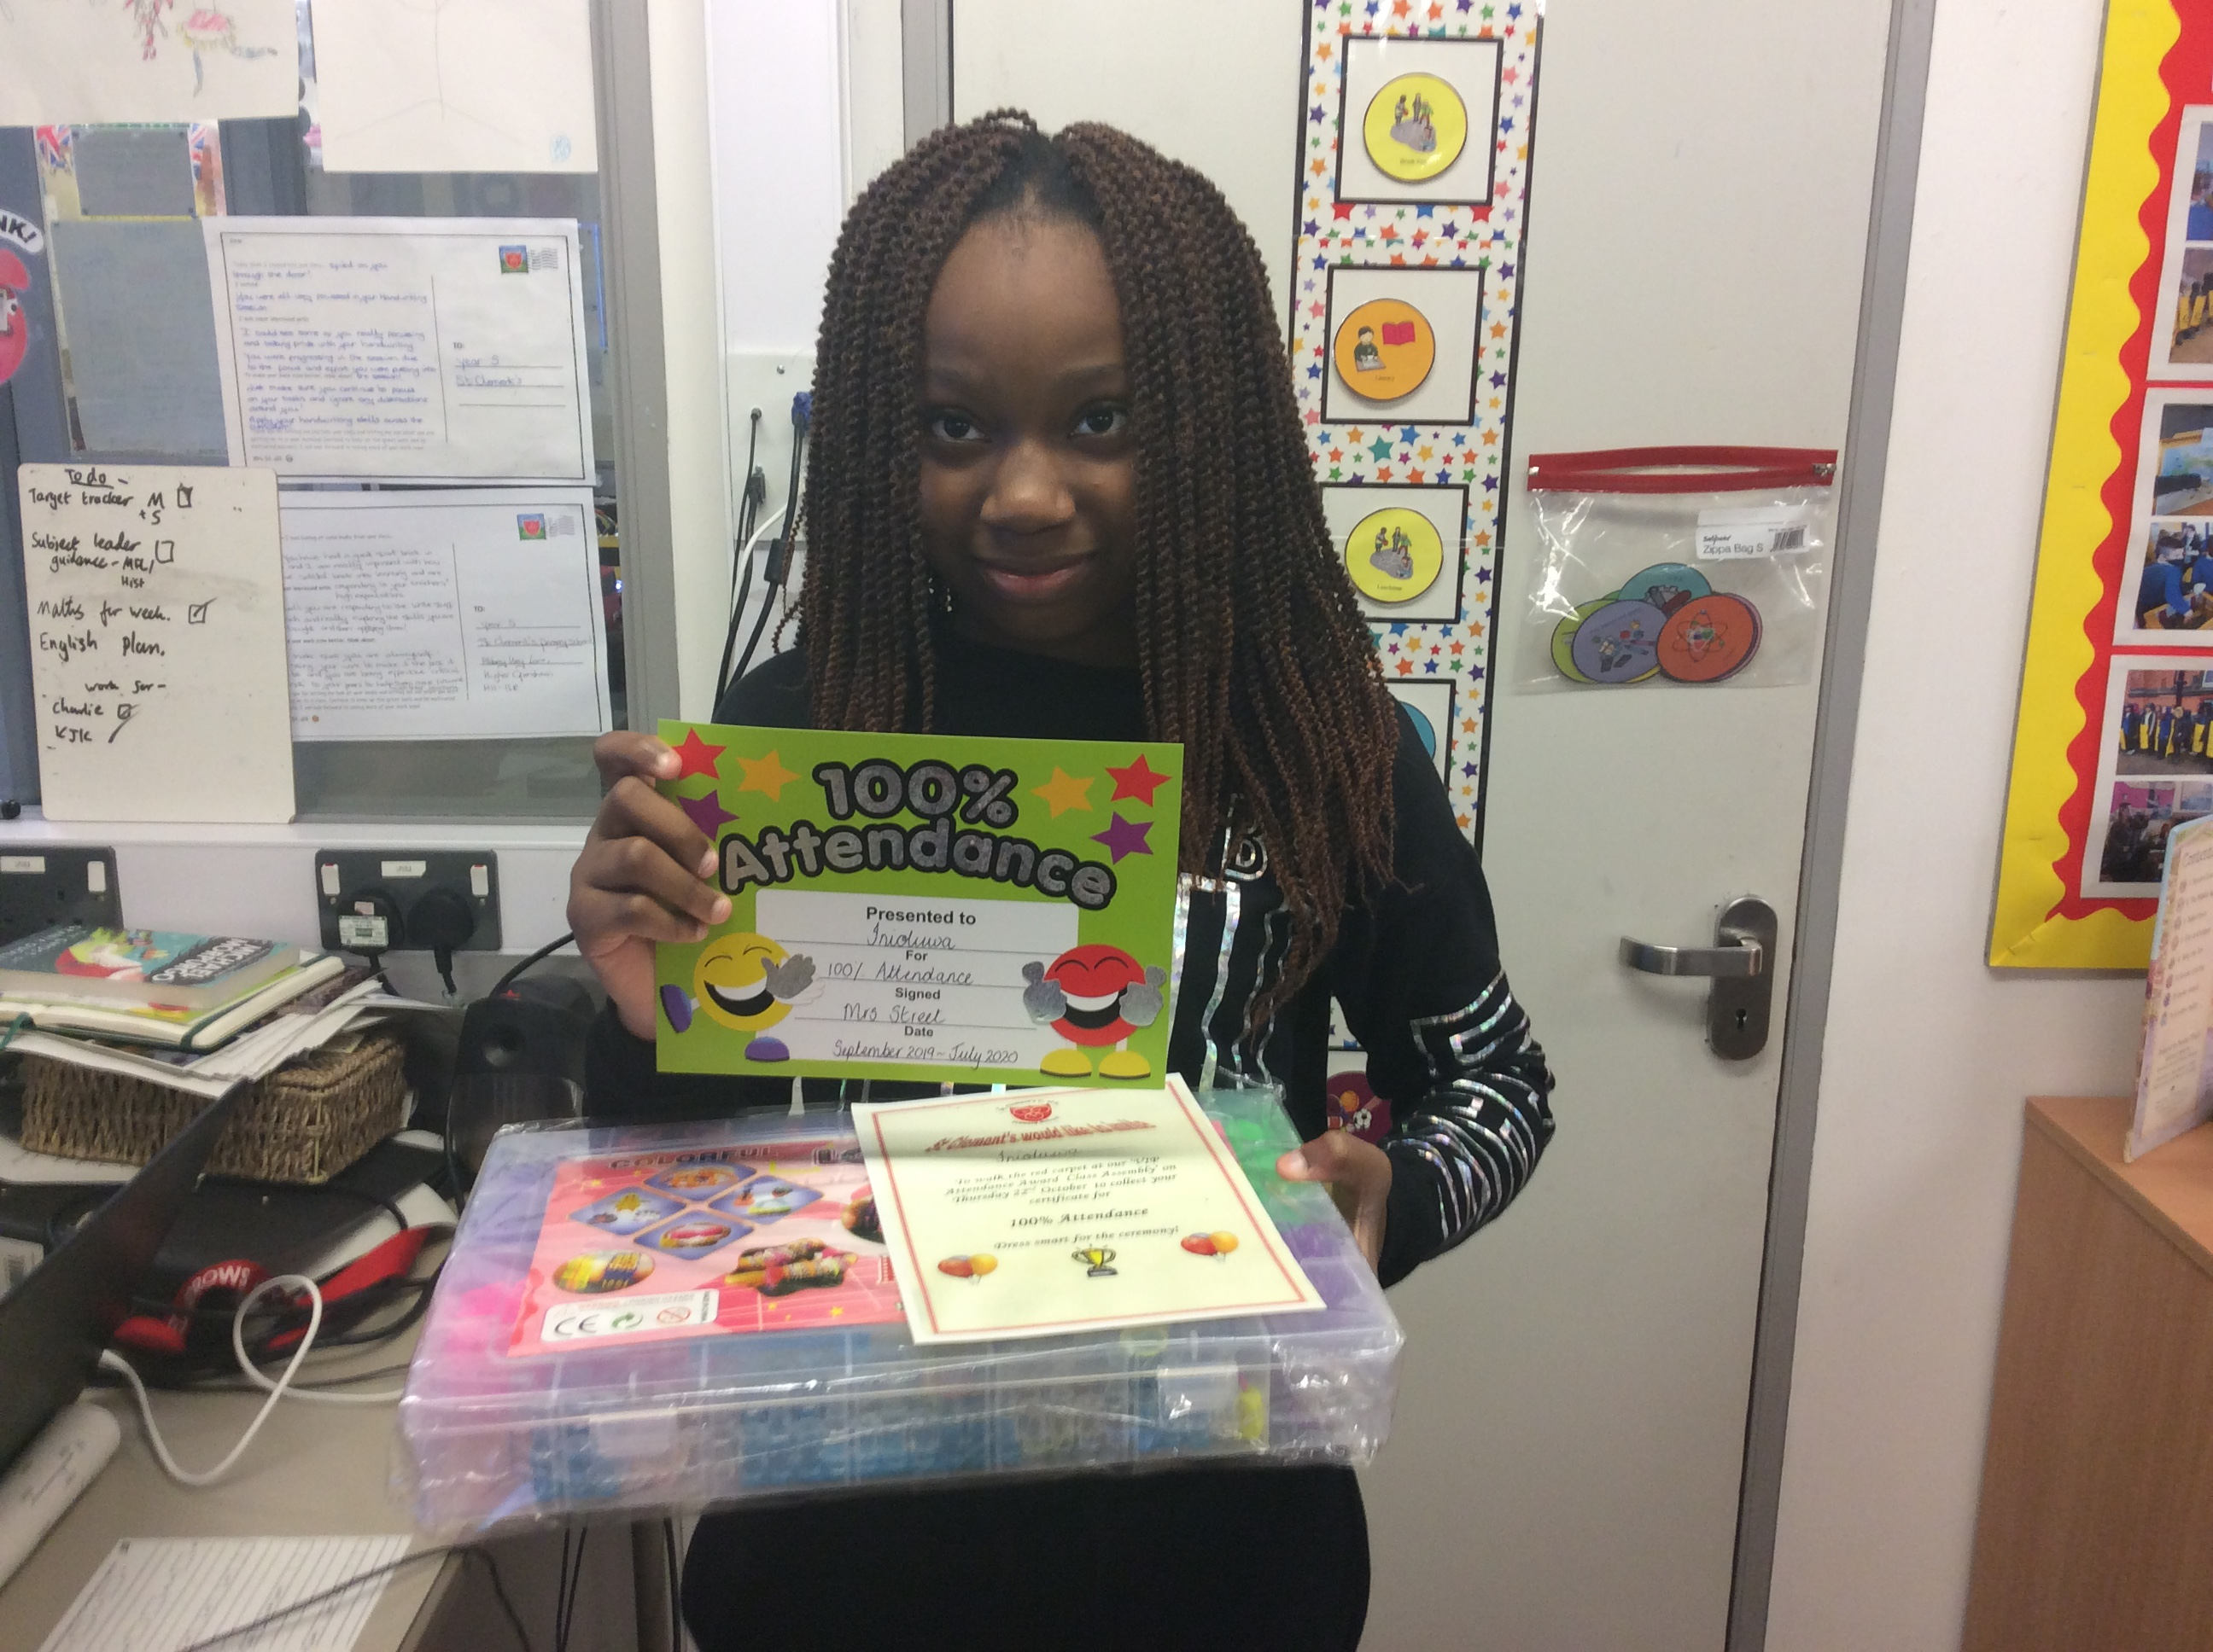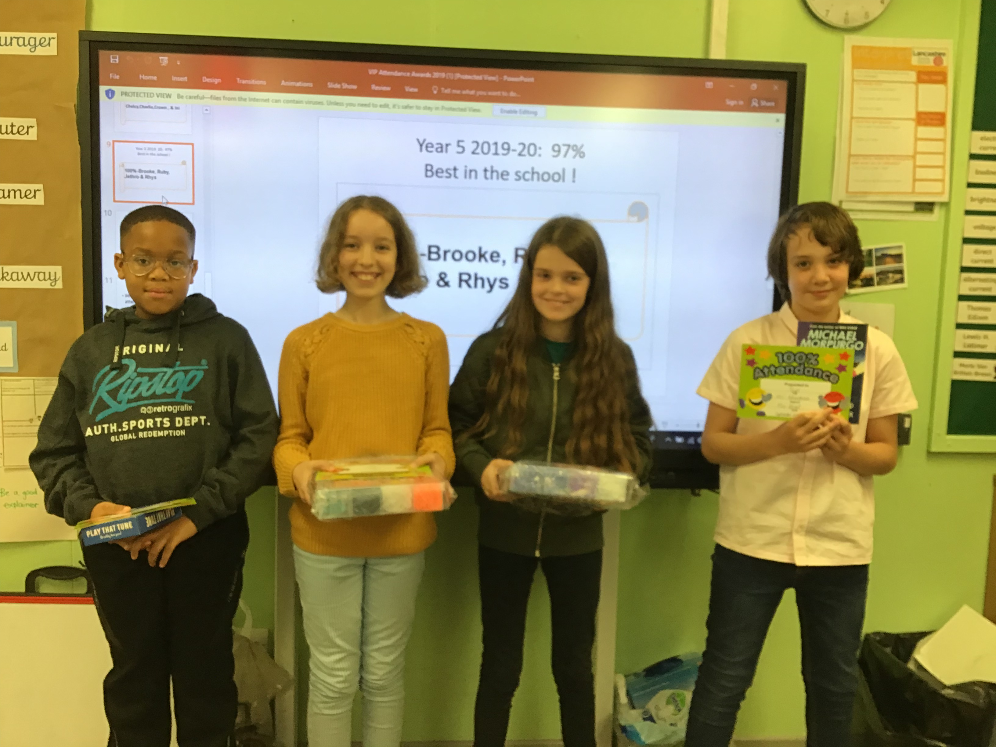

2020 Poppy Appeal:

This year, the Royal British Legion, have not sent their usual paper poppies into school for us to sell. They have instead, sent in a range of merchandise such as zip cords (suggested donation of 50p), reflector poppy to go on coats or bags (suggested donation of 50p); wristbands (suggested donation of £1) & snap bands (suggested donation of £1.50).After half term, if your child wishes to support the Poppy Appeal to help those wounded in service to our country & their families, from November 3rd, please send them in with the appropriate amount of money & the office will provide them with what they want. Stock is limited.

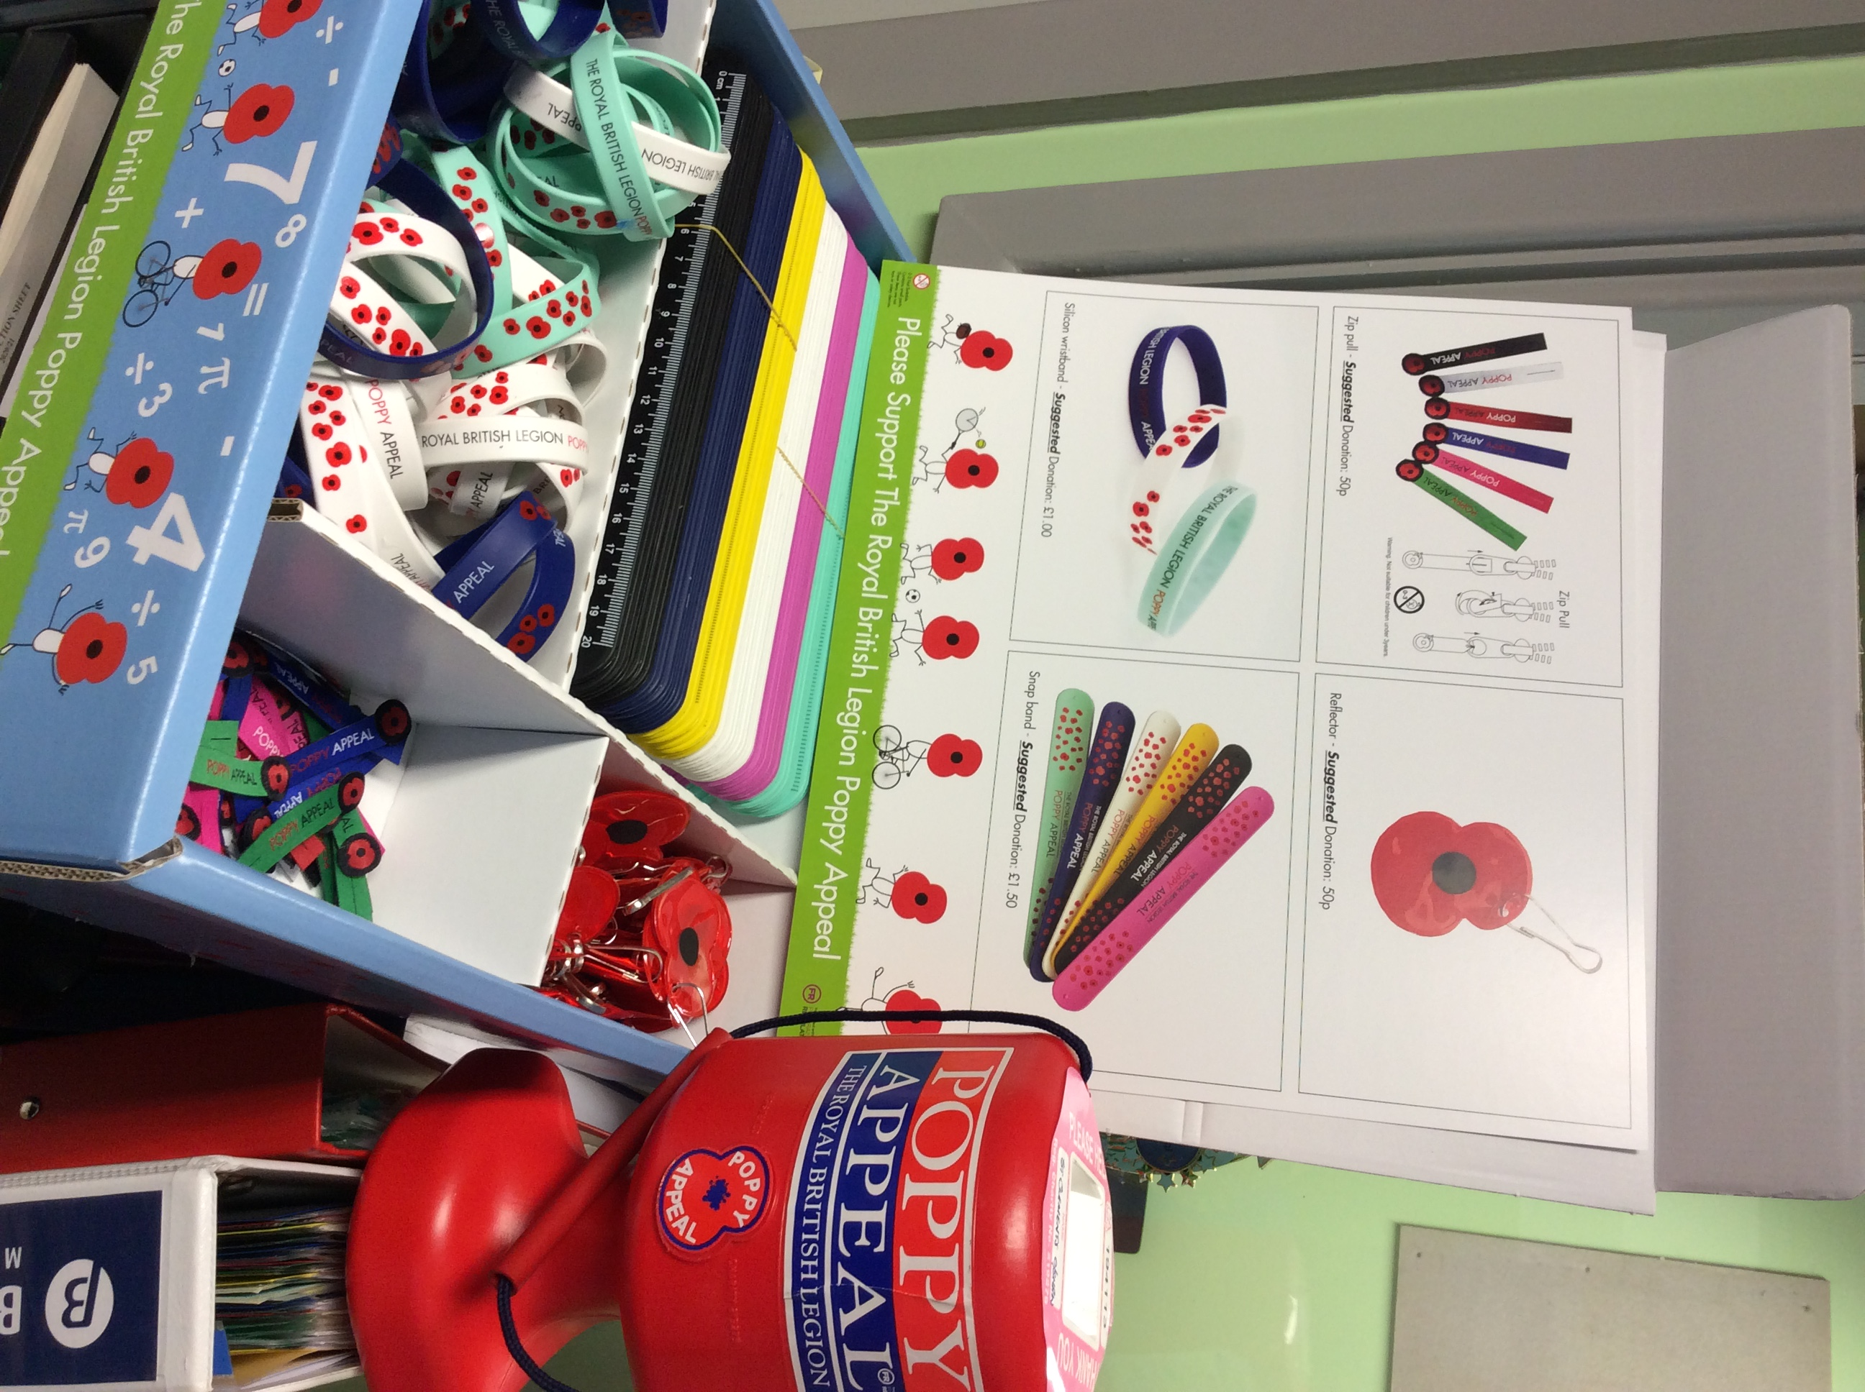

PUNCTUALITY


We have started to see a decline in the time that some children are arriving at school now that we have been back a few weeks.
External classroom doors will be shut 5 minutes after arrival times. This is due to late arriving pupils interrupting the learning that has already started and to prevent staff from having to go backwards & forwards to the doors.
It is also important we stick to the times for each class to avoid overcrowding & mixing of year groups on the playground during this time of the corona virus.
Any child arriving 5 minutes after their start time from now on, will have to enter school via the office.
If late marks start to build up for certain pupils, then myself & Mrs Street will meet with these parent/carers.

-8.30am start: Years Reception & Year 6 (doors close 8.35am)
-8.45am start: Years 1 & 5 (doors close at 8.50am)
-9.00am start: Years 2 & 4 (doors close at 9.05am)
-9.15am start: Years Nursery & 3 (doors close at 9.20am)

If some children are starting earlier to arrive with a sibling or have made arrangements with myself to arrive later for special circumstances, we again expect them to arrive at the time that was decided or no later than 5 minutes after that time.

NASAL FLU SPRAY PROGRAMME

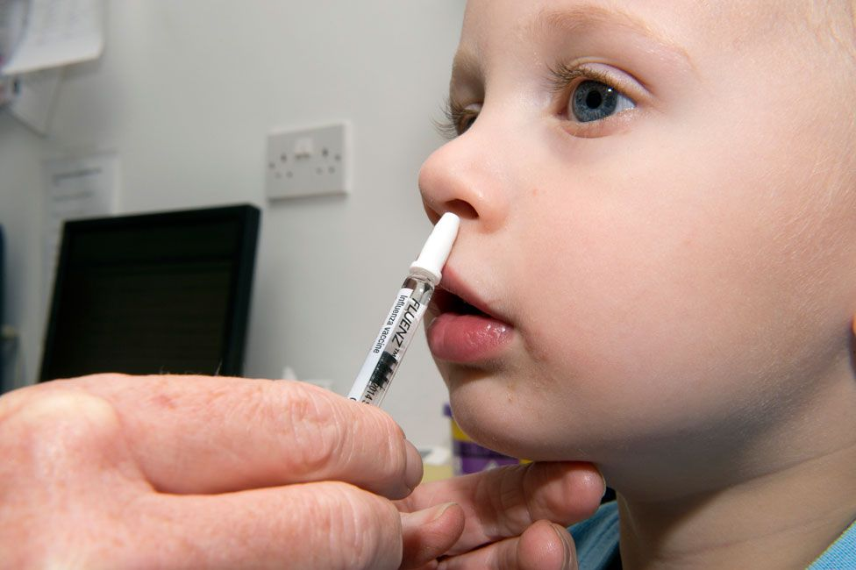

We have a high take up rate of children having the nasal flu spray each year. The company who carry out the programme have booked themselves in to administer the spray to pupils in Reception - Year 6 on Thursday 19th November.
This year, they have asked parent/carers to click on the link below to inform them if you DO or DO NOT want your child to have the nasal flu spray.

If you are having difficulty accessing the link, then please come into school & we can help you by accessing one of our computers.
The link to consent or decline for this year’s nasal flu vaccinations https://www.nhsimms.uk/FLU/information?Id=105501&Type=FLU the link will close 12/11/20 If you have any questions or queries please don't hesitate to get in touch on
0333 358 3397

COVID 19 UPDATE:
Staff continue to work hard to ensure that cleanliness and distancing guidelines are followed in school. They are also doing a great job in remaining calm so that the children are learning in a positive atmosphere where they know that they are safe.

Parent/carers- you have continued to be great at keeping a social distance on site and making sure you arrive on time to drop off & collect your child/ren and leave the site promptly to reduce contact with other adults. We really appreciate your support in this.

A reminder again about the symptoms of corona virus:
-a continuous, dry cough
-a high temperature (37.8 C or higher)
-loss of taste
-loss of smell

It is that time of year where seasonal colds are starting. (We have booked in our nasal flu sprays for November!) It is tricky to know if the symptoms your child may have are from a cold or COVID related. So always seek medical advice from your GP or the pharmacist if they are busy.

It is also important to note that if an adult or child does not have symptoms, they should be attending school.
However, if someone in their household has been sent home from school/work because they are presenting with the above symptoms, the ill person in the house, needs to get tested and other children & adults in the household need to self isolate- they need to stay at home and not leave the house for 14 days. Do not go out even to buy food or other essentials, and any exercise should be taken within your home. This 14-day period starts from the day when the first person in your house became ill or if they do not have symptoms, from the day their test was taken.

We have had a few cases of symptoms in school and children and families remaining at home until they or a family member get tested. As a result of this, I have asked class staff to contact families to ask about providing home learning for our children whilst they are self isolating or awaiting the outcome of a test- which at the moment, is taking longer to get. We don’t want our children to miss out on any further learning time, that is why we are providing work if needed.

Let’s keep on communicating and supporting one another and we will work through this together- Keep Safe.



