St Clement’s C. of E. Primary School



Drugs & Alcohol Policy

Reviewed and Approved by JP & LS: April 2020

Review date: April 2021

Growing Together To Let Our Light Shine

Mission Statement:
We encourage and inspire children to aim high and challenge themselves in everything they do.
As a compassionate, Christian school, we are strong in our faith. We believe in love and forgiveness and are thankful for the opportunities we have to live and learn in our community.
(REVIEWED JULY 2019)

Our Christian Values Reflected In This Policy
Faith
Hope
Love
Respect
Thankfulness
Compassion
Forgiveness

(September 2017)

DDA STATEMENT
At St. Clement’s we will aim to:
- Promote equality of opportunity between disabled people and others.
- Eliminate discrimination that is unlawful under the Act.
- Eliminate harassment of disabled pupils that is related to their disabilities.
- Promote positive attitudes towards disabled people.
- Encourage participation by disabled people in public life.
- Take account of a disabled person’s disabilities, even when that involves treating a disabled person more favourably than another person.

St Clement’s C of E Primary School

Drugs and Alcohol Policy

Drug Incidents Coordinator: Head teacher - Mrs Parker

Drugs Education Coordinator: Miss L Steeles

School Governor with lead responsibility for Drug Related Issues: S Poole

Important Phone Numbers

- Healthy Schools - Drugs and Alcohol: 0161 946 9403

- Eclypse: 0161 839 2054

- Local PSCO’s -Michelle and Will : 01618563521

Policy Development Process
This policy was developed in consultation with Healthy Schools, the school nurse, teaching staff, governors, parents and pupils.

The policy is available to all stake holders via the school website, a hard copy can be requested from the school office. In addition it is available to staff digitally on Pindigo.

The policy should be considered in conjunction with other written polices such as PSHCE (Personal, Social, Health and Citizenship Education), RSE (Relationship and Sex Education), Child Protection, Behaviour, Anti-bullying, Health and Safety, Medicines in School, Medical Conditions, Child Protection and School Educational Visits.

1. Purpose of the Policy
In our school we aim to serve our community by providing an education of the highest quality, within the context of Christian belief and practice. This policy is developed as part of a whole school ethos to develop healthy children, with high self-esteem who are able to take responsibility for their own learning and actions.

Through drugs education we aim to enable children and young people to have the knowledge, skills and attitudes to be able to make informed and responsible choices now and later in life and be aware of the possible consequences of drug use and misuse.

2. Context
The school operates within the statutory, legislative and local policy framework in relation to the use and/or misuse of all drugs. The drug policy applies to the school and outdoor areas including pupils, staff, governors, parents/carers, and anyone else visiting the school. It also includes all pupils, staff and volunteers on educational visits, and pupils who are partly educated in an alternative setting.
The school considers that illegal and other unauthorised drugs are not acceptable within these boundaries.

3. Definitions and Terminology
Definition of a Drug
We define a drug as a substance people take to change the way they feel, think or behave. This term encompasses all prescribed and over-the-counter medicines, all legal drugs such as alcohol, tobacco, volatile (sniffable) substances e.g. solvents, drugs known as New Psychoactive Substances (NPS) (formerly known as ‘’Legal Highs’’) and all illegal drugs covered by the Misuse of Drugs Act (1971).

A Drug Incident
A drug incident is the suspicion or evidence of any situation or specific event involving a drug. This could relate to a pupil, parent/carer, member of staff or visitor to the school.

4. The school’s stance towards drugs, health and the needs of pupils
The school has a policy on the administration of prescription medicines when necessary, which conforms to Local Authority guidelines. Medicines will only be administered at school when it would be detrimental to pupil’s health or attendance not to do so. No medication will be administered without prior written permission from the parents/carers. No changes to the administration or dosage of medication will carried out without written authority from parents/carers. Please refer to our Medicines in School policy and Medical Conditions Policy for further information.

The first concern in managing medication is the health & safety of the school community and meeting the pastoral needs of pupils.

5. Drug Education - Aims and Objectives

Aims:
- Our drugs education programme aims to provide opportunities for pupils to develop their knowledge, skills, attitudes and understanding about drugs and appreciate the benefits of a healthy lifestyle, relating this to their own and others’ actions.
- Through drugs education we aim to: minimise the number of young people engaging in drug use; delay the onset of first use; reduce the harm caused by drugs; and enable those who have concerns about drugs to seek help.

Objectives:
The school’s drug education curriculum is part of a whole school approach to the health education of pupils. The overall aim is to give pupils the knowledge, understanding, skills and attitudes to take responsibility for making informed choices about their health and the use and misuse of drugs, both now and later in life, and to emphasise the benefits of a healthy lifestyle. Drug education links to the whole school ethos of promoting high self-esteem and emotional literacy within pupils.

- To promote and develop positive attitudes and behaviour towards good health.
- To enable pupils to make healthy, informed choices.
- To foster and develop self-esteem.
- To provide accurate information.
- To increase understanding about the implications and possible consequences of use and misuse.
- To practice the skills necessary to deal with a drug offer situation.
- To widen understanding about health and social issues.
- To enable young people to identify sources of appropriate personal and professional support.

- Implementation
- Drugs education is supported by the whole school community and led by Mrs Parker (Head teacher).
- Drug education is part of a well-planned programme of PSHE education.
- Staff have access to high quality training and support from the Manchester Healthy Schools Team.
- All class teachers are responsible for teaching the relevant sections of the Science, PSHE and Healthy Schools curricula and for developing the school ethos within their class.
- All staff working with children should be aware of any worries and concerns that individuals may have, and ensure that children get appropriate support.
- Class teachers are responsible for assessing pupils’ needs within their class in relation to drug education and ensuring learning opportunities are differentiated appropriately.

7. Methodology and Resources
We deliver the Manchester Healthy Schools PRIDE 123 curriculum in school. PRIDE stands for Parents’ Role in Drugs and Safety Education. The aim is to promote the safety of children in primary school by increasing their knowledge and understanding of the dangers of drugs and medicines and help them consider rules about safety. Parents and teachers are involved in a programme of activities with the children at school and in the home.

Themes and Key Messages

Reception/Year 1 learn about
- Some things that we put in to the body keep us well and some things can harm us.
- Some things are not safe for children to touch and can harm the body.
- Some people need medicines to stay healthy.
- It is not safe to share medicines.
- The key people who give us medicines.
- Medicines in school.

Year 2 learn about
- The methods by which commonly used medicines get in to the body.
- Ways to stay healthy and well.
- Some people need medicines to stay healthy.
- Rules for different situations.
- The importance of rules to keep us safe.
- Recognising that some items in the home can be dangerous.
- Recognising hazard symbols.

Year 3 learn
- To identify ways that we can keep safe and healthy.
- To identify that we breathe air into our lungs.
- To identify that sometimes it is difficult to breathe.
- To identify that smoke comes in many guises and can be found in the air around us.
- To recognise that smoke can affect the way we feel.

Year 4 learn
- To identify ways that we can keep healthy, safe and happy.
- To understand the meaning of the word drug.
- To be able to identify medicines as drugs.
- To consider whether some drugs and medicines are dangerous.
- To identify that smoking is unhealthy for the lungs.
- To recognise that self-control is a skill that can help us in life.
- To analyse strategies that can help us when it is more difficult
to use self-control.

Year 5 learn
- To understand that some drugs are legal and some drugs are illegal.
- To understand the rules and risks of drugs.
- To have an awareness of common drugs that can damage health.
- To be aware of healthy and unhealthy habits and why habits can be difficult to change.
- To identify risks in different situations.
- To identify signs in the body when we feel unsafe.
- To develop strategies for responding to dares and peer pressure.
- To recognise that actions lead to consequences.
- To have an age appropriate awareness of criminal exploitation.

Year 6 learn
- To recognise the power of self-belief to influence choices and accomplishments.
- To understand the harmful effects of smoking including health issues and financial costs.
- To understand the law and identify that some drugs are legal, some are restricted and some are illegal to own, use and supply to others.
- To be aware of the effects of common drugs on the body and identify short and long term risks.
- To identify that solvent abuse can put a person’s life at risk.
- To identify that sometimes people can try to influence them to do something dangerous or unhealthy, that makes them uncomfortable, anxious or that they believe is wrong.
- Practise using basic techniques for resisting peer pressure.
- To have an age appropriate awareness of criminal exploitation.
8. Staff Support and Training
Healthy Schools Training
PRIDE for primary schools
Good practice in Drugs Education
Basic Drugs Awareness for primary and secondary schools

Other training will be accessed to support CPD needs as identified.

9. Assessment, monitoring, evaluation and reviewing
Within the PRIDE 123 curriculum the first and last lesson for each year group involves an assessment of what pupils know. The assessment information is used to ensure learning opportunities meet the needs of the pupils and that resources and activities are differentiated effectively. Gaining feedback from pupils supports us to evaluate and review the impact of learning activities and identify next steps.

10. Managing Drug Related Incidents
The principal concern in the management of all incidents is the preservation of health and safety of all pupils and the school community.

If any drug related incident should occur, the safety and wellbeing of the child or young person will always be the overriding concern. Each incident will be considered taking into account the circumstances of the individual and the family. Police and other appropriate agencies will be informed according to the needs of the individual concerned. There may be interest in drug related incidents by the media. Confidentiality of pupils will be a priority. The Head teacher will respond to media questions.

11. Informing Parents/Carers
In cases of substance-related incidents, the school will inform parents or appropriate responsible adult about the incident. In instances involving substance misuse or supply on the premises parents will be informed at the earliest opportunity. The school and the parents/carers can then work together to support the child involved. Parents are encouraged to approach the school if they are concerned about any issue related to drugs and their child. However, the following points will be taken into consideration:

The Head teacher, who is also the Lead Designated Safeguarding Lead will decide whether to inform parents or not, if a child is on child protection procedures or is deemed to be at risk. Young people involved will be consulted and informed about the home-school contact.

Guidance will be available, on how to access appropriate external support e.g. Eclypse (specialist drugs service for young people in Manchester). Parents/carers will be encouraged to maintain contact with the school after an incident, to ensure that all parties are working together to support the young person.

12. Managing Specific Drug Incidents
A drugs incident can involve suspicions, observations, disclosures or discoveries of situations involving illegal or other unauthorised drugs.

The school treats all drug related incidents very seriously. They will be dealt with on an individual basis which is in line with our pastoral support system and behaviour policy. Guidance on dealing with specific incidents is given in the flow chart at the end of this document. The Head teacher will make final decisions about what actions are taken, to allow the policy to be adapted to specific situations. When dealing with incidents which do not fit either the flow-chart or notes further guidance is available from Healthy Schools or in the DfES Drugs: Guidance for Schools, 2004 or in the DfE and ACPO Drug Advice for Schools, 2012.

The following guidance is based upon DfES Drugs: Guidance for Schools 0092/2004 and local best practice. These complement the school’s health and safety policy.

Safety within school and school premises
- Caretaker to check the grounds regularly.
- All staff to be vigilant for evidence of drug use.

If someone reports finding a syringe or needle
- Ask informer to show where or give exact location.
- Ensure that students do not have access to the location until the area has been cleared.
- Inform appropriate person who has the correct equipment for removing dangerous items.
- If there are more than isolated incidents, seek advice from the Public Health Development Advisor(s) at Healthy Schools.

If a teacher/parent/carer suspects that a child has been in contact with a syringe
- Seek immediate medical advice.
- Reassure parent/carer to keep calm and prevent fear in the child.

If substances are found on the premises
- If a suspicious substance is found and you think that it may be illegal, then it should be treated as such.
- Inform the Head teacher, who is the Drug Incident Co-ordinator, or in their absence, the Drugs Education Co-ordinator, Assistant Heads or School Business Manager- they will begin further investigation.
- The law permits school staff to take temporary possession of a substance suspected of being an illegal drug for the purpose of preventing an offence from being committed or continued in relation to that drug providing that all reasonable steps are taken to destroy the drug or deliver it to a person lawfully entitled to take custody of it.
- Make a record of actions taken with description, location and date (e.g. one white tablet found in cloakroom).
- If there are particular concerns contact the Healthy Schools (Drugs and Alcohol) Specialist for advice and guidance and/or the police Safer Schools Partnership team/Integrated Neighbourhood Policing Team.

School events: sale/supply of alcohol to parents
The school is aware of the need to first assess whether it is appropriate and necessary to sell or supply alcohol to parents at social events. This may include offering alcohol to attract parents to open evenings, parent/teacher events, school fairs and festivals, or as prizes within school raffles and tombolas.
It is recommended that organisers consider the role of the school in promoting the health and well-being of a multi-cultural school community as well as the value of showing that social events can be attended and enjoyed without alcohol. The school is aware of the way in which children draw their understanding of social norms from observing adult behaviour from a young age and that events on school grounds need to be consistent with the messages given in alcohol education. Further consideration should also be given to parents who may be driving to and from school events.
If there are occasions where the school considers that it is appropriate and necessary to offer parents alcohol, the school is aware of and follows the Licensing Act 2003. For guidance on types of license, the school may contact the Manchester City Council Licensing Unit on 0161 234 4512. For advice on risk assessing the sale/supply of alcohol at school events, the school may contact the licensing representative for MSCB on 0161 234 3330.
Reporting concerns about illegal sales/supply
The school has the right to inform the licensing unit, police or trading standards if they have witnessed or have heard reports of illegitimate sale/supply of age restricted products (e.g. alcohol, tobacco or solvents) in the school vicinity. They have also the right to inform the licensing unit or police if they have sufficient evidence or have witnessed crime and disorder (including illicit drug activity), noise nuisance, threats to public safety and threats to the protection of children from harm as a result of the operations of a licensed venue in the school’s vicinity. This may include concerns around alcohol promotions that are attractive to children as well as street drinking in the area.

If incidents occur on school trips
- Complete a risk assessment before a school trip. This should include procedures for dealing with medical emergencies e.g. staff access to mobile phone and emergency numbers.
- The lead member of staff should deal with incidents, making contact with the Head teacher where appropriate.
- Where possible incidents should be dealt with in line with standard school policy or in line with the policy of the centre being visited. It is recognised that the timescale for dealing with incidents on a trip may be longer than in school e.g. being able to meet with parents.
- The school is aware that laws on drugs and policing vary between countries. The school will ensure that they (and all participants on the trip) are aware of these differences.
- Consider informing local authorities or venue staff. For in-country advice the school will contact the British embassy or consulate.
- Where appropriate, a clause will be inserted in consent forms; that if a pupil breaches the rules and is returned home, the parents/carers will meet the cost of such arrangements.

If a parent/carer is under the influence of drugs on school premises
- Assess whether there is a medical or safety issue for the individual or others.
- Consider calling for medical help or the police if appropriate.
- Stay calm and try to reassure the parent/carer and the child.
- Discuss alternative arrangements if there are concerns about discharging the pupil into the care of the adult e.g. another parent/carer could take the pupil home.
- If appropriate follow school procedures in relation to child protection.
- The focus for staff will always be the maintenance of the child’s welfare.
- Inform the Head teacher who is the Drug Incident Co-ordinator, they will begin further investigation.
- Consider offering parents/carers appropriate support e.g. preventative health promotion advice/ awareness sessions or responsive treatment advice offering referral to appropriate agencies e.g. Eclypse.

If a member of staff is under the influence of drugs on school premises or on a school trip
- Assess whether there is a medical or safety issue for the individual or others.
- The school has clear expectations for staff conduct. All staff are made aware of these expectations which should refer to issues such as alcohol on site, being at work under the influence of alcohol and alcohol consumption on trips. Staff are made aware of the school’s No Smoking policy/Substance Misuse Policy for staff.
- The school has a staff disciplinary procedure which may be used if staff are not seen to be fulfilling their duty of care to pupils entrusted to the school (including when on trips).
- Consider offering staff appropriate support e.g. preventative health promotion advice/awareness sessions in staff areas or responsive treatment advice offering referral to appropriate agencies.

If the police are involved in dealing with a drug incident
- The police work in partnership with the school, in relation to specific input into the curriculum and in dealing with incidents. Local police do not wish to criminalise children and young people.
- Legal Drugs: Police do not need to be involved. The school may inform the police about inappropriate sale or supply of tobacco, alcohol or volatile substances.
- Illegal Drugs: The school has no legal obligation to report drug related incidents to the police. Nevertheless, not informing the police may prove to be counter-productive for the school and the wider community. The Head teacher may inform the police if they consider it appropriate, bearing in mind: the quantities involved, the vulnerability of those concerned and the possible impact on the school and the community or where local intelligence may be of help.
- The school supports local protocols agreed by Healthy Schools and the police. Once the police are formally involved in dealing with a drug related incident it may lead to a criminal investigation and prosecutions.
- The police should be involved in the disposal of suspected illegal drugs.
- For supply (or suspected supply) of illegal substances by pupils or adults the school will inform the police directly.

If a person is suspected of concealing illegal or unauthorised drugs
- Schools can search a pupil for any item banned under the school rules, if the pupil agrees (the ability to give consent may be influenced by the child’s age or other factors).
- Head teachers and staff authorised by them have a statutory power to search pupils or their possessions, without consent, where they suspect the pupil has certain prohibited items. The items that can be searched for under this power are knives or weapons, alcohol, illegal drugs and stolen items.
- School staff can seize any banned or prohibited item found as a result of a search or which they consider harmful or detrimental to school discipline.

Every effort should be made to persuade the person to hand over voluntarily any drugs, in the presence of a second adult witness. For more information please see the DfE guidance: Screening, searching and confiscation, 2012.

If a substance has been confiscated or found
- DfE: Guidance for Schools 0092/2004 states that schools may temporarily store illegal substances in a secure designated place e.g. school safe. This storage should be recorded with an adult witness present, but this storage must be short term. To dispose of an illegal substance the school may notify the police who will arrange for collection or disposal. If the police are involved the law does not require the school to divulge the name of the pupil from whom the drugs were taken. The DfE guidance also states that locally agreed protocols may be followed for disposal of illegal substances. In Manchester, the police have agreed that schools may dispose of substances safely e.g. flush down the toilet, as soon as possible after initial investigations in the presence of an adult witness. Any disposal should be recorded as a drug incident.

If a referral needs to be made
- The school is aware of a range of agencies (not solely drug specific ones) which complement the pastoral role of the school. Schools have a role to play in identifying pupils who have drug related concerns. The school recognises that early intervention can prevent more problematic use. In Manchester, Eclypse (0161 839 2054) is recognised by Manchester Healthy Schools as offering targeted group work and individual support for young people who are using or thinking about using drugs. Referrals can be made by the school, but this should be discussed with the young person. Students may also refer themselves. Eclypse provide appropriate support to more vulnerable young people with specific needs. Permission will be sought from parents/carers for individual work with young people, but not for group education work. Training is offered by Healthy Schools for pastoral staff to be able to identify and refer appropriately to Eclypse and support young people who may present as misusing substances.

If a drug incident occurs it needs recording
- Staff will record drug related incidents and these will be monitored by the Head teacher. Staff should record facts, not opinions e.g. time, date, place and people present and what was said. Storage of sensitive information is secure and accords with the Data Protection Act 1998. The school is aware that records may be used in subsequent court proceedings.

If the media are involved
- In the first instance members of the school community should refer enquiries from the press to the Head teacher.

13. Relationship with other Policies
a) PSHE
Drug education forms a central part of the PSHE curriculum and as such is planned, delivered, co-ordinated, assessed and monitored in line with the school’s PSHE policy.

b) Child Protection
If any disclosure occurs during a drugs lesson or concerns are raised, teachers will follow the school’s procedure for Child Protection.

Teachers have a duty of care and so any incident or potential incident (e.g. involving drug using parents) must be treated as a Child Protection issue. Procedures and guidance are given in the school’s child protection policy.

c) Confidentiality
Children have rights under the Children’s Act 1989 and can thus expect drug related incidents to be treated sensitively. However, staff should not give guarantees of confidentiality where the safety and welfare of a child is at risk. Further guidance is given in the school’s confidentiality policy.

d) Tobacco
The school’s smoking and tobacco control policy gives clear guidance on specific issues related to tobacco.

e) Manchester City Council Substance Misuse Policy
The school is aware of the Manchester City Council guidelines on substance misuse in the workplace. It gives clear guidance on specific issues related to the welfare of staff.

f) Behaviour
The school’s behaviour policy outlines a range of strategies available to staff in dealing with drug related incidents including tobacco, alcohol and illegal substances.

g) Medicines in Schools
The school nurse is recognised as having a key role in the development and implementation of these guidelines. The school follows Manchester City Council guidance on medicines in schools.

- Date and Review of Policy

Date of approval and adoption by the governors:

Date for next review:

This policy will be reviewed annually, unless there are changes to National or Local Guidance before the planned review date.

Responding to drug related incidents – an example of a flow chart to assist schools
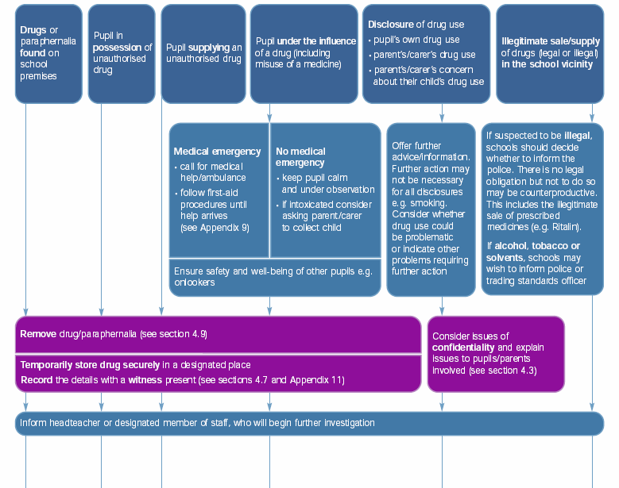
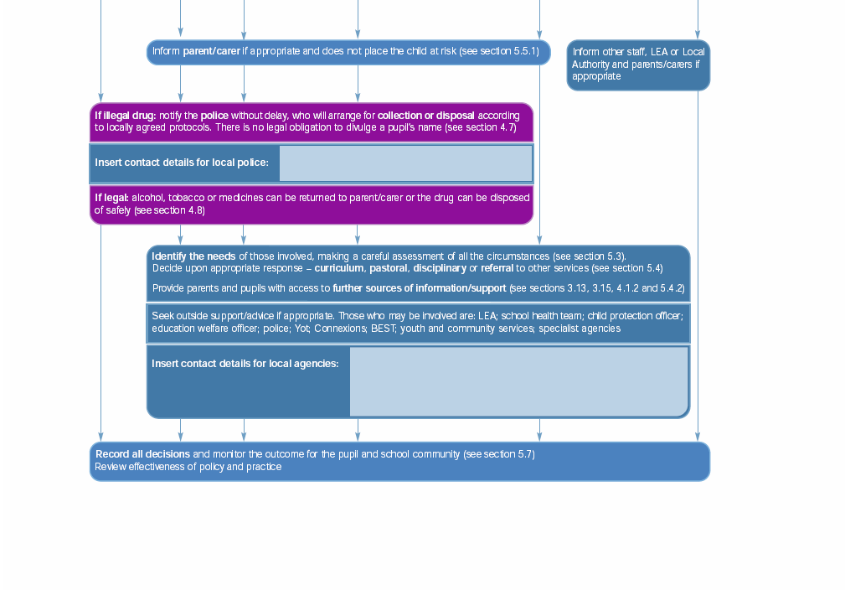
0161 8563521

- Healthy Schools (Drugs and Alcohol) – 0161 946 9403
- Eclypse (Young Peoples Drugs Agency) – 0161 8392054

Adapted from Drugs: Guidance for schools, 2004 (sections in brackets refer to sections in guidance)

