
“Growing together to let our light shine”
Welcome to your weekly newsletter!! Week Beginning 14th December 20
Christmas Events:
Due to COVID restrictions, Christmas will be different in school this year. However, we are trying to keep things as festive as possible by:

-Still sending Christmas Cards. From 1st December, your child can bring cards in to send Christmas wishes to their friends & staff. The post box is back! Please ensure the first name (Second name as well if there is more than one Alfie in a class, for example) and class are written clearly on the front & cards will be delivered 72 hours after collection. LAST POSTING DATE FOR CHRISTMAS DELIVERY IS MONDAY 14TH DECEMBER!!
-Still having Christmas performances, but we will be recording or photographing them & posting them on dojo for you to see instead. Children will be performing nativities, singing or reciting poetry in their class bubbles as we can’t get classes together to rehearse.
-Each class will be having a ‘Cosy Christmas’ pyjama, hot chocolate & DVD event in their own classes on Tuesday 15th December. We are unable to hold parties as the hall is used until later in the afternoon for the serving of meals and due to timings, some children have to leave early & will have their dinner later, meaning parties for some would be too short.
-Still having a Christmas dinner on Thursday 17th December.

Parent/Carers will be receiving a letter from the phase leaders, giving you more detail about the arrangements above.



EPIC Afternoon Tea

On Thursday, it was a pleasure for me to host afternoon tea for some VIPs (Very Important Pupils) who have achieved the EPIC award this half term, in the past or were a friend coming along with an EPIC award winner.

Children came along in their class bubbles and talked to me about what they are enjoying about school, what could be better for them and sharing some fantastic work too.

Well done on achieving the highest award in our school children- we are all proud of you!

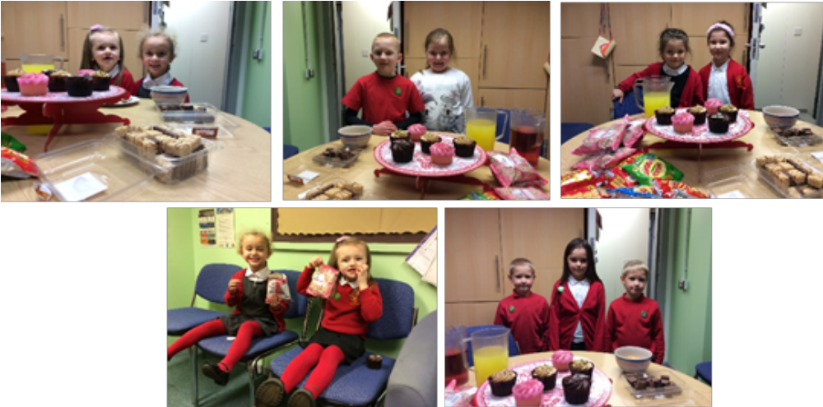


CHANGE TO END OF TERM DATES:
On Tuesday, the government announced that schools who were due to end their term on 18th December, can do so a day earlier on Thursday 17th December instead. This is to prevent school staff having to carry out Track & Trace responsibilities after the 23rd December.
With agreement from our Governing Body, we have decided to follow government guidance to end our term on Thursday 17th December at 3.15pm.

We will inform all parent/carers of how to contact us to inform us of confirmed cases of coronavirus in any of our pupils after 17th December on dojo & via group call text message.

.

Attendance Updates

Despite this being a difficult half term in terms of attendance, we have achieved over 90% attendance on average every week & sometimes we have exceeded what we got in the same week last year!

This is a great achievement and we know that the vast majority of our parent/carers recognise the impact that missing school has on a child’s life chances. In the short term, they miss lessons and then need to catch up due to gaps in their learning. In the longer term, it impacts them socially & emotionally.

If you or your child are having issues preventing your child from attending school, then please speak to Mrs Street.
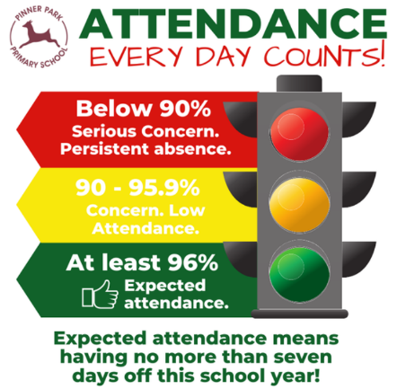

Values Award Winners:
As it is approaching the end of a half term, we celebrated our Values Award winners- rewarding those pupils who have shown our Christian Values of Respect & Love. Thank you & well done to the following pupils:
Y6- Ruby & Alfie Y5- Gracie & Prince
Y4- Joanna & Leo Y3- Amelia & Stanley
Y2- Alfie & Christiana Y1- Abdullah & Jake Reception- Layton & Sunshine
Nursery- Amaya & Shalom

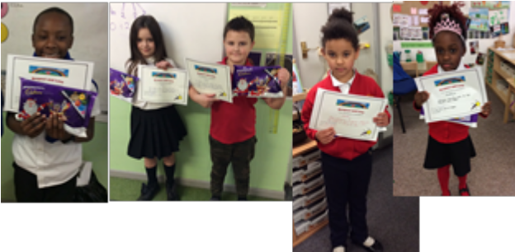

PUNCTUALITY
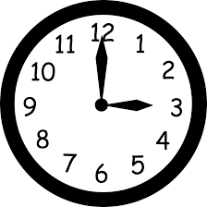
We have started to see a decline in the time that some children are arriving at school now that we have been back a few weeks.
External classroom doors will be shut 5 minutes after arrival times. This is due to late arriving pupils interrupting the learning that has already started and to prevent staff from having to go backwards & forwards to the doors.
It is also important we stick to the times for each class to avoid overcrowding & mixing of year groups on the playground during this time of the corona virus.
Any child arriving 5 minutes after their start time from now on, will have to enter school via the office.
If late marks start to build up for certain pupils, then myself & Mrs Street will meet with these parent/carers.

-8.30am start: Years Reception & Year 6 (doors close 8.35am)
-8.45am start: Years 1 & 5 (doors close at 8.50am)
-9.00am start: Years 2 & 4 (doors close at 9.05am)
-9.15am start: Years Nursery & 3 (doors close at 9.20am)

If some children are starting earlier to arrive with a sibling or have made arrangements with myself to arrive later for special circumstances, we again expect them to arrive at the time that was decided or no later than 5 minutes after that time.
Parent/Carer Survey- We asked, You said….

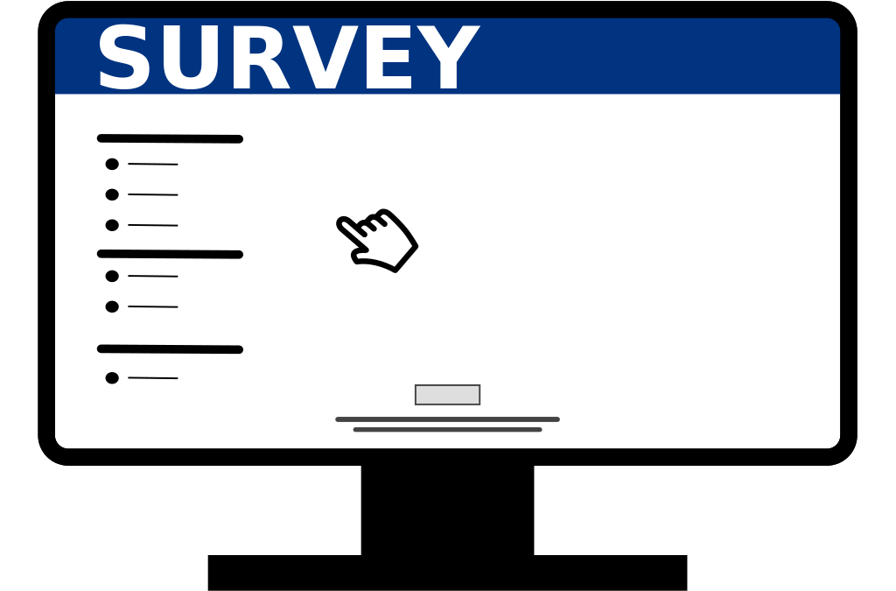

On our annual Parent/Carer Survey- 60 surveys were completed.
All statements had an overwhelmingly positive response- eg 54-58 parent/carers strongly agreeing or agreeing to most questions- particularly important questions such as saying their child is happy & they feel safe at St Clements.
Going forward, we are going to ask parent/carers, when we are working and communicating with them on a concern or bullying incident, if they have been satisfied with the way that school has dealt with their issue.
Other comments were…

“Thank you so much for all your hard work and dedication to our children. We could not ask for more!”
“Thank you to all the Teachers and staff for working hard and ensuring everyone is keeping safe during these strange times”
“Needs some improvements regarding children who need additional support”

COVID 19 UPDATE:
Staff continue to work hard to ensure that cleanliness and distancing guidelines are followed in school. They are also doing a great job in remaining calm so that the children are learning in a positive atmosphere where they know that they are safe.

Parent/carers- you have continued to be great at keeping a social distance on site and making sure you arrive on time to drop off & collect your child/ren and leave the site promptly to reduce contact with other adults. We really appreciate your support in this.

A reminder again about the symptoms of corona virus:
-a continuous, dry cough
-a high temperature (37.8 C or higher)
-loss of taste
-loss of smell

It is that time of year where seasonal colds are starting. (We have booked in our nasal flu sprays for November!) It is tricky to know if the symptoms your child may have are from a cold or COVID related. So always seek medical advice from your GP or the pharmacist if they are busy.

It is also important to note that if an adult or child does not have symptoms, they should be attending school.
However, if someone in their household has been sent home from school/work because they are presenting with the above symptoms, the ill person in the house, needs to get tested and other children & adults in the household need to self isolate- they need to stay at home and not leave the house for 14 days. Do not go out even to buy food or other essentials, and any exercise should be taken within your home. This 14-day period starts from the day when the first person in your house became ill or if they do not have symptoms, from the day their test was taken.

We have had a few cases of symptoms in school and children and families remaining at home until they or a family member get tested. As a result of this, I have asked class staff to contact families to ask about providing home learning for our children whilst they are self isolating or awaiting the outcome of a test- which at the moment, is taking longer to get. We don’t want our children to miss out on any further learning time, that is why we are providing work if needed.

Let’s keep on communicating and supporting one another and we will work through this together- Keep Safe.



