[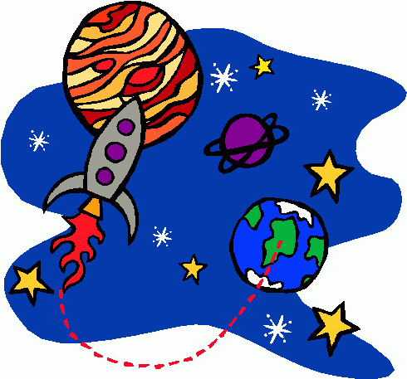](http://www.google.co.uk/url?sa=i&rct=j&q=&esrc=s&frm=1&source=images&cd=&cad=rja&docid=gzP1HPtB2x5XcM&tbnid=rI18YIJp3ZiOHM:&ved=0CAUQjRw&url=http://bestclipartblog.com/25-space-clip-art.html/space-clip-art-4&ei=vIPcUZGwK9Cb0AXn0oDIDw&bvm=bv.48705608,d.d2k&psig=AFQjCNGQKCz-0zOv_4R0Cn0oyc1QKcTyXw&ust=1373492535522801)

**History focus:**

**The Kingdom of Benin**

In this module we’ll be looking at Benin and why this civilisation is worthy of study. We’ll be using evidence to find what Benin was like and contrast this with British history.

**Geography Focus:**

**You have the power!**

In Geography we’ll be looking at what settlers need, and how society needs resources such as food, electricity and water.

**Art Focus:**

-Identify features of Art from Benin

-Sculpture – clay crocodiles or leopards

**DT Focus:**   
-Research food taken to the ISS and identify food groups.  
-Research do’s and don’ts of space food.

**ICT:**

**Online Safety-** Pupils will be looking at how to stay safe online.

**Using a search engine-** Pupils will be looking at how you can direct an online search in order to find exactly what you’re looking for.

Topic: Spring Term 2021 Year 5

Out of This World

**PE and Music:**

**PE:** Dance

**Music:** At the Movies and Life cycle.

**Science:**

Out of this world: This unit is all about space which links in perfectly with our current topic! We learn about; the movement of Earth and other planets in relation to the sun, the movement of the moon relative to Earth, explain day and night and the apparent movement of the sun across the sky using the idea of Earth’s rotation.

Let’s get moving: This unit is all about forces and magnets. We learn about; gravity, air resistance, water resistance, friction, levers, pulleys and gears.

**Writing Opportunities:**

Opportunities will be provided for children to complete some cross-curricular writing:

* Nonfiction information booklets about Space.
* Diary entries in the life of an Astronaut.
* Arguments for and against space travel for animals.

**Drama/S&L Opportunities:**

In the reading area, children will be able to explore a rocket for role play and drama. S+L activities will be available.

**Stories/Texts/links:**

Selection of nonfiction books about space

Extracts from Astronaut Journals

Poetry about Space

Recounts – Alien earth experiences.

**Debate:** Animals sent to Space…is it right to take something from their home?

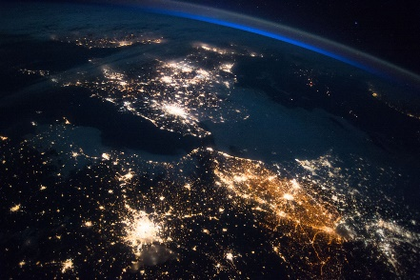

**RE:**

Women of the Old Testament

Easter Victory

**MFL:** The children will learn vocabulary, stories, songs and formulate sentences about Hobbies and School Trips.

**Numeracy Links:**

MathsNoProblem!

This term we will be focusing on Word Problems involving our four operations, Graphs, and finish with fractions.

This will build upon the work we have done with addition, subtraction, multiplication and division.