 serving Jesus

**Questions children want to investigate:**

Who was LS Lowry?

What was Manchester like a long time ago?

-

**History:**

Victorians

LS Lowry

Industrial Manchester and Openshaw

**Geography:**

Our Local Area – Manchester / Openshaw now and in the past.

Year 1 Topic: **Where We Live** (Spring 1 & 2 2021)

**Art /DT**

**Art –** learning about the life and work of LS Lowry and producing our own Lowry inspired artwork.

**D.T** – creating a 3-d model of a Lowry scene using junk modelling techniques.

**PE and Music:**

**Dance:** children will be using simple movements to create dances.

**Gym:** Apparatus work

**Music:** Following the Music Express Scheme

**RE:** Using the Blackburn Diocese Scheme

Jesus is Special

Easter

New Life

**PSHE /Heartsmart**:   
- Too much selfie isn’t healthy

* Don’t rub it in, rub it out!

**Numeracy:**

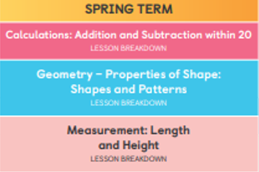

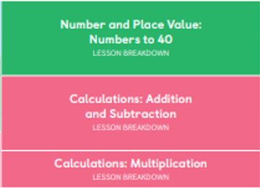

**Computing:**  Sort IT (collecting data and making pictograms)

E - Safety

**Science:**

Plants and growing

Seasonal Change - Spring

**Drama/S&L Opportunities:**

**Role Play:**

**Stories/Texts/links:**

*Rosie Revere Engineer*

Non – Chronological reports - Bees/LSLowry, Manchester / Openshaw fact file, Explanations

Rosie Revere Engineer

**Writing Opportunities:**

**Stories** –Little Red Riding Hood.

**Non – Fiction** – Recount of trip to the woods.