St Clement’s governor blog

The end is in sight…

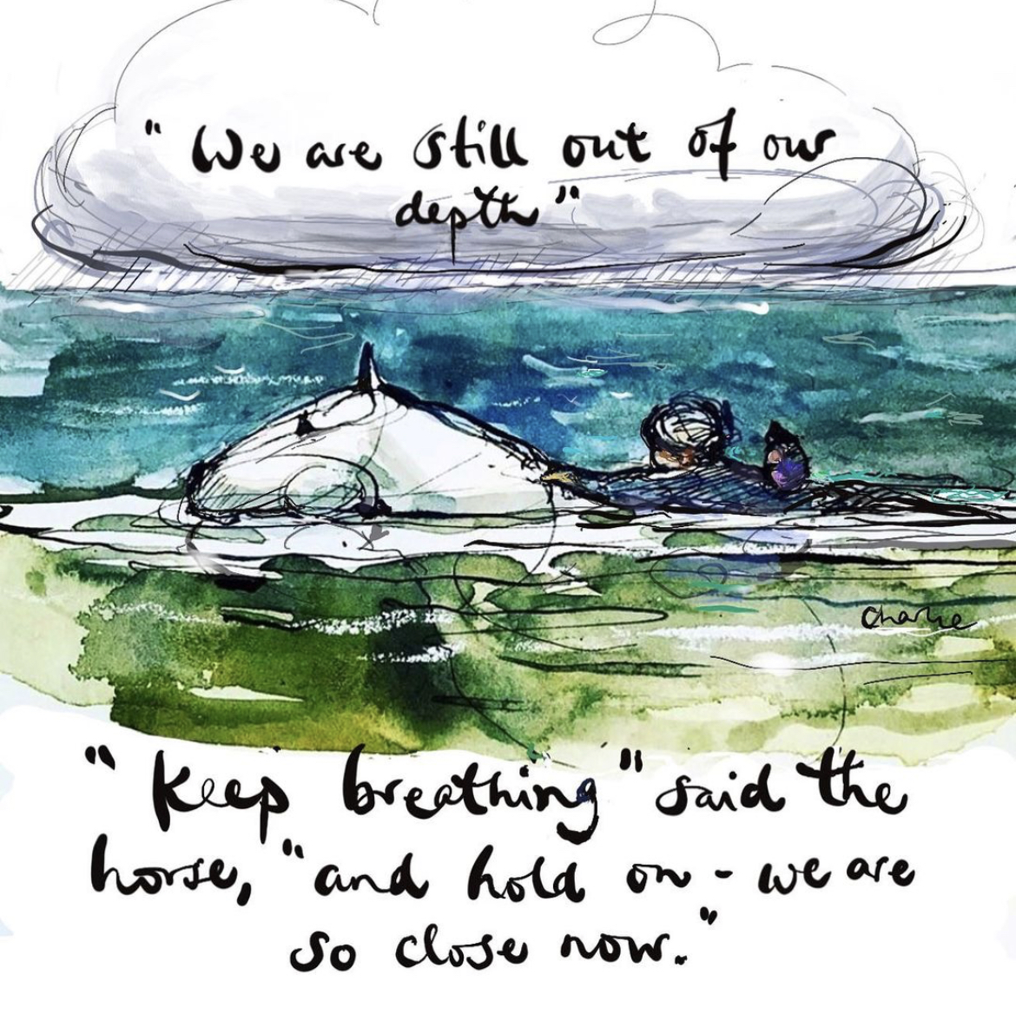

This week marks a year of restrictions, a year of lockdowns, masks, limited social contact and a year of isolation for so many of us. I got an email from work this week that said that in Manchester we’ve been out of lockdown for a total of 23 days in the last year. When I read that it definitely brought home just how tough it’s been. However, the end appears to be in sight & we are so close now!
In spite of the national lockdown, many aspects of school life have continued. There has been limited provision for some pupils in school, whilst others learnt at home. The governors have continued to meet on zoom and we’ve had our full governing body (FGB) meeting and also safeguarding, health & safety, & finance and budget planning meetings have taken place. One of the over arching comments at our meetings is how well the school community has worked together throughout these unprecedented times. So, on behalf of the governors, I wanted to say a huge thank you to everyone in our school community for the incredible hard work and dedication that they’ve shown throughout the year. Everyone has pulled together & worked hard to keep things going for the children.
I think we can all agree that the children have been amazing and shown such resilience through such a turbulent time. Parent/carers had to become teachers overnight and if you’re anything like me, it definitely had it’s challenges!! I struggled enough with year 2 grammar, what’s an adverb of time?? So hats off to those of you with children higher up the school who had to contend with fronted adverbials!! Of course, we couldn’t have got through lockdown without our wonderful staff. Both teaching staff & non teaching staff have gone above and beyond to support our children and their families. Providing work for the children at home whilst still having to teach children in the classroom, home visits, copying work sheets, answering dojo’s, the list could go on. I have always respected the teaching profession but after this lockdown my respect and appreciation has gone to another level.
I’m praying that we have now passed the worst of this pandemic and we can start looking to a brighter future as things hopefully become a bit more “normal”

