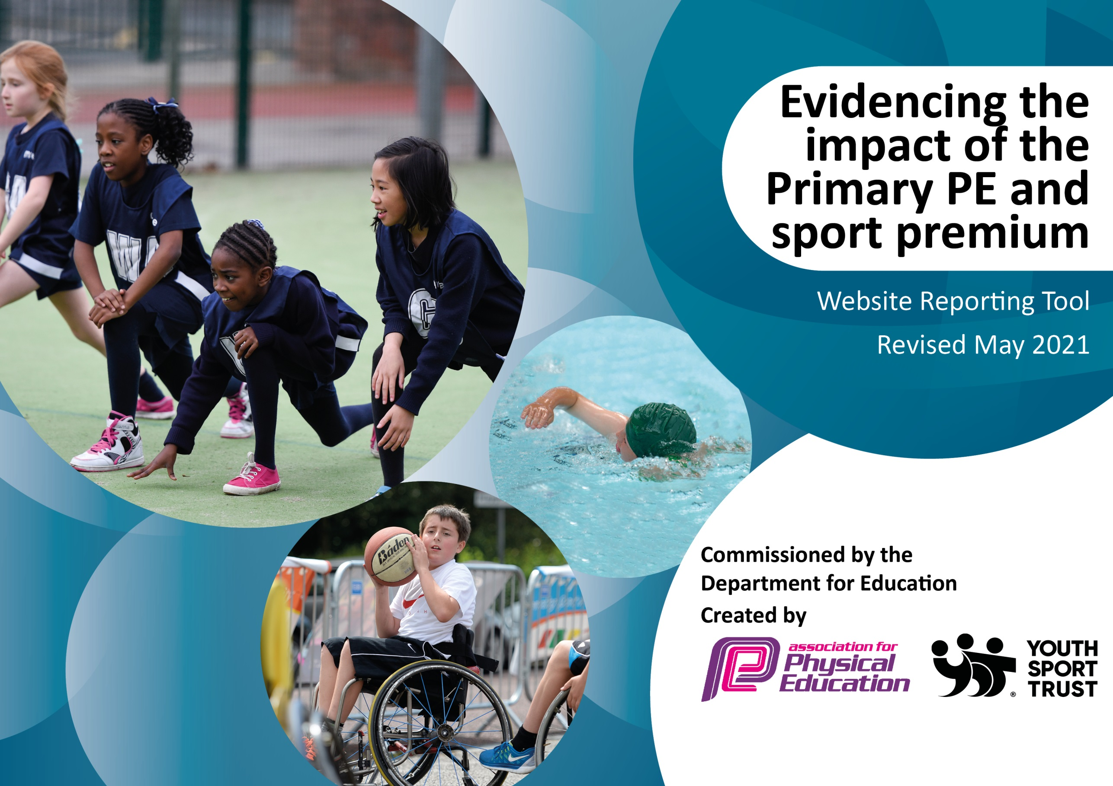

It is important that your grant is used effectively and based on school need. The Education Inspection Framework (Ofsted 2019 p64) makes clear there will be a focus on ‘whether leaders and those responsible for governors all understand their respective roles and perform these in a way that enhances the effectiveness of the school’.

Under the Quality of Education criteria (p41) inspectors consider the extent to which schools can articulate their curriculum (INTENT), construct their curriculum (IMPLEMENTATION) and demonstrate the outcomes which result (IMPACT).

To assist schools with common transferable language this template has been developed to utilise the same three headings which should make your plans easily transferable between working documents.

Schools must use the funding to make additional and sustainable improvements to the quality of Physical Education, School Sport and Physical Activity (PESSPA) they offer. This means that you should use the Primary PE and sport premium to:

- Develop or add to the PESSPA activities that your school already offer
- Build capacity and capability within the school to ensure that improvements made now will benefit pupils joining the school in future years
- The Primary PE and sport premium should not be used to fund capital spend projects; the school’s budget should fund these.
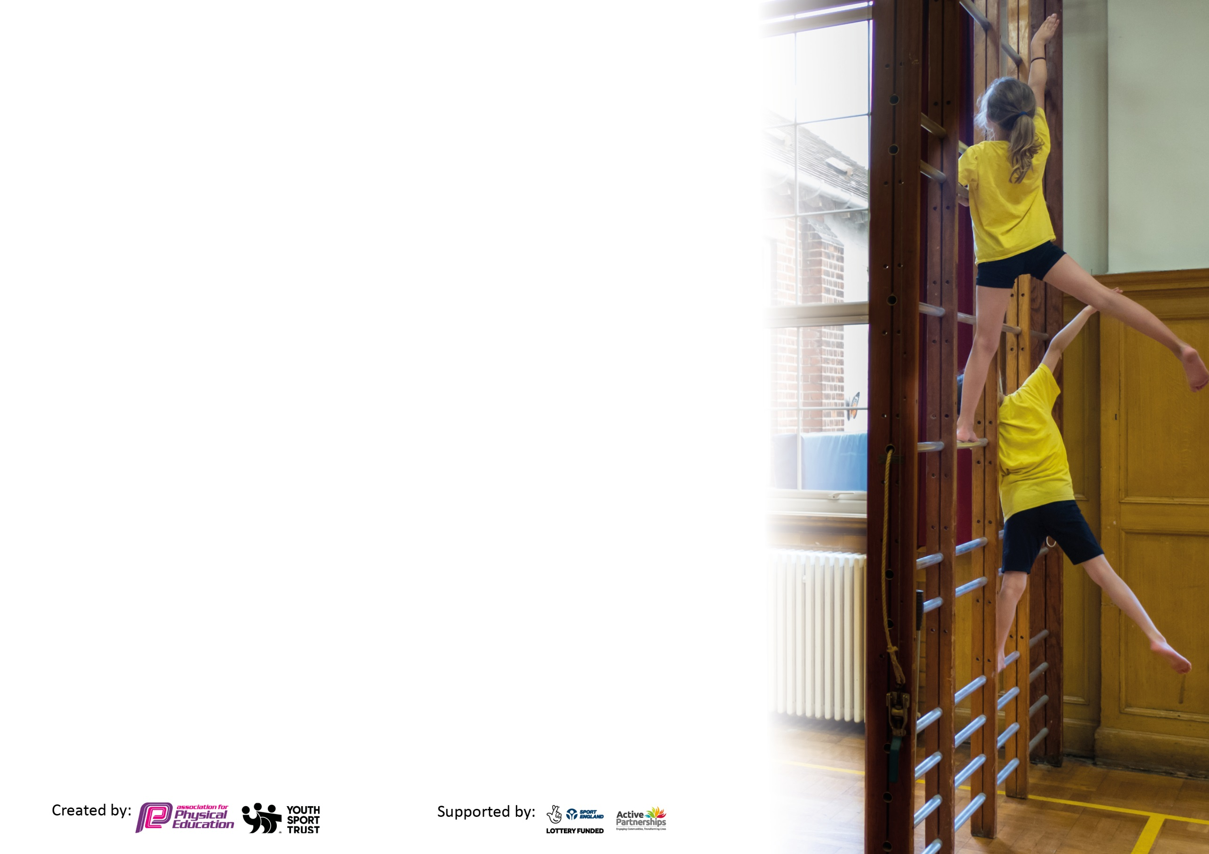
Please visit gov.uk for the revised DfE guidance including the 5 key indicators across which schools should demonstrate an improvement. This document will help you to review your provision and to report your spend. DfE encourages schools to use this template as an effective way of meeting the reporting requirements of the Primary PE and sport premium.

We recommend you start by reflecting on the impact of current provision and reviewing the previous spend.

Schools are required to publish details of how they spend this funding, including any under-spend from 2019/2020, as well as on the impact it has on pupils’ PE and sport participation and attainment by the end of the summer term or by 31st July 2021 at the latest.

We recommend regularly updating the table and publishing it on your website throughout the year. This evidences your ongoing self-evaluation of how you are using the funding to secure maximum, sustainable impact. Final copy must be posted on your website by the end of the academic year and no later than the 31st July 2021. To see an example of how to complete the table please click HERE.

Please note: Although there has been considerable disruption in 2020 it is important that you publish details on your website of how you spend the funding - this is a legal requirement.
Support for review and reflection - considering the 5 key indicators from DfE, what development needs are a priority for your setting and your pupils now and why? Use the space below to reflect on previous spend and key achievements and areas for development.

N.B. In this section you should refer to any adjustments you might have made due to Covid-19 and how these will influence further improvement.
Key achievements to date until July 2021: | Areas for further improvement and baseline evidence of need:
PE Subject Leader Programme 2020-21 - £195.00 key indicator 3 - Increased confidence, knowledge and skills of all staff in teaching PE and sport.  Swimming Programme - £4,111.25  Transport - £2,152.75  Manchester Schools’ PE Association - £1309.00 + Government subsidy £459.00 (20/21) -  PlaySound Services  6 monthly Operational Inspection of equipment - £175.00  Manchester School’s PE Association  MPEA Membership - £850.00 (For academic year 21/22)  Sports Directory  Various items of equipment to provide a wider range of sport to children  TOTAL £1,013.00  Davies Sports  Various items of equipment to provide a wider range of sport to children  TOTAL £3,312.12  TTS (EYFS)  Various items of equipment to provide a wider range of sport to children  TOTAL £315.75  Amazon  Various items of equipment to provide a wider range of sport to children  TOTAL 175.78  Sport First Coaching lunchtime supervision  TOTAL £4,978.00  Sport First Coaching Afterschool Clubs  TOTAL £1,239.00  Sport First Coaching  (Sept 20) 28/09 European Sports Day - £189.00  (May21) Friday Fitness Sessions - £120.00  (Jun21) Friday Fitness Sessions - £60.00  Sports Day / Week £1000.00  Yr6 (Transition) 3 days £500.00 | Children have returned from lockdown having not taken part in sport for a number of months. Children have lower fitness levels and some have gained weight as a result.  Quality of equipment has deteriorated over time. There is also a shortage of variety in equipment to allow new sports to be introduced to the children so a significant amount of funding will need to be spent re-equipping the school.

Did you carry forward an underspend from 2020-21 academic year into the current academic year? YES/NO * Delete as applicable
Total amount carried forward from 2020/2021 £0
+ Total amount for this academic year 2021/2022 £17799
= Total to be spent by 31st July 2022 £17799
Meeting national curriculum requirements for swimming and water safety.

N.B Complete this section to your best ability. For example you might have practised safe self-rescue techniques on dry land which you can transfer to the pool when school swimming restarts.
Due to exceptional circumstances priority should be given to ensuring that pupils can perform safe self rescue even
if they do not fully meet the first two requirements of the NC programme of study.
What percentage of your current Year 6 cohort swim competently, confidently and proficiently over a distance of at least 25 metres?  N.B. Even though your pupils may swim in another year please report on their attainment on leaving primary school at the end of the summer term 2021.  Please see note above. | 42%
What percentage of your current Year 6 cohort use a range of strokes effectively [for example, front crawl, backstroke and breaststroke]?  Please see note above. | 9%
What percentage of your current Year 6 cohort perform safe self-rescue in different water-based situations? | 0%
Schools can choose to use the Primary PE and sport premium to provide additional provision for swimming but this must be for activity over and above the national curriculum requirements. Have you used it in this way? | Yes/No  This is something to consider for this academic year

Action Plan and Budget Tracking
Capture your intended annual spend against the 5 key indicators. Clarify the success criteria and evidence of impact that you intend to measure to evaluate for pupils today and for the future.

Academic Year: 2021/22 | Total fund allocated: £ 21199 | Date Updated: September 2021
Key indicator 1: The engagement of all pupils in regular physical activity – Chief Medical Officers guidelines recommend that primary school pupils undertake at least 30 minutes of physical activity a day in school |  |  |  | Percentage of total allocation:
Intent | Implementation |  | Impact
Your school focus should be clear what you want the pupils to know and be able to do and about  what they need to learn and to  consolidate through practice: | Make sure your actions to achieve are linked to your intentions: | Funding allocated: | Evidence of impact: what do pupils now know and what can they now do? What has changed?: | Sustainability and suggested next steps:
Increase the amount of physical activity taking place at less active times.  Consider PE as an intervention for some children  Increase the amount of children attending after school clubs.  Healthy life styles week. | Complete the Activity Heatmap.  Ask regular attenders of breakfast club how they would like to be active e.g. dance. Currently NA  Look into active maths with maths leads to see if this is something we could implement.  Consider buddies at breaktime leading activities- sports council. TBC  Offer a range of after school clubs.  Get feedback from children about after school clubs and plan accordingly.  Monitor attendance of after school clubs to ensure best use.  Healthy lifestyles week.  Lunchtime active sessions  Introduce the Daily Mile  Liaise more closely with other organisations to provide sport to children.  Introduce lunchtime competitions | £5000
Key indicator 2: The profile of PESSPA being raised across the school as a tool for whole school improvement |  |  |  | Percentage of total allocation:
Intent | Implementation |  | Impact
Your school focus should be clear what you want the pupils to know and be able to do and about  what they need to learn and to  consolidate through practice: | Make sure your actions to achieve are linked to your intentions: | Funding allocated: | Evidence of impact: what do pupils now know and what can they now do? What has changed?: | Sustainability and suggested next steps:
Plan activities to achieve the Gold school games mark.  Dedicate specific days to sport.  Children to understand the importance of exercise on learning.  Children to understand and follow the rules of sports to ensure successful break and lunchtimes.  Children to relate to sport positively.  More opportunities for children to take part in cross curricular activity  Use pupil voice to understand children’s opinion of PE and exercise | PE lead to look at criteria and plan activities accordingly.  Continue with Sports Council (2 children from each class 1-6).  Train sports council on leading activities for breaktimes.  School to take part in European School Sports Day.  School sports day planned for summer term.  Daily Mile to continue.  PE lead to remind staff about 10 minutes a day.  Continue to celebrate children’s achievements via sports star of the week.  New court rules to be written up by sports council and shared with their classes.  Decided court rules to be ordered and put up in playground. | £3000

Key indicator 3: Increased confidence, knowledge and skills of all staff in teaching PE and sport |  |  |  | Percentage of total allocation:
Intent | Implementation |  | Impact
Your school focus should be clear | Make sure your actions to | Funding | Evidence of impact: what do | Sustainability and suggested
what you want the pupils to know | achieve are linked to your | allocated: | pupils now know and what | next steps:
and be able to do and about | intentions: |  | can they now do? What has
what they need to learn and to |  |  | changed?:
consolidate through practice:
Ensure teaching of PE lessons in school is GOOD.  Adapt the PE curriculum where necessary  PE lead is able to make improvements to schools PE and sport.  Gymnastics and Dance training for staff. | PE lead to audit and monitor the sports coach.  PE lead to audit and monitor teachers running PE.  LA PE audit.  PE lead to attend lead meetings every term.  PE lead to have release time in school.  PE lead to feedback to sports coach any relevant information.  PE lead to dedicate time to meeting with sports coach for updates. | £6000
Key indicator 4: Broader experience of a range of sports and activities offered to all pupils |  |  |  | Percentage of total allocation:
Intent | Implementation |  | Impact
Your school focus should be clear | Make sure your actions to | Funding | Evidence of impact: what do | Sustainability and suggested
what you want the pupils to know | achieve are linked to your | allocated: | pupils now know and what | next steps:
and be able to do and about | intentions: |  | can they now do? What has
what they need to learn and to |  |  | changed?:
consolidate through practice:
Increase the variety of after school clubs on offer.  Ensure equipment is available.  Improve a skill across school.  Children participate in a range of activities.  Develop community links for children outside of school.  Children to be given the opportunity to access forest school. TBC due to different timings of Nursery staff available to deliver sessions.  Use partnership with Salford Red Devils to further enhance profile of PE across the school. | Regularly check on the attendance of after school clubs and offer alternatives if numbers are dwindling.  Audit equipment in school and replenish anything dwindling or purchase any additional resources.  Purchase new equipment set for breaktimes.  Y5 to do bikeability.  Attend change for life festivals.  Forest schools in place to develop health and wellbeing.  Organise for local sporting companies to come and do an assembly.  PE lead to look into an activity day for each year group doing an activity they can’t access in school e.g. canoeing at debdale or rock climbing at Manchester climbing centre. | £5500

Key indicator 5: Increased participation in competitive sport |  |  |  | Percentage of total allocation:
Intent | Implementation |  | Impact
Your school focus should be clear | Make sure your actions to | Funding | Evidence of impact: what do | Sustainability and suggested
what you want the pupils to know | achieve are linked to your | allocated: | pupils now know and what | next steps:
and be able to do and about | intentions: |  | can they now do? What has
what they need to learn and to |  |  | changed?:
consolidate through practice:
More SEN/less active children to participate in competitive sport.  Increase the number of inter school competitions that the school takes part in.  Increase the number of intra school competitions.  Competitions at lunchtimes  Arranging own competitions with local or partner schools.  Enter the Panathlon Games for SEND children | Take part in INSPIRE competitions running in Manchester.  Target SEN and less active to attend Inspire competitions.  Continue membership for PE association.  Plan for at least 6 different inter school competitions.  Both B and C teams to participate in inter school competition (3-1)  Book transport for events  At least 1 intra school competition every half term ran by the coach at lunchtimes.  Increase number of KS1 competitions. | £2000

Signed off by
Head Teacher:
Date:
Subject Leader: | Craig Thirsk
Date: | 9.9.21
Governor:
Date:

