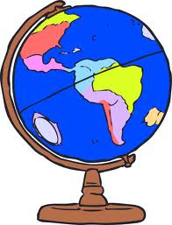 serving Jesus

**Art /DT:**

**DT** – Space vehicles using axels and wheels/ Hot air balloons/Card Viking Long Boat/ Paper Aeroplanes

**Art –** Pastel drawings of space.

Footprints in clay - representing the moon. Art work – Poppies - Remembrance

**Humanities: History/Geography Focus**

**Space and Flight**

**Neil Armstrong**

**Amelia Lockhart**

**The Wright Brothers**

**Hot Air Balloons**

***Map of the GB and the world***

***Continents and Oceans***

**Topic: Year 2 Flying High Autumn 2021**

**Questions children want to investigate:**

*What was the first transport? How do aeroplanes fly when they are so heavy?*

*How do you make aeroplanes?*

*How many planets are there?*

*Who jumped from the moon?*

*How big is the moon?*

*How do rocket ships start?*

-

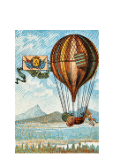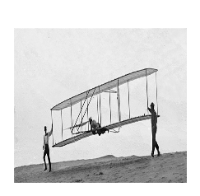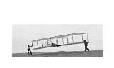

**RE:** The Bible and Special Books

Christmas Good news and The journey to Bethlehem

**PHSE:** Heartsmart scheme of work for year 2

**Science:**

Material Monster- classifying material Properties of materials - Recycling

Changing materials - Materials in the home

Building materials

Animals including humans – food and growth

**Writing Opportunities:**

**All literacy this term will be directly linked to the topic.**

**Imaginative Stories-The Train Ride**

Non Fiction text about Space and Flight

Star Poems

**Drama/S&L Opps:**

**Role Play: Train/Space Area**

**Stories/Texts/links:**

Narrative: Imaginative Stories -Information Text about space and flight, Poetry, Recount of trip

Instructions (linked with DT)

Recount of trip

Instructions (linked with DT) Information Texts

Poetry

**PE and Music:**

Net Games – Striking for Accuracy

Invasion Games – Sending and receiving **Music: Music Express –** Ourselves,

Travel, Toys and Number

**Numeracy Links:**

Primary Numeracy Framework linking with Medium Term plans:

Solve problems involving counting, adding, subtracting, doubling or halving in the context of numbers, measures or money, for example to 'pay' and 'give change' *Role play*

*Reasoning and Application*

*Multiplication 2,5,10- looking at arrays*

Partitioning numbers into tens and units

Identify objects that turn about a point (e.g. scissors) or about a line (e.g. a door); recognise and make whole, half and quarter turns *Using maps of our study areas. Co-ordinates*

*Measurement- How far will my space mobile travel?*

**ICT:** Getting to know IT – Basic skills

Word Processing

Creating Pictures