[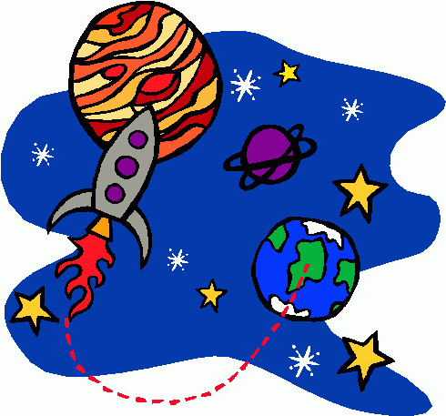](http://www.google.co.uk/url?sa=i&rct=j&q=&esrc=s&frm=1&source=images&cd=&cad=rja&docid=gzP1HPtB2x5XcM&tbnid=rI18YIJp3ZiOHM:&ved=0CAUQjRw&url=http://bestclipartblog.com/25-space-clip-art.html/space-clip-art-4&ei=vIPcUZGwK9Cb0AXn0oDIDw&bvm=bv.48705608,d.d2k&psig=AFQjCNGQKCz-0zOv_4R0Cn0oyc1QKcTyXw&ust=1373492535522801)

**Geography Focus:**

-To locate Washington D.C. on a map.

- Explain what settlers need.

- Explain how and where in the UK electricity is generated and distributed.

- Discuss renewable sources of electricity.

-Explain where our food comes from and use digital maps to create food miles.

- To understand the importance of conserving food, water and energy supplies.

- Explain that access to natural resources varies in different countries.

History Focus:

-Understand the time-line of Kingdom of Benin.T o Examine the context of the Kingdom of Benin in place and time-To Discover what Benin was like 500-100 years ago-To use evidence to deduce what Benin was like-To understand that Benin was absorbed into the British Empire  
-Describe key technological differences between now and the time of the Apollo 11 moon landing.

**Art Focus:**

-Identify some pieces of space themed art from particular artists.   
-African art

**DT Focus:**   
-Motorised space buggies

**ICT:**

**Online Safety-** Pupils will be looking at how to stay safe online.

**Using a search engine-** Pupils will be looking at how you can direct an online search in order to find exactly what you’re looking for.

Topic: Spring Term 2022 Year 5

Out of This World

**PE and Music:**

**PE:** Dance & Gymnastics

**Music:** Solar system and At the movies

**Science:**

Out of this world: This unit is all about space. We learn about; the movement of Earth and other planets in relation to the sun, the movement of the moon relative to Earth, explain day and night and the apparent movement of the sun across the sky using the idea of Earth’s rotation.

Let’s get moving: This unit is all about forces and magnets. We learn about; gravity, air resistance, water resistance, friction, levers, pulleys and gears.

**Writing Opportunities:**

Opportunities will be provided for children to complete some cross-curricular writing:

* Non-fiction information booklets about Space.
* Biographies of women in the Old Testament.
* Menus
* Persuasive texts

**Drama/S&L Opps:**

Drama through role play of astronauts and scientists. S&L opportunities throughout.

**Debate**: Should we travel to space/ will there be humans in space in the future?

**Stories/Texts/links:**

Selection of nonfiction books about space

Extracts from Astronaut Journals

Poetry about Space

Quality scientific texts for guided reading.

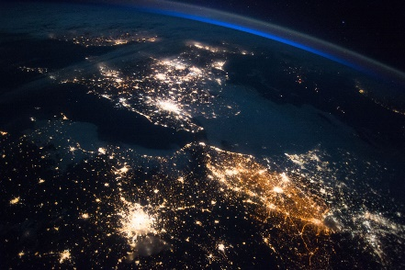

**RE:**

Women of the Old Testament

Easter Victory

**MFL:** The children will learn vocabulary, stories, songs and understand the main points of a text.

**Numeracy Links:**

Maths No Problem!

Our focus is on fractions and percentages this half term!

In Science children will be using data and tables, interpreting them and analysing it. They will also be making graphs and presenting data, making links with previous learning in maths.