serving Jesus

Spring 2022 Year 2: **Wild about Animals**

**Humanities: Wild about animals**

**History:** Complete work on explorers from the past.

**Geography:**

Map Work, UK countries, the continents and oceans. Then we will compare the city of London with a more rural location looking at the landscape and animals that live there.

**Questions children want to investigate:**

How many different countries are there?

Why are there different animals in different countries?

What is a rainforest?

 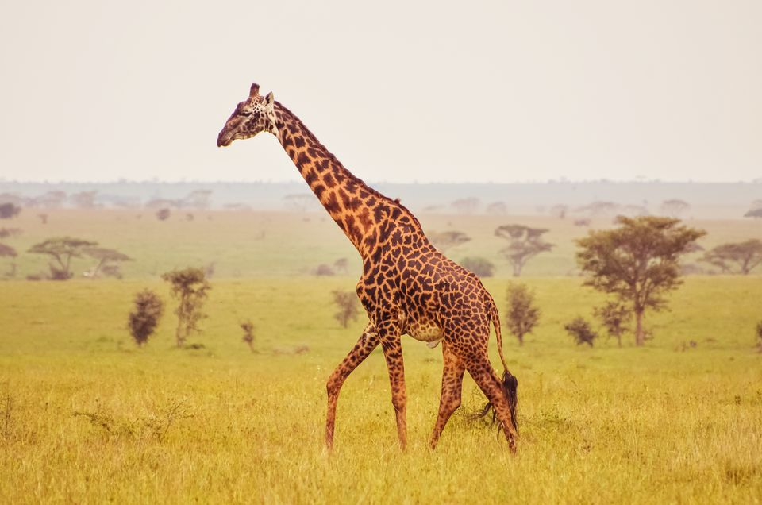

**Writing Opportunities:**

We will be doing some nonfiction writing: A Non-chronological report about bears and another animal of our choice.

We will also be doing a range of writing based around our new text, which will be A Bear Called Paddington, by Michael Bond.

.

**PE and Music:**

Outdoor Games

Music: We will be looking at South American Music and following the Music Express Scheme. We will also choose a new class song for our class worship.

**Art /Design and Technology:**

**DT**: Making healthy snacks and exploring Peruvian food and ingredients

**Art:** We will study art and textiles from Peru, including sewing/weaving and some Nazca printing.

**Drama and Speaking and Listening:**

We will be thinking about how to make someone welcome when we first meet them – inspired by our Literacy work on Paddington.

We will also be doing spoken presentations about different animals from around the world.

**Maths:**

We are continuing to use our new Maths No Problem! Scheme of work. We will be learning about:

Multiplication

Division

Measurement – length, mass, temperature and money

Shapes – 2D, 3D

Fractions

**Science:**

Plants - we will be looking at different types of plants and how some plants are foods. We will also be looking at healthy foods.

Mini Worlds- where we will be looking closely at invertebrates and their habitats and comparing them to animals found in South America and the rainforests.



**Computing:**

E-Safety: We will be learning about what the dangers are online and how to keep ourselves safe.

**RE:**

Using the Blackburn scheme of work:

Jesus: Friend to Everyone and Easter Symbols

Heart smart units: Too much selfie isn’t healthy, Don’t rub it in, rub it out!