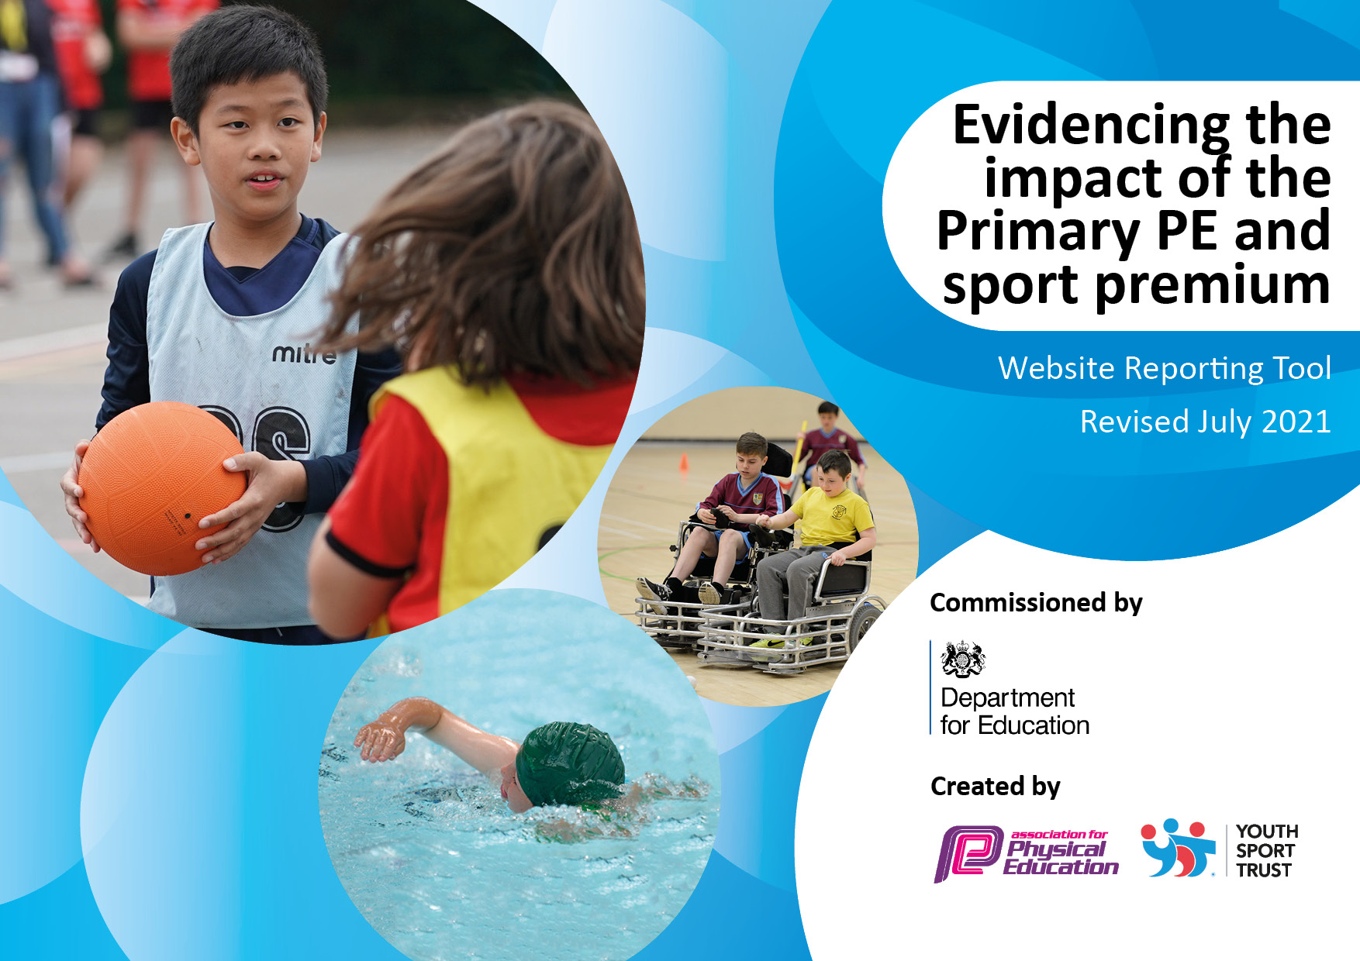
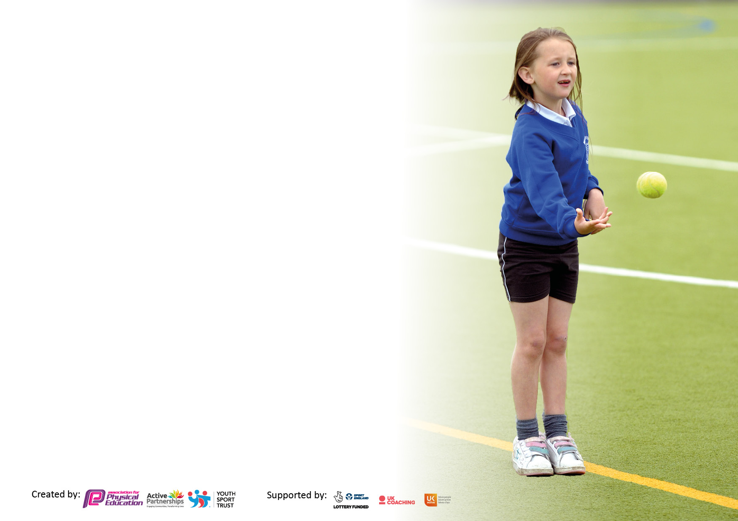

It is important that your grant is used effectively and based on school need. The Education Inspection Framework makes clear there will be a focus on ‘whether leaders and those responsible for governors all understand their respective roles and perform these in a way that enhances the effectiveness of the school’.

Under the Quality of Education Ofsted inspectors consider:
Intent - Curriculum design, coverage and appropriateness
Implementation - Curriculum delivery, Teaching (pedagogy) and Assessment
Impact - Attainment and progress

To assist schools with common transferable language this template has been developed to utilise the same three headings which should make your plans easily transferable between working documents.

Schools must use the funding to make additional and sustainable improvements to the quality of Physical Education, School Sport and Physical Activity (PESSPA) they offer. This means that you should use the Primary PE and sport premium to:

- Develop or add to the PESSPA activities that your school already offer
- Build capacity and capability within the school to ensure that improvements made now will benefit pupils joining the school in future years
- The Primary PE and sport premium should not be used to fund capital spend projects; the school’s budget should fund these.

Pleasevisitgov.ukfortherevisedDfEguidanceincludingthe5keyindicatorsacrosswhichschoolsshoulddemonstrate animprovement.Thisdocumentwillhelpyoutoreviewyourprovisionandtoreportyourspend.DfEencouragesschools to use this template as an effective way of meeting the reporting requirements of the Primary PE and sport premium.

We recommend you start by reflecting on the impact of current provision and reviewing the previous spend.

Schools are required to publish details of how they spend this funding, including any under-spend from 2019/2020, as well as on the impact it has on pupils’ PE and sport participation and attainment. All funding must be spent by 31st July 2022.

We recommend regularly updating the table and publishing it on your website throughout the year. This evidences your ongoing self-evaluation of how you are using the funding to secure maximum, sustainable impact. Final copy must be posted on your website by the end of the academic year and no later than the 31st July 2021. To see an example of how to complete the table please click HERE.

Details with regard to funding
Please complete the table below.

Total amount carried over from 2019/20 | £3400
Total amount allocated for 2020/21 | £21199
How much (if any) do you intend to carry over from this total fund into 2021/22? | £0
Total amount allocated for 2021/22 | £17799
Total amount of funding for 2021/22. To be spent and reported on by 31st July 2022. | £17799
Swimming Data
Please report on your Swimming Data below.

Meeting national curriculum requirements for swimming and water safety.

N.B. Complete this section to your best ability. For example you might have practised safe self-rescue techniques on dry land which you can then transfer to the pool when school swimming restarts.
Due to exceptional circumstances priority should be given to ensuring that pupils can perform safe self rescue even if they do not fully meet the first two requirements of the NC programme of study
What percentage of your current Year 6 cohort swim competently, confidently and proficiently over a distance of at least 25 metres?  N.B. Even though your pupils may swim in another year please report on their attainment on leaving primary school at the end of the summer term 2020.  Please see note above | 42%
What percentage of your current Year 6 cohort use a range of strokes effectively [for example, front crawl, backstroke and breaststroke]?  Please see note above | 9%
What percentage of your current Year 6 cohort perform safe self-rescue in different water-based situations? | 0%
Schools can choose to use the Primary PE and sport premium to provide additional provision for swimming but this must be for activity over and above the national curriculum requirements. Have you used it in this way? | Yes/No This is to be considered for this year.

Action Plan and Budget Tracking
Capture your intended annual spend against the 5 key indicators. Clarify the success criteria and evidence of impact that you intend to measure to evaluate for pupils today and for the future.

Academic Year: 2020/21 | Total fund allocated: £17799 | Date Updated: September 2021
Key indicator 1: The engagement of all pupils in regular physical activity – Chief Medical Officers guidelines recommend that primary school pupils undertake at least 30 minutes of physical activity a day in school |  |  |  | Percentage of total allocation:
 |  |  |  | %
Intent | Implementation |  | Impact
Your school focus should be clear what you want the pupils to know and be able to do and about  what they need to learn and to  consolidate through practice: | Make sure your actions to achieve are linked to your intentions: | Funding allocated: | Evidence of impact: what do pupils now know and what can they now do? What has changed?: | Sustainability and suggested next steps:
Increase the amount of physical activity taking place at less active times.  Consider PE as an intervention for some children  Increase the amount of children attending after school clubs.  Healthy life styles week. | Complete the Activity Heatmap.  Ask regular attenders of breakfast club how they would like to be active e.g. dance. Currently NA  Look into active maths with maths leads to see if this is something we could implement.  Consider buddies at breaktime leading activities- sports council. TBC  Offer a range of after school clubs.  Get feedback from children about after school clubs and plan accordingly.  Monitor attendance of after school clubs to ensure best use.  Healthy lifestyles week.  Lunchtime active sessions  Introduce the Daily Mile  Liaise more closely with other organisations to provide sport to children.  Introduce lunchtime competitions | £5000 | Aut 1  School took part in ESSD. Children each had 2 hours active time over the course of the day.  Range of activities available for children to take part in at lunchtime.  Competitions have begun to be delivered at lunchtime by CaRe with a winner chosen each week.  After school clubs are running for all year groups with attendance relatively high for each one.  Aut 2  After school clubs are still running with good attendance and children speak about how they enjoy the sessions provided for them.  Lunchtime competitions with weekly awards have begun.  Football matches have been played against other schools for all KS2 year groups – boys, girls and mixed.  Spr Term  All afterschool clubs are now open to multiple year groups following the relaxation of COVID restrictions meaning more children can attend.  CaRe has begun an active intervention based around fitness. Staff have nominated those children most in need.  Healthy lifestyles week has begun to be planned by LS. This will continue this half term.  Health Champions have begun work on action planning for Summer term.  CaRe has continued to run lunchtime challenges. The next step is for Health Champions to run these.  Y3 have begun fitness sessions daily. This will be rolled out across the school throughout the term.  Y3 football tournament at Mcr United.
Key indicator 2: The profile of PESSPA being raised across the school as a tool for whole school improvement |  |  |  | Percentage of total allocation:
 |  |  |  | %
Intent | Implementation |  | Impact
Your school focus should be clear what you want the pupils to know and be able to do and about  what they need to learn and to  consolidate through practice: | Make sure your actions to achieve are linked to your intentions: | Funding allocated: | Evidence of impact: what do pupils now know and what can they now do? What has changed?: | Sustainability and suggested next steps:
Plan activities to achieve the Gold school games mark.  Dedicate specific days to sport.  Children to understand the importance of exercise on learning.  Children to understand and follow the rules of sports to ensure successful break and lunchtimes.  Children to relate to sport positively.  More opportunities for children to take part in cross curricular activity  Use pupil voice to understand children’s opinion of PE and exercise | PE lead to look at criteria and plan activities accordingly.  Continue with Sports Council (2 children from each class 1-6).  Train sports council on leading activities for breaktimes.  School to take part in European School Sports Day.  School sports day planned for summer term.  Daily Mile to continue.  PE lead to remind staff about 10 minutes a day.  Continue to celebrate children’s achievements via sports star of the week.  New court rules to be written up by sports council and shared with their classes.  Decided court rules to be ordered and put up in playground. | £3000 | Aut 1  School took part in ESSD. Children each had 2 hours active time over the course of the day.  CT is continuing to work with individual/small groups of children to regulate their behaviour and link it to the rules of sport  CT and CaRe have chosen the children for Sport council. Work to begin next half term.  Aut 2  Children understand the rules of lunchtime games that are provided and as such incidents are down on this time last year.  Review of PE curriculum has begun in Aut2 and will carry on in Spr 1. Pupil voice has been considered as well as that of the coach/es  Sports Council has not taken place. This is a priority for Spr 1.  Football matches have been played against other schools for all KS2 year groups – boys, girls and mixed. The take up of girls in Y5 has been a particular success.  Spr Term  CaRe has continued to run lunchtime challenges. The next step is for Health Champions to run these.  Y3 have begun fitness sessions daily. This will be rolled out across the school throughout the term.  CaRe has begun an active intervention based around fitness. Staff have nominated those children most in need.  Healthy lifestyles week has begun to be planned by LS. This will continue this half term.  Health Champions have begun work on action planning for Summer term.  CaRe has worked with individuals around the rules of sports to ensure that children play fairly and understand the games they are playing.  Sports Day has begun to be planned. CaRe has been in touch with WRC to see if there are any resources available.

Key indicator 3: Increased confidence, knowledge and skills of all staff in teaching PE and sport |  |  |  | Percentage of total allocation:
 |  |  |  | %
Intent | Implementation |  | Impact
Your school focus should be clear | Make sure your actions to | Funding | Evidence of impact: what do | Sustainability and suggested
what you want the pupils to know | achieve are linked to your | allocated: | pupils now know and what | next steps:
and be able to do and about | intentions: |  | can they now do? What has
what they need to learn and to |  |  | changed?:
consolidate through practice:
Ensure teaching of PE lessons in school is GOOD.  Adapt the PE curriculum where necessary  PE lead is able to make improvements to schools PE and sport.  Gymnastics and Dance training for staff. | PE lead to audit and monitor the sports coach.  PE lead to audit and monitor teachers running PE.  LA PE audit.  PE lead to attend lead meetings every term.  PE lead to have release time in school.  PE lead to feedback to sports coach any relevant information.  PE lead to dedicate time to meeting with sports coach for updates. | £6000 | Aut 1  PE teaching is of a good standard and has been monitored via informal lesson walkthroughs and feedback from staff.  Strong focus on the entirety of the curriculum being taught this year as we move back to a more normal way of teaching. All classes are receiving the breadth of the PE curriculum.  Aut 2  Lessons taught continue to be of a good standard and follow the MTPs as they are now.  Review of PE curriculum has begun in Aut2 and will carry on in Spr 1. Pupil voice has been considered as well as that of the coach/es  Dance and gymnastics specialist coaches have been organised for Spr term for the delivery of these areas so children receive the very best lessons they can.  Regular meetings have taken place between the PE lead and coach to ensure that all relevant updates are shared (eg COVID regs, Schools Game Mark etc)  CT has continued to attend the PESL meetings.  Spr Term  Regular meetings have taken place between the PE lead and coach to ensure that all relevant updates are shared (eg COVID regs, Schools Game Mark etc)  CT has continued to attend the PESL meetings.  CT and CaRe have continued to meet on a regular basis to discuss updates from lead meetings.  New curriculum has been purchased and has begun to be used across the school.  After school staff fitness sessions have begun to increase fitness and improve moral. As part of this, CaRe links the activities to how they can be adapted for children.  Staff meeting to be run by CaRe during Aut 1 2022 to share knowledge and expertise in regard to the teaching of PE.
Key indicator 4: Broader experience of a range of sports and activities offered to all pupils |  |  |  | Percentage of total allocation:
Intent | Implementation |  | Impact
Your school focus should be clear | Make sure your actions to | Funding | Evidence of impact: what do | Sustainability and suggested
what you want the pupils to know | achieve are linked to your | allocated: | pupils now know and what | next steps:
and be able to do and about | intentions: |  | can they now do? What has
what they need to learn and to |  |  | changed?:
consolidate through practice:
Increase the variety of after school clubs on offer.  Ensure equipment is available.  Improve a skill across school.  Children participate in a range of activities.  Develop community links for children outside of school.  Children to be given the opportunity to access forest school. TBC due to different timings of Nursery staff available to deliver sessions.  Use partnership with Salford Red Devils to further enhance profile of PE across the school. | Regularly check on the attendance of after school clubs and offer alternatives if numbers are dwindling.  Audit equipment in school and replenish anything dwindling or purchase any additional resources.  Purchase new equipment set for breaktimes.  Y5 to do bikeability.  Attend change for life festivals.  Forest schools in place to develop health and wellbeing.  Organise for local sporting companies to come and do an assembly.  PE lead to look into an activity day for each year group doing an activity they can’t access in school e.g. canoeing at debdale or rock climbing at Manchester climbing centre. | £5500 | Aut 1  After school clubs are running for all year groups with attendance relatively high for each one.  Equipment has been bought to widen the offer for the children.  Links are in place with Salford Red Devils and CT is waiting on a reply. Possible link with Mcr Giants – more information being sought.  Forest School to be utilised in Aut 2. After school club planned and another session to be delivered during the school day.  Aut 2  Afterschool clubs have been well attended throughout the year so far. To be continued for Spr 1 before changing the provision.  New equipment continues to be ordered as necessary  Forest School has had to be postponed until the new year due to inconsistent staffing in key year groups.  Spr Term  Forest school is taught weekly as an after school club.  All afterschool clubs are now open to multiple year groups following the relaxation of COVID restrictions meaning more children can attend.  Y6 are attending an outdoor adventure day in Summer term.  Tournaments at Mcr United have been arranged for Y3 and Y5.

Key indicator 5: Increased participation in competitive sport |  |  |  | Percentage of total allocation:
 |  |  |  | %
Intent | Implementation |  | Impact
Your school focus should be clear | Make sure your actions to | Funding | Evidence of impact: what do | Sustainability and suggested
what you want the pupils to know | achieve are linked to your | allocated: | pupils now know and what | next steps:
and be able to do and about | intentions: |  | can they now do? What has
what they need to learn and to |  |  | changed?:
consolidate through practice:
More SEN/less active children to participate in competitive sport.  Increase the number of inter school competitions that the school takes part in.  Increase the number of intra school competitions.  Competitions at lunchtimes  Arranging own competitions with local or partner schools.  Enter the Panathlon Games for SEND children | Take part in INSPIRE competitions running in Manchester.  Target SEN and less active to attend Inspire competitions.  Continue membership for PE association.  Plan for at least 6 different inter school competitions.  Both B and C teams to participate in inter school competition (3-1)  Book transport for events  At least 1 intra school competition every half term ran by the coach at lunchtimes.  Increase number of KS1 competitions. | £2000 | Aut 1  Competitions have begun to be planned between SFC partner schools. This is to carry on throughout the year.  Competitions have begun to be delivered at lunchtime by CaRe with a winner chosen each week.  Aut 2  Transport has been booked to take children to matches at other local schools. The variety of sports on offer will widen into the new year (restrictions dependent)  Lunchtime competitions have begun and are continuing throughout the year. Weekly prize in assembly for the winners (Not always chosen as the highest scorer, effort and enjoyment are also considered)  Wider competitions to be booked in the new year  Spr Term  Tournaments at Mcr United have been arranged for Y3 and Y5.  Meeting to arrange a tournament at Dane Bank Primary arranged for 3.5.22 @ 10.30. CaRe to attend.  CaRe has continued to run lunchtime challenges. The next step is for Health Champions to run these.  Plan for SEND children to take part in competitions within school during Summer term.

Signed off by
Head Teacher: | J.Parker
Date: | 10.9.21
Subject Leader: | C.Thirsk
Date: | 9.9.21
Governor:
Date:

