St Clement’s C. of E. Primary School

Editing and Improving Policy

Reviewed by JY, HSH & CG (Literacy Leads): May 2022
Approved by JP (Head): May 2022

Due for review: May 2023

Growing Together To Let Our Light Shine
John 3:18 ‘Little children, let us not love in word or talk but in deed and in truth.'
Mission Statement:
We encourage and inspire children to aim high and challenge themselves in everything they do.
As a compassionate, Christian school, we are strong in our faith. We believe in love and forgiveness and are thankful for the opportunities we have to live and learn in our community.
(REVIEWED JULY 2019)

Our Christian Values Reflected In This Policy
Faith
Hope
Love
Respect
Thankfulness
Compassion
Forgiveness
(September 2017)

DDA STATEMENT

At St. Clement’s we will aim to:
- Promote equality of opportunity between disabled people and others.
- Eliminate discrimination that is unlawful under the Act.
- Eliminate harassment of disabled pupils that is related to their disabilities.
- Promote positive attitudes towards disabled people.
- Encourage participation by disabled people in public life.
- Take account of a disabled person’s disabilities, even when that involves treating a disabled person more favourably than another person.

Rights Respecting School Link to Articles: 1, 2, 3, 4, 5, 12, 14, 16, 17, 18, 19, 28, 29 & 41.

Editing and improving in our school:
At St.Clement’s C of E Primary School, we believe providing feedback to our pupils is an essential aspect of the Teaching and Learning process. We ensure all of our pupils are provided with regular feedback during their learning. We believe pupils should be actively involved in the marking and feedback process, and we believe feedback at the point of learning (both verbally and written) is one of the things that can have an impact on our pupil’s learning and progress – e.g. praising and letting pupils know what they are doing well; ensuring misconceptions are dealt with at the point of learning. Through feedback at the point of learning, pupils can be given next steps to act upon/have their thinking challenged and progress in all sessions.
In English, we want pupils to understand the importance of the stages of the writing journey that we promote in school: the exploring and practising of skills in phase 1, the planning stage in phase 2 and then drafting, revising, editing, and publishing in phase 3- as all authors go through this writing process in order to produce their best final piece of writing. We expect pupils to use their English exercise books, for phases 1, 2 and 3 of our Literacy Learning journeys. In Key Stage 2, we have Literacy three books, in which mixed groups work together to carry out speaking and listening (S&L) activities/Talk for writing activities/activities linked to the shared reading being carried out. Pupils will also carry out short writes, which will be in their own exercise books. Throughout Phase 1 of the Literacy Learning Journey, pupils use their English exercise books to develop their writing skills, and we don’t expect this to always be their best presented work (level 2 handwriting).
Throughout the phases, pupils will be carrying out writing and during phase 3, pupils will draft pieces of writing in their exercise books, applying skills they have been exposed to, explored and practised in phase 1 and using their plans derived in phase 2. Pupils will continually self-assess and improve their work in response to self, peer, group evaluation or after discussion with the teacher. We are actively training our pupils to be more proactive by proof reading and checking for errors with their basic skills, spellings (please see Spelling Policy for more guidance) and to make sure their writing makes sense etc. In books you may see the coding below used by teaching staff or in some cases pupils (please see the Presentation, Marking and Feedback policy for more details). This is where pupils have been encouraged to proof read their work to check their basic skills and for errors in spelling, grammar and punctuation – pupils use pencils to correct their errors or improve their writing.
The coding system:
P = Punctuation error
C = Capital letters errors
G = Grammar issue
= Missing word/words
S = Spelling error
V = Vocabulary choice
Pupils are also encouraged to put a dot under words that they have found challenging, so they can return to it to check the spelling of it. Towards the end of reception and in Year 1, pupils are being encouraged to proof read each other’s work, to check: it makes sense, for finger spaces, for capitals and full stops, and if they are applying their phonic skills – they wear ‘glasses’ to get in to the important role of a reader to read and check their partners work! (Please refer to the spelling policy for more details on how to support pupils with spelling amendments).
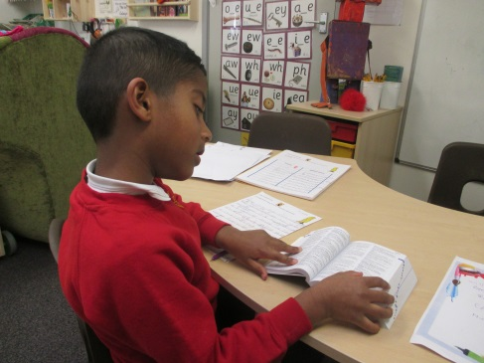
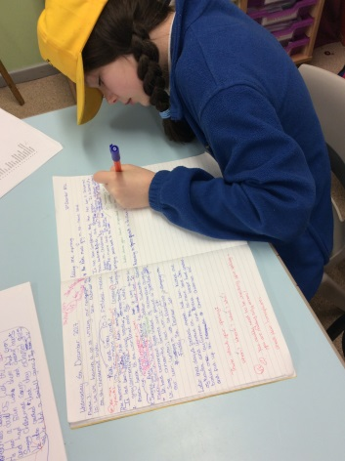
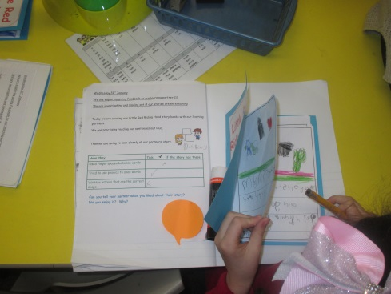

Year 6 Pupil editing and improving

Year 4 Pupil editing and improving

Year One, wearing their glasses

Year 2 Pupil editing and improving
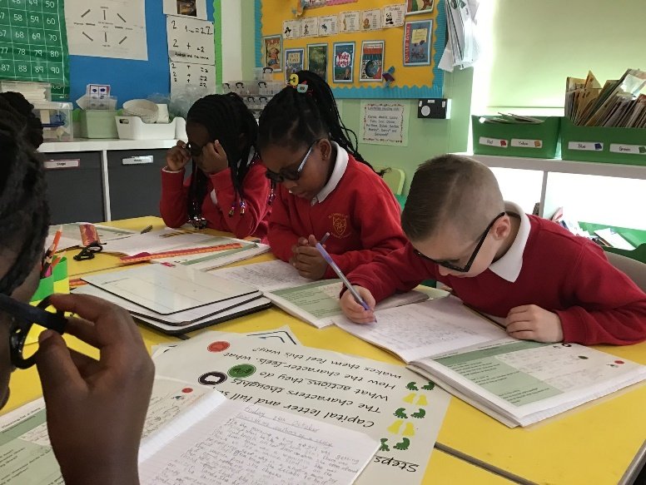
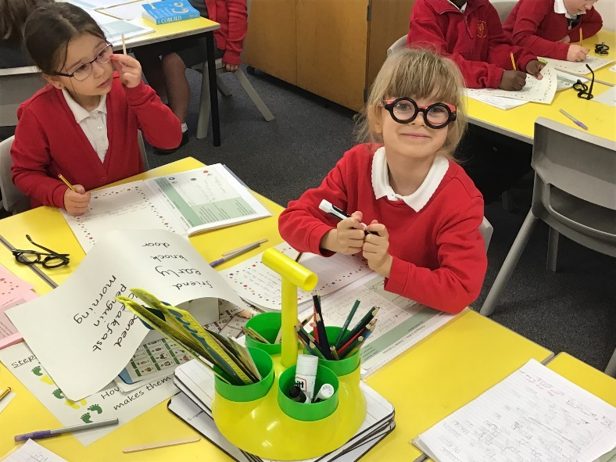
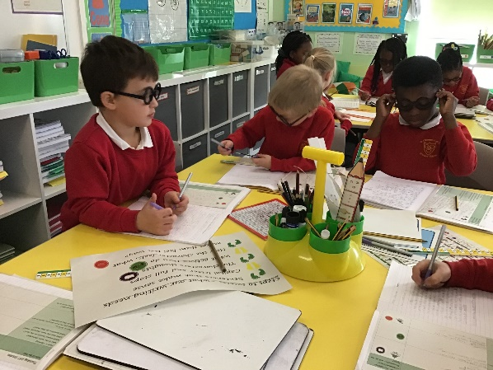

We are also teaching our pupils, at the appropriate level, of how to edit and improve their writing effectively: using writing skills they are taught, exposed to through shared reading/writing, and from the three areas of the “Writing Rainbow”: The Grammaristics, The Fantastics and the Boomtastics, taken from the Write Stuff approach.
Teachers will model to pupils how to edit and proof read writing live in the shared writes. Teachers will also use Guided Writes as an opportunity to guide pupils about how to edit and improve their writing to make it the best it can possibly be. In phase 3 teachers may provide 1 to 1 opportunities in order to discuss and together think of next steps to improve their writing. Pupils may focus on specific aspects they need to edit and improve in order to improve their piece of writing e.g. word modification, sentence construction and punctuation and text cohesion or linked to The Grammaristics, The Fantastics and the Boomtastics.
Editing and improving, where used, should be appropriate to the age and ability of the child, and may vary across year groups and key stages. In year 1 the expectation is for pupils to proof read for their basic skills and try and fix these, but to also show they can improve part of their writing to the best it can be and possibly publish it for their Wonderful Writing Book. It is the teacher’s discretion what the focus of editing and improving needs to be and how much of it needs to be edited and improved. There may be different focusses for different sessions e.g. for some pupils it may only be specific sentences, for others specific paragraphs, for other pupils, more capable with editing and improving, they may be able to edit and improve all of their writing as they go along or in response to given feedback.
In some classes pupils have the opportunity to have some 1 to 1 feedback time with a member of teaching staff. The member of teaching staff will read/talk through the pupils work with them and talk about the strengths of the piece of writing and then discuss with the pupil possible ways to improve the piece of writing. The pupil will then respond to the feedback independently. The teacher may plan a guided writing focus session to support pupils who have displayed the same areas of need, and work with the group to model and support pupils with editing & improving specific focuses/parts of their writing.
In year 2 and at the beginning of year 3 until the end of Autumn 2, pupils are using purple pens to show their editing/additions to improve their writing.
In years 4 to 6, pupils are encouraged to neatly correct their work (with pencil to highlight these changes) if they have made errors and make improvements in response to feedback or in response to proof reading and self-assessment of their own work. We want our pupils to understand the drafting, editing & improving process of writing is key and this is a process authors go through:
- https://www.youtube.com/watch?v=4iGfYt8fR4U
However, some written pieces the children produce, will not always follow the above process in depth (e.g. not Learning Journey unit pieces), these may be timed pieces of work, shorts writes, one off pieces of writing (whole school creative write), a piece of writing carried out in another subject where pupils are applying their writing skills and pieces of writing set to encourage pupils to apply previous taught skills. Pupils can still edit and improve, but this will only be through self-assessment. The brief alongside the piece of writing in the Wonderful Writing Book will give details about the writing.

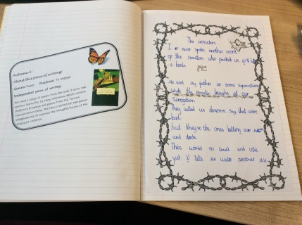

Example of Wonderful Writing book brief

It is essential teaching staff are constantly modelling editing and improving strategies throughout the English curriculum and the rest of the curriculum and continue to provide pupils with the knowledge, support and resources needed to do this effectively and confidently. Final drafts (the best a pupil can do), which have been edited and improved in response to self, peer, or group evaluation will then be published by the pupil and put in to their Wonderful Writing Book, this will not be marked by the teacher as it is the final draft and the best the child is capable of doing, therefore an accurate representation where the pupil can be assessed at with their writing. We aim to support our pupils in becoming independent, motivated, confident writers throughout the writing process. We also want to celebrate our pupil’s writing.

Expectations for Wonderful Writing Books 2021 - 2022:
Please see below the revised expectations for what should be in pupils Wonderful Writing Books (WWB). We still want to keep the WWBs, as we have been praised for these and ultimately we want our children to see the process that an author goes through of exploring writing, planning for writing, drafting, editing, improving their writing, then finally, publishing, but we do not want it to be an onerous task for pupils, as we want them to be motivated writers, proud of their final write and enjoy the writing up session.
Allowing pupils to be illustrators too motivates them, or to read/show their final writes to an audience gives them an incentive, or invite parents/carers in to see their final writes motivates some pupils and obviously acknowledgement/awards for producing quality work. Again as the Editing & Improving policy states – the Wonderful Writing pieces should be the pupils ‘best for them’ piece of writing in response to adults’ feedback, self/peer assessment. There should be a noticeable difference between the draft and final draft as shown in our Presentation policy for Literacy. They should not be marked – as the marking will have been done in their Literacy books and the final draft is to show their response.
Please continue to write briefs to explain what the piece of writing is/the support given etc – please find the format for this if needed on the Literacy file.
Year groups: | Expectation:
Foundation Stage | To continue what is in already in place
KS1 | At least 1 Literacy unit written up/published per term in pupils’ best handwriting (level 1) and presented creatively in their Wonderful Writing Books e.g. they may present it in a book/on special paper etc.  Pupils should also publish sentences/paragraphs/short writes they are proud of and these can be stuck up.  There should also be evidence of cross curricular writing pieces in their WWB’s, again presented creatively and applying their level handwriting skills.  You may allow pupils to type up a piece of writing, so they can apply their ICT skills – but the auto-correct must be taken off to show pupils capability.  *If pupils have brought some quality writing in from home/for homework these can also be stuck in, but just need to be listed on the additional writing on the contents page.
Ks2 | At least 1 Literacy unit written up/published per term in pupils’ best handwriting (level 1) and presented creatively in their Wonderful Writing Books e.g. they may present it in a book/on special paper etc.  Pupils should also publish sentences (SEN)/paragraphs/short writes they are proud of and these can be stuck up.  There should also be evidence of cross curricular writing pieces in their WWB’s, again presented creatively and applying their level 1 handwriting skills.  You may allow pupils to type up a piece of writing, so they can apply their ICT skills – but the auto-correct must be taken off to show pupils capability.  KS2 writing projects may also be an opportunity for pupils to write something for their WWB.  *If pupils have brought some quality writing in from home/for homework these can also be stuck in, but just need to be listed on the additional writing on the contents page.

Editing Writing Progression
St Clements Primary School Years R-6
Editing writing does not just mean making corrections to errors in written work e.g. changing a lower-case letter into a capital letter at the start of a sentence. Editing can also include revision of longer sections of work to further improve what has already been written and can also include additions to the original piece of work. It may help to use the following 3 terms in your editing and feedback sessions:
correct improve
add
Please note that teacher modelling of the correct editing process must be taught and shared with the children in each year group before they should be expected, to edit their own writing. You may need to revisit/reteach a particular editing skill at the start of each editing session, so that children are aware of your high expectations for correcting their work.

 | Editing Expectations | Editing & Responding to Feedback
Reception | From the start of the summer term, children should be shown how to edit their writing to check for errors and correct:  - Capital letters, full stops,  - Finger spaces  - Re – reading for sense  - Spellings (key words and phonetically decodable words from phases 2 and 3).  Word mats / vocabulary vaults (word banks) / phonics mats should be provided in sessions. | - Correct handwriting (especially correct letter formation; punctuation formation and spaces between words)  - Correct punctuation CL .  - Correct spellings (Phase 2/3 spelling and phonics rules taught)
Year 1 | Building on editing skills previously taught in Reception class children should continue to edit writing with support as listed above. From the start of the spring term, children should be encouraged to begin to develop their independence and have a go at editing their writing to check for errors and correct.  - Capital letters, full stops, question marks and exclamation marks.  - Spellings (key words, learnt rules and spellings from the Year 1 & 2 curriculum). Word mats / vocabulary vaults / spelling rule sheets and phonics mats should be provided in editing sessions.  - * Sentence Sense  This then needs to be overseen by a teacher and feedback given. (Teachers need to be considerate of each child’s individual developmental progress as some children may not be ready for this).  Higher ability children can be introduced to peer assessment and proof read a friends work looking errors, then give verbal feedback to their friend. | Purple Pen for editing writing as below:  - Correct handwriting (especially correct letter; punctuation formation and spaces between words)  - Correct punctuation CL . ? !  - Correct spellings (Y1 common exception words, spelling and phonics rules taught)  - *Children who are working confidently at the EXS standard for Year 1 in the summer term can begin to correct sentence sense by rewriting the whole sentence on a sentence flap
Year 2 | Building on the editing skills taught in year 1 children should be encouraged to edit more independently. Then have the support from teachers to give feedback. From the start of the spring term, children should be proof reading work from others and independently editing their own writing to check for errors and correct:  - Capital letters, full stops, question marks and exclamation marks.  - Spellings (key words, learnt rules and spellings from the Year 1 & 2 curriculum). Word mats / vocabulary vaults / spelling rule sheets and phonics mats should be provided in editing sessions.  - * Sentence Sense  This then needs to be overseen by a teacher and feedback given. | Purple Pen for editing writing as below:  - Correct handwriting (especially correct letter formation & joins; punctuation formation)  - Correct punctuation CL . ? !  - Correct spellings (Y1/2 common exception words, spelling and phonics rules taught)  - *Children who are working confidently at the EXS standard for Year 2 in the summer term can begin to correct sentence sense by rewriting the whole sentence below (especially checking verb tenses to indicate time, including in the continuous form e.g. I am walking, I was walking, I will be walking).
Year 3 | From the Autumn term, children should begin to independently correct their writing using the Year 2 editing expectations above for punctuation, spelling, handwriting and sentence sense.  From the Spring term, pupils will continually self-assess and improve their work in response to self, peer, or group evaluation, or after discussion with the teacher.  Proof reading other children’s work should be becoming common practise.  Children should begin to include improvements to their writing in the form of vocabulary in-line with the Year 3 NC objectives. | Autumn term- Purple pen thus moving to pencil as and when the children are ready to write with pen - for editing writing as below:  - Correct handwriting errors (especially correct letter formation & joins; punctuation formation)  - Correct spellings – common exception words, spelling rules taught and words from the Y3/4 word lists. Word mats / vocabulary vaults / spelling rule sheets and phonics mats should be provided in editing sessions.  - Correct any punctuation taught so far  - Correct sentence sense – verbs, plurals and missing words.  - Improve vocabulary such as adjectives and adverbs.  Writing flaps can be used to support this.  Children to be introduced to the coding system.

Year 4 | From the Autumn term, children should begin to independently correct their writing using the Year 3 editing expectations above for punctuation, spelling, vocabulary and sentence sense.  It is the expectation that by Year 4, joined legible handwriting is a given. Children who require further support should continue to practise handwriting and letter joins as part of their feedback and editing session but also have a discreet intervention in place. | Pencil for editing writing as below:  - Correct spellings – words from the Y3/4 word lists. Word mats / vocabulary vaults / spelling rule sheets and phonics mats should be provided in editing sessions. Dictionaries should be provided for children to use the first two or three letters of a word to check its spelling (only once this skill has been taught as part of the Y4 curriculum). * Dictionaries are not useful for pupils who cannot yet spell, since these pupils do not have sufficient knowledge of spelling to use them efficiently. Other spelling resources should be provided.  - To avoid pupils taking up valuable learning time to find a word in a dictionary, teachers should give the word and prompt pupils to explore a strategy to enable the pupil to spell the word in the future  - Correct any punctuation taught so far  - Correct sentence sense – verbs, plurals and missing words  - Improve vocabulary such as adjectives, verbs, adverbs and adverbial phrases  - Improve independently a sentence, to demonstrate an aspect of writing from the task’s success criteria that may not have been met / has been met but further examples would improve the writing (this could be teacher led). A writing flap could be used  Use the coding system during marking and feedback
Year 5 and 6 | From the Autumn term, children should be independently correcting their writing using the editing expectations from Year 4 with additional expectations to be modelled and taught throughout the year.  It is the expectation that by Year 5, joined legible handwriting is a given. Children who require further support should continue to practise handwriting and letter joins as part of their feedback and editing session but also have a discreet intervention in place. | Pencil for editing writing as below:  - Correct spellings – words from the Y3/4 and 5/6 word lists. Word mats / vocabulary vaults / spelling rule sheets and phonics mats should be provided in editing sessions. Dictionaries should also be provided for children to use the first three or four letters of a word to check its spelling  - To avoid pupils taking up valuable learning time to find a word in a dictionary, teachers should give the word and prompt pupils to explore a strategy to enable the pupil to spell the word in the future  - Correct any punctuation taught so far  - Correct sentence sense – verbs, plurals, missing words, comma splicing and complex sentence errors.  - Improve vocabulary, using a thesaurus or other vocabulary resources provided in the session  - Improve independently a sentence or sentences, to demonstrate an aspect of writing from the task’s success criteria (this could be teacher led) – use a writing flap  - Add in words, phrases or sentences to a specific section or paragraph identified by the teacher as needing improvements. Feedback in books or as part of a whole class feedback session should clearly identify what aspect of writing is needed to improve the section of the child’s work.  - *For children working at GDS standard in Year 5, and for children working at EXS or GDS in Year 6, to Improve and Add whole sections or paragraphs, identified by the teacher in the first instance, but moving towards being independently able to identify whole sections or paragraphs that need improving or adding to their work, by the summer term.  Use the coding system during marking and feedback.

