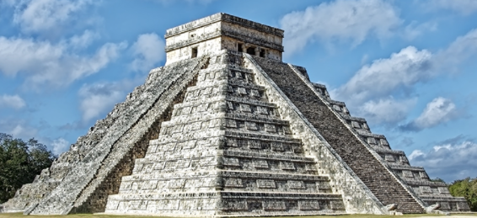 serving Jesus

**Literacy:**

**We’ll be looking at ‘Windrush Child’ by Benjamin Zephaniah as our class text. In Guided Reading we’ll be continuing practicing answering questions using writing gems.**

Topic: Summer 2022

Magical Mayans Year 6

**Topic:**

The Mayans and Mayan Empire-We’ll be examining this fascinating empire – where it was, what it was made up of and how they lived. We’ll be doing map work to further our knowledge.

The Titanic-We’ll be using our History skills to examine the context around the building of this famous vessel, and will be using this for writing opportunities!

**Art /DT:**

Pop Art – Looking at famous pop artists – Warhol/Lichtenstein – before creating our own pieces inspired by them!

DT-

Titanic Models – Can we create our own luxury liner?

Mayan feather fans – Making our own fans using our DT knowledge

Clay work – Making our own Mayan Calendars

**ICT:**

**Spreadsheets**

**Using spreadsheets for presenting Data**

**Film Making**

**Using ICT to make our own films!**

**Numeracy Links:**

We will be following the Maths No Problem scheme of work in preparation for the SATS.

We’ll later be focusing on Algebra and shape work to finish our KS2 work.

**Writing Opportunities:**

**Biography**

**Recounts**

**Narrative pieces**

**Description**

**Character work**

**RE:**

**Life is a Journey – Very appropriate for the journey ahead!**

**Pilgrimage**

**Drama/S&L Opps:**

Children to share their views about traditions in other countries.

Children to present their findings about specific topics for the countries we are studying.

Giving own views and listening to others views about wealth and poverty.

Debates about Graffiti

Debate about deforestation

**Science:**

**Animals (Including Humans)**

**The Human Body, including blood, the circulatory system, the heart, and other essential organs**

**We’ll be looking at how these fundamental parts of the body work and conducting investigations!**

**PE and Music:**

**Athletics/Striking and Fielding**

**Growth/Moving on**

**Languages: Children will be learning French and practicing sentences and pronunciation.**