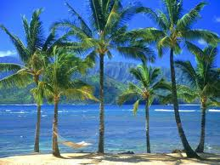

**Humanities: Polar and Tropical**

**Regions (Geography focus)**

Children are going to examine a globe and think about where the hottest and coldest places are. They will consider why this might be and then look in more detail at these two habitats.

They will be able to identify where the North and South Poles and the Equator are.

They will also start to explore what life is like in these two environments.

**Year 2 Topic: Wild about Animals**  
Summer 1 & 2 2022

**Art /DT:**

**DT** – Design and make healthy snacks

**Art –** Making different polar and tropical habitats from shoe boxes

Pastel African Artwork and Inuit Artwork to compare

**Questions children want to investigate:**

1. Where are the hot and cold places in the world?
2. What is it like to live in these places?
3. What or who lives there?
4. How do you get to these polar and tropical places?

-

**Writing Opportunities:**

Recount

Non Chronological Report

Stories by the same author – Julia Donaldson/Emily Gravett

**PE and Music:**

**Dance and Gym:** Dance based on simple movement patterns

**Music:** Following the Music Express Scheme – Storytime, Weather, Animals, Our Bodies

Weather

Animals

Our bodies

**ICT:** Computing– directional and instructional maths vocab

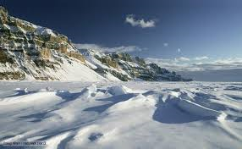



**RE:** The Church and Places of Worship

Multicultural Christianity

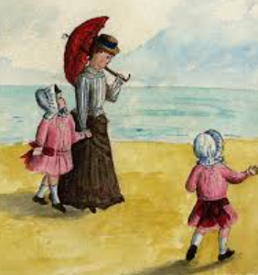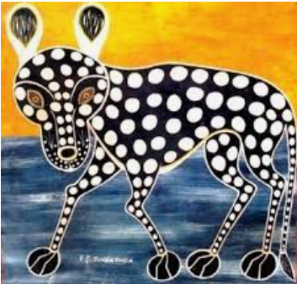

**Drama Opportunities:**

Travel and exploration, the lives of nocturnal animals and travelling to polar regions.

**Science:**

Living things and their habitats

Food Chains

**Humanities:**

**Polar and Tropical**

**Regions History Focus:** Seaside holidays in Victorian times, similarities and differences, how seaside towns have changed over time.

time.

**Numeracy Links:**

Measuring weather and temperature.

Time work based around travelling, distances and journeys and seasons