

St. Clement’s C. of E. Primary School, Abbey Hey Lane, Higher Openshaw, Manchester, M11 1LR
Tel. 0161 301 3268, Fax 0161 371 0267
E-mail address: head@st-clements.manchester.sch.uk
Head Teacher: Mrs Jane Parker B.Ed (Hons) NPQH
Website address: www.stclementsprimary.co.uk

Tuesday 7th March 2023
Dear Parent/Carers,
You may be aware from media coverage that the National Education Union have declared further strike action, which will take place on Wednesday 15th and Thursday 16th March 2023. The strike is happening because of a national dispute between the unions and the government and not because of any issues at our school.
I’m getting in touch to give you as much notice as possible about our arrangements for Wednesday 15th and Thursday 16th March 2023:
- Pupils in Reception, Year 2, Year 3, Year 4 and Year 5 will be unable to attend school.
- Remote Learning – Your child will still be able to take part in learning on this day. Below are details of how they will be able to do so.
- Your child should have their login details for the online platforms that we subscribe to. If not, then please speak to your child’s class teacher. These platforms are: Times Tables Rock Stars, Oxford Reading Buddy and IDL (if applicable). The Oak National Academy that was used by schools during COVID-19 restrictions is also still available for your child to use. This can be found at https://classroom.thenational.academy/
- Your child can use their stationary pack to record any work that they do at home. This could take any form, for example; book reviews, times tables practice, spelling games etc. However, we would encourage your child to revisit their learning by completing a project based on some of their topics from the year so far. Some of these include:
- Reception- Toys now and in the past, Materials, Weather
- Year 2 – Animals, Materials, History of Flight, Explorers
- Year 3- Stone Age, Materials, Weather
- Year 4 – Teeth, Electricity, Vikings, Scandinavian Geography
- Year 5 – Materials, Space, Roman Britain, UK landmarks
- Your child will also have their school reading book to read. Any reading that they do should be recorded in their reading record, as normal once they have read.

- If your child is in Reception or Years 2, 3, 4, or 5 and are eligible for a benefits related free school meal, then we will provide them with a packed lunch that will be available for you to collect from school on Wednesday 15th & Thursday 16th March from 11.30am- 12.30pm. Please complete the reply slip at the bottom of this letter informing us if you do or don’t wish to pick up a packed lunch for your child. If we don’t receive the reply slip back from you by the end of Friday 10th March, then we will take this as you do not require a lunch for your child.
- Breakfast club will be open as usual from 8.00am for those pupils in Nursery, Year 1 and Year 6 who have a place.
- After School Clubs will be cancelled on Wednesday 15th & Thursday 16th March.
I’m sorry that you will have to make alternative arrangements for your child and that they will experience disruption to their education. I understand that this situation may be frustrating, and ask that all members of our school community continue to treat each other with respect.
We are working closely with our local authority and union representatives to keep up to date with the situation, and I will inform you as soon as possible if arrangements change further.
If you have any questions, please contact myself or speak to the staff in the office.
Yours sincerely

Mrs J L Parker
Head Teacher


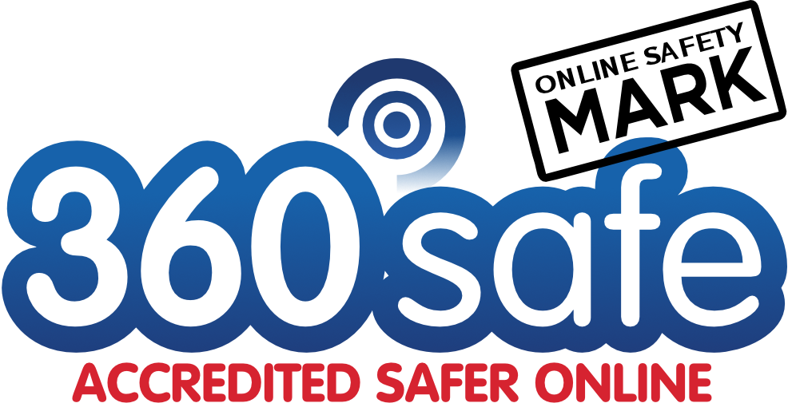
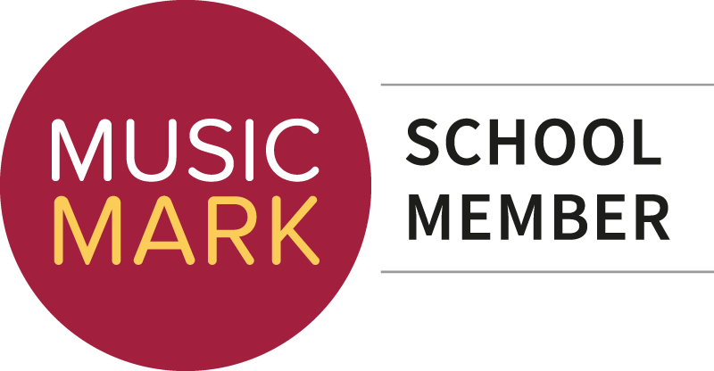
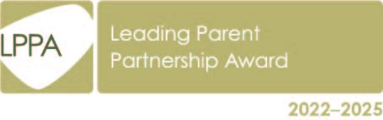

Child’s name: ……………………………………………………………. Class: ……………………………….

I would like to collect a packed lunch for my child on Weds 15th & Thurs 16th March

Sandwich choice (Please select) Egg Cheese Tuna Ham

I do not require a packed lunch for my child on Weds 15th & Thurs 16th March

Signed: ……………………………………………….

