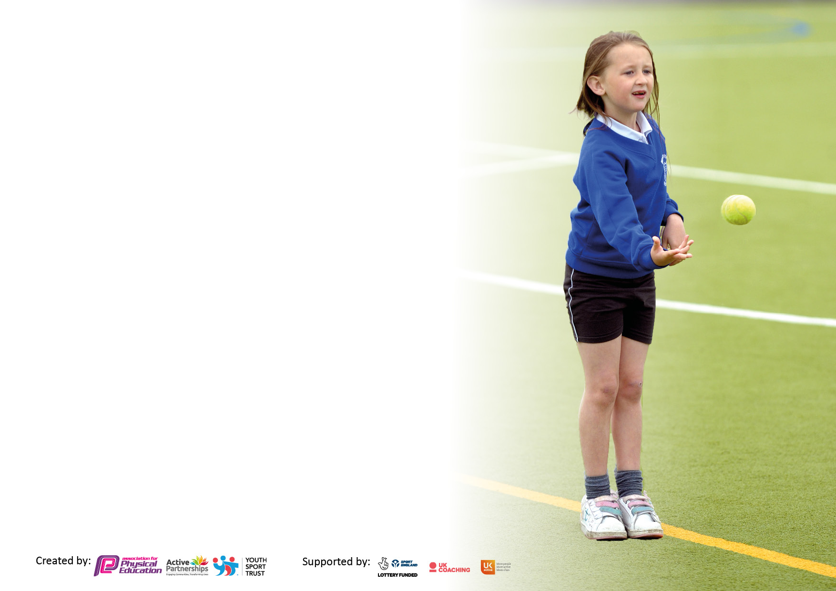

It is important that your grant is used effectively and based on school need. The Education Inspection Framework makes clear there will be a focus on **‘whether leaders and those responsible for governors all understand their respective roles and perform these in a way that enhances the effectiveness of the school’**.

Under the Quality of Education Ofsted inspectors consider:

**Intent** - Curriculum design, coverage and appropriateness

**Implementation** - Curriculum delivery, Teaching (pedagogy) and Assessment

**Impact** - Attainment and progress

To assist schools with common transferable language this template has been developed to utilise the same three headings which should make your plans easily transferable between working documents.

Schools must use the funding to make **additional and sustainable** improvements to the quality of Physical Education, School Sport and Physical Activity (PESSPA) they offer. This means that you should use the Primary PE and sport premium to:

* Develop or add to the PESSPA activities that your school already offer
* Build capacity and capability within the school to ensure that improvements made now will benefit pupils joining the school in future years
* The Primary PE and sport premium should not be used to fund capital spend projects; the school’s budget should fund these.

Please visit gov.uk for the revised DfE guidance including the5keyindicatorsacrosswhichschoolsshoulddemonstrate an improvement. This document will helpyoutoreviewyourprovisionandtoreportyourspend.DfEencouragesschools to use this template as an effective way of meeting the reporting requirements of the Primary PE and Sport Premium.

We recommend you start by reflecting on the impact of current provision and reviewing the previous spend.

Schools are required to publish details of how they spend this funding, including any under-spend from 2021/2022, as well as on the impact it has on pupils’ PE and sport participation and attainment. The funding **should** be spent by 31st July but the DfE has stated that there will be **no clawback** of any unspent money so this can be carried forward into 2023/24.

We recommend regularly updating the table and publishing it on your website throughout the year. This evidences your ongoing self-evaluation of how you are using the funding to secure maximum, sustainable impact. Final copy must be posted on your website by the end of the academic year and no later than the 31st July 2023. To see an example of how to complete the table please click HERE.

**Details with regard to funding**

Please complete the table below.

|  |  |
| --- | --- |
| Total amount carried over from 2021/22 | £0 |
| Total amount allocated for 2021/22 | £17799 |
| How much (if any) do you intend to carry over from this total fund into 2022/23? | £0 |
| Total amount allocated for 2022/23 | £17799 |
| Total amount of funding for 2022/23. **Ideally should** be spent and reported on by 31st July 2023. | £17799 |

**Swimming Data**

Please report on your Swimming Data below.

|  |  |
| --- | --- |
| Meeting national curriculum requirements for swimming and water safety.  N.B. Complete this section to your best ability. For example you might have practised safe self-rescue techniques on dry land which you can then transfer to the pool when school swimming restarts.  **Due to exceptional circumstances priority should be given to ensuring that pupils can perform safe self rescue even if they do not fully meet the first two requirements of the NC programme of study** |  |
| What percentage of your current Year 6 cohort swim competently, confidently and proficiently over a distance of at least 25 metres?  **N.B.** Even though your pupils may swim in another year please report on their attainment on leaving primary school at the end of the summer term 2023.  Please see note above | 33% |
| What percentage of your current Year 6 cohort use a range of strokes effectively [for example, front crawl, backstroke and breaststroke]?  Please see note above | 17% |
| **What percentage of your current Year 6 cohort perform safe self-rescue in different water-based situations?** | 23% |
| Schools can choose to use the Primary PE and sport premium to provide additional provision for swimming but this must be for activity **over and above** the national curriculum requirements. Have you used it in this way? | Yes/No This is to be considered for this year. |

**Action Plan and Budget Tracking**

Capture your intended annual spend against the 5 key indicators. Clarify the success criteria and evidence of impact that you intend to measure to evaluate for pupils today and for the future.

|  |  |  |  |  |
| --- | --- | --- | --- | --- |
| **Academic Year:** 2022/23 | **Total fund allocated: £17799** | **Date Updated: July 2023** | |  |
| **Key indicator 1:** The engagement of all pupils in regular physical activity – Chief Medical Officers guidelines recommend that primary school pupils undertake at least 30 minutes of physical activity a day in school | | | | Percentage of total allocation: |
| % |
| **Intent** | **Implementation** | | **Impact** |  |
| Your school focus should be clear what you want the pupils to know and be able to do and about  what they need to learn and to  consolidate through practice: | Make sure your actions to achieve are linked to your intentions: | Funding allocated: | Evidence of impact: what do pupils now know and what can they now do? What has changed?: | Sustainability and suggested next steps: |
| Increase the amount of physical activity taking place at less active times.  Consider PE as an intervention for some children  Increase the amount of children attending after school clubs.  Healthy life styles week.  Teachers delivering PE | Complete the Activity Heatmap.  Ask regular attenders of breakfast club how they would like to be active e.g. dance.  Consider buddies at breaktime leading activities- sports council. TBC  Offer a range of after school clubs.  Get feedback from children about after school clubs and plan accordingly.  Monitor attendance of after school clubs to ensure best use.  Healthy lifestyles week.  Lunchtime active sessions  Introduce the Daily Mile  Liaise more closely with other organisations to provide sport to children.  Introduce lunchtime competitions | £5000 | Aut Term  Breakfast club has been enhanced by having activities provided by a sports coach to keep children active during this time.  ASC have been planned with CT, CaRe and ZL to make full use of the equipment we have in school as well as based on feedback from children.  Lunchtimes continue to be well provided with a wide variety of activities available for children to take part in. This, alongside adult deployment, has ensured children are busy during this time.  CaRe has continued to develop links with other organisations by taking children to sporting events he has planned.  Spring Term  Breakfast club has been enhanced by having activities provided by a sports coach to keep children active during this time.  ASC have been planned with CT, CaRe and ZL to make full use of the equipment we have in school as well as based on feedback from children.  Lunchtimes continue to be well provided with a wide variety of activities available for children to take part in. This, alongside adult deployment, has ensured children are busy during this time.  CaRe has continued to develop links with other organisations by taking children to sporting events he has planned.  Summer Term  June 23 - Healthy lifestyles week planned and run. All children had access to extra PE sessions during this week.  ASC have been planned with CT, CaRe and ZL to make full use of the equipment we have in school as well as based on feedback from children.  Lunchtimes continue to be well provided with a wide variety of activities available for children to take part in. This, alongside adult deployment, has ensured children are busy during this time.  CaRe has continued to develop links with other organisations by taking children to sporting events he has planned. |  |
| **Key indicator 2:** The profile of PESSPA being raised across the school as a tool for whole school improvement | | | | Percentage of total allocation: |
| % |
| **Intent** | **Implementation** | | **Impact** |  |
| Your school focus should be clear what you want the pupils to know and be able to do and about  what they need to learn and to  consolidate through practice: | Make sure your actions to achieve are linked to your intentions: | Funding allocated: | Evidence of impact: what do pupils now know and what can they now do? What has changed?: | Sustainability and suggested next steps: |
| Plan activities to achieve the Silver school games mark.  Dedicate specific days to sport.  Children to understand the importance of exercise on learning.  Children to understand and follow the rules of sports to ensure successful break and lunchtimes.  Children to relate to sport positively.  More opportunities for children to take part in cross curricular activity  Use pupil voice to understand children’s opinion of PE and exercise | PE lead to look at criteria and plan activities accordingly. Open in Summer Term  Continue with Sports Council (2 children from each class 1-6).  Train sports council on leading activities for breaktimes.  School to take part in European School Sports Day.  School sports day planned for summer term.  Daily Mile to continue.  Plan ‘girl only’ sports events throughout the year | £3000 | Aut Term  All children in the school took part in an extra PE session to mark ESSD. As part of this, CaRe spent time in each session highlighting the importance of exercise on all aspects of our lives.  Children continue to have a healthy attitude towards PE and are engaged within lessons. Class staff are now delivering weekly sessions of their own which again shows the children the importance of this.  CaRe meets with the sport council to gain child feedback on attitudes and to see how we can alter provision across the school.  Spring Term  Children took part in gymnastics sessions during this half term. Class staff also observed these lessons as CPD.  Girls continue to have access to ‘girl only’ events on a weekly basis. Certain year groups have also attended competitions at Man Utd and City as well as events at other local schools.  Summer Term  June 23 - Healthy lifestyles week planned and run. All children had access to extra PE sessions during this week.  Y5 children attended a PE-based well-being session at WRC.  Children took part in gymnastics sessions during this half term. Class staff also observed these lessons as CPD.  Girls continue to have access to ‘girl only’ events on a weekly basis. Certain year groups have also attended competitions at Man Utd and City as well as events at other local schools.  Whole school sports day planned and delivered with all children taking part from Nur – Y6. Parents were invited to take part as well as opportunity to take part in events themselves. |  |

|  |  |  |  |  |
| --- | --- | --- | --- | --- |
| **Key indicator 3:** Increased confidence, knowledge and skills of all staff in teaching PE and sport | | | | Percentage of total allocation: |
| % |
| **Intent** | **Implementation** | | **Impact** |  |
| Your school focus should be clear | Make sure your actions to | Funding | Evidence of impact: what do | Sustainability and suggested |
| what you want the pupils to know | achieve are linked to your | allocated: | pupils now know and what | next steps: |
| and be able to do and about | intentions: |  | can they now do? What has |  |
| what they need to learn and to |  |  | changed?: |  |
| consolidate through practice: |  |  |  |  |
| Ensure teaching of PE lessons in school is GOOD.  Adapt the PE curriculum where necessary  PE lead is able to make improvements to schools PE and sport. | PE lead to audit and monitor the sports coach.  PE lead to audit and monitor teachers running PE.  LA PE audit.  PE lead to attend lead meetings every term.  PE lead to have release time in school.  PE lead to feedback to sports coach any relevant information.  PE lead to dedicate time to meeting with sports coach for updates. | £3000 | Aut Term  A new PE curriculum has been introduced this academic year. The plans are detailed and easy to follow for non-specialists. Monitoring with CT and CaRe is due to take place for this in Spr 1 as a specialist dance teacher will be taking the sessions usually given to CaRe.  PE lessons continue to be taught to a good standard by CaRe and is able to differentiate for children of all abilities. Where possible, CaRe links this to wider life such as the values held within school and individual sports, as well as the importance of a healthy lifestyle.  CT continues to attend meetings and adapt provision where necessary.  Spring Term  PE lessons continue to be taught to a good standard by CaRe/MM/class staff and all are able to differentiate for children of all abilities. Where possible, CaRe links this to wider life such as the values held within school and individual sports, as well as the importance of a healthy lifestyle.  CT continues to attend meetings and adapt provision where necessary.  Summer Term  PE staff attended PESL meeting where links were made with local high schools regarding transition and updates regarding national guidance.  PE lessons continue to be taught to a good standard by CaRe/class staff and all are able to differentiate for children of all abilities. Where possible, CaRe links this to wider life such as the values held within school and individual sports, as well as the importance of a healthy lifestyle. |  |
| **Key indicator 4:** Broader experience of a range of sports and activities offered to all pupils | | | | Percentage of total allocation: |
|  |
| **Intent** | **Implementation** | | **Impact** |  |
| Your school focus should be clear | Make sure your actions to | Funding | Evidence of impact: what do | Sustainability and suggested |
| what you want the pupils to know | achieve are linked to your | allocated: | pupils now know and what | next steps: |
| and be able to do and about | intentions: |  | can they now do? What has |  |
| what they need to learn and to |  |  | changed?: |  |
| consolidate through practice: |  |  |  |  |
| Increase the variety of after school clubs on offer.  Ensure equipment is available.  Improve a skill across school.  Children participate in a range of activities.  Develop community links for children outside of school.  Children to be given the opportunity to access forest school.  Create links with sports clubs throughout the year | Regularly check on the attendance of after school clubs and offer alternatives if numbers are dwindling.  Audit equipment in school and replenish anything dwindling or purchase any additional resources.  Y5 to do bikeability.  Attend change for life festivals.  Forest schools in place to develop health and wellbeing.  Organise for local sporting companies to come and do an assembly.  PE lead to look into an activity day for each year group doing an activity they can’t access in school e.g. canoeing at debdale or rock climbing at Manchester climbing centre. | £8500 | Aut Term  Children continue to take part in a variety of sports based on the new curriculum. This will alter through the year for each year group.  ASC are changed termly (or sooner if numbers dictate) based on equipment in school and children’s opinions.  Individual children continue to be provided for with out of school provision where possible (EG football/dance clubs run by sports coaches.  Children are accessing forest school as an after school club.  Spring Term  Children continue to take part in a variety of sports based on the new curriculum. This will alter through the year for each year group.  ASC are changed termly (or sooner if numbers dictate) based on equipment in school and children’s opinions.  Individual children continue to be provided for with out of school provision where possible (EG football/dance clubs run by sports coaches.  Children are accessing forest school as an after school club.  Summer Term  June 23 - Healthy lifestyles week planned and run. All children had access to extra PE sessions during this week. (not curriculum PE)  Y6 attended Debdale Outdoor Centre for a morning of kayaking and sailing.  Children continue to take part in a variety of sports based on the new curriculum. This will alter through the year for each year group.  ASC are changed termly (or sooner if numbers dictate) based on equipment in school and children’s opinions.  Individual children continue to be provided for with out of school provision where possible (EG football/dance clubs run by sports coaches.  Children are accessing forest school as an after school club. |  |

|  |  |  |  |  |
| --- | --- | --- | --- | --- |
| **Key indicator 5:** Increased participation in competitive sport | | | | Percentage of total allocation: |
| % |
| **Intent** | **Implementation** | | **Impact** |  |
| Your school focus should be clear | Make sure your actions to | Funding | Evidence of impact: what do | Sustainability and suggested |
| what you want the pupils to know | achieve are linked to your | allocated: | pupils now know and what | next steps: |
| and be able to do and about | intentions: |  | can they now do? What has |  |
| what they need to learn and to |  |  | changed?: |  |
| consolidate through practice: |  |  |  |  |
| More SEN/less active children to participate in competitive sport.  Increase the number of inter school competitions that the school takes part in.  Increase the number of intra school competitions.  Competitions at lunchtimes  Arranging own competitions with local or partner schools.  Enter the Panathlon Games for SEND children | Take part in INSPIRE competitions running in Manchester.  Target SEN and less active to attend Inspire competitions.  Continue membership for PE association.  Plan for at least 6 different inter school competitions.  Both B and C teams to participate in inter school competition (3-1)  Book transport for events  At least 1 intra school competition every half term ran by the coach at lunchtimes.  Increase number of KS1 competitions. | £2000 | Aut Term  Less active children have the opportunity to take part in extra sessions with CaRe to improve attitudes and fitness. There has been some opposition from certain parents, however, these spaces have been allocated to other children within the school.  Competitions continue to be planned and run with outside agencies and schools. The feedback from children is overwhelmingly high and they are extremely proud to represent the school.  Spring Term  Less active children have the opportunity to take part in extra sessions with CaRe to improve attitudes and fitness. There has been some opposition from certain parents, however, these spaces have been allocated to other children within the school.  Competitions continue to be planned and run with outside agencies and schools. The feedback from children is overwhelmingly high and they are extremely proud to represent the school.  Summer Term  Year 5 and 6 basketball event organised and run with two local schools.  Less active children have the opportunity to take part in extra sessions with CaRe to improve attitudes and fitness. There has been some opposition from certain parents, however, these spaces have been allocated to other children within the school.  Competitions continue to be planned and run with outside agencies and schools. The feedback from children is overwhelmingly high and they are extremely proud to represent the school. |  |

|  |  |
| --- | --- |
| Signed off by | |
| Head Teacher: | J.Parker |
| Date: | 21.7.23 |
| Subject Leader: | C.Thirsk |
| Date: | 21.7.23 |
| Governor: |  |
| Date: |  |