Pupil premium strategy statement 2022-23

This statement details our school’s use of pupil premium funding to help improve the attainment of our disadvantaged pupils.

It outlines our pupil premium strategy, how we intend to spend the funding in this academic year and the effect that last year’s spending of pupil premium had within our school.

School overview
Detail | Data
School name | St Clements C of E Primary
Number of pupils in school | 233
Proportion (%) of pupil premium eligible pupils | 55.4%
Academic year/years that our current pupil premium strategy plan covers (3 year plans are recommended) | 2021-2022-  2024-2025
Date this statement was published | 29th November 2022
Date on which it will be reviewed | July 2023
Statement authorised by | Eleanor Ward- Chair of Governors
Pupil premium lead | Jane Parker- Head Teacher
Governor lead | Tony Daly- PPG link governor
Funding overview
Detail | Amount
Pupil premium funding allocation this academic year | £3,392.00 EYFS (01 Sept - 31 March)  £2,650.00 EYFS (01 Apr -  31 Aug)  £94,526.00 R - Yr6 (01 Sept - 31 March)  £72,750.00 R - Yr6 (01 Apr - 31 Aug)
Recovery premium funding allocation this academic year | £16,965.00
Pupil premium funding carried forward from previous years (enter £0 if not applicable) | £17,736.00 – this was due to receiving additional grants in relation to COVID
Total budget for this academic year | £97,918.00 (01 Sept - 31 March)  £75,400.00 (01 Apr -  31 Aug)  £16,965.00 academic year 22/23  £17,736.00 bought forward

Part A: Pupil premium strategy plan

Statement of intent
Our intention is that all pupils, irrespective of their background or the challenges they face, make good progress and the majority achieve age related or higher attainment across all subject areas. The focus of our pupil premium strategy is to support disadvantaged pupils to achieve that goal, diminishing the difference between their non-disadvantaged peers, including progress for those who are already high attainers.
We are aware of the challenges faced by vulnerable pupils and their families, such as those who have a social worker or are living in deprivation. The activity we have outlined in this statement is also intended to support their needs, regardless of whether they are disadvantaged or not.
Quality first teaching is at the heart of our approach, with a focus on areas in which disadvantaged pupils require the most support. This is proven to have the greatest impact on closing the disadvantage attainment gap and at the same time will benefit the non-disadvantaged pupils in our school. Implicit in the intended outcomes detailed below, is the intention that non-disadvantaged pupils’ attainment will be sustained and improved alongside progress for their disadvantaged peers.
Our strategy is also integral to wider school plans for education recovery, notably in its targeted support for pupils whose education has been worst affected, including non-disadvantaged pupils.
Our approach will be responsive to common challenges and individual needs, rooted in findings from assessment, not assumptions about the impact of disadvantage. The approaches we have adopted complement each other to help pupils excel. To ensure they are effective we will:
- ensure disadvantaged pupils are challenged in the work that they’re set
- act early to intervene at the point need is identified
- adopt a whole school approach in which all staff take responsibility for disadvantaged pupils’ outcomes and raise expectations of what they can achieve

Challenges

This details the key challenges to achievement that we have identified among our disadvantaged pupils.
Challenge number | Detail of challenge
1 | The majority of pupils enter our nursery with communication and language needs, impacting on their ability to speak and understand which in turn delays their ability to read and write.
2 | The ability to write to a standard similar to other pupils of the same age, is difficult for the vast majority of our pupils.
3 | In some classes and subjects, the gap between disadvantaged and non disadvantaged pupils is wide. If this continues, it will impact on their outcomes at the end of Key Stage 1 & 2 and into Key Stage 2 & 3. (new 22-23)
4 | Lack of awareness of some parent/carers regarding the importance of working in partnership with school and how to support their child’s learning.
5 | Persistent absence for some disadvantaged pupils has increased compared to their non-disadvantaged peers during the last academic year. Our assessments and observations indicate that absenteeism is negatively impacting disadvantaged pupils’ progress.
6 | Pupils with specific social and emotional needs which affect their learning due to a lack of focus, low self esteem and minimal coping strategies. This is likely to continue to be an issue in 22-23 due to the negative experiences that most of our families faced in the lockdowns and the impact of the cost of living crisis

Intended outcomes
This explains the outcomes we are aiming for by the end of our current strategy plan, and how we will measure whether they have been achieved.
RAG rating (Red, Yellow & Green) denotes if the outcome was not met (Red), partially met (Yellow) & fully met (Green).
Intended outcome | Success criteria | Actual Outcome
Improved oral language skills and vocabulary among disadvantaged pupils. | - Improved understanding of pupils SALT needs  - Improvement in SALT outcomes- e.g. increased levels in key word understanding, speech sound articulation  - Impact on pupil’s abilities to read and write- if they can articulate sounds, they will then be able to say words to support their reading and writing skills. | -In Sept 22, 5/26 Nursery pupils scored at their age related expectation (ARE) on the baseline WELLCOMM screening. Focusses were identified by the Nursery staff who implemented these into group sessions and continuous provision. By the time of the exit screening in June 23, a further 5 pupils had reached (ARE) with a further 7 pupils catching up to be just one band below there are.  -In Reception, pupils were also WELLCOMM re-screened in July 23 and 12 pupils scored at ARE, with 7 scoring one band below there ARE.  -The NELI intervention was not as successful this year. From their starting points, 1 has made significant progress, 2 have made good progress- but we still have concerns abt their expressive skills, 1 boy has made a slight improvement, but will need to receive further support in Y1 & 1 girl has regressed- already known to our SALT & receiving input. As a result of these outcomes, we have decided to not use NELI as a SALT intervention in 23-24.  -Not as many pupils have been discharged from the caseload of the SALT we commission via PPG funding during 22-23. This is due to the pupils that are receiving therapy, needing a greater amount of input from the SALT & class staff.  -During lesson observations and monitoring of books, the vocabulary used by pupils is good- showing that they are being exposed to words that extend their understanding and use in their communication across the curriculum.
Improved writing attainment among disadvantaged pupils | - Teacher’s skills will be improved in teaching writing  - Through the use of quality written feedback by adults at the point of learning or after a lesson that pupils are expected to respond to.  - Increased progress and % of pupils at age related expectations in writing increases. | -At the end of Key Stages, outcomes were as follows:  -Reception: More disadvantaged pupils achieved at the expected standard in Writing than non-disadvantaged pupils  -Year 2: Disadvantaged and non-disadvantaged pupils achieved in line with one another  -Year 6: More disadvantaged pupils achieved at the expected standard in Writing than non-disadvantaged pupils  -In the interim year groups, it is only in Year 1 where disadvantaged pupils are achieving higher in writing than their non-disadvantaged peers.  -During 22-23, as well as regular, in school moderation, teachers attended cluster moderation and also received external advisor moderation support too. Although improvements in handwriting and spelling have been evident as a result of the training, writing still remains the subject that we need to focus on as it was the subject with fewest pupils at age related expectations in comparison to reading & maths.
Attainment gap between disadvantaged and non-disadvantaged pupils narrows in certain subjects and classes | - As the academic year goes on, termly data and pupil progress meetings, show that the gap is narrowing in the classes and subjects identified.  - By the end of the academic year, the attainment in the focus subject in those classes has increased so that the gap between disadvantaged and non-disadvantaged pupils has narrowed or it has surpassed the attainment of non-disadvantaged pupils. | -Diminishing the difference reports show that in every class except Nursery, the attainment gap has been narrowed between disadvantaged and non-disadvantaged pupils- particularly in Reading and Maths.  -In the 22-23 Year 1 & 6 classes, disadvantaged pupils attained higher than their non-disadvantaged peers.  This will still have to remain a focus in the next academic year.
Increase in parent/carer involvement in their child’s learning and their own understanding of how to support their child/ren | - Parent/carers are more able to support their child’s learning at home  - Increased rates of progress & % of pupils at age related expectations (ARE) | -Social events, class & rewards worships continue to result in the highest attendance. However, events in EYFS such as the Story & Toast and learning together events, have seen at least half of the parent/carers in a class attend.  -We note that when parent/carers attend events to support their child’s learning or seek support and advice from teachers about how to support their child, the difference in the progress of that child in comparison to their peers whose parent/carers have not received this input, is marked.
To achieve and sustain improved attendance for all pupils, particularly our disadvantaged pupils. | - The percentage of all pupils who are persistently absent is no more than 8% and the figure among disadvantaged pupils being no more than 10% | -Fischer Family Trust (FFT) data showed that by the end of 22-23, the attendance of our disadvantaged pupils was 93% (21-22=90.5%) in comparison to 95.4% for non-disadvantaged pupils (21-22=94.9%).  -22% of pupils were persistently absent (PA) in 22-23. 43 pupils had attendance below 90% and  32 of these were disadvantaged pupils.  Work to reduce PA has to continue in 23-24.
Pupils and families are applying strategies learnt during 1:1 or group sessions to result in a reduction in emotional outbursts both at home and school | - To provide dedicated time and support to pupils (1:1 and group)  - To improve the self esteem, social skills and behaviour of identified pupils leading to increased confidence and attainment in the classroom (use of Boxall Profile as a measure as well as attainment & progress data)  - To provide support to parent/carers in understanding their child’s needs and to improve relationships and routines at home. | -There have been no fixed term or permanent exclusions in school during 22-23 and generally, emotional outbursts in school have not increased and impacted on learning.  -A number of families have had intensive support from the Family Support team (this also includes the Head/SENDCO & SENDTA) to talk through presenting behaviours, routines and strategies to reduce confrontation and outbursts. Although incidents still occur, the frequency has reduced and parent/carers report to feeling more confident in dealing with incidents, and most importantly, recognising successes too.

Activity in this academic year
This details how we intend to spend our pupil premium this academic year to address the challenges listed above.

Teaching (for example, CPD, recruitment and retention)
Budgeted cost: £13,731.00 Actual Cost: £15,161.00
SALT meetings - £1,500.00
Coaching - £3,000.00 £3,500.00
Implementation of our Presentation, Marking & Feedback Policy - £2,000.00
Handwriting Training - External provider Nov 22 - £475 £1,205.00
Spelling Scheme & Training - Cost of books - £2,756.00 & CPD throughout 22-23 - £1,000.00 £1,200.00
Zones of Regulations Training - £3,000.00

Activity | Evidence that supports this approach | Challenge number(s) addressed
Increase knwldg and undstg of Speech & language issues with all staff & parent/carers via training sessions & meetings | Oral language interventions can have a positive impact on pupils’ language skills. Approaches that focus on speaking, listening and a combination of the two show positive impacts on attainment:  Oral language interventions | EEF (educationendowmentfoundation.org.uk) | 1, 2, 3, 4 & 6
Implementation of a coaching approach with teachers and teaching assistants to further develop the Write Stuff Approach (our Writing curriculum) in school | Sharing good practice across a school that uses the same teaching approach in a curriculum area, has been proven to develop knowledge, skills and approaches  Effective Professional Development EEF  https://educationendowmentfoundation.org.uk/education-evidence/guidance-reports/effective-professional-development | 2 & 3
Embedding our Presentation, Marking & Feedback policy to ensure written comments and marking are acted upon by supporting pupils to focus future learning on areas of weakness, through identifying and explaining misconceptions, through supporting them in taking greater responsibility for their own improvement or through increasing pupils’ motivation to improve. | There is evidence to suggest that feedback involving metacognitive and self-regulatory approaches may have a greater impact on disadvantaged pupils and lower prior attainers than other pupils. Pupils require clear and actionable feedback to employ metacognitive strategies as they learn, as this information informs their understanding of their specific strengths and areas for improvement, thereby indicating which learning strategies have been effective for them in previously completed work.  Teacher Feedback to Improve Pupil Learning EEF  https://educationendowmentfoundation.org.uk/education-evidence/guidance-reports/feedback | 2 & 3
Update class based staff’s knowledge about how we teach handwriting via refresher training delivered by an external provider in Nov 22 | Sharing good practice across a school that uses the same teaching approach in a curriculum area, has been proven to develop knowledge, skills and approaches  Effective Professional Development EEF  https://educationendowmentfoundation.org.uk/education-evidence/guidance-reports/effective-professional-development | 2
Provide CPD to class based staff to introduce a consistent approach to the teaching of spelling via a scheme that supports our existing approach to the teaching of writing. | Sharing good practice across a school that uses the same teaching approach in a curriculum area, has been proven to develop knowledge, skills and approaches  Effective Professional Development EEF  https://educationendowmentfoundation.org.uk/education-evidence/guidance-reports/effective-professional-development | 2
Continuation of half termly whole staff training on behaviour management and anti-bullying approaches via the Zones of Regulation materials with the aim of developing our school ethos and improving behaviour across school. | Both targeted interventions and universal approaches can have positive overall effects:  Behaviour interventions | EEF (educationendowmentfoundation.org.uk) | 6

Targeted academic support (for example, tutoring, one-to-one support structured interventions)
Budgeted cost: £45,709.00 Actual Cost: £50,512.00
SALT (1yr) - £8,912.00
SALT TA (½ salary for 1yr) – £12,674.00 £15,849.00
Other SALT interventions - £3,300.00 £3,405.00
English Lead Writing Interventions - £7,723.00 Cost of HSH 4.5 hours a week £8,596.00
Class based staff booster group/1:1 intervention - £4,600.00 £5,250.00
Parent’s meetings & Resources - £3,500.00
Computing Subscriptions - £5,000.00

Activity | Evidence that supports this approach | Challenge number(s) addressed
Commissioning of a qualified Speech and Language therapist (SALT) for 1 day per week to assess pupils, implement SALT programmes (weekly meetings with SALT TA who implements below) | Oral language interventions can have a positive impact on pupils’ language skills. Approaches that focus on speaking, listening and a combination of the two show positive impacts on attainment:  Oral language interventions | EEF (educationendowmentfoundation.org.uk) | 1, 2, 3 & 6
Implementation of programmes and individual communication plans to improve listening, narrative and vocabulary skills for disadvantaged pupils who have relatively low spoken language skills. | Oral language interventions can have a positive impact on pupils’ language skills. Approaches that focus on speaking, listening and a combination of the two show positive impacts on attainment:  Oral language interventions | EEF (educationendowmentfoundation.org.uk) | 1, 2
Use of our non class based AHT, who is also one of our English leads, to provide tuition in writing and EGPS. A significant proportion of the pupils who receive tutoring will be disadvantaged, including those who are high attainers. | Tuition targeted at specific needs and knowledge gaps can be an effective method to support low attaining pupils or those falling behind, both one-to-one:  One to one tuition | EEF (educationendowmentfoundation.org.uk)  And in small groups:  Small group tuition | Toolkit Strand | Education Endowment Foundation | EEF | 2 & 3
Use of class based staff to work with pupils in a group or on a 1:1 basis for a limited amount of time in a specific subject that data shows disadvantaged pupils are attaining lower than their non-disadvantaged peers in | Tuition targeted at specific needs and knowledge gaps can be an effective method to support low attaining pupils or those falling behind, both one-to-one:  One to one tuition | EEF (educationendowmentfoundation.org.uk)  And in small groups:  Small group tuition | Toolkit Strand | Education Endowment Foundation | EEF | 3
Delivery of 1:1 or group meetings/sessions with parent/carers to increase their awareness of where their child/ren are at in their learning and providing them with additional support & activities to progress their child/ren further | Parents play a crucial role in supporting their children’s learning, and levels of  parental engagement are consistently  associated with better academic outcomes.  Evidence suggests that effective parental engagement can lead to learning gains of +3 months over the course of a year.  Working with Parents to Support their  Children’s Learning  https://educationendowmentfoundation.org.uk/education-evidence/guidance-reports/supporting-parents | 4
Use of technology to provide targeted educational support to supplement quality first teaching- eg subscription to Splingo, IDL literacy, Oxford Reading Buddy, Times Tables Rockstars | Using technology in ways which support improved teaching or improved pupil learning (e.g. by increasing the quality and quantity of pupil practice).  Using Digital Technology to Improve  Learning  https://educationendowmentfoundation.org.uk/education-evidence/guidance-reports/digital | 1, 2, 3 & 4

Wider strategies (for example, related to attendance, behaviour, wellbeing)
Budgeted cost: £85,931.00 Actual Cost: £88,504.00
Parental Support £19,670.00 £18,203.00
Attendance Officer £16,590.00 £19,840.00
Learning Mentor & Parental Support £24,007.00 £24,153.00
Social Worker £25,264.00 £25,908.00
Attendance Rewards - £400.00

Activity | Evidence that supports this approach | Challenge number(s) addressed
Commissioning of a social worker based in school for 3 days per week & 6 days out of term time Sept 22-March 23 | We are hoping that by continuing to employ a school based social worker, it will increase capacity not only for our families who will be signposted to agencies that can support them but also, increase capacity for the 5 other designated persons for child protection in school who also have other roles. | 4, 5 & 6
Release time for the attendance support officer and social worker to develop and implement new procedures to improve attendance. | The DfE guidance has been informed by engagement with schools that have significantly reduced levels of absence and persistent absence.  DfE’s Working Together to Improve School Attendance (non statutory guidance Sept 22) | 5
Dedicated time and support to pupils (1:1 and group) to improve the self esteem, social skills and behaviour of identified pupils leading to increased confidence and attainment in the classroom. Also, to provide support to parent/carers in understanding their child’s needs and to improve relationships and routines at home. | By Improving Social and Emotional Learning in Primary Schools it increases the resilience and independence of pupils and families. It is especially important for children from disadvantaged backgrounds and other vulnerable groups, who, on average, have weaker SEL skills at all ages than their non-disadvantaged classmates.  Improving Social & Emotional Learning in Primary Schools EEF  https://educationendowmentfoundation.org.uk/education-evidence/guidance-reports/primary-sel | 4 & 6
Total budgeted cost: £145,371.00
Actual cost: £154,177.00
The difference in income and actual cost is £53,842.00 for 22/23, which includes £17,736.00 brought forward from 21/22, which was not spent as predicted due to additional grants received.
The under spend of £53,842.00 has been spent but is not listed in the specific challenges listed above but alongside to support achieving the required outcomes and are listed below.
- Additional Maths resources - £3,132.00
- Educational Psychologist - £6,825.00
- Educational Visits - £5,893.00
- Private Maths Tutor - £18,010.00
- TA additional hours - £4,555.00
- Writing Catch up Groups - £2,387.00
- Additional Support for identified families - £4,253.00
TOTAL - £45,055.00
c/f £8,787.00

Part B: Review of outcomes in the previous academic year

Pupil premium strategy outcomes
This details the impact that our pupil premium activity had on pupils in the 2022-23 academic year.
DISADVANTAGED PUPIL DATA (JULY 23)
SCHOOL FSM ELIGIBLE: 133 pupils = 56.8%

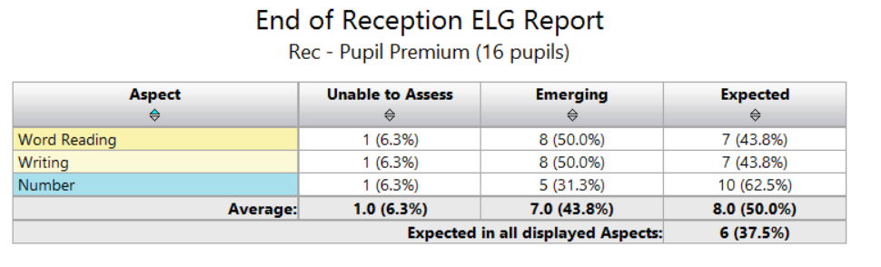
-More FSM pupils achieved the Early Learning Goal in W & M than NFSM pupils
Y1 PHONICS:
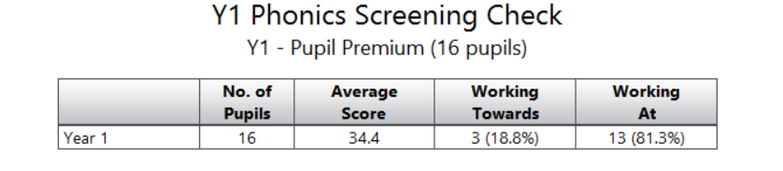
13/16 PPG eligible pupils passed the phonics screening check. Their average score was 34 (pass mark 32) higher than their NPPG peers who performed worse on the phonics screening check with an average score of 29 and only 8/15 passing the phonics screening check.

KS1: % ACHIEVING EXPECTED STANDARD
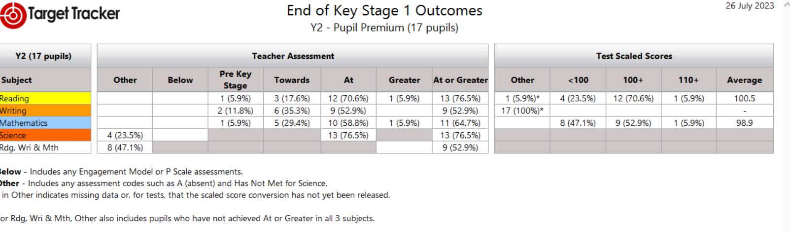
PPG pupils are attaining at a higher standard than their NPPG peers at the expected standard in Reading, Maths and Science. However, not as many PPG eligible pupils are attaining at greater depth and this reduces their average point score.

KS2: % ACHIEVING EXPECTED STANDARD
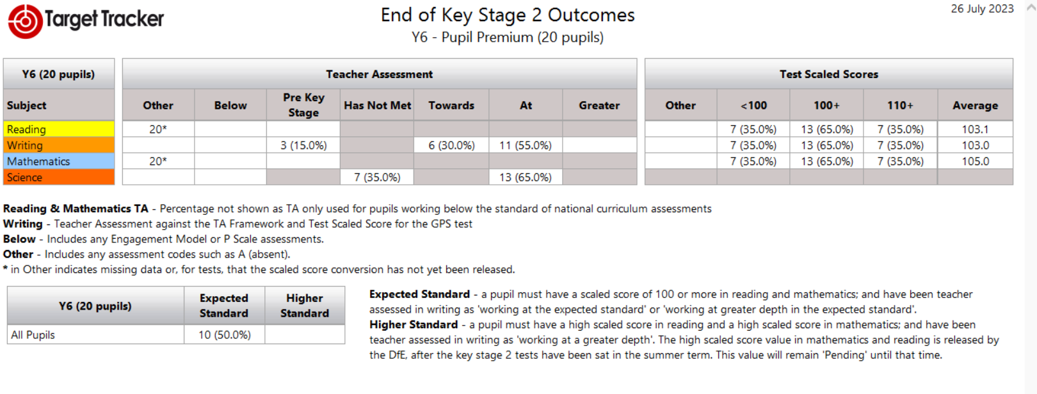
-Looking at the Test Scaled Scores, more PPG pupils achieved at the expected or higher standard than NPPG pupils. However, their average point score is not as high due to more PPG pupils not reaching the expected standard (NB Writing on the test scaled scores refers to the SPAG test). Writing was teacher assessed and again, more PPG pupils achieved the expected standard in comparison to NPPG pupils.
-More PPG pupils achieved the expected standard in the combined subjects- R, W & M (10) than NPPG pupils (4)

Externally provided programmes
Programme | Provider
Lancashire Phonics Catch Up Intervention | Lancashire County Council
Oxford Reading Buddy (online reading) | Oxford Reading Tree
IDL Literacy (online reading and spelling intervention) | IDL Solutions

Service pupil premium funding (optional) N/A
Measure | Details
How did you spend your service pupil premium allocation last academic year?
What was the impact of that spending on service pupil premium eligible pupils?

Further information (optional)
- The success of the individual pupil premium interventions that lie beneath the activities noted above are described in detail on our Blue Hills Provision map. Staff who deliver the intervention/s are expected to set baseline and exit outcomes as well as completing evaluations after each session. This is overseen by the PPG lead, who regularly reviews the frequency of intervention delivery and the quality of the written evaluations. The provision map also costs each intervention so we can evaluate impact versus cost to determine if the intervention is worth repeating or a different approach is needed.
- Looked After or Previously Looked After Pupils also have their own funding cost centres (£2,410.00) and reports. Although many of them take part in the interventions listed in this statement, their parent/carers are contacted at least twice a year to inform them of what was spent and the impact of this expenditure in the previous academic year and to also ask them what they would like to purchase to support their child. Requests have included electronic devices to support home learning and payment for extra curricular activities such as swimming lessons.
- St Clements has continued to implement the NELI (Early Language Intervention) programme for a third year now after being accepted onto the programme on return to school in spring 2021. In the previous two cohorts, all pupils have made gains in their speech, language and communication (SLCN) from their baseline assessments, resulting in 2 pupils in each cohort making substantial gains and no longer requiring SLCN support going forwards. We are now focussing on screening the current Reception pupils to see who would benefit from targeted intervention this year.
- St Clements have been fortunate to again be awarded £20,000 from the Forgotten Forty (F40) Foundation in 2022-23 after our initial award in 2021-22 (sponsored by INEOS). This is due to the high percentage of pupils in receipt of a FSM in school. In 22-23, we intend to spend the award on financing educational visits and visitors to bring our curriculum to life and provide our pupils with experiences outside of their immediate locality that a number of them would not experience. Also, to move our focus on the Arts from experiencing live music to visiting local art galleries.
- The PPG lead, Jane Parker (Head Teacher) participated in ‘Making the Difference for Disadvantaged Learners’ CPD led by the Research Schools Programme and heavily subsidised by the Education Endowment Foundation from 7th January- 30th June 2022. The programme provided participants with the latest evidence and supported them in implementing change through the tiered model for school planning that leads to school improvement.

