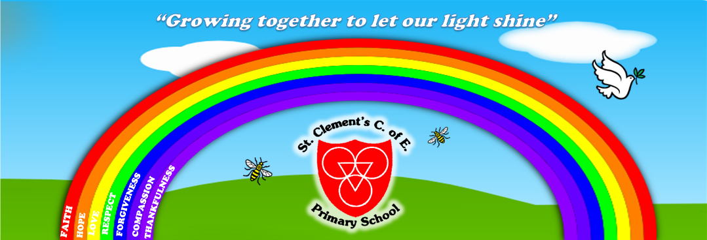
“Growing together to let our light shine”
St Clement’s C of E Primary School Monthly Newsletter: 25.9.23
Welcome to our first newsletter of the new school year!
Welcome also to our new Nursery pupils and their families who are starting to increase their time in school.
Also, to pupils who have joined our Reception class: Aaminah, Fariya, Henos, Maddison, Owen, Robert-Gabriel, Ruth and T-Faith.
New pupils in Years 1-6 too: Michelle, Lilac, Jeff & Imran.

Dates for your Diary:
-Wb 25/9/23-Nursery Yellow group attending full time
-Wb 25/9/23- Nursery Blue Group attend 11.20-3.15pm (inc lunch)
-27/9/23 All Day Year 4 Viking Visitor experience in class
-29/9/23-Macmillan Coffee Morning
-29/9/23 AM- Reception-Y6 pupils nasal flu
-Wb 2/10/23- Nursery Blue Group attending full time
-4/10/23 9am- Reception Reading & Writing at home Parent/Carer session
-4/10/23-Harvest
-4/10/23- Y1 Autumn Experience Day
-5/10/23-Y6 Experience Day- War Time Food
-11/10/23 8.45am- EYFS Story & Toast Morning
-12/10/23 9.15am- Reception Class Welcome service at St Clement’s Church
-12/10/23 PM- Reception Maths home pack session with parent/carers
-12/10/23 PM- EPIC Afternoon Tea
-13/10/23- Top Table Award
-18/10/23- Nursery Rhyme Mouse Club session for parent/carers
-17&18/10/23-PARENT/CARER EVENING MEETINGS
-19/10/23 9am- Year 6 Class Worship
-20/10/23- Values Award worship
-20/10/23 3.15pm- End of Autumn 1 half term.

Star Moment Award Winners- We have launched a new award to replace Work of the Week- called ‘My Golden Star Moment’. An idea from Mrs St Hill, staff stick a golden star on to a pupil’s work if they have really impressed, tried hard, improved their work or mastered a new skill- at the point of learning in the lesson, so pupils are also aware of how well they have done too.

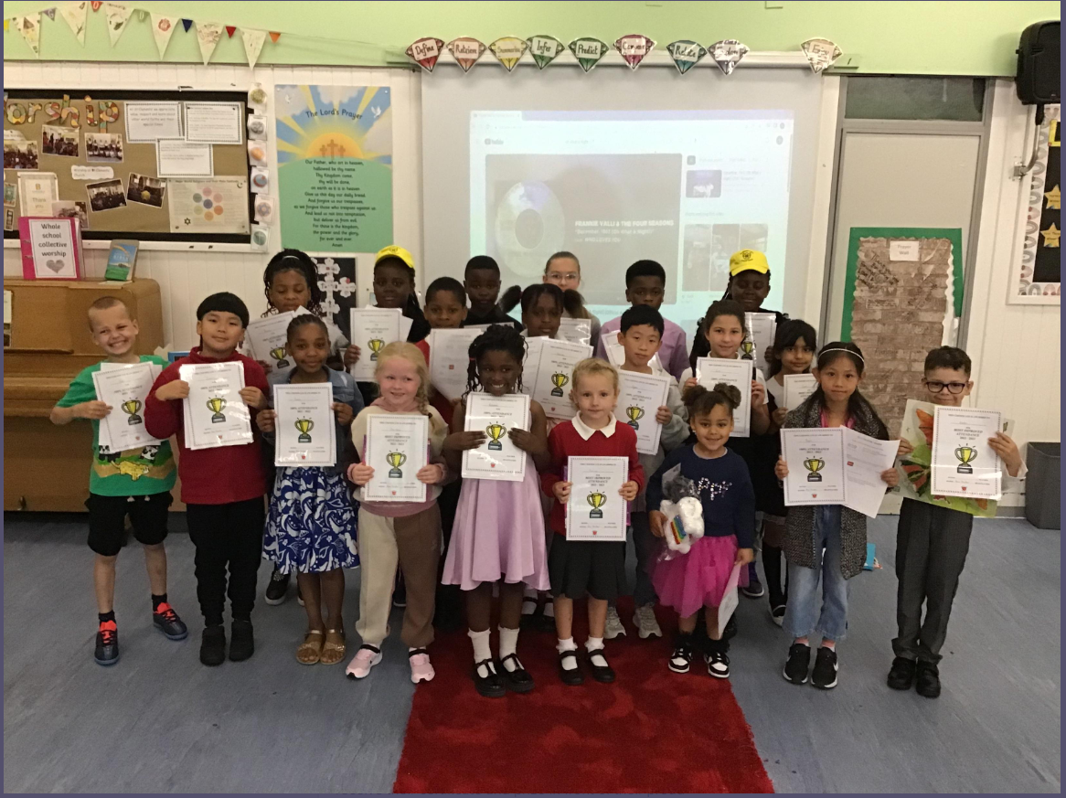
Very Important Person (VIP) Attendance Awards
On the 14th September, we celebrated those pupils who achieved 100% or the most improved attendance last year. They could get dressed up if they wanted and every one walked down our special red, VIP carpet to receive their certificate and prize in front of their proud parent/carers, friends and teachers.
Well done to all of these VIPs and a special thanks to their families for ensuring excellent and improved attendance in 2022-23. We hope to see even more children taking part in this special event next year!

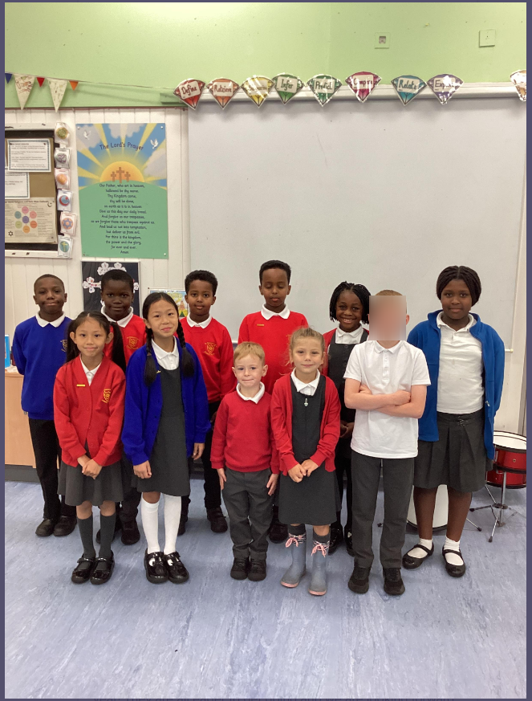

New School Council Elected!
On the 15th September, our new school councillors were elected by their friends in Years 1-6. During this year, they will be involved in making decisions about our school rules, suggesting ideas and getting feedback from their friends to discuss at their meetings.

Year 3 Stone Age Experience Day- On the 19th September, Year 3 learnt more about their topic, The Stone Age, during a day where they listened to an expert, had a go at cave painting on slate and hunting for wild animals (on pictures!) with bow and arrows! The expert commented on what a great class they were and I know the children gained a lot from the day.

Year 5 Invade Chester- On the 20th September, Year 5 went to Chester to learn more about Roman life as part of their topic this term. They saw Roman artefacts in the museum and around the city where they dressed as Roman Centurions on a march!

Year 5 Delia Darbyshire Day- On the 21st September, Year 5 took part in a day where they learnt more about the music of Delia Darbyshire (Dr Who theme tune composer). They learnt about how she created the music, the instruments she used and had a go at creating their own music too.

Macmillan Coffee Event- On Friday 29th September, we will be joining in the world’s largest coffee morning in aid of Macmillan Cancer Support.
We will be setting up a stall in the playground (weather permitting) from 2.45pm-3.30pm so parent/carers can arrive a little earlier to collect the children and enjoy a coffee and some cake and children are also able to take some cake home with them once they finish at 3.15pm.
We hope to see you all there to help raise funds for this important charity.

Harvest!
It's that time of year again where we collect for harvest.
This year we are again collecting for our local food bank ready for our assembly on Thursday 5th October.
We would appreciate donations of tinned food, pasta, flour, sugar, oil, rice, cereals, toiletries such as soap, toothpaste, shower gel, deodorant and washing up liquid would be greatly appreciated amongst any other non perishable items not mentioned.

Parent/Carer Evening
Your child will be bringing home a letter this week for you to request the date and time you would like to speak to your child/ren's teacher.
Please return the slip by Monday 9th October so teachers can set appointments and let you know by Friday 13th October.
If you require separate appointments for parents who don't live together, then please speak to your child's teacher and parent/carers who require an interpreter, will have their meeting at a separate time, not during those evenings.

