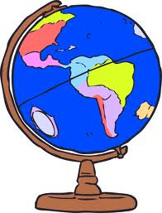

**Art /DT:**

**DT** – **Moving Parts- 3D playground models**

**Art – Traditional art techniques.**

**Study of a Summer Tree**

**Create a seaside collage**

**Humanities: Where in the UK**

**History/Geography Focus**

Our local area, plot the countries within the United Kingdom. Learn about the different countries within the UK

The rise of the British holiday.

**Year 1 Summer Topic: Where in the UK?**

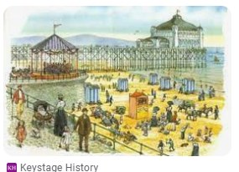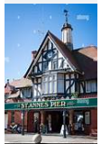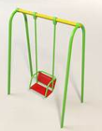

**ICT:** Word Processing/

Creating Pictures

**Science:**

Animals including Humans.

* Animal categories.
* Omnivores, carnivores and herbivores.

Seasonal Change

Summer

**PE and Music:**

Gym: Apparatus

Animal Dances

Music: Music Express Scheme

**RE:**

What does it mean to belong to a Faith Community?

**Drama/S&L Opps:**

**Role Play: Travel Agents and Stories/Texts/links:**

Narrative: Stories from other cultures, Poetry, Instructions

**Writing Opportunities:** Stories from different cultures

Information texts – instructions

Writing postcards

Holiday Review

St Anne’s Trip Recount

**Numeracy:**

